A picture of the UK scientific workforce

Diversity data analysis for the Royal Society
Summary report
A picture of the UK scientific workforce
Diversity data analysis for the Royal Society
Summary report
Issued: February 2014 DES3214
© The Royal Society, 2014

Requests to reproduce all or part of this
document should be submitted to:
The Royal Society
6 – 9 Carlton House Terrace
London SW1Y 5AG
T +44 20 7451 2500
E diversity@royalsociety.org
W royalsociety.org
For more information visit our diversity
webpages at royalsociety.org/about-us/diversity

Cover image: one of the first examples of genetic fingerprinting developed by Alec Jeffreys FRS, 1984.
Contents
Foreword 5
Executive Summary 6
Background 6
Findings 6
Overall scientific workforce 6
Gender 6
Disability 7
Ethnicity 7
Socio-economic background 7
Chapter 1: Introduction 9
Chapter 2: Defining and understanding the scientific workforce 10
Chapter 3: Diversity Programme – data gathering definitions and activities 11
Socio-economic status and socio-economic background 11
A definition of the scientific workforce 12
TBR/Science Council definition of the science workforce 12
Royal Society diversity programme definition of the scientific workforce 13
Royal Society data gathering activities 14
A. Diversity and socio-economic status within the scientific workforce 14
B. Socio-economic background and social mobility within the scientific workforce 16
C. Leaving STEMM higher education/the STEMM academic workforce 18
Chapter 4: Profile of today’s scientific workforce 19
Impact of the health sector 19
Organisation size 20
Socio-economic status 21
Earnings 23
Qualification levels 24
Gender 25
Ethnicity 27
Disability 29
Age 29
Chapter 5: Exploring the impact of diversity and socio-economic background on careers in science 31
Likelihood of working in science 31
Time taken to enter science 32
Impact of education and level of education 33
Cohort members’ routes into science 33
Career patterns in science 34
Speed of progression through occupational levels
and the ability to reach higher occupational levels 35
Career breaks 35
Chapter 6: Graduate activities/outcomes and qualification levels in the scientific workforce 37
Graduate activities of men and women 37
Graduate activities of disabled students and non-disabled students 38
Graduate activities of BME students and White students 39
Graduate activities of students with different parental backgrounds 40
Leaving destinations for staff from STEMM higher education 40
Next steps 40
Chapter 7: Diversity profile of academic career stages 41
Gender profile of career stage from first degree to professor level 42
Disability profile of career stages from first degree to professor level 44
Ethnicity profile of career stages from first degree to professor level 47
Recommendations 50
Appendix 1: Data gathering activity A – definitions 54
Appendix 2: Data gathering activity B – definitions 57
Socio-economic background 57
Parents’ education: 57
Cohort member’s education: 57
Other defined characteristics 57
Appendix 3: Data gathering activity C – definitions 59
Definition of a student 61
Graduation destinations of students 61
Staff 62
Appendix 4: TBR/Science Council – summary of qualitative research 64
Perceptions of the current workforce 64
Organisational culture 64
The business case for diversity 65
Participation and access routes 65
The role of recruitment in encouraging diversity 65
Training and progression 65
Recruitment and retention 66
Supporting aspirations 66

Foreword
As part of the Royal Society’s diversity programme the Society set out to analyse and understand the composition of the scientific workforce in terms of gender, disability, ethnicity and socio-economic status and background. We commissioned several data gathering exercises to explore these issues. This summary presents the key findings from the data, highlights where there are gaps in data or questions the data were not able to answer, and sets out a number of recommendations.
This proved to be a more challenging task than anticipated, most significantly because the various datasets available do not share a common definition of what constitutes the scientific workforce. Gaps in the data and the differing purposes for which it has been collected also limit the extent to which the data can be interrogated. This report therefore presents a complex picture from which it is difficult to draw simply-expressed conclusions and has raised more questions than it has answered. However, this is also the first time that such data have been analysed in relation to diversity characteristics across the whole of the scientific workforce. Provided the limitations of the input data are kept firmly in mind, the findings headlined in the executive summary provide a new, useful and instructive insight into the present status of diversity in science. We have also published the data tables to allow colleagues in the scientific community to use the data to look in more detail at the picture in their sector or discipline.
Our data gathering exercises are part of a larger programme of work, funded by the Department for Business, Innovation and Skills (BIS), which aims to identify barriers to entry and progression within the scientific workforce and is running projects and activities to highlight good practice, with a view to removing these barriers and increasing the diversity of the scientific workforce. The findings from this report will feed into recommendations for the development of work programmes to increase the diversity of the scientific workforce. In parallel a project is being developed to explore some of the consequences of diversity in scientific teams.
The Royal Society will work with the scientific community to address some of the gaps in data and questions still to be answered following this report. This summary and the accompanying reports provide a top-level picture to inform debate and set a baseline that can be built and improved upon. We hope that together with other learned societies, interested organisations, employers and colleagues in government, we can address some of the issues and gaps in data that these exercises have highlighted and work to build a fuller picture of the scientific workforce in relation to diversity, so that diversity and inclusion initiatives can be better targeted and we can assess whether barriers to entry and progression in the scientific workforce are being removed and progress is indeed being made.

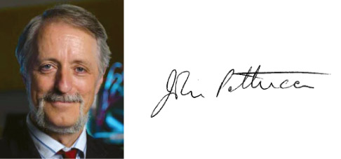

Professor Dame Julia Higgins,
DBE, FRS, FREng
Chair of the Royal Society’s Diversity Programme Steering Group
Professor John Pethica,
FRS, FREng
Physical Secretary and Vice-President
of the Royal Society

Executive Summary

Background
The Royal Society is concerned with excellent science wherever and by whomever it is done. A lack of diversity across the scientific community represents a potential loss of talent to the UK. This report is part of a four-year programme of work to understand any barriers to entry and progression in science, with a view to removing them.
This report describes the diversity of the UK’s scientific workforce based on three separate commissioned analyses of different datasets. The first uses the Annual Population Survey 2011 to provide a snapshot of the current scientific workforce compared with the overall workforce. The second looks at the career progression of a cohort of mid-career individuals, using the longitudinal British Cohort Study of over 16,000 people who were born in 1970. The third focuses on the university sector, examining the destinations of people leaving higher education, based on data from the Higher Education Statistics Agency over a period of 5-6 years.
The datasets were collected for other purposes, and the extent to which it is possible to interrogate them to describe the diversity of the scientific workforce is necessarily limited. There are large gaps in the data, the questions and definitions in the cohort study have changed over time, and most significantly, there is no shared definition of the scientific workforce. Insofar as it is possible, the analyses presented here concentrate on individuals for whom their scientific knowledge, training, and skills are necessary for the work that they do.
The results present information about the gender, disability, ethnicity and socio-economic background of people in the scientific workforce. Other diversity characteristics tend not to be recorded in the datasets. The three commissioned studies are published separately.

Findings
The picture that emerges from the data is very complex but even with the highly imperfect nature of the available data, distinct patterns emerge.

Overall scientific workforce
- Approximately 20 per cent of the people in the UK workforce need scientific knowledge and training to do their current jobs.
- Approximately one half of these people work in the private sector, one quarter in different parts of the education system and one quarter in other parts of the public sector.
- Of the cohort of mid-career individuals, 47 per cent have at one time or another worked in science.
- As a whole, the scientific workforce is better paid than people in other occupations, but relatively few people who work in science are in the very highest wage band.

Gender
- Women are not underrepresented in the overall scientific workforce, but they are highly underrepresented at the most senior roles.
- Women are also underrepresented in certain subjects in academia; for example, the proportion of first degree students who are female varies from over 79% in subjects in Psychology and Behaviour Sciences and Veterinary Science to 9.6% in Mechanical Aero and Production Engineering subjects.
- For a cohort of mid-career individuals, those women who entered the scientific workforce took longer to do so after finishing education than men did. They were also less likely than men to remain in science throughout their careers.
- For the same cohort, women working in science were less likely to take career breaks than women who work in other occupations. When women working in science do take career breaks, the break is more often connected to the birth of a child than other reasons and are often shorter.
- Women are less likely than men to progress from a first degree to further research-based study.
- For mathematics, computer sciences, engineering and technology, men are more likely to be employed in science occupations after graduating from university than are women. In subjects allied to medicine the pattern is reversed and in other disciplines, men and women are equally likely to go into employment in the scientific workforce.

Disability
- Disabled people are underrepresented in the workforce as a whole, but they are no more underrepresented in the scientific workforce than in other occupations.
- They are less likely to be in the most senior roles than people who are not disabled, but this trend is less pronounced in science than in other sectors.

Ethnicity
- The pattern of ethnicity in the scientific workforce is extremely complex.
- Overall in the scientific workforce, black and minority ethnic workers are relatively concentrated at the two ends of the spectrum – they are overrepresented in the most senior and most junior parts of the scientific workforce. However, black and black British people are slightly underrepresented in the most senior roles. Other ethnic groups, most notably Chinese, are overrepresented in the most senior roles.
- For the mid-career cohort, people from white ethnic backgrounds were 1.5 times as likely to have worked in science at some stage of their careers so far than those from black or minority ethnic communities.
- For the same cohort, an individual’s ethnic group is also related to sector of employment – for example, people from white ethnic backgrounds who work in science are more likely to work in manufacturing or academia than those from black and minority ethnic backgrounds.
- Black and minority ethnic students are less likely to progress to scientific jobs after graduating than white students.

Socio-economic background
- Socio-economic background has a strong effect on an individual’s likelihood of entering the scientific workforce. For the mid-career cohort, science workers living in households in the highest income bracket (£20,800 or over) at age 16 in 1986 are more than five times as likely to progress to a professional level occupation than those in the lowest household income bracket (less than £5,199 pa).
- For the same cohort, people with better educated parents and people from middle-income families were most likely to enter science.
- Individuals from lower socio-economic backgrounds who did enter the scientific workforce took longer to do so than those from higher socio-economic backgrounds.
Recommendations
The Society believes that in order to better understand the diversity makeup of the scientific workforce and entry, progression and retention within the workforce future analysis of datasets could be improved through:
- An agreed definition of the scientific workforce used across and by government departments and dataset owners would allow data to be compared and help improve understanding of entry into and progress through the STEMM workforce for underrepresented groups.
- Consistency between the definitions of and variables within diversity characteristics which would allow better data collection and analysis of multiple datasets on the STEMM workforce.
- Improved links between existing datasets to better understand the diversity of the scientific workforce and community, from school through to vocational, further and higher education and into the workplace, across the full range of STEMM sectors.
- Better data for the private sector to build a full picture of the scientific workforce in relation to diversity and entry into and progression within the scientific workforce.
- Further exploration of graduate outcomes by ethnicity, disability, gender and parental occupation (a measure for socio-economic background).

Introduction
The Royal Society is the national academy of science in the UK. It is a self-governing Fellowship of many of the world’s most distinguished scientists and is the oldest scientific academy in continuous existence.
The Royal Society is concerned with excellent science wherever and by whomever it is done. The Society is committed to promoting diversity in UK science, technology, engineering, mathematics, and medicine (STEMM) by seeking to increase participation from underrepresented groups.
A lack of diversity across the scientific community represents a large loss of potential talent to the UK. Restricted opportunity and diversity limits not only UK competitiveness and prosperity, but also vitality in the wider scientific workforce and creativity in society. Individuals from lower socio-economic backgrounds, certain minority ethnic groups, women, and disabled people are all currently underrepresented in education, training and employment related to STEMM.
The Royal Society and the Royal Academy of Engineering are funded by the Department for Business, Innovation and Skills (BIS) to run a programme of work aimed to address the issue of diversity in the STEMM workforce. The programme runs over four years from 2011 and is made up of two strands, one run by the Royal Society and the other by the Royal Academy of Engineering. There are a number of areas of overlap including comprehensive data gathering, pilot activities, and providing positive and accessible role models.
The Royal Society’s diversity programme is investigating ways to remove barriers to entry, retention and progression within the scientific workforce. It focuses on gender, ethnicity, disability and socio-economic status and background in the first instance and aims to cultivate leadership in the scientific community towards removing barriers to increased diversity. The Society’s programme is particularly focused on individuals making key career transitions, for example from further education to university or to the workforce or from one level within the workforce to another. For the purposes of the project, the ‘scientific workforce’ is taken to comprise all those for whom their scientific knowledge, training, and skills are necessary for the work that they do.
A significant element of the diversity programme has been collating data to improve our understanding of the scientific workforce, its makeup in terms of diversity and barriers to entry and progression, identifying where gaps exist from existing quantitative data, and carrying out primary qualitative work to identify existing good practice and areas where the Royal Society could add value.
This report is a summary of the data gathering exercises that the Royal Society has commissioned under the diversity programme. The summary outlines how the Society defines the scientific workforce, highlights the key findings from the data, identifies where there are gaps in data or questions still to be answered, and sets out a number of recommendations.

Defining and understanding the scientific workforce
The Royal Society’s aim in this report is to improve understanding of the scientific workforce in relation to diversity. This has proven to be a challenging task, in large part because there is no agreed definition of the scientific workforce in use by government and researchers or across the various relevant datasets. Many of the datasets that have been considered and analysed by the researchers for this project use information that has been collected for other purposes; as a result pulling out relevant data in relation to diversity characteristics and the STEMM workforce has been difficult.
The three separate reports summarised in this document present a complex picture, from which it is difficult to draw simply-expressed conclusions.
Intersectionality (the interplay between different diversity characteristics) is important and something the Society has tried to consider throughout the projects under the diversity programme. Unfortunately for some of the data gathering exercises it has often proved too difficult to analyse to a greater level of detail and to cut the data by more than one equality strand, because the sample sizes are too small. There are many questions the data are as yet unable to answer on the makeup of the scientific workforce and there is scope for further and more detailed work to be undertaken. The detailed reports and data tables that sit behind this summary are available to download on our diversity web pages and can be used for further analysis and interrogation.
There is also further work to be done around the definition of the scientific workforce.
Bearing in mind the difficulties of interrogating the data, this summary and the accompanying reports provide a top-level picture to inform debate. They will help to devise recommendations for the development of work programmes to increase the diversity of the scientific workforce.

Diversity Programme – data gathering definitions and activities
The Equality Act 2010 introduced nine protected characteristics for which discrimination is unlawful. The protected characteristics under the Act are:
- Age
- Disability
- Gender reassignment
- Marriage and civil partnership
- Pregnancy and maternity
- Race
- Religion or belief (including lack of belief)
- Sex
- Sexual orientation
Provisions within the Equality Act 2010 that placed a duty on public bodies to take into account the impact of socio-economic inequalities when making decisions were not brought into force. Socio-economic inequality or disadvantage is not therefore a protected characteristic under current equality legislation. Nonetheless, the Society has investigated socio-economic status and background to understand issues around entry, progression and retention within the scientific workforce.

Socio-economic status and socio-economic background
The Society’s diversity programme focuses on gender, ethnicity, disability and socio-economic status and background. Data gathering and analysis have also focused on these characteristics and various other characteristics of the workforce such as an individual’s wage band or the size of employing organisations. The specific definitions of the variables used in relation to each piece of commissioned research can be found in Appendices 1 – 3.
Socio-economic status considers the current relative position of an individual, determined by their occupation, income, material possessions, etc. Socio-economic background describes the conditions of the household in which an individual lived as a child and is often closely related to the individual’s life chances.
The first piece of data analysis undertaken (see data gathering activity A in this Chapter for further details) used the Annual Population Survey 2011 (APS 2011) to understand the current composition of the scientific workforce. This survey is a snapshot of a moment in time and it only looks at socio-economic status. It enables us to answer questions about the extent to which different groups of people (defined for example by gender, disability or ethnic origin) achieve a job role in the most senior socio-economic status groups in science.
The qualitative data gathering which was carried out alongside analysis of the APS 2011 by Trends Business Research (TBR) and the Science Council revealed that socio-economic background is often the ‘hidden’ issue within equality and diversity; interviewees and focus group participants were less comfortable discussing background than gender and racial inequality. For further details on the qualitative part of this study see Appendix 4.
To further understand social mobility within the scientific workforce the Society commissioned research to look at the impact of socio-economic background on entry into and progression within the scientific workforce. This research used the British Cohort Study 1970 (BCS70), a longitudinal study (see data gathering activity B in this Chapter for further details) which tracks a large number of people born during one week in 1970.
Parental socio-economic status is frequently used as a proxy for socio-economic background, along with an individual’s own education. Following a review of other studies exploring socio-economic background the indicators used in the analysis of BCS70 include parental occupation, household income during childhood, the educational achievements of parents and an individual cohort member’s own education.

A definition of the scientific workforce
There is no recognised and agreed definition of the scientific workforce. Unavoidably, two slightly different definitions have been used across the three pieces of commissioned research and data analysis summarised in this report.
An agreed definition of the scientific workforce used across various datasets and by government departments and researchers would allow robust comparisons and help improve understanding of entry into and progress through the STEMM workforce for underrepresented groups.
Different research studies currently use different definitions of the scientific workforce including those that have a background in STEMM, those with STEMM knowledge or skills, and those working in STEMM occupations or sectors. There is no single agreed definition even among government departments.
Some use definitions of STEMM education as a precursor to STEMM employment. However, people who are working in STEMM jobs do not always need STEMM skills or education and those with STEMM skills or education do not always work in STEMM jobs. Consequently, using education as a measure makes it difficult to capture the total scientific workforce.
If STEMM industries are used as a measure, this can include all non-STEMM workers in STEMM industries (e.g. a human resources manager in a technology company) and can exclude STEMM workers in non-STEMM industries (e.g. a specialist science journalist or a sales manager in a technical company).
Those with science knowledge and skills can be found in sectors as diverse as health and social care, education, food and farming, communications, finance, retail and public sector services.

TBR/Science Council definition of the science workforce
The first two pieces of commissioned research (see data gathering activities A and B in this Chapter for further details) used a definition previously established by TBR for the Science Council. This uses Standard Industrial and Occupational Classifications (SIC/SOC) that are used in the majority of UK sectoral analysis, in an ‘industry/occupation matrix’. This was developed to identify the sector in which a scientist is most likely to work for each occupation and attempts to capture the whole of the scientific workforce, not just those working in a narrow band of science sectors.
All occupations have a Standard Occupational Classification (SOC) code; the Science Council definition splits these codes into three groups based on their activities;
- Primary science workers: workers in occupations that are purely science based and require the consistent application of scientific knowledge and skills in order to execute the role effectively, e.g. chemists, science and engineering technicians, pharmacists, ophthalmic opticians etc.
- Secondary science workers: workers in occupations that are science related and require a mixed application of scientific knowledge and skills alongside other skill sets, which are often of greater importance to executing the role effectively, e.g. civil and mechanical engineers, conservation and environmental protection workers, Environmental health officers, Teaching professionals etc.
- Non-science workers: workers in occupations that are not science based and have no requirement for science based knowledge or skills, e.g. marketing and sales managers, travel agents, musicians, etc.
TBR acknowledge that with no recognised and agreed definition of the scientific workforce their definition work ‘is subject to professional judgement as to which group SOCs are part of’.
When disaggregating the scientific workforce by primary and secondary workers there are some key differences in relation to equality groups. The primary science workforce is less diverse than the overall science workforce across a range of indicators. Findings in relation to this are highlighted in Section 4.

Royal Society diversity programme definition of the scientific workforce
The Science Council definition used by TBR Ltd for their research uses Standard Industrial and Occupational classifications (SIC/SOC).
However, when the Royal Society’s diversity programme steering group examined the full list of occupations that were included under this definition it was felt that they were insufficiently wide enough to meet the definition the Society is using for its diversity programme – for the purposes of the project, the ‘scientific workforce’ is taken to comprise all those for whom their scientific knowledge, training, and skills are necessary for the work that they do.
It was also felt that quite a large proportion of the SOC classifications were incorrect and misleading. For example, using SOCs teachers were classified as non-STEMM, although a significant proportion will be science teachers, who certainly need scientific training as part of their jobs. TBR and the Science Council’s solution to this was to allocate all teachers into the secondary science workers group. However, most teachers do not teach science and so this approach artificially inflated the scientific workforce. The steering group also found it unsatisfactory that some engineering disciplines were not included within the definition of primary science workers. It was felt that mechanical engineering was indeed an occupation that was “purely science based and required the consistent application of scientific knowledge and skills”.
In order to be fully inclusive and to correct misleading allocations the diversity programme steering group studied in detail the list of SOCs to identify STEMM and non-STEMM occupations. Engineering UK’s definition for engineering occupations was used, which includes a wide range of occupations from engineers to clothing advisors, steel erectors and bricklayers. Many occupations previously classified in the non-STEMM category but which include significant numbers of scientists, such as science teachers and certain members of the armed forces (for example a Royal Engineer would be classified as a member of the armed forces and therefore non-STEMM but would use STEMM skills and training on a day to day basis), were put into a new ‘possibly STEMM’ category.
This new definition was used for the third piece of data analysis detailed below in data gathering activity C which analysed HESA data to identify at what point people leave STEMM academia, and, if/when they do leave, where it is that they go.
See the Royal Society’s definition of the scientific workforce and the full list of occupations used for analysis of HESA data on our diversity web pages.

Royal Society data gathering activities
In order to address the first theme of the Royal Society’s diversity programme, to define and understand the scientific workforce, the Society commissioned three separate studies:

A. Diversity and socio-economic status within the scientific workforce
TBR and the Science Council were commissioned to investigate and provide an understanding of diversity and socio-economic status within their definition of the scientific workforce.
The research study consisted of;
- A literature review to ‘take stock’ of current knowledge and to reach agreement on definitions for socio-economic status and the scientific workforce.
- Quantitative data analysis of the Annual Population Survey (APS) 2011 based on the Standard Industrial and Occupation Classifications (SIC/SOC) identifying the scientific workforce. The analysis included ethnicity, gender, disability, firm size, broad sector, highest qualification, and wage band, and cross-tabulated the data against the eight Office for National Statistics socio-economic classifications (NS-SEC).
- Interviews with private and public sector employers of scientists, researchers interested in social mobility, individuals chosen because of their background and career paths, representatives from key employers, and organisations that have undertaken diversity initiatives.
- Focus groups with employees and employee organisations, and with key stakeholders (policy makers, employer bodies, sector bodies etc.). See Appendix 4 for a summary of findings from the qualitative work.
Very few studies exist on the socio-economic background or status of the scientific workforce; this is largely due to the lack of data. This research makes use of data from the Office for National Statistics (ONS) Annual Population Survey 2011, which defines socio-economic status by the Socio Economic Classification (SEC).
The NS-SEC groups people into 8 classifications:
- Higher managerial and professional occupations (SEC 1)
- Lower managerial and professional occupations (SEC 2)
- Intermediate occupations (SEC 3)
- Small employers and own-account workers (SEC 4)
- Lower supervisory and technical occupations (SEC 5)
- Semi-routine occupations (SEC 6)
- Routine occupations (SEC 7)
- Never worked and long-term unemployed (SEC 8)
The eight classification groups are derived from Standard Occupational Classifications and details of employment status (whether an employer, self-employed or employee; whether a supervisor; number of employees at the workplace).
These groups are more closely aligned to occupations than skills. The NS-SEC grouping provides an accessible and measurable tool for research and policy analyses. It is based on routinely and widely collected data.
Each of the classification groups can be further subdivided into operational categories and sub-categories. For example, SEC1 is broader than can be conveyed by the few examples in Table 1,
and includes;
- Employers in enterprises employing 25 or more people, and who delegate some part of their managerial and entrepreneurial functions to salaried staff.
- Higher managerial and administrative occupations.
- Higher professional occupations – occupations that have been designated by ONS as professional.
For further details on the category descriptions visit ons.gov.uk/ons/guide-method/classifications/current-standard-classifications/soc2010.
Some examples across the scientific workforce are given in Table 1 below. This is useful for some groupings more than others as the ONS provides examples, but these are not always sector specific or linked to science occupations.
Table 1: NS-SEC with Occupation Examples
NS-SEC | ONS | Industry  Examples | Education Examples | Public Sector Examples
Higher managerial and professional | Chief executives and senior officials  Production managers and directors in manufacturing | Managing Director  Chief Executive | Vice Chancellor  Head of Departments and Faculties in Higher Education | Senior Government Official  Head of Health Department or Public Health Director
Lower managerial and professional | Chemical scientists  Biological scientists and biochemists  Physical scientists  Medical practitioners  Environment professionals  Senior professionals of educational establishments | Veterinarians  Physicists, geologists and meteorologist  Research or Company Scientist | Head Teacher  Higher Education Lecturer or Researcher | General practitioner  Environmental Health officer
Intermediate occupations | Teaching and other educational professionals – not elsewhere classified (n.e.c.)  Paramedics  Nurses  Physiotherapists  IT engineers  Waste disposal and environmental services managers | Engineering Technicians  Software engineer | School and Further Education Teachers  Higher Education Teaching assistant and technicians | Health & Safety Officer  Medical secretaries  Dental technicians
Small employers and own account workers | Construction and building trades – not elsewhere classified (n.e.c.)  Product, clothing and related designers | Micro business owner  Business consultants | Educational Consultants | Consultants to public sector
Lower supervisory and technical | Routine inspectors and testers  Skilled construction and building trades supervisors  Precision instrument makers and repairers  TV, video and audio engineers  Chemical and related process operatives | Health and safety inspector  Concrete building supervisor  Electricians & mechanic | School and Further Education technicians | Health and safety inspector  Staff nurse  Quality assurance technicians
Semi-routine occupations | Educational support assistants  Veterinary nurses  Dental nurses  Pharmacy and other dispensing assistants  Hospital porters | Electronic Production Assembler  Metalworking machine operator  Power plant operator | Learning Support Assistants  Teaching Assistant | Care assistants  Home carers  Receptionists
Routine occupations | Smiths and forge workers  Metal plate workers, and riveters  Welding trades  Textile process operatives  Coal mine operatives | Sheet metal worker  Scientific glass blower | Caretaker  School crossing patrol attendants  School mid-day assistants | Hospital cleaner  Administrator
Never worked, unemployed, and not elsewhere classified (n.e.c.) |  | Students; Occupations not stated or inadequately described; and Not classifiable for other reasons, are added as ‘Not classified’. Does not apply also includes methodological inaccuracies and coding issues.
Source: TBR and the Science Council (2012) Leading the way: increasing the diversity of the UK Science workforce, p. 21 – ONS data (2012)
In order to provide further clarity on the findings from TBR’s analysis of the APS 2011, the Society commissioned Point Research Ltd. to undertake further analysis of the data, focusing on the scientific workforce as a whole (rather than spilt by primary and secondary science workers) compared with the non-scientific workforce and total workforce across diversity and workforce characteristics. Some of the key findings and figures from this analysis are in Section 4 of this summary. The full analysis and tables can be downloaded from our diversity web pages.

B. Socio-economic background and social mobility within the scientific workforce
As part of TBR’s original commissioned research, the Royal Society requested an investigation into whether it was feasible to use longitudinal data sets to understand;
- Routes into and career pathways within the scientific workforce
- The impact of socio-economic background on entry into and progress through the scientific workforce
TBR were commissioned to carry out this research, which aimed to define career transitions and progression routes for members of the scientific workforce and understand how these varied according to socio-economic background.

Choosing a dataset
TBR investigated several datasets that would allow comparison to be made between an individual’s socio-economic background and their socio-economic progress in later life. One of the main challenges in using these datasets is that social attitudes of the time can be evident in panel surveys. For example, in some surveys women could not be classified as the head of a household so the survey was discontinued when this was discovered and no further data on the family or cohort individual were collected.
The review found that the following datasets might be suitable:
- The British Household Panel Survey (BHPS)
- The National Child Development Study (NCDS)
- The British Cohort Study (BCS70)
All of the data sources contain extensive information on a number of topics, from the individuals’ early lives to their adult careers, and are stored in complex datasets.
Following review the datasets below were not taken further:
- The BHPS because the survey sample decreases considerably and thus loses the ability to track careers of individuals in the initial sweep further into the study.
- The NCDS as there are some important gaps in the collected data, for example the survey does not provide a classification for employment sector (but does have occupation) and does not give a consistent view of economic activity across the survey (specifically, periods of economic inactivity have poor coverage).
The researchers selected the British Cohort Study (BCS70) which is a longitudinal dataset that tracks households and the individuals who have been part of them over time, and covers a broad range of economic and social indicators including employment, income and household relationships. The BCS70 collected data on the births and families of babies born in the UK in one particular week in April 1970, and who are therefore now 43 years old and in the middle of their careers.
There were research challenges to overcome, including a large amount of coding in order to homogenise inconsistently held or incorrectly captured data between survey sweeps. Other difficulties included:
- BCS70 was originally a health survey and successive waves gathered information on physical, educational, social, and economic characteristics and information. There were changes in the questions asked across the waves which needed reconciling.
- Definitions of variables such as ethnicity and disability have changed over time. For example there were seven ethnicity categories in 1975 and 16 in 2004 so the data had to be connected together across the sweeps.
- Many participants dropped out and there was poor data fill for some variables. There are almost half as many people in the 7th sweep (in 2008 – 9) (8,874 people) compared with the 1st sweep (1970) (16,571 people) so certain analyses can lead to small sample sizes and missing information on particular characteristics.
The BCS70 provides some information on a group of individuals that were born in 1970 and finished secondary school in the mid-1980s. It provides a useful indication of the scale and broad nature of the impact of socio-economic background on routes into and career pathways within the scientific workforce. It is the best that can be done at present with the available datasets but there is a need for new and up to date data on the current picture of socio-economic background and movement into STEMM careers.
This analysis provides some information in relation to social mobility into and within the scientific workforce for those from different socio-economic backgrounds. The full report by TBR (which can be downloaded from our diversity web pages) also contains details on trends in the wider economy/social context or specific events that may have impacted on the cohort and the results from this survey. The analysis uses quantitative data based on the questions asked of the cohort as part of the survey. It does not include qualitative information on the reasons behind the findings. Exploring the reasons behind some of the findings on entry into and progress through the scientific workforce would require further qualitative work.

C. Leaving STEMM higher education/the STEMM academic workforce
The Royal Society commissioned Oxford Research & Policy (ORP) to undertake an analysis of HESA data to identify at what point people leave STEMM academia and where it is that they go.
The data source for this analysis is the Higher Education Statistics Agency (HESA). HESA is the central source for the collection and dissemination of statistics about publicly funded UK higher education. The Destinations of Leavers from Higher Education (DLHE) survey asks leavers from higher education what they are doing six months after graduation. A very high proportion – about three quarters of leavers – complete this survey.
The analysis by ORP looked at the destinations of undergraduates, taught masters graduates and doctoral graduates studying STEMM subjects based on their:
- Gender
- Ethnicity
- Disability
- Parental occupation (parent’s socio economic status as a proxy for socio-economic background)
- Degree class (where applicable)
- Nationality (UK/non-UK) (Note: destinations data are not as comprehensive for non-UK graduates as for UK graduates)
The destinations of higher education staff were also examined by:
- Cost centre
- Grade (professor, senior lecturer/lecturer, researcher, other)
- Gender
- Ethnicity
- Nationality
- Disability
The methodology used to allocate the employment and study options between non-STEMM, STEMM and possibly STEMM can be found in Appendix 3. See Chapter 3 of this report for the Royal Society diversity programme definition of the scientific workforce.

Profile of today’s scientific workforce
The following section uses secondary data analysis of the Office for National Statistics (ONS) Annual Population Survey 2011 (APS). This analysis cross-tabulated the eight ONS socio-economic classifications against equality and sector/work characteristics of the workforce. For a description of the variables examined including the fields see Appendix 1.
This section also uses the TBR/Science Council definition of the scientific workforce which splits the scientific workforce into two categories, primary and secondary science workers. For further details on this definition see TBR/Science Council definition of the science workforce in Chapter 3 above.
Socio-economic background cannot be identified through the APS 2011 so this is not investigated here. The Society commissioned analysis of the British Cohort Study 1970 (see data gathering activity B in Chapter 3 and Chapter 5 for further details of this research) to investigate the impact of socio-economic background on entry, progression and retention within the scientific workforce.
Science provides around 20% of the total workforce. Three broad sectors for the scientific workforce were identified – the private sector, the public sector and a separate category of the education sector. Just over a quarter of the science workforce works in education (25.4%), about half of all scientifically trained workers are employed in the private sector (46.9%) and the remainder are in non-education areas of the public sector (27.5%).
The table below shows how this compares to the total workforce:
Table 2: Broad Sector by Science Workforce (2011)
Workforce | Private | Public | Education
Overall Science | 46.9% | 27.5% | 25.4%
Total Workforce | 72.1% | 16.7% | 10.7%
Source: TBR and the Science Council (2012) Leading the way: increasing the diversity of the UK Science workforce, p. 93

Impact of the health sector
- The Annual Population Survey 2011 (APS) identifies the following science sectors:
- Advanced Manufacturing
- Agriculture and Aquaculture
- Chemicals
- Construction and Installation
- Consultancy
- Education
- Energy and Environmental
- Food and Drink
- Health
- ICT
- Manufacturing
- Metals
- Military
- Pharmaceuticals
- Professional Organisations
- Public Sector
- Research and Development
- Rubber and Plastics
- Textiles
The primary science workforce comprises just over one million employees, of which the health sector accounts for almost 40%. Similarly, the secondary science workforce comprises just under 4 million employees, of which the health sector accounts for just under 25%. The presence of the health sector within the overall scientific workforce therefore has the potential to distort its profile.
TBR analysed the total scientific workforce both with and without the health sector across many of the equality and sector/work characteristics of the workforce. Key differences in relation to including or excluding the health sector from the total scientific workforce can be found in TBR’s full report which can be downloaded from our diversity web pages.
Removing the health sector reduces the diversity of the science workforce across most characteristics. The inclusion or exclusion of the health workforce can be decisive in determining whether or not the science workforce appears more or less diverse than the total UK workforce.
Restricting analysis to the primary science workforce and excluding the health workforce has a compound impact; levels of diversity in this restricted group are often much lower. For example, although women working in science are more likely to be in higher socio-economic status groupings than women in the total UK workforce, the representation of women in the workforce is lower in the primary science workforce when the health sector is removed from the analysis.
The table below shows the impact of excluding health sector employees from the analysis. The representation of women in the primary science workforce drops to just 25%.
Table 3: Relative gender differences in the primary science workforce, removing health
Workforce | Male | Female | Count
Primary Science (without health) | 75% | 25% | 758,600
Primary Science | 62% | 38% | 1,245,290
Science Workforce | 50% | 50% | 6,015,890
Total Workforce | 45% | 55% | 28,693,810
Source: TBR and the Science Council (2012) Leading the way: increasing the diversity of the UK Science workforce, p. 77

Organisation size
A large proportion of the scientific workforce (much like the non-science workforce) works in small and medium sized enterprises (SMEs – less than 250 employees). Micro SMEs (1 – 10 employees) employ 10.5% of the scientific workforce, 11.6% are employed within firms that are between 25 and 49 people and 23% are employed in firms that employ between 50 and 249 employees. This shows the importance of very small firms and enterprises to the science workforce.
Figure 1: Scientific workforce by firm size (2011)
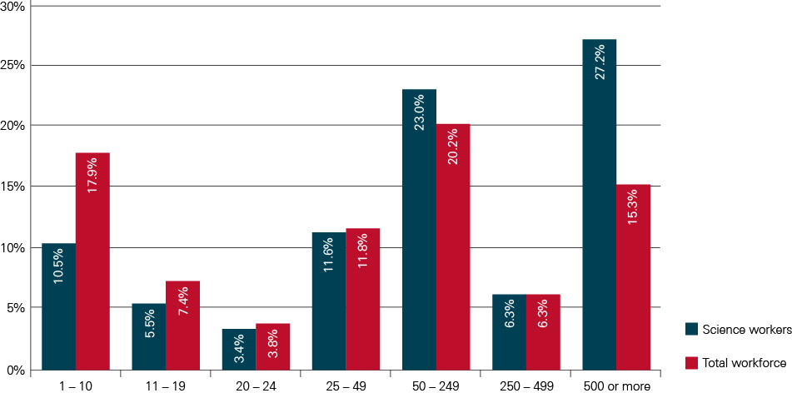
Source: TBR and the Science Council (2012) Leading the way: increasing the diversity of the UK Science workforce, p. 91 – APS 2011
The proportion of those in SMEs is smaller in the science workforce than in the non-science and total workforces (54% in the scientific workforce, 63% in the non-scientific workforce and 61.1% in the total workforce).

Socio-economic status
The socio-economic status composition of the science workforce is characterised by high proportions of employees in the managerial and professional classifications (the top socio-economic classification [SEC1]: 35.6% and the second highest [SEC2]: 42.3%), relative to the total UK workforce. A relatively small proportion of the scientific workforce is spread across the remaining socio-economic classification categories.
Figure 2: Scientific, non-scientific and total workforce by SEC category
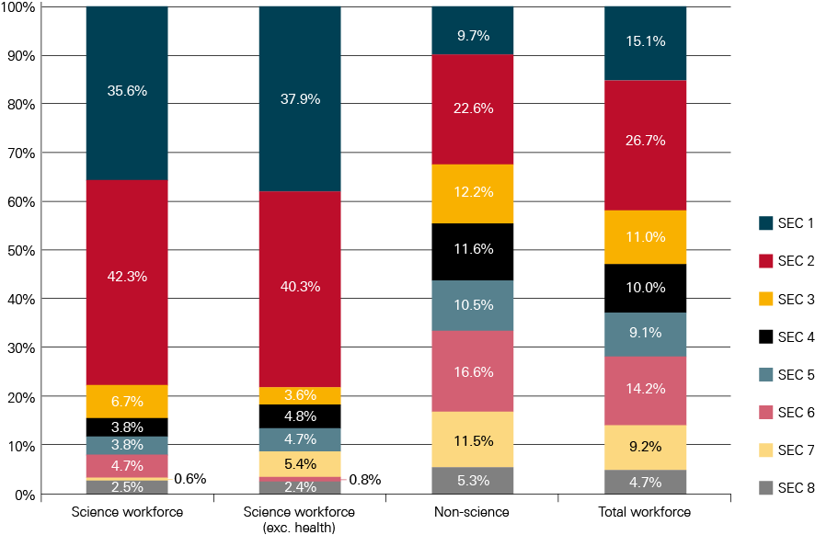
Source: Point Research Limited (2013) The diversity of the UK science workforce: Quantitative analysis of the Annual Population Survey, p. 13

Earnings
As a whole, the scientific workforce is better paid than the non-science and total workforces. 47.0% of the scientific workforce earn within the top 3 wage bands (£30,000 to £39,999, £40,000 to £49,999, and £50,000+), compared with 21.4% of the non-scientific and 27.3% of the total workforce.
Figure 3: Scientific, non-scientific and total workforce, by wage band
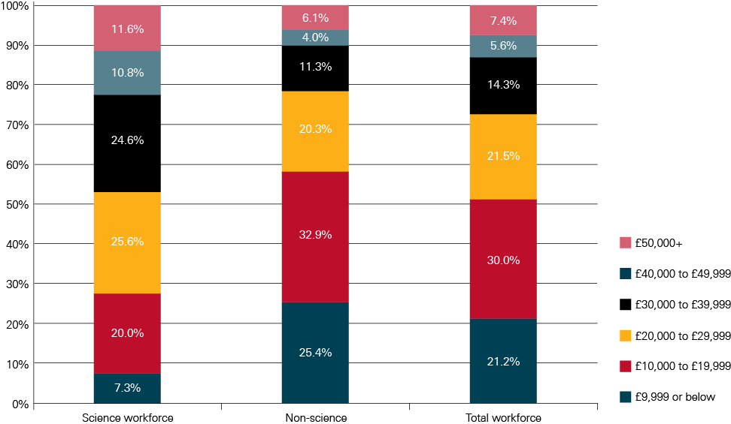
Source: Point Research Limited (2013) The diversity of the UK science workforce: Quantitative analysis of the Annual Population Survey, p. 14
Scientific workers in the two top socio-economic classifications (SEC 1 and 2) – and to a lesser extent, SEC 5 – are better paid than scientific workers in the other SEC categories, with the majority in each earning £20,000 or more (89.7% of those in SEC 1, 75.2% in SEC 2 and 53.0% in SEC 5).
Compared with the non-science and total workforces, the scientific workforce earn higher wages on the whole. This is likely due to the higher proportion of the scientific workforce in SEC 1 and 1, compared with the non-science and total workforces. However, it is not the case that the scientific workforce is better paid than the non-science workforce in every SEC category. In the higher socio-economic classification categories such as SEC 1 and 2, wages are concentrated in the mid-range wage bands and less likely to be on the extreme ends of the pay scale. Fewer scientific workers in SEC 1 are in the top wage band: 24.1% of the scientific workforce earns wages in the top wage band (£50k+), compared with 32.3% of the non-scientific workforce and 28.2% of the total workforce. In contrast, in lower level SEC categories (SEC 3, 5, and 6) science workers are better paid than non-science workers.
A person who works in science is more likely to have a better paid job than someone who does not work in science, although someone working in science in the top socio-economic group (SEC1) is less likely to reach the highest wage band (£50k+) than someone not working in science.

Qualification levels
Scientific workers have higher levels of formal qualifications than the non-science workforce:
58.7% of the scientific workforce have a highest qualification of Level 5 or above (graduate and postgraduate qualifications) compared with less than 1 in 4 of the non-science workforce (22.3%) and less than 1 in 3 of the total workforce (29.9%). Indeed, 24.0% of the scientific workforce have the highest possible qualification (‘NQF Level 7 and 8’ – i.e. postgraduate degrees), compared with only 4.8% of the non-science workforce and 8.8% of the total workforce.
Conversely, only 2.3% of the scientific workforce has no qualifications, compared with 8.2% of the non-science and 7.0% of the total workforce.
Figure 4: Scientific, non-scientific and total workforce, by highest qualification
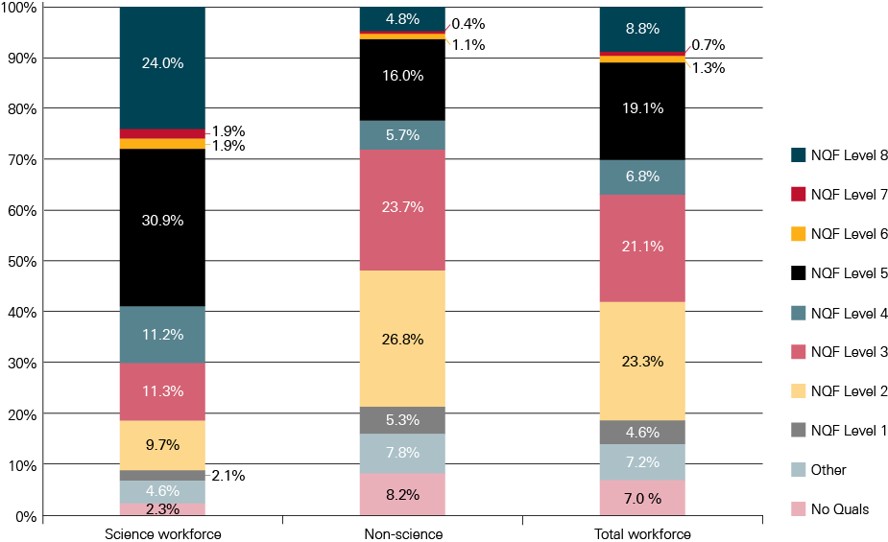
Source: Point Research Limited (2013) The diversity of the UK science workforce: Quantitative analysis of the Annual Population Survey, p. 23
As a general trend, the higher the level of socio-economic classification category, the greater the proportion of the scientific workforce with NQF Level 7 and 8 (masters and doctorate degrees), the highest possible qualifications.
Within qualification levels, the distribution of workers is more evenly spread across SEC categories in the non-science workforce than in the science workforce.
- For example, 93.3% of science workers with NQF level 7 and 8 are in SEC 1 and 2, the highest socio-economic classifications, compared with 74.0% of non-science workers with the same level of highest qualification (85.0% total workforce).
Although those in the science workforce are more likely to fall into the top two SEC categories if they have higher level qualifications, those in the science workforce with lower level qualifications are still more likely to fall into these groups than they would in the total workforce.
- 41.3% of scientific workers with a highest qualification of NQF Level 1 (the lowest possible qualification) are in SEC 1 or 2, compared with only 19.7% of the non-science workforce and 21.7% of the total workforce.

Gender
The following section considers the distribution of men and women within socio- economic classification (SEC) categories. As noted in Chapter 2 of this report intersectionality is an important issue. Women are not a homogeneous group and certain groups of women may face different barriers or face barriers in disproportion to women in general; for example BME women, disabled women or women with caring responsibilities. Unfortunately the analysis below only considers women as one group and the data are not cut further by other diversity characteristics which could provide information on whether certain groups of women are more or less likely to be underrepresented (or indeed overrepresented) in particular SEC categories. This further analysis could not be run in the timescale for this report but the APS 2011 or future APS surveys could be analysed to a greater degree of granularity.
Women make up a slight majority of the science workforce (50.3%). This is not the case for the non-scientific workforce and the total workforce as a whole (45.3% and 46.3% respectively).
Figure 5: Scientific, non-scientific and total workforce, by gender
(including and excluding Health sector)
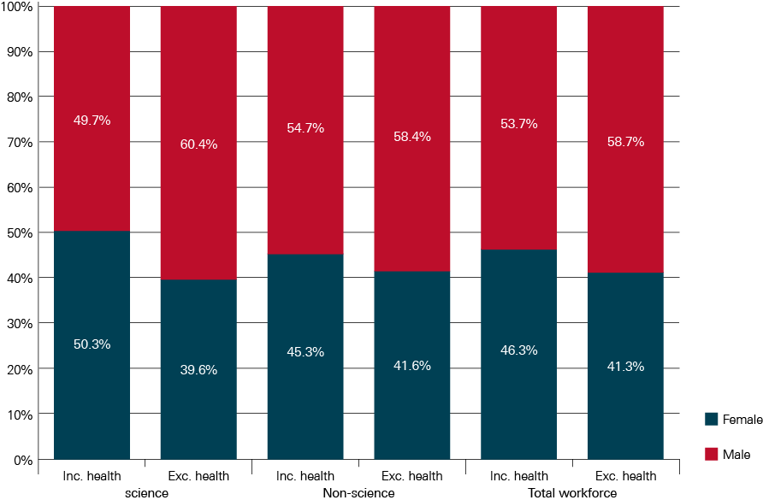
Source: Point Research Limited (2013) The diversity of the UK science workforce: Quantitative analysis of the Annual Population Survey, p. 32
There are, however, gender disparities within socio-economic classification (SEC) categories, with women in the scientific workforce underrepresented in all but three. Women are most keenly underrepresented in SEC 1, 4 and 5, and less so in SEC 6 and 7. Men in the scientific workforce are more than twice as likely to be in the highest level SEC category as women: 47.5% are in SEC 1, compared with only 23.6% of women. Women are concentrated in the lower level SEC 2 (54.5% of women, compared with 30.1% of men). A similar pattern is also evident in the top two socio-economic classifications within the non-science workforce suggesting a ‘glass ceiling’ situation – a concentration of women in lower managerial and professional roles and marked underrepresentation in higher senior management positions.
Figure 6: Female/Male workforce by SEC categories
(scientific, non-scientific and total workforce)
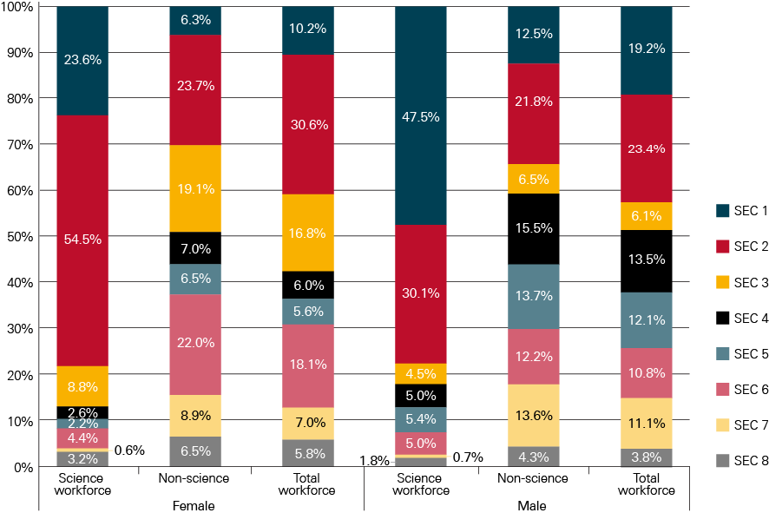
Source: Point Research Limited (2013) The diversity of the UK science workforce: Quantitative analysis of the Annual Population Survey, p. 34
Figure 7: SEC categories by gender (scientific, non-scientific and total workforce)
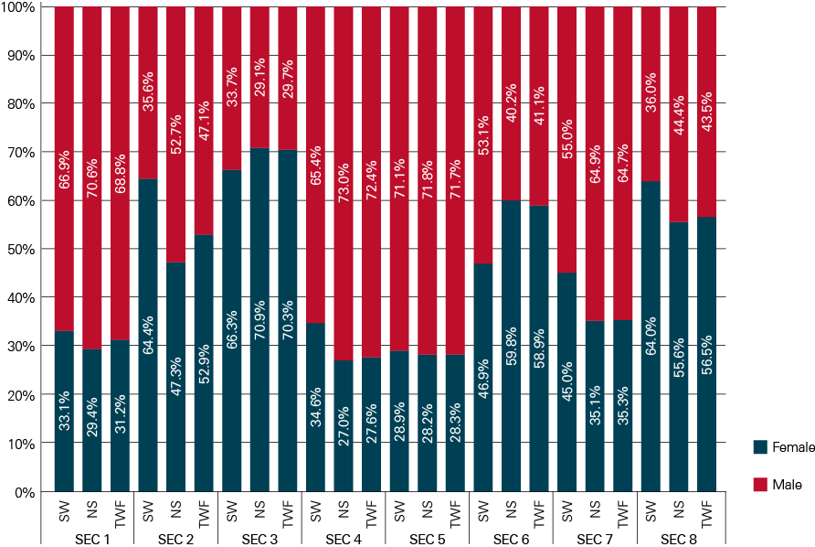
Source: Point Research Limited (2013) The diversity of the UK science workforce: Quantitative analysis of the Annual Population Survey, p. 33

Ethnicity
The distribution of ethnicity groups in the science workforce is similar to that of the non-science and total workforces. The largest ethnic group is White, followed by Asian or Asian British, Black or Black British, and Other. Very small proportions of the scientific workforce are Mixed or Chinese.
As with the science workforce in general, the majority of each ethnic group work in SEC 1 or SEC 2. Likewise, the proportion of each ethnicity group working in semi-routine or routine occupations (SEC 6 and 7) is very low, as is the case for the science workforce as a whole.
The ethnic composition within SEC categories generally reflects that of the scientific workforce as a whole. However, as a group Black and Minority Ethnic (BME) workers (who make up 10.5% of the scientific workforce) are overrepresented in SEC 1, 6 and 8 and underrepresented in SEC 2, 4, 5 and 7. These findings are relatively consistent with that of the non-science and total workforces, with the exception of SEC 1 and 7.
With the exception of Black or Black British, there is a higher proportion of every ethnic group in SEC 1 than of White scientific workers. This is most marked among Chinese scientific workers (72.0% of whom are in SEC 1 occupations). In contrast, only 29.3% of Black or Black British scientific workers are in SEC 1 – slightly below White (34.5%) and the overall scientific workforce (35.6%).
Figure 8: BME group workforces by SEC categories
(scientific, non-scientific and total workforce)
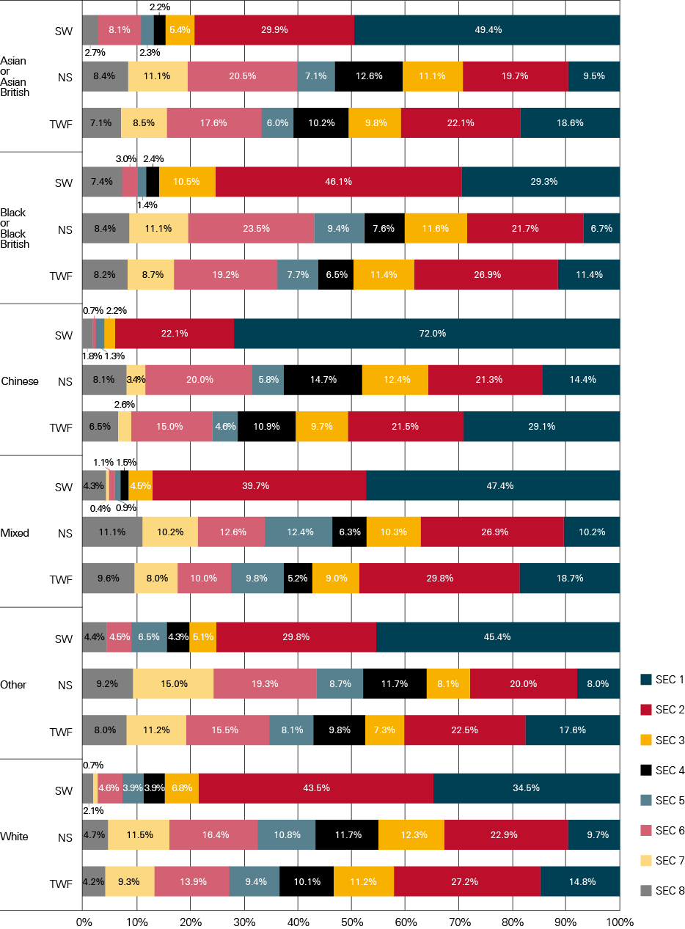
Source: Point Research Limited (2013) The diversity of the UK science workforce: Quantitative analysis of the Annual Population Survey, p. 41

Disability
The proportions of workers who are disabled (13.5%) and non-disabled (86.5%) in the science workforce are similar to that of the non-science (14.7%, 85.3%) and total workforces (14.5%, 85.5%).
A higher proportion of workers in middling and lower level SEC categories (SEC 3, 4, 5, and 7) are disabled compared with SEC 1, 2, 6 and 8. However, relative to the non-science and total workforces, disabled science workers are slightly better represented in higher level SEC categories (i.e. SEC 2, 3, 4) and less so in lower level SEC categories (5, 6, 7, 8).
Figure 9: Disabled/Non disabled workforce by SEC categories
(scientific, non-scientific and total workforce)
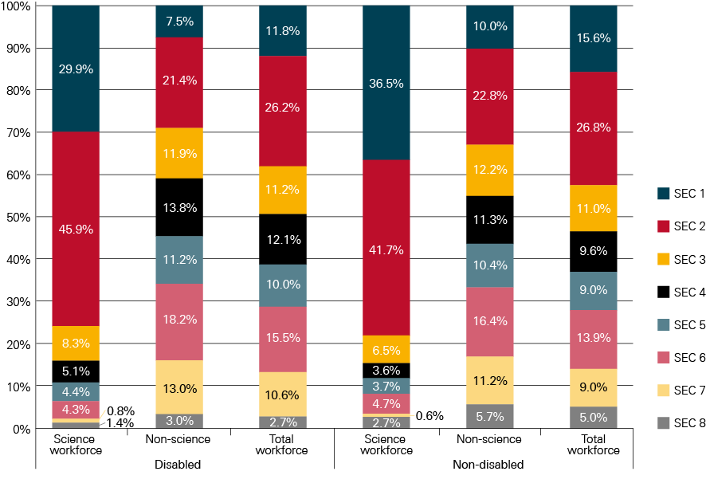
Source: Point Research Limited (2013) The diversity of the UK science workforce: Quantitative analysis of the Annual Population Survey, p. 48

Age
The scientific workforce has a generally older age profile than the non-science and total workforces. However, this varies by SEC category. Science workers in intermediate occupations (SEC 3) or who have never worked, are long-term unemployed or otherwise unclassified (SEC 8) exhibit a markedly older profile than those in the non-science and total workforces. However, scientific workers in routine occupations (SEC 7) have a younger profile relative to the non-science and total workforces.
As might be expected, as age increases, so does the proportion of those in higher level SEC categories. However, the incline is steeper for the scientific workforce compared with the non-science and total workforces. By age group 25 – 29, 76.8% of the scientific workforce is in SEC 1 and 2, compared with only 33.5% of the non-science and 42.6% of the total workforces.
Figure 10: Proportion of workforce in SEC 1 – 2 over age band
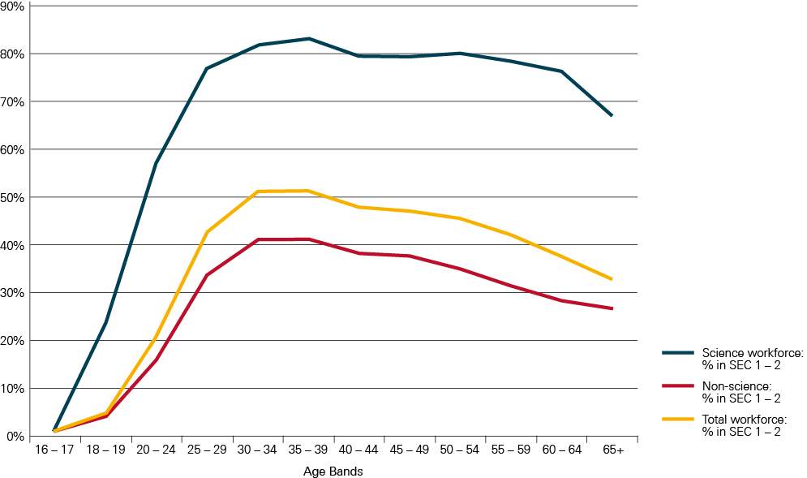
Source: Point Research Limited (2013) The diversity of the UK science workforce: Quantitative analysis of the Annual Population Survey, p. 62
Accordingly, a greater proportion of the total workforce falls in lower level SEC categories than the scientific workforce – a disparity that increases with age group in some SEC categories, such as
SEC 4.

Exploring the impact of diversity and
socio-economic background on careers in science
The following chapter includes data and analysis from the British Cohort Study of 1970 (BCS70).
The findings in this section are relevant only to this particular cohort but provide a useful indication of the impact of socio-economic background on routes into and career pathways within the scientific workforce. See Appendix 2 for the variables used for this analysis.
For further detail on trends in the wider economy/social context or specific events that may have impacted on the cohort and the results from this survey see TBR’s full report which can be downloaded from our diversity web pages.
This analysis of BCS70 uses the TBR/Science Council definition of the science workforce – see Chapter 3 of this report for this definition.
It is important to highlight that the data in this section look at the likelihood of working in science and time taken to enter science and does not consider the level at which an individual may have entered or be working at in science. Figure 11 suggests that those with parents who left school at 15 and under are only about 18% less likely to ‘work in science’ than those with parents who left at 22 and over. Figure 12 suggests an impact of only about 29% on the time to ‘enter science’ of having parents in unskilled as compared with professional occupations. It is likely that individuals with parents from professional occupations are not only more likely to work in science and take less time to do so but that they also enter at and reach higher levels in science than those with parents from unskilled occupations. These are likely to be significant additional factors. As the BCS70 looks only at socio-economic background and does not link this to socio-economic status this unfortunately cannot be interrogated in depth.

Likelihood of working in science
Around half (47%) of the BCS70 cohort have worked in science in one form or another at some stage in their lives.
Socio-economic background has an impact upon the likelihood of entering the science workforce. The higher an individual’s socioeconomic background, measured in terms of parental social class or parental education, the more likely they are to work in science. Measured using these indicators the relationship between socio-economic background and working in science is so strong that it could be described as a gradient, just as the relationship between socioeconomic background and a child’s educational achievement is often described in the literature as a gradient. The figure below illustrates this relationship.
Figure 11: Percentage entering science by parents’ age on leaving continuous full-time education
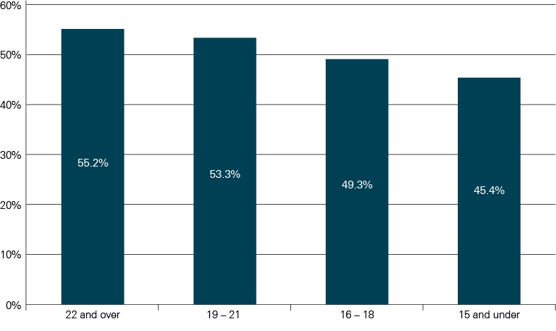
Source: TBR (2013) Leading the way; increasing the diversity of the science workforce. Project two: exploring the impact of socio-economic background on careers in science, p. 17 – BCS70
The relationship between household income during childhood and the likelihood of working in science is less clear. Individuals in households in the middle income bracket at age 16 (£10,400 to £15,999 pa in 1986) are most likely to have worked in science while those in the households in the lowest income bracket at age 16 (less than £5,199 pa) are least likely to have worked in science.
Men in the overall cohort are slightly (1.2 times) more likely than women to have worked in science.
People from White ethnic backgrounds are 1.5 times more likely to have worked in science than those from Black or Minority Ethnic (BME) communities.

Time taken to enter science
From the cohort data, women tend to take longer to enter science after leaving continuous full-time education than men.
A high proportion (70%) of individuals in BCS70 join the science workforce around the ages of
29 – 34.
In general, individuals from lower socio-economic backgrounds take longer to enter science after leaving continuous full-time education than those from higher socio-economic backgrounds, as shown in the figure below.
Figure 12: Years between leaving full-time education and entering science by parental social class
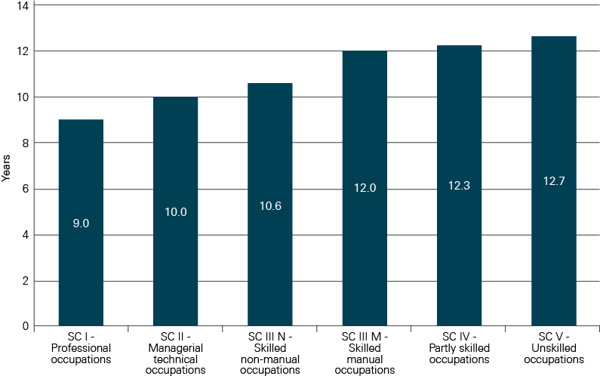
Source: TBR (2013) Leading the way; increasing the diversity of the science workforce. Project two: exploring the impact of socio-economic background on careers in science, p. 19 – BCS70

Impact of education and level of education
From the cohort data, the longer an individual spends in continuous full-time education and the higher their qualifications on leaving, the more likely they are to work in science and the more likely they are to progress to a professional level occupation in science faster if they enter at a lower level. Those leaving education with degree-level or postgraduate qualifications were almost twice as quick to start a science career as individuals leaving school without five O-levels or equivalent.
At technician level those who achieved Level 3 qualifications (two A-levels or equivalent) by the time they had left education progressed more quickly to technician level occupations than those leaving education without qualifications at this level.

Cohort members’ routes into science
The cohort data suggest a ‘typical’ route for the cohort of remaining in full-time education through further and higher education, and the longer an individual spends in continuous full-time education and the higher their qualifications on leaving, the more likely they are to work in science.
Table 4: Three illustrative careers in science from the cohort sampled
 | Person A (male) | Person B (male) | Person C (female)
Career pattern in science | Moved to a science-related job after working in another sector. Promoted to a technician level occupation after almost 9 years. Left science shortly after. | Started work in a technician-level science occupation, and has been in science roles since. Promoted to a professional level occupation after 6 years. | Moved to a technician-level science occupation after starting work in another sector. Took a career break at age 30, before returning to work part-time. Left science a few years later.
Parental social class | SC IV – Partly skilled occupations | SC I – Professional occupations | SC III – Skilled non-manual occupations
Household income at  age 16 | £5,200 to £10,399 pa | £20,800 or over | £10,400 to £15,599
Parents’ age on leaving continuous full-time education | 15 | 21 | 17
Parents’ highest qualification | Below Level 2 | Degree | Level 3
Age left continuous  full-time education | 16 | 21 | 18
Highest qualification  at end of continuous  full-time education | Five O-levels | Degree | Level 3
Age started work in science | 27 | 21 | 28
First occupation in science | Level 2 | Level 3 | Level 3
Sectors worked in | Manufacturing | Academia, other education | Health, other education
Highest occupation reached | Level 3 | Level 4 | Level 3
Source: TBR (2013) Leading the way; increasing the diversity of the science workforce. Project two: exploring the impact of socio-economic background on careers in science, p. 21

Career patterns in science
Generally in the cohort, individuals from higher socio-economic backgrounds are more likely to work in science education than those from lower socio-economic backgrounds. People from lower socio-economic backgrounds tend to be more likely to work in manufacturing than those from higher socio-economic backgrounds.
Men in the BCS70 are more likely to have spent their entire working life so far in science than women. Approximately 50% of women who have worked in science started work in another sector compared with approximately 33% of men, and women who started work in science are more likely to have left the sector than men who started work in science.
Among science workers in the cohort, women are more likely to work in education or health than men, and men are more likely to work in manufacturing than women.
People from White ethnic backgrounds are more likely to work in academia or manufacturing than those from BME communities. People from BME backgrounds are more likely to work in health than people from White ethnic backgrounds.

Speed of progression through occupational levels and the ability to reach higher occupational levels
In this cohort, people who have worked in science at some point in their career are more likely to reach higher occupational levels than those who have never worked in science. Working in science also correlates with career progression in other sectors. Compared with those who have never worked in science, people who work in science are more likely to reach higher level occupations even if they leave the sector.
Among those who have worked in science, the higher an individual’s socioeconomic background the more likely they are to progress to higher occupational levels. For example science workers living in households in the highest income bracket (£20,800 or over) at age 16 are more than five times as likely to progress to a professional level occupation as those in the lowest household income bracket (less than £5,199 pa).
Among those who have worked in science, individuals from lower socio-economic backgrounds take longer to progress to technician and professional level occupations than those from higher socio-economic backgrounds. It also takes women in science longer to progress to technician level occupations than men.
These data only look at ‘progressing to a professional level occupation’. It is important to highlight that professional level occupations can cover a wide band and if the comparison were narrowed to compare for example, the likelihood of getting to be a STEMM professor in a top 20 university by age 45-55 (the approximate average age at which individuals achieve a professor level role) or a chief executive of a large STEMM industrial employer, the ratio is likely to be larger.

Career breaks
The definition of a career break used in the BCS70 can include a period in education, looking after home or family, in voluntary work, on maternity leave, travelling or on extended holiday follow the end of a period of employment, including employment left due to pregnancy. The definition is wider than maternity leave, and the average length of career breaks for the BCS70 cohort are longer than may be assumed (for those that have worked in science the average length of career breaks taken by women is 44 months). See Appendix 2 for the variables used for this analysis.
The analysis below pulls out some findings in relation to women taking a career break associated to the birth of a child but it does not analyse the career breaks by reason for taking them in any greater detail. The findings are therefore fairly top-level.
There is a strong influence of career breaks on women’s working lives. Almost a third of women (32%) in the BCS70 sample had taken one or more career breaks. Most women had taken a single career break; relatively few (4% of all women in the sample) have taken more than one; and no-one in the sample had taken more than three career breaks. Very few men (3%) had taken a career break.
Women working in science are less likely to take careers breaks than the wider population. When women working in science do take career breaks, the break is more often connected to the birth of a child than other reasons and are often shorter.
- 28% of women who have worked in science have taken a career break, compared with 36% of women who have never worked in science.
- 27% of the career breaks taken by women in science are associated with the birth of a child compared with 17% of the career breaks taken by women who have never worked in science.
The majority of women in the cohort who take a career break (for any reason) return to work on a part-time basis even if they worked full-time previously, with women in science slightly more likely to do this than those who have never worked in science. However, women in the cohort that have taken a career break to have a baby are more likely to return to work part-time than those taking a career break for other reasons, again with women in science more likely to do this than those who have never worked in science.
For further analysis on the impact of career breaks on progression through occupational levels and time taken to progress see the full report.
Figure 13: Proportion of women working full-time before a career break who returned to work full-time
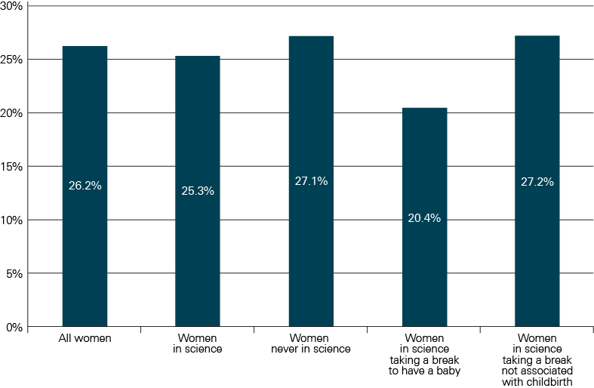
Source: TBR (2013) Leading the way; increasing the diversity of the science workforce. Project two: exploring the impact of socio-economic background on careers in science, p. 29 – BCS70

Graduate activities/outcomes and qualification levels in the scientific workforce
The data in this chapter are from analysis by Oxford Research and Policy (ORP) on behalf of the Royal Society, using the HESA Destinations of Leavers from Higher Education (DLHE) survey. The DLHE survey asks leavers from higher education what they are doing six months after graduation. About three quarters of leavers complete the survey.
Data for graduate outcomes are averaged over the same four academic years 2007/08 to 2010/11 (5 years’ worth could not be completed due to subject name changes between 2006/07 data fields and 2007/08 to 2010/11 data fields).
Up to 2010/11, the HESA DHLE survey was restricted to UK and European Union-domiciled leavers only but from 2011/12 onwards the population includes leavers from all domiciles. Analyses of the DHLE data by ORP used data from 2007/08 to 2010/11 and consequently are restricted to UK and European Union-domiciled leavers for analyses broken down by gender and disability, and have been further restricted to UK-domiciled leavers only for analyses broken down by ethnicity.
This section uses the Royal Society definition of the scientific workforce details of which can be found in Chapter 3 of this report.
The main graduate activities include Full-time paid work only (including self-employed), Part-time paid work only, Voluntary/unpaid work only, Work and further study, Further study only, Assumed to be unemployed and Not available for employment.
The data below only looks at the graduate level activities from STEMM courses by one diversity group at a time. Unfortunately the data proved too difficult to analyse to a greater level of detail
and to cut the data by more than one equality strand. Due to the number of different groups within these broad diversity groupings (different ethnic groups and types of disability for example) this meant that when considering the number of possible graduate activities the numbers were too small to allow meaningful comparisons to be made.
It may also be of interest to look at degree attainment when considering graduate outcomes. Information on this and gender, ethnicity and disability degree attainment gaps can be found through Equality Challenge Unit in their higher education statistical reports.
For the HESA data subject groups and individual subjects and methodology used to assign employment and study options to the Society’s scientific workforce definition see Appendix 3.
Considering individual subject groups some interesting findings have been pulled out below. For
in-depth analysis of individual subject groups see the full summary of observations by ORP, downloadable from our diversity web pages.

Graduate activities of men and women
Overall a top level analysis of the activities of graduates from STEMM courses at first degree, masters and doctoral levels suggests that across subject groups there are some differences between the graduate activities of men and women.
In the majority of subject groups, overall, men are more likely than women to be undertaking research-based further study.
Considering individual subject groups:
- In individual medicine and dentistry subjects there are few clear differences between activities for male and female graduates from these courses. The vast majority of male and female graduates from first degree courses across medicine and dentistry subjects enter STEMM employment.
- High proportions of men and women graduates from subjects allied to medicine courses go on to work in STEMM occupations, which would be expected given the vocational nature of many subjects in this subject group.
- The patterns of activity for male and female graduates from biological science subjects are similar. Overall relatively low proportions of graduates are in STEMM occupations six months after completing first degrees and high proportions are in non-STEMM occupations.
- There are differences the post-completion activities of men and women graduating from vocational courses in the veterinary sciences, agriculture and related subjects group. Overall, men are less likely than women to be in STEMM activities. For higher level degrees the pattern is reversed: women are more likely than men to be in non-STEMM activities.
- A similar proportion of men and women, across all the physical sciences first degree courses went on to STEMM employment. However, of those in non-STEMM activities with a physical sciences degree, women are more likely to be in non-STEMM occupations. On the whole men are more likely than women to undertake research after completion or to be working in STEMM occupations.
- Among the mathematical and computer sciences subject group, at individual subject level there are differences between the post-completion patterns of activity of men and women, with men being more likely than women to be in STEMM employment or undertaking research-based further study. At masters level women and men are equally likely to be in STEMM employment, women more likely than men to be in non-STEMM employment and less likely to be undertaking a research-based course. Men are more likely than women to be working in STEMM employment after completing doctoral level qualifications.
- In engineering higher proportions of male graduates than female graduates enter STEMM employment at all levels. In some engineering subjects there are no clear differences between the patterns of activity of men and women six months after completion. However, in other engineering disciplines such as electronic and electrical engineering and production and manufacturing engineering men are more likely than women to be in STEMM after first degrees.
- Overall, there are some differences in the patterns of activity of male and female graduates from technology courses. Relatively high proportions of both men and women are engaged in non-STEMM activities: 60.3% of men and 61.3%.
- Male graduates from architecture, building and planning first degree courses are more likely to be undertaking STEMM activities than female graduates with great variation among subjects.
For more detailed analysis on individual subject groups seethe full analysis of HESA data downloadable from our diversity web pages.

Graduate activities of disabled students and non-disabled students
The proportion of students with a declared disability varies a little between subject groups. Within a given subject group proportions of students without a declared disability are similar at first degree and masters level, but are in general higher at doctoral level.
Table 5: Proportion of all students with known disability status with no declared disability across subject groups
Subject Group | Proportion of all students with known disability status with no declared disability
Subject Group | First Degree | Masters | Doctorate
Medicine and Dentistry | 93.0% | 91.1% | 95.7%
Subjects allied to Medicine | 91.2% | 91.5% | 92.1%
Architecture, Building and Planning | 90.5% | 91.9% | 94.4%
Biological Sciences | 90.0% | 90.0% | 91.1%
Engineering | 91.7% | 91.7% | 92.2%
Mathematical and Computer Sciences | 90.6% | 90.6% | 89.9%
Physical Sciences | 89.9% | 90.3% | 91.8%
Technologies | 87.0% | 87.5% | 93.9%
Veterinary Sciences, Agriculture and related subjects | 87.4% | 87.4% | 94.3%
Source: Oxford Research & Policy (2013) Summaries of observations on the destinations of STEMM leavers from higher education and on higher education staff including their previous employment and leaving destinations p. 39
Data presented on the proportions of students from a particular group taking a subject are 5 years worth of data 2006/07 – 2010/11 (there are a small number of subjects for which only four years’ data are presented due to subject name changes – see the full analysis of HESA data for subject groups on our diversity web pages).
In the majority of subjects the differences between patterns of activity of graduates with and without a declared disability six months after completion at first degree level are not significant. In addition, in general the numbers of graduates with a declared disability at masters and doctoral levels are too small to allow comparisons to be made.
However, at subject group level there are often significant differences at first degree level between the outcomes of graduates with and without a declared disability. Graduates without a declared disability are more likely than graduates with a declared disability to be in STEMM occupations and less likely to be in non-STEMM occupations at first degree level six months after completion. Where numbers of graduates with a declared disability are sufficiently large to analyse, the same pattern is often observed at masters level.
There are some variations in the patterns of activity of graduates with and without a declared disability at individual subject level but again where differences in patterns of activity are significant, graduates without a declared disability are more likely to be in STEMM occupations than graduates with a declared disability.
For analyses of the subject groups download the analysis of HESA data from our diversity web pages. These analyses only look at the effect of having a declared disability. More work is required to examine the effects of different disabilities on post-course outcomes, although it should be noted that in many cases the numbers of graduates with specific disabilities may not be great enough to enable patterns of activity to be compared.

Graduate activities of BME students and White students
Overall a top level analysis of the distribution of students studying STEMM courses at first degree, masters and doctoral level suggests that there are differences in the distributions of different ethnic groups between subjects.
In particular Asian groups are more likely to study medicine and dentistry, subjects allied to medicine, and mathematical and computer science subjects than White students. Chinese students are also more likely to study medicine and dentistry subjects than White students, and female Chinese students are more likely to study engineering or mathematical and computer science subjects than White female students. Also, BME groups are less likely to study physical sciences or veterinary sciences, agriculture and related subjects than White students.
The numbers of graduates from different ethnic groups across employment and study options are too low to report on. This analysis therefore combines ethnic groups into Black and Minority Ethnic (BME) graduates and White graduates. Overall BME graduates, at all levels, are less likely than White graduates to be working in STEMM occupations in particular, or STEMM activities in general, six months after completing their courses. In general numbers of graduates in individual subjects are too low to draw firm conclusions about employment patterns.
For detailed analysis of BME and White graduate outcomes by subject group see the full analysis of HESA data available on our diversity web pages.

Graduate activities of students with different parental backgrounds
The data on graduate outcomes of students with different parental backgrounds presents a complex picture across the eight socio-economic classifications. In many cases the numbers are too low at subject level to draw meaningful conclusions. Further investigation is required to fully understand the relationship, if any, between parental background and graduate outcomes across STEMM subjects.

Leaving destinations for staff from STEMM higher education
Data for the destinations of STEMM academic staff that have left employment at a higher education institution have been averaged over five academic years 2006/07 – 2010/11. The leaving destinations for staff have been looked at by cost centre as the numbers for individual subjects are often too low.
For the majority of cost centres the number of female professors with known previous employment or leaving destinations is too small to be able to draw any conclusions when compared to the previous employment or leaving destinations of male professors. Even where the numbers of leavers is reasonably large those numbers are spread over a number of previous employment/leaving destinations catagories.
Also in general the numbers of BME staff and disabled staff are too small to draw any firm conclusions in respect of the patterns of previous employment or leaving destination.
For patterns of previous employment and leaving destinations of staff by cost centre download the full analysis of HESA data from our diversity web pages.

Next steps
The data above provide a snapshot of graduate outcomes six months following graduation. As noted in many cases the numbers of students (and also of staff) are too low at subject level across the number of different leaving destinations and the numbers of different categories (within BME for example) to draw firm conclusions. However, there are some interesting top-level findings when you look at subject group level.
The Royal Society is interested in exploring graduate outcomes by ethnicity, disability, gender and parental background further. There are a number of small studies that look further than six months after graduation that focus on graduate outcomes from a particular higher education institution or a particular diversity characteristic. It would be valuable to conduct a comprehensive literature review to pull together findings in this area. Further exploration of graduate employment in STEMM by diversity characteristics through qualitative work such as interviews and focus groups would also be valuable.

Diversity profile of academic career stages
Career stages are often characterised as a pipeline and it is common to use the terminology of a “leaky pipeline” to describe situations in which trained individuals leave a particular career stage, such as the pathway from undergraduate studies through a higher degree into postdoctoral research and then an academic post. What is clear from the study of the scientific workforce as a whole is that a leak from one sector can be an inflow to another. The data from the British Cohort Study 1970 in Chapter 5 show that individuals flow in and out of the scientific workforce throughout their careers.
Data from HESA allow the career stages to be examined separately for each subject by comparing the proportions of individuals with particular diversity characteristics at each stage of an academic career. It is not possible to study the actual pipeline because these data compare the current professorial cohort with the current undergraduate cohort, not with the undergraduate cohorts from which current professors were drawn. As is usual in studies of this kind, all profile data in this section are from the same period of time, in this case from one academic year – 2011/12. The data do, however, allow comparisons among different disciplines of the proportions of women, disabled people and different minority ethnic groups at each stage of an academic career from first degree to holding a professorial chair.
Students are classified by the subject they are studying and staff are allocated to a cost centre. For some subjects, e.g. physics and chemistry, the subject studied and staff cost centre map across easily. However, other subjects have no obvious home cost centre, so a selection of cost centres that could be mapped easily (for physical and biological sciences) is shown in the table and graphs below. To view the data and to compare particular cost centres and/or diversity characteristics using an online data tool see our diversity web pages.
Although women make up a slight majority of the scientific workforce (50.3%), entry patterns in academia show variance between STEMM disciplines in terms of the representation of women. Women are underrepresented in certain subjects; the proportion of first degree students who are female varies from 9.6% in Mechanical Aero and Production Engineering subjects to over 79% in subjects in Psychology and Behaviour Sciences and Veterinary Science.

Gender profile of career stage from first degree to professor level
Table 6: Proportions of female degree students to female professors by HESA cost centre
HESA Cost centre | Proportion  of first degree students  who are female | Proportion  of masters students  who are female | Proportion  of doctoral students  who are female | Proportion  of researchers who are female | Proportion  of senior Lecturers/ Lecturers who are female | Proportion  of  professors who are female
Agriculture and Forestry | 50.60% | 49.60% | 48.50% | 54.20% | 43.50% | 8.80%
Anatomy and Physiology | 62.90% | 60.90% | 57.20% | 56.70% | 48.90% | 20.60%
Architecture Built Environment and Planning | 30.20% | 38.80% | 36.60% | 39.40% | 30.90% | 14.20%
Biosciences | 57.90% | 57.50% | 54.20% | 49.90% | 44.00% | 16.40%
Chemical Engineering | 25.60% | 25.90% | 35.30% | 32.90% | 24.40% | 15.20%
Chemistry | 43.20% | 44.20% | 39.70% | 28.30% | 28.90% | 7.90%
Civil Engineering | 16.10% | 25.50% | 31.30% | 28.90% | 18.90% | 6.30%
Clinical Dentistry | 59.00% | 47.20% | 57.30% | 58.90% | 42.10% | 18.90%
Clinical Medicine | 55.40% | 60.80% | 55.70% | 60.80% | 45.50% | 22.30%
Electrical Electronic and Computer Engineering | 12.00% | 16.50% | 18.90% | 15.90% | 14.20% | 6.30%
General Engineering | 14.00% | 18.80% | 20.50% | 23.10% | 20.70% | 9.10%
Health and Community Studies | 75.50% | 72.20% | 70.80% | 73.20% | 68.20% | 43.80%
Information Technology and Systems Sciences, Computer Software Engineering | 16.40% | 22.00% | 24.10% | 19.60% | 23.60% | 13.00%
Mathematics | 40.10% | 37.90% | 29.90% | 21.80% | 27.40% | 7.40%
Mechanical Aero and Production Engineering | 9.60% | 14.90% | 20.20% | 20.50% | 15.30% | 5.00%
Mineral Metallurgy and Materials Engineering | 54.60% | 39.40% | 30.00% | 28.50% | 26.80% | 10.40%
Nursing and Paramedical Studies | 90.00% | 83.70% | 75.70% | 79.60% | 74.00% | 58.20%
Pharmacy and Pharmacology | 61.10% | 63.40% | 54.00% | 55.90% | 48.90% | 19.80%
Physics | 21.30% | 26.50% | 22.40% | 19.20% | 20.30% | 7.00%
Psychology and Behavioural Sciences | 79.30% | 78.00% | 76.90% | 67.50% | 61.00% | 28.80%
Sports Science and  Leisure Studies | 33.10% | 34.90% | 41.20% | 47.00% | 39.20% | 16.00%
Veterinary Science | 79.30% | 72.40% | 62.90% | 59.10% | 56.40% | 24.60%
Source: Oxford Research & Policy (2013), STEMM higher education pipeline data 2011-12
Figure 14: Gender profile of career stages from Undergraduate first degree –
Professor in the Biological Sciences
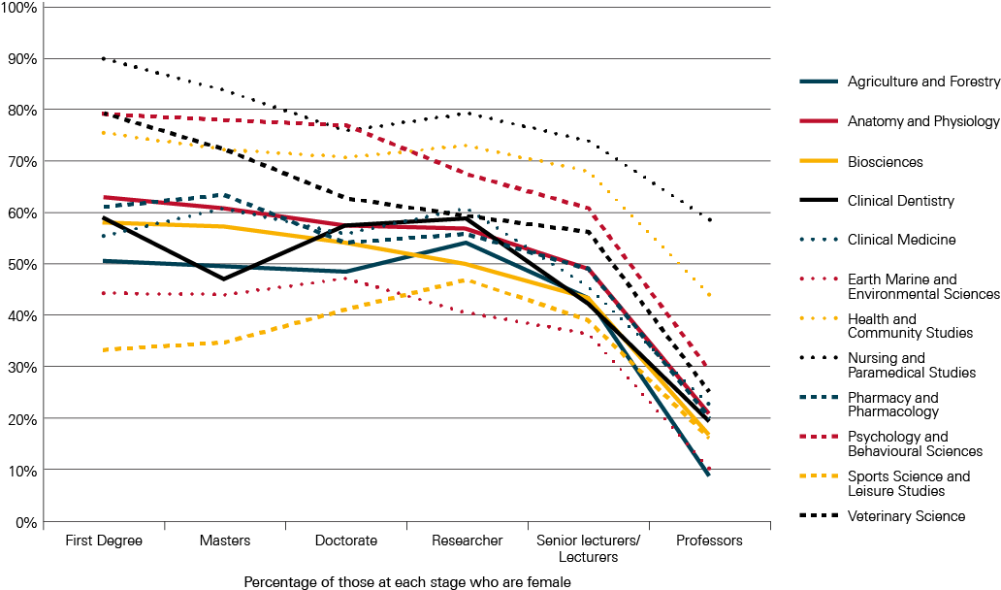
Source: Oxford Research & Policy (2013), STEMM higher education pipeline data 2011 – 12
Figure 15: Gender profile of career stages from Undergraduate first degree –
Professor in the Physical Sciences
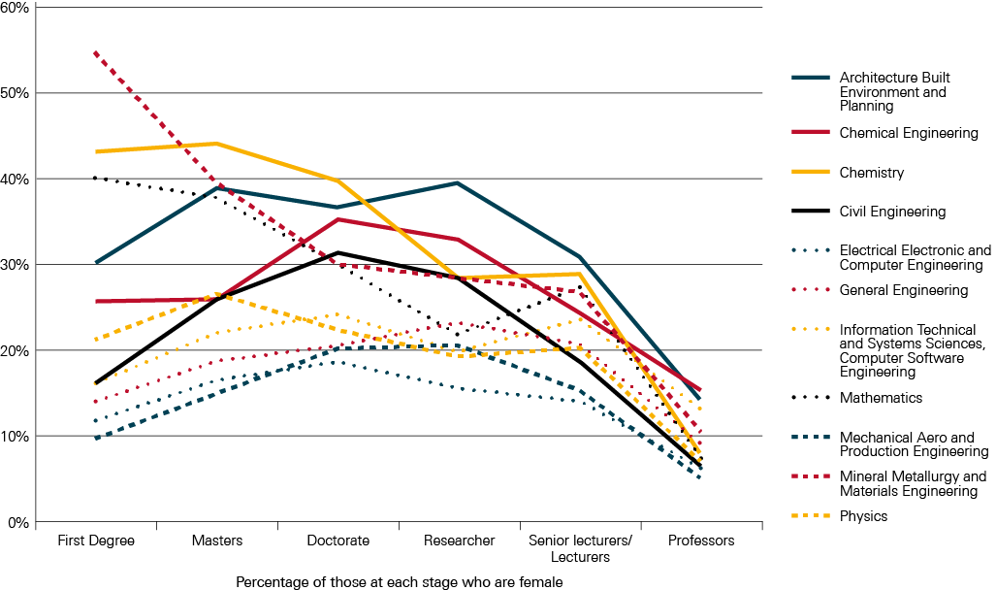
Source: Oxford Research & Policy (2013), STEMM higher education pipeline data 2011 – 12

Disability profile of career stages from first degree to professor level
Table 7: Proportions of first degree students with a declared disability to professors with a declared disability by HESA cost centre
Cost centre | Proportion of first degree students with a declared disability | Proportion of masters students with a declared disability | Proportion of doctoral students with a declared disability | Proportion of researchers with a declared disability | Proportion of senior Lecturers/ Lecturers with a declared disability | Proportion of professors with a declared disability
Agriculture and Forestry | 15.4% | 8.3% | 4.8% | 0.5% | 2.8% | 0.0%
Anatomy and Physiology | 9.90% | 5.0% | 5.0% | 3.0% | 3.3% | 2.9%
Architecture Built Environment and Planning | 9.4% | 7.1% | 5.0% | 3.2% | 3.0% | 2.9%
Biosciences | 9.6% | 6.9% | 5.6% | 2.2% | 2.6% | 2.7%
Chemical Engineering | 4.7% | 2.6% | 3.2% | 1.2% | 1.4% | 3.1%
Chemistry | 8.6% | 6.2% | 5.4% | 2.3% | 2.9% | 0.9%
Civil Engineering | 6.7% | 4.4% | 4.9% | 1.3% | 2.0% | 1.5%
Clinical Dentistry | 5.3% | 1.6% | 1.5% | 1.3% | 1.6% | 1.9%
Clinical Medicine | 7.5% | 4.1% | 3.9% | 2.1% | 1.8% | 1.9%
Earth Marine and Environmental Sciences | 11.6% | 7.7% | 6.6% | 3.1% | 4.3% | 1.4%
Electrical Electronic and Computer Engineering | 7.5% | 2.2% | 3.8% | 2.3% | 2.7% | 1.9%
General Engineering | 8.3% | 3.5% | 4.6% | 3.4% | 3.8% | 3.8%
Health and Community Studies | 13.0% | 6.0% | 6.2% | 2.3% | 3.1% | 4.3%
Information Technology and Systems Sciences, Computer Software Engineering | 9.8% | 4.1% | 5.3% | 2.9% | 4.0% | 2.5%
Mathematics | 6.9% | 3.8% | 5.1% | 1.6% | 2.6% | 1.8%
Mechanical Aero and Production Engineering | 7.2% | 2.8% | 5.1% | 1.6% | 2.6% | 2.2%
Mineral Metallurgy and Materials Engineering | 11.5% | 5.2% | 5.3% | 1.5% | 2.5% | 3.0%
Nursing and Paramedical Studies | 8.8% | 5.7% | 7.8% | 4.0% | 5.2% | 4.3%
Pharmacy and Pharmacology | 5.6% | 2.9% | 4.2% | 2.0% | 1.7% | 1.8%
Physics | 10.2% | 7.7% | 7.0% | 1.9% | 2.2% | 1.2%
Psychology and Behavioural Sciences | 12.1% | 9.7% | 9.1% | 2.7% | 4.0% | 3.8%
Sports Science and Leisure Studies | 8.3% | 6.6% | 4.9% | 1.8% | 2.7% | 0.6%
Veterinary Science | 13.9% | 6.7% | 7.5% | 3.0% | 2.1% | 2.8%
Source: Oxford Research & Policy (2013), STEMM higher education pipeline data 2011 – 12
Figure 16: Disability profile of career stages from Undergraduate first degree –
Professor in the Biological Sciences
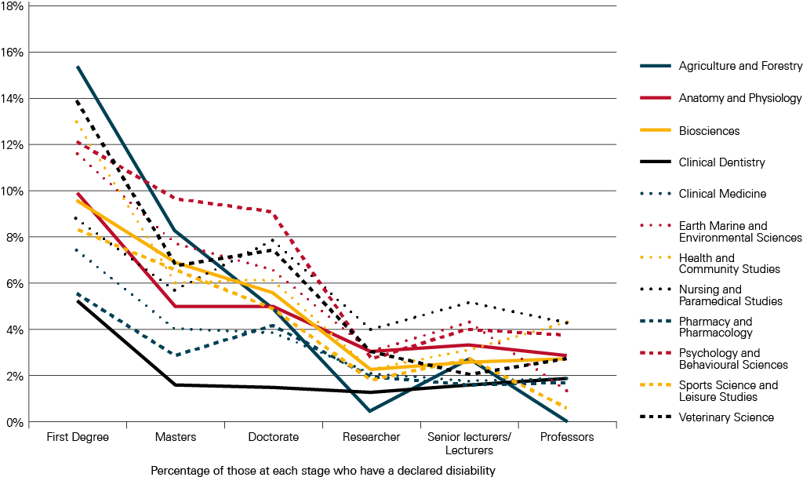
Source: Oxford Research & Policy (2013), STEMM higher education pipeline data 2011 – 12
Figure 17: Disability profile of career stages from Undergraduate first degree –
Professor in the Physical Sciences
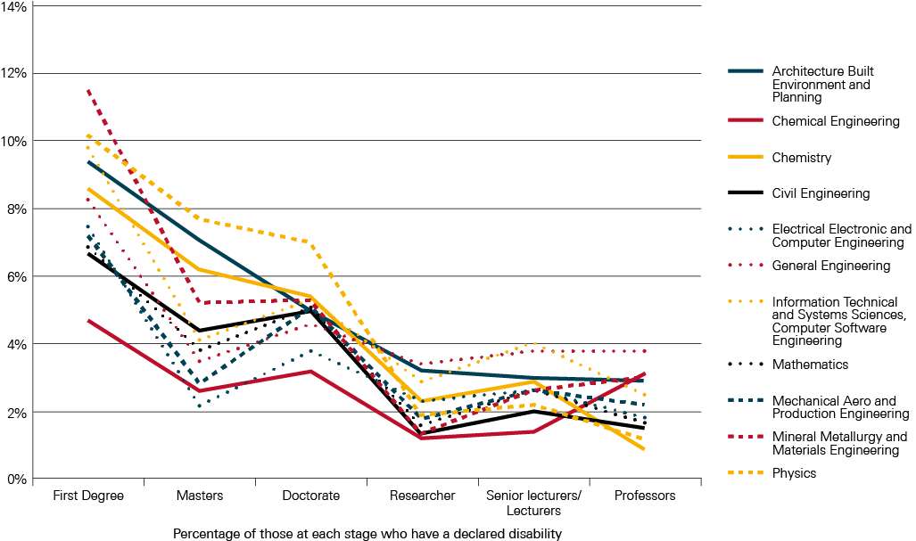
Source: Oxford Research & Policy (2013), STEMM higher education pipeline data 2011 – 12

Ethnicity profile of career stages from first degree to professor level
Table 8: Proportions of BME first degree students to BME professors by HESA cost centre
Cost centre | Proportion of BME first degree students | Proportion of BME masters students | Proportion BME of doctoral students | Proportion of BME researchers | Proportion of BME senior Lecturers/ Lecturers | Proportion of BME professors
Agriculture and Forestry | 2.4% | 4.8% | 9.1% | 4.4% | 2.4% | 3.9%
Anatomy and Physiology | 19.7% | 14.7% | 14.7% | 16.0% | 11.4% | 8.5%
Architecture Built Environment and Planning | 18.4% | 19.2% | 19.6% | 8.0% | 7.5% | 7.2%
Biosciences | 23.9% | 22.5% | 13.7% | 9.3% | 7.6% | 4.4%
Chemical Engineering | 34.3% | 31.5% | 28.4% | 19.9% | 17.1% | 15.1%
Chemistry | 19.1% | 28.1% | 11.8% | 8.4% | 7.2% | 2.9%
Civil Engineering | 23.6% | 23.5% | 22.9% | 7.0% | 14.3% | 16.2%
Clinical Dentistry | 43.6% | 45.2% | 30.1% | 28.1% | 17.8% | 8.4%
Clinical Medicine | 29.8% | 34.8% | 27.4% | 14.7% | 12.7% | 8.1%
Earth Marine and Environmental Sciences | 5.6% | 10.3% | 7.8% | 4.1% | 2.9% | 1.0%
Electrical Electronic and Computer Engineering | 28.1% | 40.7% | 27.2% | 14.1% | 16.0% | 22.2%
General Engineering | 15.8% | 20.0% | 22.1% | 8.6% | 9.0% | 7.1%
Health and Community Studies | 18.1% | 25.8% | 19.3% | 3.4% | 5.0% | 1.7%
Information Technology and Systems Sciences, Computer Software Engineering | 28.1% | 33.9% | 20.3% | 9.5% | 10.5% | 12.4%
Mathematics | 22.0% | 22.9% | 15.0% | 9.0% | 6.7% | 5.5%
Mechanical Aero and Production Engineering | 22.1% | 28.7% | 21.4% | 10.3% | 11.2% | 13.1%
Mineral Metallurgy and Materials Engineering | 21.3% | 15.2% | 20.3% | 15.8% | 10.8% | 9.9%
Nursing and Paramedical Studies | 17.0% | 15.4% | 11.7% | 5.9% | 6.4% | 3.5%
Pharmacy and Pharmacology | 63.0% | 43.5% | 19.5% | 14.4% | 13.7% | 3.5%
Physics | 10.3% | 19.3% | 8.8% | 7.2% | 5.6% | 4.2%
Psychology and Behavioural Sciences | 18.5% | 17.0% | 12.6% | 7.9% | 5.8% | 3.3%
Sports Science and Leisure Studies | 10.3% | 7.6% | 7.2% | 4.1% | 2.1% | 5.3%
Veterinary Science | 4.2% | 4.0% | 9.1% | 8.3% | 3.7% | 4.6%
Source: Oxford Research & Policy (2013), STEMM higher education pipeline data 2011 – 12
Figure 18: BME profile of career stages from Undergraduate first degree –
Professor in the Biological Sciences
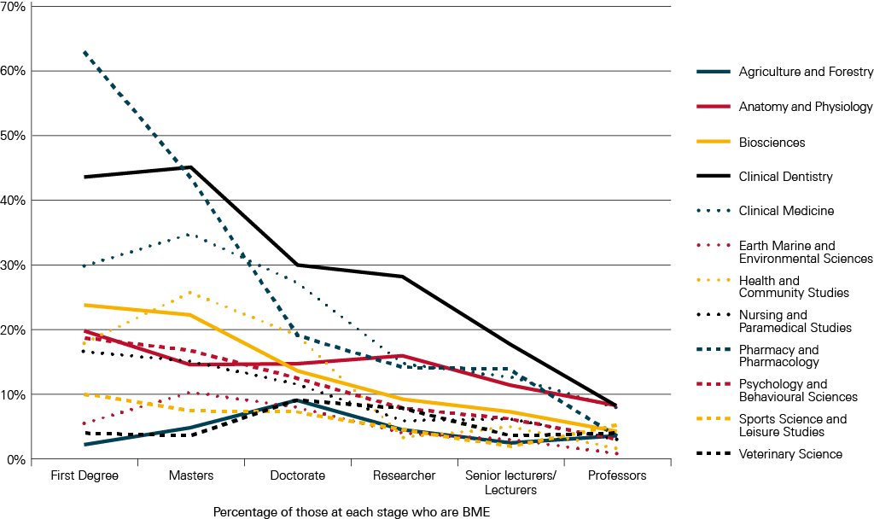
Source: Oxford Research & Policy (2013), STEMM higher education pipeline data 2011 – 12
Figure 19: BME profile of career stages from Undergraduate first degree –
Professor in the Physical Sciences
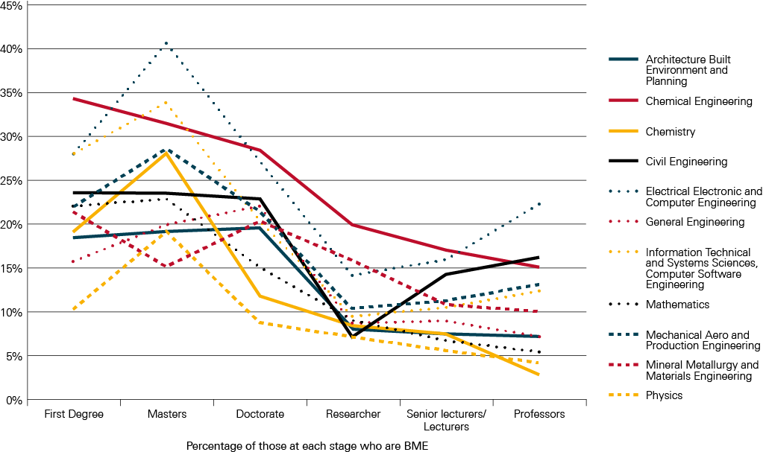
Source: Oxford Research & Policy (2013), STEMM higher education pipeline data 2011 – 12
Data are not collected on parental backgrounds for staff. As such a profile of career stages from undergraduate to professor level for those from different parental backgrounds could not be done.

Recommendations

The Society believes that in order to better understand the diversity makeup of the scientific workforce and levels of entry, progression and retention within the workforce, future analysis of datasets could be improved through:
- An agreed definition of the scientific workforce that more accurately represents the workforce, which is used across and by government departments and other owners of datasets to allow data to be compared and to help improve understanding of entry into and progress through the STEMM workforce for underrepresented groups.
There is no unanimously agreed definition for the scientific workforce and economic sectors which are connected to STEMM. An agreed definition that more accurately represents the workforce, used across various datasets and by government departments, for industrial sectors (most usefully using SICs) and occupations (SOCs) would support future analysis of the workforce and potentially help to identify elements of science which are facing challenging economic and workforce issues. It would allow data to be compared and help improve understanding of entry into and progress through the STEMM workforce for underrepresented groups.
- Consistency between the definitions of and variables within diversity characteristics which would allow better data collection and analysis of multiple datasets on the STEMM workforce.
The datasets analysed for the Society were collected for other purposes and the extent to which it is possible to interrogate them to describe the diversity of the scientific workforce is limited. There are also large gaps in the data, definitions of diversity characteristics vary between datasets, and the questions and definitions in the cohort study have changed over time. There is a need for better and more data collection on the STEMM workforce. Improvements around longitudinal datasets would ensure that social mobility and socioeconomic background are more straightforward to assess. This would be an important step not only for those investigating science but for the investigations of socioeconomic linkages across all elements of the UK workforce.
- Improved links between existing datasets to better understand the diversity of the scientific workforce and community, from school through to vocational, further and higher education and into the workplace, across the full range of STEMM sectors.
The lack of consistency between datasets and linking of data also hindered robust comparisons and tracking of underrepresented groups through STEMM career stages. Work is needed to look at how existing datasets (such as UCAS data, HESA data, the Annual Population Survey, the Labour Force Survey and other datasets) can be better linked to be able to fully understand the diversity of the scientific workforce and community, from school through to vocational, further and higher education and into the workplace, across the full range of STEMM sectors.
- Better data for the private sector to build a full picture of the scientific workforce in relation to diversity and entry into and progression within the scientific workforce.
There is very little or no data comparable to the level of detail available in HESA data for the private sector scientific workforce. This data would be very useful to build a full picture of the scientific workforce in relation to diversity and entry into and progression within the scientific workforce.
- Further exploration of graduate outcomes by ethnicity, disability, gender and parental occupation (a measure for socio-economic background).
This summary has identified several areas for further research. In particular, for graduate outcomes, in many cases the numbers of staff and students are too low at subject level across the number of different leaving destinations and the numbers of different categories to draw firm conclusions. However, there are some interesting top-level findings at subject group level. Further exploration of graduate outcomes by ethnicity, disability, gender and parental background would be useful. There are a number of small studies that look further than six months after graduation that focus on graduate outcomes from a particular higher education institution or on a particular diversity characteristic. It would be valuable to conduct a comprehensive literature review to pull together findings in this area. Further exploration of graduate employment in STEMM by diversity characteristics through qualitative work such as interviews and focus groups would also be valuable.

Glossary
Term | Definition
1970 British Cohort Study (BCS70) | The 1970 British Cohort Study (BCS70) follows the lives of more than 17,000 people born in England, Scotland and Wales in a single week of 1970. Over the course of cohort members lives, the BCS70 has collected information on health, physical, educational and social development, and economic circumstances among other factors. The BCS70 is managed by Centre for Longitudinal Studies and funded by the Economic and Social Research Council. Since the birth survey in 1970, there have been seven ‘sweeps’ of all cohort members at ages 5, 10, 16, 26, 30, 34 and 38. The age 42 survey was conducted from 2012 – 13.
Annual Population Survey (APS) | The Annual Population Survey (APS) is a combined survey of households in Great Britain which is conducted quarterly by the Office for National Statistics (ONS). Its purpose is to provide information on key social and socioeconomic variables between the 10-yearly censuses, with particular emphasis on providing information relating to sub-regional (local authority) areas. The APS is published quarterly with each dataset containing 12 months of data. For each dataset, the sample size is approximately 170,000 households and 360,000 individuals.
BME | Black and minority ethnic
Destination of Leavers from Higher Education (DLHE) survey | The Destinations of Leavers from Higher Education (DLHE) survey asks leavers from higher education what they are doing six months after graduation. About three quarters of leavers complete the survey. Where leavers indicate that they are employed, they are asked what sort of work they are doing (industry/occupation), where they are working and their basis of employment (permanent/self-employed/internship etc.). Much of the data are also linked to data from the HESA Student Record allowing analysis of destinations by students’ attributes such as gender, subject of study and qualification obtained.
Equality Act 2010 | The Equality Act 2010 brings together, strengthens and extends existing equality legislation. The Act legally protects people from discrimination in the workplace and in wider society and sets out the different ways in which it is unlawful to treat someone.
Higher Education Statistics Agency (HESA) | HESA collects a range of data every year UK-wide from universities, higher education colleges and other differently funded providers of higher education. This data is then provided to UK governments and higher education funding bodies to support their work in regulating and funding higher education providers. In addition information derived from the data is published as official statistics and in many accessible formats for use by a wide range of organisations and individuals for a variety of purposes, including HE providers, academic researchers, students, prospective students, private companies, professional bodies and the press and media.
Intersectionality | The interplay between different diversity characteristics and/or strands of inequality or disadvantage. For example, women are also not a homogeneous group and there are barriers that particular groups of women may disproportionately face compared to women as a whole, for example BME women or women with caring responsibilities.
National Qualifications Framework (NQF) | The NQF provides an indication of the relative demand of different qualifications. Qualifications in the NQF are grouped together according to their difficulty. They are given a level from entry level to level 8. The levels are based on the standards of knowledge, skill and competence needed for each qualification. Qualifications at the same level can be very different in terms of content and the length of time they take to complete.
National Statistics Socio Economic Classifications  (NS-SEC) | Within national government statistics, the Socio Economic Classification (SEC) is used to determine socio-economic status based on occupation. Since 2001, NS-SEC has been available for use in all official statistics and surveys. The classification groups workers into the following 8 categories, with SEC 1 being the highest level and SEC 8 being the lowest. To assign a person to an NS-SEC category the ONS combines occupation title with information about a person’s employment status, whether they are employed or self-employed, and whether or not they supervise other employees.  SEC 1: Higher managerial and professional occupations  SEC 2: Lower managerial and professional occupations  SEC 3: Intermediate occupations  SEC 4: Small employers and own account workers  SEC 5: Lower supervisory and technical occupations  SEC 6: Semi-routine occupations  SEC 7: Routine occupations  SEC 8: Never worked and long-term unemployed
Office for National Statistics (ONS) | The Office for National Statistics (ONS) is the UK’s largest independent producer of official statistics and is the recognised national statistical institute for the UK. It is responsible for collecting and publishing statistics related to the economy, population and society at national, regional and local levels. The ONS manages the NS-SEC, SICs and SOCs.
SMEs – Small and medium sized enterprises | Most UK organisations and the government refer to the European Commission’s definition of SME. SMEs are made up of enterprises which employ fewer than 250 persons. The European definition also takes in account turnover or balance sheet total.
Social mobility | Social mobility considers socio-economic background as well as socio-economic status. An individual has scope to alter their socio-economic status through the acquisition of Further Education or changing jobs; this is known as intra-generational mobility. Their socio-economic background will always remain the same. Recent research has displayed a greater interest in the extent to which an individual’s ability to maximise their socio-economic status is determined before they enter adulthood. What impact does where people are born, the characteristics of their neighbourhood as a child, their access to education, and the socio-economic status of their parents have on their ability to achieve their potential for example. This is an inter-generational approach to analysing social mobility.
Socio-economic background | Socio-economic background describes the conditions of the household in which an individual lived as a child and is often closely related to the individual’s life chances. Parental socio-economic status/occupation is frequently used as a proxy for socio-economic background along with an individual’s own education. Other indicators used to measure socio-economic background include household income during childhood and the educational achievements of parents.
Socio-economic status | Socio-economic status considers the current relative position of an individual, determined by their occupation, income, material possessions etc. See national Socio-Economic Classifications above which are used to determine socio-economic status based on occupation.
Standard Industrial Classifications (SIC) | A Standard Industrial Classification (SIC) was first introduced into the UK in 1948 for use in classifying business establishments and other statistical units by the type of economic activity in which they are engaged. The classification provides a framework for the collection, tabulation, presentation and analysis of data, and its use promotes uniformity. In addition, it can be used for administrative purposes and by non-government bodies as a convenient way of classifying industrial activities into a common structure. Since 1948 the classification has been revised in 1958, 1968, 1980, 1992, 1997, 2003 and 2007.
Standard Occupational Classifications (SOC) | The Standard Occupational Classification (SOC) is a common classification of occupational information for the United Kingdom. Within the context of the classification jobs are classified in terms of their skill level and skill content. It is used for career information to labour market entrants, job matching by employment agencies and the development of government labour market policies. SOC2010 is the latest update.
STEMM | Science, Technology, Engineering, Mathematics and Medicine
UCAS | Universities and Colleges Admissions Services

Appendix 1: Data gathering activity A – definitions
See full report on our diversity web pages for further details: TBR and the Science Council (2012), Leading the way: increasing the diversity of the UK Science workforce.
Socio-Economic Status: within national government statistics, the Socio Economic Classification (SEC) is used to determine socio-economic status. The classification groups workers into the following 8 categories, with SEC 1 being the highest level and SEC 8 being the lowest.
SEC 1: Higher managerial and professional occupations
SEC 2: Lower managerial and professional occupations
SEC 3: Intermediate occupations
SEC 4: Small employers and own account workers
SEC 5: Lower supervisory and technical occupations
SEC 6: Semi-routine occupations
SEC 7: Routine occupations
SEC 8: Never worked and long-term unemployed
Science workforce (SW): analysis of the science workforce includes both primary and secondary science workers.
- Primary science workers: workers in occupations that are purely science-based and require the consistent application of scientific knowledge and skills in order to execute the role effectively, e.g. chemists, science and engineering technicians, pharmacists, bio scientist, etc.
- Secondary science workers: workers in occupations that are science-related and require a mixed application of scientific knowledge and skills alongside other skill sets, which are often of greater importance to executing the role effectively, e.g. civil and mechanical engineers, conservation and environmental protection workers, etc.
Non-science workforce (NS): workers in occupations that are not science based and have no requirement for science-based knowledge and skills. E.g. Travel agents, town planners, musicians, legal professionals, etc.
Total workforce (TWF): science and non-science workforce combined.
Wage band: wages earned by worker.
- £0 – £9,999
- £10,000 – £19,999
- £20,000 – £29,999
- £30,000 – £39,999
- £40,000 – £49,999
- £50,000+

Highest qualification: worker’s highest qualification.
- NQF Level 1
- NQF Level 2
- NQF Level 3
- NQF Level 4
- NQF Level 5
- NQF Level 6
- NQF Level 7
- NQF Level 7 and 8
- Other
- No qualifications
Firm size: size of employer.
- Small and medium size enterprises (SME) –units sized between 1 – 250 employees.
- Non-SME – units not sized between 1 – 250 employees.
Broad Sector
- Public
- Private
- Education (all levels of education in both public and private sector)
Gender
- Female
- Male
Ethnicity
- Asian or Asian British
- Black or Black British
- Chinese
- Mixed
- Other
- White
Disability
- Disabled: as defined by the Disability Discrimination Act (DDA), which has since been superseded by the Equality Act 2010.
- DDA disabled: covers a ‘long term health problem or disability that substantially limits a person’s ability to carry out normal day-to-day activities.’
- Work-limiting disabled: covers long-term health problem or disability that affects the amount or type of work a person can do.
- DDA disabled and work-limiting disabled: where an individual is classified as both ‘DDA disabled’ and ‘work-limiting disabled.’
- Non-disabled
Age band
- Aged 16 – 17
- Aged 18 – 19
- Aged 20 – 24
- Aged 25 – 29
- Aged 30 – 34
- Aged 35 – 39
- Aged 40 – 44
- Aged 45 – 49
- Aged 50 – 54
- Aged 55 – 59
- Aged 60 – 64
- Aged 65 – 99

Appendix 2: Data gathering activity B – definitions
See full report on our diversity web pages for further details: TBR (2013), Leading the way; increasing the diversity of the science workforce. Project two: exploring the impact of socio-economic background on careers in science.

Socio-economic background
The following variables for socio-economic background within BCS70 were used:
Parental social class based on occupation, using the Registrar General’s Social Class (SC) classification:
SC I – Professional occupations
SC II – Managerial and technical occupations
SC III N – Skilled non-manual occupations
SC III M – Skilled manual occupations
SC IV – Partly skilled occupations
SC V – Unskilled occupations
Household income at age 16, using figures not adjusted for inflation.

Parents’ education:
- Highest age of either parent on leaving continuous full-time education.
- Highest qualification of either parent

Cohort member’s education:
- Age the cohort member left continuous full-time education
- Highest qualification on leaving continuous full-time education

Other defined characteristics
There are thousands of variables available in the BCS70 and the potential for extensive supplementary analysis of the experiences of those from a range of backgrounds. A number other variables are analysed in the data:
Gender | The data makes clear distinctions between the genders. Later BCS70 sweeps record where someone’s gender has changed, but no cohort member in the analysis has undertaken gender reassignment.
Income | The following income brackets were used in the analysis to provide the analysis with an income/wealth socioeconomic background indicator:  Less than £5,199 per annum (pa)  £5,200 to £10,399 pa  £10,400 to £15,599 pa  £15,600 to £20,799 pa  £20,800 or over  Adjusting these for inflation:  Less than £12,915 pa  £12,916 to £25,832 pa  £25,833 to £38,749 pa  £38,750 to £51,666 pa  £51,667 or over
Ethnicity | Coding of ethnicity varies between BCS70 sweeps, depending on the Census classifications used at the time of each sweep. Due to the inconsistencies in survey coding it was difficult to develop an indicator which appropriately distinguishes between different minority ethnic groups. The analysis therefore distinguishes between cohort members from white ethnic backgrounds and those from black and minority ethnic communities.
Employment  Breaks  Entry to sector  Leave sector | Activity and employment status of an individual across different sweeps is linked in the BCS70 Activity Histories dataset, to which a number of variables have been matched to create employment histories which help to identify when an individual takes a break from employment, moves in and out of working in science (occupations and sectors) and how long they spend in each role and sector.
Education  Routes  Qualifications | A detailed educational history was created by matching data from the various survey sweeps. This was used to provide a detailed account of each cohort member’s educational achievements, linked to their employment history. Limited data was available relating to type of school the cohort member attended and the institutions in which they achieved further qualifications, and it was not possible to explore routes into science in any great detail. Qualifications were coded against equivalent NVQ levels:  Level 5 and above – Postgraduate qualifications  Level 4 – First degree, teaching qualification, nursing qualification  Level 3 – Two or more A-levels, RSA Advanced Diploma or Certificate  Level 2 – Five or more O-levels, one A-level, RSA Diploma  Below Level 2 – Less than five O-levels
Occupation  Level | An individual’s occupations are categorised according to the level of skill associated with each occupation. Skill levels reflect the length of time it normally takes someone to become fully competent in a job, including the time needed for work-related training, to achieve any formal qualifications required, or to acquire the necessary experience. Occupations are described in terms of four skill levels:  Level 1 – Entry level occupations usually require the completion of compulsory education, but may not require formal qualifications. They typically involve little work-related training. Examples include postal workers, hotel porters, cleaners and catering assistants.  Level 2 – Semi-skilled occupations usually require a good general education, often signalled by the achievement of a satisfactory set of school-leaving examination grades. They typically involve more work-related training than Level 1 occupations. Examples include machine operation, caring occupations, retailing, and clerical and secretarial occupations.  Level 3 – Technician level occupations usually require qualifications from further education or training after the completion of compulsory schooling, though not normally degree-level qualifications. They include skilled trades, and may involve a lengthy period of vocational training. Examples include electricians, chefs and laboratory technicians.  Level 4 – Professional level occupations usually require Higher Education qualifications, or an equivalent period of relevant work experience. They include senior management positions. Examples include pharmacists, engineers, doctors and teaching professionals.
Career breaks | An individual is considered to have started a career break if they have left a job to take a career break or because they are pregnant, and if they are currently looking after home or family, on maternity leave, in education, in voluntary work, travelling or on extended holiday, or engaged in another, unspecified activity. Individuals are considered to have ended a career break if their subsequent activity is recorded as employment, a Government training scheme, illness, disability, or retirement.

Appendix 3: Data gathering activity C – definitions
See full report on our diversity web pages for further details: Oxford Research & Policy (2013), Summaries of observations on the destinations of STEMM leavers from higher education and on higher education staff including their previous employment and leaving destinations.

HESA data subject group and subjects
Subject Group | Subject
Medicine and Dentistry | Clinical dentistry
Medicine and Dentistry | Clinical medicine
Medicine and Dentistry | Others in medicine and dentistry
Medicine and Dentistry | Pre-clinical dentistry
Medicine and Dentistry | Pre-clinical medicine
Subjects allied to Medicine | Broadly-based programmes within subjects allied to medicine
Subjects allied to Medicine | Medical technology
Subjects allied to Medicine | Nursing
Subjects allied to Medicine | Nutrition
Subjects allied to Medicine | Ophthalmics
Subjects allied to Medicine | Anatomy, physiology and pathology
Subjects allied to Medicine | Aural and oral sciences
Subjects allied to Medicine | Complementary medicine
Subjects allied to Medicine | Others in subjects allied to medicine
Subjects allied to Medicine | Pharmacology, toxicology and pharmacy
Architecture, Building and Planning | Architecture
Architecture, Building and Planning | Broadly-based programmes within architecture, building and planning
Architecture, Building and Planning | Building
Architecture, Building and Planning | Landscape design
Architecture, Building and Planning | Others in architecture, building and planning
Architecture, Building and Planning | Planning (urban, rural and regional)
Biological Sciences | Biology
Biological Sciences | Botany
Biological Sciences | Broadly-based programmes within biological sciences
Biological Sciences | Genetics
Biological Sciences | Microbiology
Biological Sciences | Zoology
Biological Sciences | Molecular biology, biophysics and biochemistry
Biological Sciences | Others in biological sciences
Biological Sciences | Psychology
Biological Sciences | Sports science
Engineering | Broadly-based programmes within engineering and technology
Engineering | Civil engineering
Engineering | General engineering
Engineering | Mechanical engineering
Engineering | Aerospace engineering
Engineering | Chemical, process and energy engineering
Engineering | Electronic and electrical
Engineering | Naval architecture
Engineering | Others in engineering
Engineering | Production and manufacturing engineering
Mathematical and Computer Sciences | Artificial intelligence
Mathematical and Computer Sciences | Mathematics
Mathematical and Computer Sciences | Operational research
Mathematical and Computer Sciences | Others in mathematical sciences
Mathematical and Computer Sciences | Software engineering
Mathematical and Computer Sciences | Statistics
Mathematical and Computer Sciences | Computer science
Mathematical and Computer Sciences | Information systems
Mathematical and Computer Sciences | Others in computing sciences
Physical Sciences | Astronomy
Physical Sciences | Broadly-based programmes within physical sciences
Physical Sciences | Chemistry
Physical Sciences | Geology
Physical Sciences | Materials science
Physical Sciences | Physics
Physical Sciences | Forensic and archaeological science
Physical Sciences | Ocean sciences
Physical Sciences | Others in physical sciences
Physical Sciences | Physical and terrestrial geographical & environmental sciences
Technologies | Maritime technology
Technologies | Metallurgy
Technologies | Minerals technology
Technologies | Ceramics and glasses
Technologies | Industrial biotechnology
Technologies | Materials technology not otherwise specified
Technologies | Others in technology
Technologies | Polymers and textiles
Veterinary Sciences, Agriculture and related subjects | Agriculture
Veterinary Sciences, Agriculture and related subjects | Food and beverage studies
Veterinary Sciences, Agriculture and related subjects | Forestry
Veterinary Sciences, Agriculture and related subjects | Animal science
Veterinary Sciences, Agriculture and related subjects | Clinical veterinary medicine and dentistry
Veterinary Sciences, Agriculture and related subjects | Others in veterinary sciences, agriculture and related subjects
Veterinary Sciences, Agriculture and related subjects | Pre-clinical veterinary medicine

Definition of a student
Students are classified by the subject they are studying. In the analyses a student studying a specific subject is defined as a student who spends 50% or more of their time studying that single subject. In other words, considering for example a physics student, physics instances are only counted where a student is recorded against physics as 0.5 FTE or more. Data are presented as headcounts of such students. To take specific examples, HEIs code students based on how much time they spend studying particular subjects. A student registered on a mathematics and physics course may be recorded as 0.5 FTE physics and 0.5 FTE mathematics. In this case that individual will count in the physics data and mathematics data. Alternatively, a student registered on a physics with mathematics course may be recorded as 0.67 FTE physics and 0.33 FTE mathematics in which case they will be included in the count of physics students but not in the count of mathematics students.
It should be noted that as a consequence of the definitions used, the figures may not match the numbers reported in some publications. In some cases authors report total FTEs reading a specific subject, in others authors may report a headcount of students who are reported as studying a subject for any amount of their time.

Graduation destinations of students
Until 2010/11 the HESA Destinations of Leavers from Higher Education (DLHE) data were collected by institutions for just UK and European Union domiciled leavers.
HESA uses a combination of two fields, ‘Employment Circumstances’ and ‘Nature of Further Study’ to generate the ‘main activity’ field, which is conventionally used to report on leavers’ outcomes.
The main activities are listed below:
Main Activity
Full-time paid work only (including self-employed)
Part-time paid work only
Voluntary/unpaid work only
Work and further study
Further study only
Assumed to be unemployed
Not available for employment

Categories highlighted in yellow have more detailed destinations data associated with them, i.e., a record of the individual's occupation (physicists, accountant, etc.) and the sector worked in (manufacture of chemicals and chemical products, insurance, etc.).
For the purposes of this study, it was important to distinguish between those students who stay in STEMM and who leave STEMM and consequently the ‘Employment Circumstances’ and ‘Nature of Further Study’ were used to generate the following ‘STEMM activities’: Working (STEMM), Working (Possibly STEMM), Working (Non STEMM), Further Study (Research), Further Study (Course), and Other Activities. The details of how these activities are derived are presented in the table below.
In generating the STEMM activities, the primary observation is whether a student is working in STEMM, non-STEMM, or possibly STEMM, or not working/looking for work. The secondary observation is whether the student is studying on a course or doing research.
If someone is undertaking ‘research’ then they are recorded as Further Study (Research) whatever their work circumstance. In general such people are probably undertaking STEMM research and so are still involved in STEMM.
Considering the rest of the population, anyone who is working in a STEMM occupation or a Possibly STEMM occupation is recorded as ‘Working (STEMM)’ or ‘Working (Possibly STEMM)’, respectively, irrespective of whether they are undertaking further study or not.
The next group to be considered is those who are undertaking a course. The data does not record the nature of their course so it is unknown whether these people are still in STEMM or not. These people have been recorded separately as ‘Further Study (Course)’.
Everyone else is then recorded as ‘Other Activities’.
The STEMM activities have been used to produce the detailed analyses available elsewhere, the key points of which are summarised in the sections below.

Employment Circumstances | STEMM occupation | Nature of Further Study
Employment Circumstances | STEMM occupation | Question not answered (default) | Engaged in private, unsupervised study | Preparing a professional portfolio of my work | Registered as a research student | Registered  on a course
Working paid full time/working paid part time/self-employed or freelance/voluntary work/other unpaid work | STEMM occupation | Working (STEMM) | Working (STEMM) | Working (STEMM) | Further study (Research) | Working (STEMM)
 | Possible STEMM occupation | Working (Possibly STEMM) | Working (Possibly STEMM) | Working (Possibly STEMM) | Further study (Research) | Working (Possibly STEMM)
 | Non STEMM occupation | Working (Non STEMM) | Working (Non STEMM) | Working (Non STEMM) | Further study (Research) | Working (Non STEMM)
Not employed but not looking for employment, further study or training |  | Other activities | Other activities | Other activities | Further study (Research) | Further study (Course)
Not working/unable to work/ unemployed/doing something else |  | Other activities | Other activities | Other activities | Further study (Research) | Further study (Course)

Staff
The HESA Staff record provides data in respect of the characteristics of members of all academic and non-academic staff employed under a contract of employment at a reporting higher education institution (HEI) in the UK. Staff employed under consultancy contracts, or on the basis of payment of fees for services without a contract of employment are not included in the record.
Higher education staff data are available from HESA broken down by:
- Cost centre
- Grade (professor, senior lecturer/lecturer, researcher, other)
- Gender
- Ethnicity
- Nationality
- Disability
Data are also available on the previously employment of staff (coverage for older staff is very low) including the previous institution of staff, and the destinations of staff leavers. For Academic staff (including postdocs) who left in 2010/11, 42% had an unknown leaving destination.
As regards destinations, the possible options are:
01 Another HEI in UK
02 HEI in an overseas country
03 Other education institution in UK
04 Other education institution in an overseas country
05 Research institution in the UK
06 Research institution overseas
07 Student in UK
08 Student in an overseas country
09 NHS/General medical or general dental practice in UK
10 Health service in an overseas country
11 Other public sector in UK
12 Private industry/commerce in UK
13 Self-employed in UK
14 Other employment in UK
15 Other employment in an overseas country
21 Not in regular employment
99 Not known
XX Not applicable/Not required (Default code)
The staff data set has examined staff in all cost centres, all STEMM cost centres, and individual STEMM cost centres in order to compare the different patterns/trends of destinations and specifically to compare the populations leaving academia by the characteristics outlined above and in particular those staff leaving STEMM. Data has been examined for the last 5 years (for academic years 2006/07 to 2010/11).

Appendix 4: TBR/Science Council – summary of qualitative research
See full report on our diversity web pages for further details: TBR and the Science Council (2012), Leading the way: increasing the diversity of the UK Science workforce.
The qualitative data gathering which was carried out alongside analysis of the APS 2011 by TBR and the Science Council included;
- Interviews with private and public sector employers of scientists, researchers interested in social mobility, individuals chosen because of their background and career paths, representatives from key employers, and organisations that have undertaken diversity initiatives.
- Focus groups with employees and employee organisations, and with key stakeholders (policy makers, employer bodies, sector bodies etc.).
The sample size for this qualitative work was small (28 interviews and two focus groups involving a total of 22 participants) but there were some interesting findings around the perspectives of individuals on diversity issues within the workforce and the success of initiatives that have sought to increase diversity.
Some of these findings are being explored through activities taking place under the Royal Society’s diversity programme such as our research into the business case for diversity, other findings will inform our work going forward and may be explored further.
A summary of the key findings is below. For further details on the findings from the focus groups and interviews download the full report from our diversity web pages.

Perceptions of the current workforce
The research revealed that socio-economic background is often the ‘hidden’ issue within equality and diversity; interviewees and focus group participants were less comfortable discussing background than gender and racial inequality.
Interview respondents from lower socio-economic backgrounds described how socio-economic background was no longer visible and background was not discussed when in a role. However, some respondents found that their ‘lack of fit’ had encouraged them to leave research or academia. There was a strong desire for a working environment that did ‘fit’, contained a more diverse team and provided a better work/life balance. This sense of a ‘lack of fit’ may be influenced by the fact that there are relatively few roles in science that fall outside of the top two socio-economic status classifications and workplaces are relatively homogeneous (compared to other employment fields). Within the science community, it is recognised that these issues have not been addressed, with some participants accepting that the science workforce was ‘like this’, and others referencing how different academia was from other work environments.

Organisational culture
The qualitative research found that there was a strong commitment to the principles of diversity across the science community but also recognition that science employers have yet to either develop or translate programmes designed for gender diversity across to other diversity characteristics.
There was a general consensus both amongst interviewees and focus group participants that legislation was important in achieving attitudinal and practical changes (such as providing impartial sources of information and guidance on how to introduce good practice). However, legislation was not sufficient on its own to drive future change.

The business case for diversity
Businesses that participated in the qualitative research stages were comfortable talking about the financial benefits of a diverse workforce with findings indicating that:
- Policies that have been adopted in respect to equality and diversity are often generic and tend not to be specifically linked to science as a sector.
- Multinational firms manage multinational workforces and recruit from a global labour market. These firms often have procedures in place to ensure that people from different backgrounds
can assimilate into their workforce. However, smaller firms are less likely to have dedicated members of staff working on recruitment policies and strategies and are also more difficult to engage with. This can present a challenge due to the relatively high proportion (54%) of the science workforce employed in SMEs.
- Reputation for fairness, equality, career development and retention of staff from less represented groups at a firm or institution is important. A good reputation fosters diverse recruitment and helps to retain talent in competitive environments.
The Royal Society’s diversity programme includes a policy study which will attempt to articulate the business case for diversity in the scientific workforce. The policy study will specifically cover the following: (i) the business case for diversity within the scientific workforce, building on the Royal Society of Edinburgh’s report ‘Tapping all our Talents’; (ii) primary research to establish the difference diversity makes to science looking at optimum group size and diversity in relation to a range of productivity measures – are diverse teams more productive?; and (iii) bringing together the data and evidence to identify ways of creating diverse teams. This will build on good practice identified as part of the data gathering work and activities set up as part of the diversity programme.
The study will include a review of existing literature, data and research on the business case for diversity in the scientific workforce, and a number of focus groups and interviews with organisations from different STEMM sectors. The report will be published in Spring2014.

Participation and access routes
A minority of those who participated in the qualitative research had had a non-traditional route into a science career, with the majority progressing from secondary school through to Higher Education. Those who had taken non-traditional routes illustrated the strong role of the public sector, enabling them to gain qualifications post-16 and then progress on to Higher Education through part-time study.

The role of recruitment in encouraging diversity
Focus groups and interview participants agreed that recruitment was an important activity through which a more diverse workforce could be achieved. Larger employers considered that a diversity of behaviours and attitudes is part of a desirable skills mix for their science and technical divisions. However, both employers and managers emphasised that their first priority was to recruit individuals with the knowledge, skills and competencies for the roles. Focus group participants criticised the phrase ‘the right person for the job’ claiming that recruitment practices would inevitably introduce some element of subjective assessment supporting the case for more interventionist policies.
One specific area of recruitment that was discussed within the focus groups was the emphasis by many leading STEMM employers on the need for 2:1 degrees from selected universities. Employers also sought additional demonstration of characteristics such as leadership, which were unlikely to promote diversity and considered to be an example of unconscious bias. Higher Education Institutions were noted as actively committed to widening participation but admissions tutors needed to be more open about accepting candidates with different backgrounds who have the drive and determination to succeed.

Training and progression
It was reported in the focus groups and interviews carried out by TBR as part of their research into diversity and socio-economic status in the scientific workforce that for those that had followed a non-traditional qualification route there were restrictions in opportunities for progression and mobility due to the narrow experience of those recruiting. The NHS was praised for its support for non-traditional educational routes to science careers. Furthermore, there was a perception that roles that combined science with other skills (for example in policy, armed services or regulation) appeared to have achieved greater diversity, perhaps because the roles required a mix of science and other skills and attributes.
Training in areas such as assertiveness was considered valuable and increasing the accessibility of training and other opportunities for disabled people was seen as important. Training and access to training would help to address the low representation of certain groups (e.g. women and disabled people) in the highest socio-economic groupings in the primary science workforce.

Recruitment and retention
There are challenges associated with juggling different responsibilities with gaining additional qualifications and training, and several interview respondents referenced the need for support and understanding. There is a need for further work to understand how part-time working occurs in the sector and how support can best be offered to maintain diversity in areas of the workforce. Issues such as career breaks can restrict development in science and practices such as late meetings, weekend events, and meetings at short notice also made science careers difficult for certain groups.

Supporting aspirations
The research showed a very wide range of early influences on career choices, some negative towards science and some positive. Those from minority ethnic backgrounds as well as lower socio-economic backgrounds commented that parents and families rarely see science as a well paid, stable career and that careers that resonate with these communities and those that are seen as achieving social status are more highly desired. This is in contrast to the data on the scientific workforce which shows that a high proportion of science workers outside of the health sector are in the top socio-economic groupings.
The research found that the quality of education available to those from disadvantaged communities is recognised as a key factor in progression to STEMM study post-16. Those with one or more parents in a science or engineering occupation appear to have clearer ambitions when they are younger and are confident about making clear choices about degree options. In contrast, those who are first in the family to go to university or first in the family to study science post-18 often make both subject and institution choice with little guidance. Academia was perceived as an unstable career option in comparison with others and financial stability was often a key driver in career choice.
Participants commented that good careers advice is also important for individuals to get on the right path and in particular to the right degree course. A lack of ‘social capital’ and ‘science capital’ was identified by several participants as a factor limiting access to advice. In order to overcome this, professional bodies were seen as another route towards recognition and inclusion; involvement with a professional body or learned society had provided many with networking opportunities and opportunities to gain skills and confidence.

The Royal Society
The Royal Society is a self-governing Fellowship of
many of the world’s most distinguished scientists
drawn from all areas of science, engineering, and
medicine. The Society’s fundamental purpose,
reflected in its founding Charters of the 1660s,
is to recognise, promote, and support excellence
in science and to encourage the development and
use of science for the benefit of humanity.
- The Society’s strategic priorities are:
- Promoting science and its benefits
- Recognising excellence in science
- Supporting outstanding science
- Providing scientific advice for policy
- Fostering international and global cooperation
- Education and public engagement
The Royal Society
6 – 9 Carlton House Terrace
London SW1Y 5AG
Founded in 1660, the Royal Society
is the independent scientific academy
of the UK, dedicated to promoting
excellence in science
Registered Charity No 207043
Issued: February 2014 DES3214

T +44 20 7451 2500
E diversity@royalsociety.org
W royalsociety.org



Adjusted for inflation, this was approximately £51,667 or over per annum in 2012.
Adjusted for inflation, this was approximately less than £12,915 per annum in 2012.
http://royalsociety.org/about-us/history/?from=welcome
TBR, (2013) Leading the way; increasing the diversity of the science workforce. Project two: exploring the impact of socio-economic background on careers in science, p. 32
http://royalsociety.org/policy/projects/leading-way-diversity/steering-group
http://royalsociety.org/policy/projects/leading-way-diversity
ONS recognises that both of these groups – the long-term unemployed and those who have never been in paid employment – are difficult to define. They are seen as positions that involve involuntary exclusion from the labour market, specifically: - those who have never been in paid employment but would wish to be; and - those who have been unemployed for an extended period while still seeking or wanting work
http://ons.gov.uk/ons/guide-method/classifications/archived-standard-classifications/soc-and-sec-archive/ns-sec-derivation-tables-based-on-soc2000--excel-.xls
It has now been replaced by the Understanding Society survey.
Excluding unknowns.
No data available for SEC4 (small employers and own account workers).
These figures are very slightly different from the numbers in Table 3 as Point Research applied data rounding to raw counts and excluded unknowns.
SW = Scientific workforce; NS = Non-scientific workforce; TWF = Total workforce
SW = Scientific workforce; NS = Non-scientific workforce; TWF = Total workforce
ONS recognises that both groups – the long-term unemployed and those who have never been in paid employment – are difficult to define. They are seen as positions that involve involuntary exclusion from the labour market, specifically: - those who have never been in paid employment but would wish to be; and - those who have been unemployed for an extended period while still seeking or wanting work.
See Appendix 2 for income fields used in BCS70.
The variable of Parental social class within the BCS70 is based on occupation and uses the Registrar General’s Social Class (SC) classification. For further details see TBR’s Technical Annex at the back of their full report.
These illustrative career routes are high level examples based on data analysed by TBR. The complexity of the data and issues with data fill for certain characteristics in the 1970 British Cohort Study means that illustrative career routes for other equality characteristics such as ethnicity could not be formulated with the data as it is currently collected.
Adjusted for inflation, this was approximately £51,667 or over per annum in 2012.
Adjusted for inflation, this was approximately less than £12,915 per annum in 2012.
TBR (2013) Leading the way; increasing the diversity of the science workforce. Project two: exploring the impact of socio-economic background on careers in science, p. 29
For more information on the DLHE survey see: www.hesa.ac.uk/index.php?option=com_content&task=view&id=1899&Itemid=239
www.ecu.ac.uk/publications/equality-in-higher-education-statistical-report-2013
BME female academics had the lowest rate of professors: 3.7% of UK BME female academics and 1.3% of non-UK BME female academics were professors, compared with 16.1% of UK white males and 12.0% of non-UK white males (Equality Challenge Unit, Equality in higher education: statistical report 2012. Part 1: staff (2012)).
Students, occupations not stated or inadequately described, and/or not classifiable for other reasons are added as ‘not classified.’ ‘Does not apply’ also includes methodological inaccuracies and coding issues.
Highest qualification was measured using the National Qualifications Framework (NQF) which incorporates academic and vocational qualifications from GCSE or apprenticeship to doctorate level. The framework is developed by Ofqual. Further details can be found at their website: http://ofqual.gov.uk/qualifications-and-assessments/qualification-frameworks/
Using an inflation rate of 148.5% between 1986 and 2012. Inflation averaged 3.5% between 1986 and 2012. The data uses figures from Retail Prices Index and is not precise but provides a better understanding in today’s money: http://www.thisismoney.co.uk/money/bills/article-1633409/Historic-inflation-calculator-value-money-changed-1900.html
HESA no longer collect detailed data on the grades of staff. Staff on professorial grades are noted but post doctoral research fellows and other permanent academic staff are not distinguished. A methodology has been developed based on the employment function of staff to distinguish between post doctoral research fellows and senior lecturers/lecturers. The method cannot be guaranteed to assign staff to the correct category in all cases, but the majority of staff will be correctly assigned.

