

The diversity of the UK science workforce

Quantitative analysis of the Annual Population Survey

Prepared by Point Research Limited for the Royal Society

19 August 2013

Enquiries about this report can be addressed to:

Stephanie Neave, Director, Point Research Ltd.

Dr. Clare Huxley, Research Consultant, Point Research Ltd.

Point Research Limited

1 Phelps Lodge, 101 Copenhagen St.

London, N1 0JN

Info@pointresearch.co.uk

www.pointresearch.co.uk

Introduction

As part of the Royal Society’s diversity programme in 2012, TBR and the Science Council were commissioned to undertake research into the equality and socio-economic composition of the scientific workforce. In addition to a literature review and qualitative work, the research included secondary data analysis of the Office of National Statistics (ONS)’s Annual Population Survey (APS); this analysis cross-tabulated the eight ONS socio-economic classifications against equality and sector/work characteristics of the workforce.

This briefing summarises the findings from analysis of the TBR/Science Council data workbook. Below provides a description, including fields, of the variables examined.

Socio-Economic Status: within national government statistics, the Socio Economic Classification (SEC) is used to determine socio-economic status. The classification groups workers into the following 8 categories, with SEC 1 being the highest level and SEC 8 being the lowest.

- SEC 1: Higher managerial and professional occupations
- SEC 2: Lower managerial and professional occupations
- SEC 3: Intermediate occupations
- SEC 4: Small employers and own account workers
- SEC 5: Lower supervisory and technical occupations
- SEC 6: Semi-routine occupations
- SEC 7: Routine occupations
- SEC 8: Never worked and long-term unemployed

Science workforce (SW): analysis of the science workforce includes both primary and secondary science workers.

- Primary science workers: workers in occupations that are purely science-based and require the consistent application of scientific knowledge and skills in order to execute the role effectively. E.g. Chemists, science and engineering technicians, pharmacists, bio scientist, etc.

- Secondary science workers: workers in occupations that are science-related and require a mixed application of scientific knowledge and skills alongside other skill sets, which are often of greater importance to executing the role effectively. E.g. Civil and mechanical engineers, conservation and environmental protection workers, etc.

Please note: this summary only reports on data relating to the scientific workforce as a whole, but further information disaggregating this group by primary and secondary workers can be found in TBR’s data workbook and in the corresponding TBR report, Increasing the diversity of the UK science workforce.

Non-science workforce (NS): workers in occupations that are not science based and have no requirement for science-based knowledge and skills. E.g. Travel agents, town planners, musicians, legal professionals, etc.

Total workforce (TWF): science and non-science workforce combined.

Wage band: wages earned by worker.
- £0-£9,999  - £10,000-£19,999  - £20,000-£29,999 | - £30,000-£39,999  - £40,000-£49,999  - £50,000+

Highest qualification: worker’s highest qualification.
- NQF Level 1  - NQF Level 2  - NQF Level 3  - NQF Level 4  - NQF Level 5 | - NQF Level 6  - NQF Level 7  - NQF Level 7 and 8  - Other  - No qualifications

Firm size: size of employer.
- Small and medium size enterprises (SME) –units sized between 1-250 employees.
- Non-SME – units not sized between 1-250 employees.

Gender
- Female | - Male

Ethnicity
- Asian or Asian British  - Black or Black British  - Chinese | - Mixed  - Other  - White

Disability
- Disabled: as defined by the Disability Discrimination Act (DDA), which has since been superseded by the Equality Act 2010.
- DDA disabled: covers a ‘long term health problem or disability that substantially limits a person’s ability to carry out normal day-to-day activities.’
- Work-limiting disabled: covers long-term health problem or disability that affects the amount or type of work a person can do.
- DDA disabled and work-limiting disabled: where an individual is classified as both ‘DDA disabled’ and ‘work-limiting disabled.’
- Non-disabled

Age band
- Aged 16-17  - Aged 18-19  - Aged 20-24  - Aged 25-29 | - Aged 30-34  - Aged 35-39  - Aged 40-44  - Aged 45-49 | - Aged 50-54  - Aged 55-59  - Aged 60-64  - Aged 65-99

Key findings

- The scientific workforce is largely composed of workers in higher managerial and professional (SEC 1: 35.6%) and lower managerial and professional occupations (SEC 2: 42.3%). A relatively small proportion of the scientific workforce is spread across the remaining SEC categories.

- In contrast, the non-science workforce has a much lower proportion of workers in SEC 1 and 2 (9.7% and 22.6%, respectively) and a higher proportion in semi-routine and routine occupations than the scientific workforce (SEC 6: 16.6% and SEC 7: 11.5%, respectively).

Wage band

- Scientific workers in SEC 1 and 2 – and to a lesser extent, SEC 5 – are comparatively better paid than scientific workers in other SEC categories, with the majority in each earning £20,000 or more.

- Compared with the non-science and total workforces, the scientific workforce earn higher wages on the whole. This is likely due to the higher proportion of the scientific workforce in SEC 1 and 2, compared with the non-science and total workforces.

- It is not the case that the scientific workforce is better paid than the non-science workforce in every SEC category. In some categories such as SEC 1 and 2, they are concentrated in the mid-range wage bands and less likely to be on the extreme ends of the pay scale. In contrast, in lower level SEC categories (SEC 3, 5, and 6) science workers are better paid than non-science workers.

Firm size

- The majority of both the scientific workforce and non-scientific workforce work in small and medium enterprises (SMEs). However, the proportion of those in SMEs is smaller in the science workforce than in the non-science and total workforces (61.8% SW, 77.6% NS, 74.1% TWF).

- The exclusion of the health sector decreases the proportion of the scientific workforce in non-SMEs from 38.2% to 32.7%. This indicates that the health sector is more likely to be in non-SMEs (i.e. larger organisations) than the rest of the scientific workforce.

The fact that the health sector has a more diverse profile than the rest of the scientific workforce suggests that the size of an organisation may influence the degree to which it is able to engage with the diversity agenda. The TBR report, Leading the way: increasing the diversity of the UK Science workforce, posits that larger organisations (such as those found in the health sector) may find it easier to address diversity issues because of the resources they may have available.

Highest qualification

- Scientific workers tend to have higher formal qualifications than the non-science workforce. The majority have a highest qualification of Level 5 or above (graduate and postgraduate qualifications) compared with less than 1 in 4 of the non-science workforce (58.7% SW, c.f. 22.3% NS and 29.9% TWF).

- As a general trend, the higher level the SEC category, the greater the proportion of the scientific workforce with NQF Level 7 & 8 (masters and doctorate degrees), the highest possible qualifications.

- Within qualification levels, the distribution of workers is more evenly spread across SEC categories in the non-science workforce than in the science workforce. For example, 93.3% of science workers with NQF level 7&8 are in SEC 1 and 2, compared with 74.0% of non-science workers with the same level of highest qualification (85.0% TWF).

- As the TBR report notes, “although those in the science workforce are more likely to fall into the top two SEC categories if they have higher level qualifications, those in the science workforce with lower level qualifications are still more likely to fall into these groups than they would be in the total workforce.” 41.3% of scientific workers with a highest qualification of NQF Level 1 (the lowest possible qualification) are in SEC 1 or 2, compared with only 19.7% of the non-science workforce and 21.7% of the total workforce.

Gender

- Women make up a slight majority of the science workforce (50.3%). This is not the case for the non-scientific workforce and the total workforce as a whole.

- There are, however, gender disparities within SEC categories, with women in the scientific workforce under-represented in all but three. Women are most keenly underrepresented in SEC 1, 4 and 5, and less so in SEC 6 and 7. When health workers are excluded, gender disparities within SEC categories become even more pronounced, with men comprising the majority within all SEC categories except SEC 2 and SEC 3.

- Men in the scientific workforce are more than twice as likely to be in the highest level SEC category than women: nearly 1 in 2 (47.5%) are in SEC 1, compared with only 23.6% of women. Conversely, women are concentrated in the lower level SEC 2 (54.5% of women, compared with 30.1% of men). This suggests a ‘glass ceiling’ situation – a concentration of women in lower managerial and professional roles and marked underrepresentation in higher senior management positions.

Ethnicity

- The distribution of ethnicity groups in the science workforce is similar to that of the non-science and total workforces. The largest ethnic group is White, followed by Asian or Asian British, Black or Black British, and Other. Very small proportions of the scientific workforce are Mixed or Chinese.

- BME workers (who make up 10.5% of the scientific workforce) are over-represented in SEC 1, 6 and 8 and under-represented in SEC 2, 4, 5 and 7. These findings are relatively consistent with that of the non-science and total workforces, with the exception of SEC 1 and 7.

- With the exception of Black or Black British, there is a higher proportion of every ethnic group in SEC 1 than White scientific workers. This is most marked among Chinese scientific workers (72.0% of whom are in SEC 1 occupations). In contrast, only 29.3% of Black or Black British scientific workers are in SEC 1 – slightly below White (34.5%) and the overall scientific workforce (35.6%).

- When the health sector is excluded, the proportion of science workforce who are White slightly increases, from 89.5% to 91.1%. This suggests that the health sector is more ethnically diverse than the rest of the scientific workforce.

Disability

- The proportions of workers who are disabled and non-disabled in the science workforce (13.5%, 86.5%) are similar to that of the non-science and total workforces.

- A higher proportion of workers in middling and lower level SEC categories (SEC 3, 4, 5, and 7) are disabled compared with SEC 1, 2, 6 and 8. However, relative to the non-science and total workforces, disabled science workers are slightly better represented in higher level SEC categories (ie. SEC 2, 3, 4) and less so in lower level SEC categories (5, 6, 7, 8).

- The proportion of the science workforce who are disabled decreases slightly when the health sector is excluded, falling from 13.5% to 12.8%.
For the purpose of this summary, all unknown data has been excluded. Proportions of unknowns are footnoted and corresponding data tables are provided in the annex.

Age band

- The scientific workforce has a generally older age profile than the non-science and total workforces. However, this varies by SEC category. Science workers in intermediate occupations (SEC 3) or who have never worked, are long-term unemployed or otherwise unclassified (SEC 8) exhibit a markedly older profile than those in the non-science and total workforces. However, scientific workers in routine occupations (SEC 7) have a younger profile relative to the non-science and total workforces.

- As might be expected, as age increases, so does the proportion of those in higher level SEC categories. However, the incline is steeper for the scientific workforce compared with the non-science and total workforces. By age group 25-29, 76.8% of the scientific workforce are in SEC 1 and 2, compared with only 33.5% of the non-science and 42.6% of the total workforces.

- Accordingly, a greater proportion of the total workforce fall in lower level SEC categories than the scientific workforce – a disparity that increases with age group in some SEC categories, such as SEC 4.

Socio-economic category [SEC.T1]

As a whole, the scientific workforce is largely composed of workers in the higher managerial and professional occupations (SEC 1: 35.6%) and lower managerial and professional occupations (SEC 2: 42.3%).

A relatively small proportion of the scientific workforce are in the remaining SEC categories: 6.7% work in intermediate occupations (SEC 3), 3.8% with small employers and own account workers (SEC 4), 3.8% in lower supervisory and technical occupations (SEC 5), 4.7% in semi-routine (SEC 6) and 0.6% in routine occupations (SEC 7). 2.5% are in SEC 8 (never worked, unemployed and nec).

In contrast, the non-science workforce is spread much more evenly across the SEC categories than the scientific workforce. Notably, the non-science workforce has a lower proportion of workers in SEC 1 and 2 (9.7% and 22.6%, respectively) and a higher proportion in SEC 6 and 7 than the scientific workforce (16.6% and 11.5%, respectively) – a reoccurring finding in all subsequent analysis.

Wage band [W.T1]

Scientific workers in SEC 1 and 2 – and to a lesser extent, SEC 5 – are comparatively better paid than scientific workers in other SEC categories, with the majority in each earning £20,000 or more (89.7% of those in SEC 1, 75.2% in SEC 2 and 53.0% in SEC 5). This is not the case for scientific workers in SEC 3, 6 and 7, each of which the majority earn in the lowest two wage bands (£9,999k and below and £10,000-£19,999).

As a whole, the scientific workforce is better paid than the non-science and total workforces. 47.0% of the scientific workforce earn within the top 3 wage bands (£30,000 to £39,999, £40,000 to £49,999, and £50,000+), compared with 21.4% of the non-scientific and 27.3% of the total workforce. This is likely due to the higher proportion of the scientific workforce in SEC 1 and 2, compared with the non-science and total workforces.

SEC categories by wage band [W.T2]
It is not the case that the scientific workforce is better paid than the non-science workforce in every SEC category. In some categories such as SEC 1 and 2, they are concentrated in the mid-range wage bands and less likely to be on the extreme ends of the pay scale. In contrast, in lower level SEC categories (SEC 3, 5, and 6) science workers are better paid than non-science workers. SEC 7 is the exception, with a smaller proportion of its scientific workers in both the lowest and highest wage bands compared with the non-scientific workforce, following a similar pattern as SEC categories 1 and 2.

- SEC 1: Scientific workers within SEC 1 are paid slightly less than non-science workers and the total workforce as a whole. Fewer scientific workers are in the top wage band: 24.1% of the scientific workforce earn wages in the top wage band (£50k+), compared with 32.3% of the non-scientific workforce and 28.2% of the total workforce. Instead, higher proportions of the scientific workforce are found in the middling wage bands than the non-science workforce.

- SEC 2: In SEC 2, scientific workforce wages are concentrated in middling bands (58.6% fall within £20-29k and £30-39k wage bands, compared with 50.7% of non-scientific workforce and 53.5% of the total workforce). The non-science workforce is more polarized, with higher proportions in both the lower and higher wage bands than the scientific workforce.
- SEC 3: The scientific workforce is slightly better paid than the non-science workforce in this category, though the differences are small. The largest difference is within the lowest wage band (£9,999k and below), which accounts for 24.1% of the non-science workforce in this category compared with 20.6% of the scientific workforce.

- SEC 4: no data available.

- SEC 5: The scientific workforce is slightly better paid than the non-scientific workforce in this SEC category. This is most apparent at the lowest wage band (£9,999k and below wage band), which accounts for 16.3% of the non-scientific workforce compared with only 8.6% of the scientific workforce.

- SEC 6: The scientific workforce is significantly better paid than non-scientific workforce in this SEC category. 44.6% of the non-scientific workforce are paid in the lowest wage band (£9,999k and below), compared with 19.2% of the scientific workforce.

- SEC 7: While a lower proportion of the scientific workforce are in the £9,999k and below wage band than the non-science workforce (28.9% c.f. 38.3% NS and 38.1% TWF), lower proportions are also in the higher bands. Only 9.2% of the scientific workforce in SEC 7 earn a wage in bands £20,000 and above, compared with 21.5% of the non-scientific workforce (and 21.3% of the TWF).

Wage bands by SEC categories [W.T3]
As might be expected, given the overall profile of the scientific workforce as compared with the non-scientific and total workforces, in every wage band a higher proportion of the scientific workforce are in SEC 1-2 and a lower proportion in SEC 6-7 compared with the non-scientific and total workforces.

Impact of excluding the health sector

No data tables excluding health sector provided.

Firm size [FS.T1]

The majority of both the science and non-science workforce work in small and medium-sized enterprises (SMEs). This may influence the extent to which a workforce is diverse. As the TBR report notes, “a generally received wisdom is that small and medium-sized enterprises (SMEs) find it more difficult to engage with the diversity agenda. This is most often driven by resources available.”

However, the proportion of those in SMEs is smaller in the science workforce than in the non-science workforce (61.8% SW cf. 77.6% NS and 74.1% TWF).

SEC categories by firm size [FS.T2]
A slight majority of the scientific workforce in SEC 1 work in non-SME firms (51.6%). For all other SEC categories, the majority work in SMEs. This is starkest within SEC 7 and SEC 2, where 95.3% and 72.0%, respectively, work in SMEs.

In comparison, within every SEC category the majority of the non-science and total workforces work in SMEs.

Firm size groups by SEC category [FS.T3]
Reflecting the fact the scientific workforce is concentrated in SEC 1 and 2, the majority of scientific workers in both SMEs and non-SMEs are in these categories. However, a higher proportion of science workers in non-SMEs are in SEC 1 than those in SMEs (47.9% c.f. 27.8%). Conversely, a higher proportion of science workers in SMEs are in SEC 2 than those in non-SMEs (51.7% c.f. 32.4%).

This is observed to a lesser extent in the non-scientific and total workforces: 17.7% of NS non-SMEs and 27.5% of TWF non-SMEs work in SEC 1 occupations, compared with 8.4% of NS SMEs and 12.0% of TWF SMEs. However, in the non-science and total workforces, a larger proportion of non-SME workers are in SEC 2 occupations than SME workers.

- SEC 2: NS – 28.8% non-SME/23.3% SME; TWF – 30.0% non-SME/28.5%.
Whereas the proportions of scientific workers in lower level SEC categories (5, 6 and 7) is roughly the same in SMEs as non-SMEs, for the non-science and total workforces a higher proportion of workers in these categories work in SMEs than non-SMEs.

- SEC 5: SW – 4.2% SME/4.1% non-SME; NS – 12.8% SME/9.3% non-SME; TWF – 11.2% SME/7.6% non-SME.
- SEC 6: SW – 5.4% SME/4.2% non-SME; NS – 20.2% SME/13.1% non-SME; TWF – 17.5% SME/10.2% non-SME.

- SEC 7: SW – 1.0% SME/0.1% non-SME; NS – 13.3% SME/9.2% non-SME; TWF – 11.1% SME/6.3% non-SME.

Impact of excluding the health sector
As the TBR report notes, many of the scientific workforce’s large firms are in the health sector, which tend to have a more diverse workforce across a range of protected characteristics than the rest of the scientific workforce. Exclusion of the health sector, accordingly, decreases the proportion of the scientific workforce in non-SMEs from 38.2% to 32.7%.

SEC categories by firm size (exc. Health) [FS.T4]
When the health sector is excluded, the majority of scientific workers in every SEC category are still found in SMEs (with the exception of SEC 1). However, this becomes more pronounced in SEC categories 2 and 3:

- SEC 2: SW (inc. Health) – 72.0% SME/28.0% non-SME; SW (exc. Health) – 83.0% SME/17.0% non-SME.

- SEC 3: SW (inc. Health) – 55.5% SME/44.5% non-SME; SW (exc. Health) – 76.2% SME/23.8% non-SME.

Firm size groups by SEC category (exc. Health) [FS.T5]
Excluding health also changes the profile of the science workforce within firm sizes. For example, within non-SMEs, the proportion working in SEC 1 increases and the proportion in SEC 2 decreases. This suggests that health workers – who have a more diverse profile than the rest of the scientific workforce – are more likely to be concentrated in SEC 2 than in SEC 1.

- SEC 1: SW (inc. Health) – 47.9% non-SME; SW (exc. Health) – 59.0% non-SME.

- SEC 2: SW (inc. Health) – 32.4% non-SME; SW (exc. Health) – 22.2% non-SME.

Highest qualification [HQ.T1]

The scientific workforce has higher levels of formal qualifications than the non-science workforce. The majority of science workers have a highest qualification of Level 5 or above (i.e. graduate and postgraduate qualifications) compared with less than 1 in 4 of the non-science workforce (58.7% SW cf. 22.3% NS and 29.9% TWF). Indeed, 24.0% of the scientific workforce have the highest possible qualification (‘NQF Level 7&8’ – i.e. postgraduate degrees), compared with only 4.8% of the non-science workforce and 8.8% of the total workforce. Conversely, only 2.3% of the scientific workforce have no qualifications, compared with 8.2% of the non-science and 7.0% of the total workforce.

SEC categories by highest qualification [HQ.T2]
As a general trend, the higher level the SEC category, the greater the proportion of scientific workers with the highest possible qualification, NQF Level 7&8. The exception to this is SEC 4, which has a greater proportion of workers with NQF Level 7&8 than SEC 3 (12.7% c.f. 6.1%). 31.9% of scientific workers in SEC 1 hold a highest qualification of NQF Level 7&8, compared to just 1.3% of those in SEC 6 and 0% in SEC 7.

This trend is also observed for the non-science workforce, though the proportions of those with NQF Level 7&8 are markedly lower than in the scientific workforce. 16.6% of non-science workers in SEC 1 hold a highest qualification of NQF Level 7&8, compared with 0.5% in SEC 7.

Highest qualifications by SEC category [HQ.T3]
Within qualification levels, the distribution of workers is more evenly spread across SEC categories in the non-science workforce than in the science workforce. For example, 93.3% of science workers with NQF level 7&8 are in SEC 1 and 2, compared with 74.0% of non-science workers with the same level of highest qualification (85.0% TWF).

However, that is not to say that the top two SEC categories (SEC 1 and 2) are limited to only those with high level qualifications. In fact, 41.3% of scientific workers with a highest qualification of NQF Level 1 (the lowest possible qualification) are in SEC 1 or 2, compared with only 19.7% of the non-science workforce and 21.7% of the total workforce. This demonstrates that “although those in the science workforce are more likely to fall into the top two SEC categories if they have higher level qualifications, those in the science workforce with lower qualifications are still more likely to fall into these groups than they would be in the total workforce.”

Impact of excluding the health sector

No data tables excluding health sector provided.

Gender [G.T1]

Women make up a slight majority of the science workforce (50.3%). This is not the case for the non-scientific workforce and the total workforce as a whole (45.3% and 46.3%, respectively).

SEC categories by gender [G.T2]
However, there are gender disparities within SEC categories, with women in the scientific workforce under-represented in all but three. Women are most keenly under-represented in SEC 1, 4 and 5, and less so in SEC 6 and 7.

Female under-representation
- SEC 1: 33.1% SW c.f. 29.4% NS, 31.2% TWF.
- SEC 4: 34.6% SW c.f. 27.0% NS, 27.6% TWF.
- SEC 5: 28.9% SW c.f. 28.2% NS, 28.3% TWF.
- SEC 6: 46.9% SW c.f. 59.8% NS, 58.9% TWF.
- SEC 7: 45.0% SW c.f. 35.1% NS, 35.3% TWF.

Female over-representation
- SEC 2: 64.4% SW c.f. 47.3% NS, 52.9% TWF.
- SEC 3: 66.3% SW c.f. 70.9% NS, 70.3% TWF.
- SEC 8: 64.0% SW c.f. 55.6% NS, 56.5% TWF.

Generally, this reflects the trends found in the non-science and total workforces. The exception to this is in SEC 6: unlike the scientific workforce where women are under-represented (46.9%), women in non-science workforce are over-represented in this category (59.8%).

While the overall trends are the same (with the exceptions noted above), the under-representation of women within SEC 4 and 7 is more marked in the non-science workforce than in the science workforce. Similarly, the over-representation of women in SEC 8 is more pronounced in the scientific workforce compared with the non-scientific workforce (see above).

Gender by SEC category [G.T3]
The scientific workforce has a higher concentration of its workforce in SEC 1 and SEC 2 than the non-scientific and total workforces (77.9%, compared with 32.3% of the NS and 41.8% of the TWF). This is reflected across both genders:

- 78.1% of women in science are in SEC 1 and SEC 2, more than double the proportion of women in the non-scientific workforce (29.9% of NS and 40.8% TWF).

- Similarly, 77.6% of men in science are in SEC 1 and 2, compared to 34.2% of men in the NS workforce and 42.6% of men in the total workforce.

However, men in the scientific workforce are twice as likely to be in the highest SEC category (higher managerial and professional occupations) than women: nearly 1 in 2 (47.5%) are in SEC 1, compared with only 23.6% of women. Women are instead concentrated in the lower SEC 2 (54.5% of women, compared with 30.1% of men). There is also a slightly higher proportion of women in SEC 3 than men (8.8% c.f. 4.5%). This suggests a ‘glass ceiling’ situation – a concentration of women in lower managerial and professional roles and marked under-representation in higher senior management positions.

The spread across all other SEC categories is relatively similar for men and women in the scientific workforce. Higher proportions of men are in SEC 5 and SEC 4 than women, but the differences are small (3.2% and 2.4% gaps, respectively). For all other SEC categories, the gender gap is 1.4% or less.

As identified previously, the scientific workforce as a whole has a lower concentration in SEC 6 (semi-routine occupations) and SEC 7 (routine occupations) than in the non-science and total workforces. This is observed across both genders:

- SEC 6: SW – 4.4% of female (F) and 5.0% of male workers (M) are in semi-routine occupations c.f. NS – 22.0% F and 12.2% M; TWF – 18.1% F and 10.8% M TWF.

- SEC 7: SW – 0.6% of F and 0.7% M are in routine occupations c.f. NS – 8.9% F and 13.6% M; TWF – 7.0% F and 11.1% M.

Impact of excluding the health sector
The exclusion of the health sector significantly changes the gender composition of the scientific workforce. When health is excluded, the proportion of the scientific workforce who are female drops from 50.3% to 39.6%.

SEC categories by gender (exc. Health) [G.T4]
The gender disparities within SEC categories become more pronounced with this exclusion, with men comprising the majority in all but two of the SEC categories (SEC 2 and SEC 8).

- SEC 1: 74.4% of SW are male when the health sector is excluded, c.f. 66.9% when health is included.
- SEC 3: 57.7% male (SW exc. Health) c.f. 33.7% male (SW inc. Health).
- SEC 4: 68.9% male (SW exc. Health) c.f. 65,4% male (SW inc. Health).
- SEC 5: 77.8% male (SW exc. Health) c.f. 71.1% male (SW inc. Health).
- SEC 6: 62.4% male (SW exc. Health) c.f. 53.1% male (SW inc. Health).
- SEC 7: 58.7% male (SW exc. Health) c.f. 55.0% male (SW inc. Health).

In contrast, the exclusion of the health sector does not substantially affect the gender composition of non-scientific workers.

Gender by SEC category (exc. Health) [G.T5]
The exclusion of health does not significantly alter how female and male science workers are distributed across SEC categories. Perhaps the most notable change is a small decrease in women falling into the SEC 3 category (3.9% of women when health is excluded, compared with 8.8% when it is included). However, all variance falls within a 5.0% range.

Ethnicity [E.T1a/E.T1b]

The distribution of ethnicity groups in the science workforce is similar to that of the non-science and total workforces. The largest ethnic group is White (89.5% SW, 90.7% NS, 90.5% TWF). This is followed by Asian or Asian British (5.2% SW, 4.6% NS, 4.8% TWF), Black or Black British (2.2% SW, 2.2% NS and 2.2% TWF) and Other (1.7% SW, 1.3% NS, 1.4% TWF). Very small proportions of the scientific workforce are Mixed (0.9% SW, 0.8% NS, 0.8% TWF) or Chinese (0.5% SW, 0.4% NS, 0.4% TWF).

As with the science workforce in general, the majority of each ethnic group work in SEC 1 or SEC 2. Likewise, the proportion of each ethnicity group working in semi-routine or routine occupations (SEC 7 and 8) is very low, as is the case for the science workforce as a whole.

SEC categories by ethnicity [E.T2a/E.T2b]
The ethnic composition within SEC categories generally reflects that of the scientific workforce as a whole. However, as a group, BME workers (who make up 10.5% of the scientific workforce) are over-represented in SEC 1, 6 and 8 and under-represented in SEC 2, 4, 5 and 7.

These findings are relatively consistent with that of the non-science and total workforces, with the exception of SEC 1 and 7. BME workers in the non-scientific workforce are not over-represented in SEC 1 or under-represented in SEC 7 (as is the case for the SW).

- SEC 1: 13.4% are BME c.f. 8.6% NS, 11.0% TWF.
- SEC 2: 8.4% BME c.f. 8.5% NS, 8.5% TWF.
- SEC 3: 9.8% BME c.f. 8.2% NS, 8.4% TWF.
- SEC 4: 6.8% BME c.f. 8.7% NS, 8.5% TWF.
- SEC 5: 7.3% BME c.f. 7.2% NS, 7.2% TWF.
- SEC 6: 12.4% BME c.f. 11.3% NS, 11.4% TWF.
- SEC 7: 0.9% BME c.f. 9.1% NS, 8.9% TWF.
- SEC 8: 18.5% BME c.f. 15.9% NS, 16.2% TWF.

Ethnic groups by SEC category [E.T3a/E.T3b]
Given that the vast majority of the scientific workforce is White, it is perhaps expected that the distribution of SEC roles within the White ethnicity group closely follows the overall distribution for the total science workforce. There are, however, significant variations within other ethnicities, the majority of which occur at the SEC 1 and 2 categories.

With the exception of Black or Black British, there is a higher proportion of every ethnic group in SEC 1 than White scientific workers. This is most marked among Chinese scientific workers (72.0% of whom are in SEC 1 occupations). In contrast, only 29.3% of Black or Black British scientific workers are in SEC 1 – slightly below White (34.5%) and the overall scientific workforce average (35.6%).

Asian or Asian British
- SEC 1: 49.4% are SEC 1 cf. 9.5% NS, 18.6% TWF.
- SEC 2: 29.9% are SEC 2 cf. 19.7% NS, 22.1% TWF.

Black or Black British
- SEC 1: 29.3% are SEC 1 cf. 6.7% NS, 11.4% TWF.
- SEC 2: 46.1% are SEC 2 c.f. 21.7% NS, 26.9% TWF.

Chinese
- SEC 1: 72.0% are SEC 1 cf. 14.4% NS, 29.1% TWF.
- SEC 2: 22.1% are SEC 2 cf. 21.3% NS, 21.5% TWF.

Mixed
- SEC 1: 47.4% are SEC 1 cf. 10.2% NS, 18.7% TWF.
- SEC 2: 39.7% are in SEC 2 c.f. 26.9% NS, 29.8% TWF.

Other
- SEC 1: 45.4% are SEC 1 cf. 8.0% NS, 17.6% TWF.
- SEC 2: 29.8% are SEC 2 cf. 20.0% NS, 22.5% TWF.

As detailed above, a much higher proportion of both Chinese and Mixed science workers are in SEC 1 and 2 than is the case for all other ethnic groups (94.1% and 87.2% respectively, compared with 75.2% - 79.2%).

Impact of excluding the health sector
When the health sector is excluded, the proportion of science workforce who are White slightly increases from 89.5% to 91.1%. This indicates that the health sector is more ethnically diverse than the rest of the scientific workforce.

SEC categories by ethnicity (exc. Health) [E.T4a/E.T4b]
The proportion of SEC 1 scientific workers who are Black or Black British science workers decreases with the exclusion of the health sector (from 2.2% to 1.6%). This suggests that the proportion of Black or Black British health workers in SEC 1 is lower than average and reduces SEC 1 levels overall in the science workforce.

Ethnic groups by SEC category (exc. Health) [E.T5a/E.T5b]
For the most part, excluding the health sector does not greatly affect SEC category in relation to its distribution across ethnic groups. However, the proportion of Black or Black British scientific workers who are in SEC 1 increases to the average level for the science workforce (despite a decrease in the overall proportion of Black or Black British scientific workers when the health sector is excluded).

- Black or Black British: 38.7% are SEC 1 cf. 7.3% NS, 11.8% TWF (all exc. Health).

Disability [D.T1, D.T6]

The proportions of workers who are disabled and non-disabled in the science workforce (13.5%, 86.5%) are similar to the non-science workforce (14.7%, 85.3%) and total workforces (14.5%, 85.5%).

SEC categories by disability group [D.T2, D.T7]
A higher proportion of workers in middling and lower level SEC categories (SEC 3, 4, 5, and 7) are disabled compared with SEC 1, 2, 6 and 8.

- SEC 1: 11.4% disabled (c.f. 11.4% NS, 11.4% TWF).
- SEC 2: 14.7% disabled (c.f. 13.9% NS, 14.2% TWF).
- SEC 3: 16.8% disabled (c.f. 14.4% NS, 14.7% TWF).
- SEC 4: 18.2% disabled (c.f. 17.4% NS, 17.5% TWF).
- SEC 5: 15.5% disabled (c.f. 15.8% NS, 15.8% TWF).
- SEC 6: 12.4% disabled (c.f. 16.1% NS, 15.8% TWF).
- SEC 7: 16.3% disabled (c.f. 16.6% NS, 16.6% TWF).
- SEC 8: 7.3% disabled (c.f. 8.5% NS, 8.3% TWF).

However, relative to the non-science workforce, disabled science workers are slightly better represented in higher level SEC categories (i.e. SEC 2, 3, 4) and less so in lower level SEC categories (5, 6, 7, 8).

Disability groups by SEC category [D.T3, D.T8]
A lower proportion of disabled workers are in SEC 1 and a higher proportion in SEC 2 compared with non-disabled workers in the science workforce. This is more pronounced for the two disability groups, ‘DDA disabled and work-limiting disability’ and ‘work-limiting disability only.’

- SEC 1: 29.9% disabled (33.0% DDA disabled, 28.4% DDA disabled and work-limiting disability and 25.3% work-limiting disability only) c.f. 36.5% non-disabled.

- SEC 2: 45.9% disabled (44.8% DDA disabled, 45.8% DDA disabled and work-limiting disability and 48.7% work-limiting disability only) c.f. 41.7% non-disabled.

Slightly higher proportions of the disabled scientific workforce are found in lower SEC categories (3-8) than observed for the non-disabled scientific workforce. Once again, the differences are more marked within scientific workers classified as having a ‘DDA disabled and work-limiting disability’ or ‘work-limiting disability only.’

Altogether, 25.8% of scientific workers in the ‘DDA disabled and work-limiting disability’ category and 26.1% of those in the ‘work-limiting disability only’ category are in SEC 3-8, compared with 21.8% of non-disabled scientific workers.

- SEC 3: 8.3% disabled (8.0% DDA disabled, 8.2% DDA disabled and work-limiting disability and 9.0% work-limiting disability only) c.f. 6.5% non-disabled.

- SEC 4: 5.1% disabled (4.8% DDA disabled, 5.3% DDA disabled and work-limiting disability and 5.6% work-limiting disability only) c.f. 3.6% non-disabled.

- SEC 5: 4.4% disabled (4.2% DDA disabled and 5.1% DDA disabled and work-limiting disability only) c.f. 3.7% non-disabled.

- SEC 6: 6.7% work-limiting disability only c.f. 4.7% non-disabled (4.3% disabled; 3.2% DDA disabled, 4.3% DDA disabled and work-limiting disability).

- SEC 7: 0.8% disabled (1.4% DDA disabled and work-limiting disability) c.f. 0.6% non-disabled.

Impact of excluding the health sector
The proportion of the science workforce who are disabled decreases slightly when the health sector is excluded, falling from 13.5% to 12.8%.

SEC categories by disability group (exc. Health) [D.T4, D.T9]
Excluding the health sector does not greatly affect the distribution of disabled and non-disabled scientific workers for any SEC category. All changes are less than 2%.

Disability groups by SEC category (exc. Health) [D.T5, D.T10]
Within disabled scientific workers, excluding the health sector increases the proportion in all SEC categories but SEC 2, 3 and 8. The largest changes are observed in SEC 1-3:

- SEC 1 (+): SW exc. health – 32.7% disabled c.f. 29.9% SW.
- SEC 2 (-): SW exc. health – 43.0% disabled c.f. 45.9% SW.
- SEC 3 (-): SW exc. health – 4.4% disabled c.f. 8.3% SW.

Age band [A.T1]

Overall, the scientific workforce has an older age profile than the non-science and total workforces. However, this varies by SEC category.

SEC categories by age band [A.T2]
Within SEC 3 and SEC 8, the scientific workforce has a markedly older age profile than that of the non-science and total workforces.

- SEC 3: 18.1% of SW who work in intermediate occupations are under 30 c.f. 29.8% NS and 28.4% TWF.

- SEC 8: 51.5% of SW in SEC 8 are under 30 c.f. 87.8% of NS and 83.7% of TWF.

In contrast, within SEC 7, the scientific workforce has a younger age profile than the non-science and total workforces.

- SEC 7: 50.8% of SW who work in routine occupations are under 30 c.f. 28.7% of NS and 28.9% of TWF.

The scientific workforce is also very slightly younger than the non-science and total workforces within SEC 1 and SEC 6, though these differences are small.

- SEC 1: 15.2% of SW in higher managerial and professional occupations are under 30 c.f. 11.9% NS, 13.6% TWF.

- SEC 6: 33.6% of SW are in semi-routine occupations are under 30 c.f. 31.1% NS, 31.1% TWF.

For all other SEC categories, the scientific workforce has an older profile than the total workforce, though once again the differences are small (<6%).

Age groups by SEC category [A.T3-A.T4]
As might be expected, as age increases, so does the proportion of those in higher level SEC categories. However, the incline is steeper for the scientific workforce compared with the non-science and total workforces.

For example, 23.7% of those in the scientific workforce aged 18-19 are in SEC 1 and SEC 2. This steadily increases with age: 56.9% of those aged 20-24, 76.8% of those aged 25-29, 81.8% of those aged 30-34, etc – peaking at 83.0% for those aged 35-39. The proportion of workers in SEC 1-2 plateaus from age 30 until age group 50-54 (between 79.4% and 83.0%). However, it then falls for aged 55 and onwards (from 78.4% to 66.9%).

This shape is relatively consistent with the non-science workforce, though the proportion begins to fall at an earlier age (after age 35-39). However, the overall proportions of the non-science workforce in SEC 1-2 are consistently lower than for the scientific workforce across all age groups. This reflects the fact that the scientific workforce in general has a greater proportion in SEC 1 and 2 than the non-science and total workforces.

Accordingly, a greater proportion of the non-science workforce fall in lower level SEC categories than the scientific workforce – a disparity that increases with age group.

- SEC 4: While there are consistently lower proportions of scientific workers in SEC 4 compared with the non-science and total workforces, this gap generally appears to widen with age.

- SEC 6-7: From age 20-24 and onwards, there are consistently lower proportions of the scientific workforce in SEC 6 and 7, compared with the non-science and total workforces.

Impact of excluding the health sector [A.T5]
The impact of excluding health workers from the science workforce is marginal on its age profile.
Annex

SEC.T1. Science, non-scientific and total workforce, by SEC (including and excluding Health sector) 13
WB.T1. Scientific, non-scientific and total workforce, by wage band 14
WB.T2. SEC categories by wage band (scientific, non-scientific and total workforce comparisons) 15
WB.T2. (continued) 16
WB.T3. Wage band by SEC category (scientific, non-scientific and total workforce comparisons) 17
WB.T3. (continued) 18
FS.T1. Scientific, non-scientific and total workforce, by firm size (including and excluding Health sector) 19
FS.T2. SEC categories by firm size (scientific, non-scientific and total workforce comparisons) 20
FS.T3. SME/non-SME workforce by SEC categories (scientific, non-scientific and total workforce) 21
FS.T4. SEC categories by firm size (scientific, non-scientific and total workforce comparisons) - without Health 22
HQ.T1. Scientific, non-scientific and total workforce, by highest qualification 23
HQ.T2a. SEC categories by highest qualification (scientific workforce) 24
HQ.T2b. SEC categories by highest qualification (non-scientific workforce) 25
HQ.T2c. SEC categories by highest qualification (total workforce) 26
HQ.T2d. Highest Qualification level workforces by SEC categories (scientific, non-scientific and total workforce) 27
HQ.T3a. Highest Qualification level workforces by SEC categories (scientific workforce) 28
HQ.T3b. Highest Qualification level workforces by SEC categories (non-scientific workforce) 29
HQ.T3a. Highest Qualification level workforces by SEC categories (total workforce) 30
HQ.T3d. Highest Qualification level workforces by SEC categories (scientific, non-scientific and total workforce) 31
G.T1. Scientific, non-scientific and total workforce, by gender (including and excluding Health sector) 32
G.T2. SEC categories by gender (scientific, non-scientific and total workforce comparisons) 33
G.T3. Female/Male workforce by SEC categories (scientific, non-scientific and total workforce comparisons) 34
G.T4. SEC categories by gender (scientific, non-scientific and total workforce comparisons) - without Health 35
G.T5. Female/Male workforce by SEC category (workforce comparisons) - includes and excludes Health 36
E.T1a. Scientific, non-scientific and total workforce by ethnicity (including and excluding Health sector) 37
E.T1b. BME scientific, non-scientific and total workforce by ethnicity (including and excluding Health sector) 37
E.T2a. SEC categories by White/BME identity (scientific, non-scientific and total workforce comparisons) 38
E.T2b. SEC categories by BME ethnic group (scientific, non-scientific and total workforce comparisons) 39
E.T3a. Ethnicity group workforces by SEC categories (scientific, non-scientific and total workforce) 40
E.T3b. BME ethnic workforces by SEC categories (scientific, non-scientific and total workforce) 41
E.T4a. SEC categories by White/BME identity (scientific, non-scientific and total workforce comparisons) - without Health 42
E.T4b. SEC categories by ethnicity (BME scientific, non-scientific and total workforce comparisons) - without Health 43
E.T5a. White/BME workforce by SEC categories (scientific, non-scientific and total workforce) - without Health 44
E.T5b. BME ethnic workforces by SEC categories (scientific, non-scientific and total workforce) - without Health 45
D.T1. Scientific, non-scientific and total workforce, by disability (including and excluding Health sector) 46
D.T2. SEC categories by disability (scientific, non-scientific and total workforce comparisons) 47
D.T3. Disabled/Non Disabled workforce by SEC categories (scientific, non-scientific and total workforce) 48
D.T4. SEC categories by disability (scientific, non-scientific and total workforce comparisons) - without Health 49
D.T5 Disabled/Non-disabled workforce by SEC categories - without Health 50
D.T6. Scientific, non-scientific and total workforce, by disability groups (including and excluding Health sector) 51
D.T7. SEC categories by disability groups (scientific, non-scientific and total workforce comparisons) 52
D.T7. (continued) 53
D.T8. Disability Group workforces by SEC categories (scientific, non-scientific and total workforce) 54
D.T9. SEC categories by disability groups (scientific, non-scientific and total workforce comparisons) - without Health 55
D.T10. Disability groups by SEC categories - without Health 56
A.T1. Scientific, non-scientific and total workforce, by age 57
A.T2a. SEC category by age band (scientific workforce) 58
A.T2b. SEC category by age band (non-scientific workforce) 59
A.T2c. SEC category by age band (total workforce) 60
A.T2d. SEC category by age band (scientific, non-scientific and total workforce) 61
A.T3. Proportion of workforce in SEC 1-2, over age band 62
A.T4a. Age band by SEC category (scientific workforce) 63
A.T4b. Age band by SEC category (non-scientific workforce) 64
A.T4c. Age band by SEC category (total workforce) 65
A.T5. SEC category by age band (scientific, non-scientific and total workforce comparisons) – without Health 66

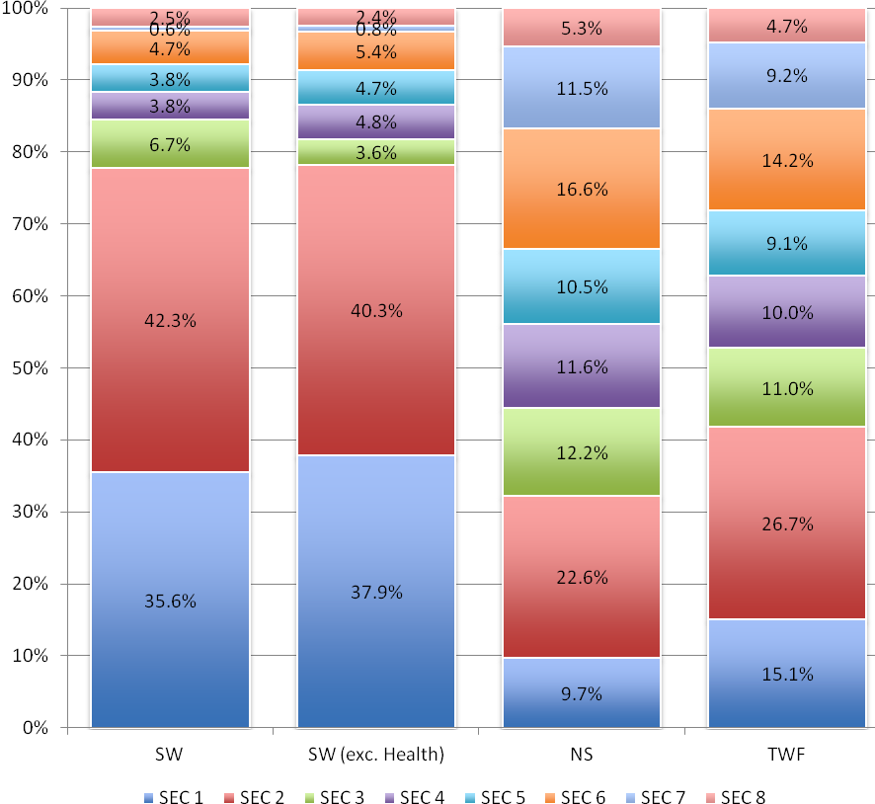
The majority of scientific workers are in higher and lower managerial and professional occupations (SEC 1 and 2), whereas the non-science and total workforces are much more evenly spread across the SEC categories.

Notably, the scientific workforce has much higher proportions of SEC 1 and 2 and lower proportions of SEC 6 and 7 than the non-science and total workforces.
 | SW | SW (exc. Health) | NS | TWF
SEC 1 | 35.6% | 37.9% | 9.7% | 15.1%
SEC 2 | 42.3% | 40.3% | 22.6% | 26.7%
SEC 3 | 6.7% | 3.6% | 12.2% | 11.0%
SEC 4 | 3.8% | 4.8% | 11.6% | 10.0%
SEC 5 | 3.8% | 4.7% | 10.5% | 9.1%
SEC 6 | 4.7% | 5.4% | 16.6% | 14.2%
SEC 7 | 0.6% | 0.8% | 11.5% | 9.2%
SEC 8 | 2.5% | 2.4% | 5.3% | 4.7%

Figure 1. SEC.T1. Science, non-scientific and total workforce, by SEC (including and excluding Health sector)
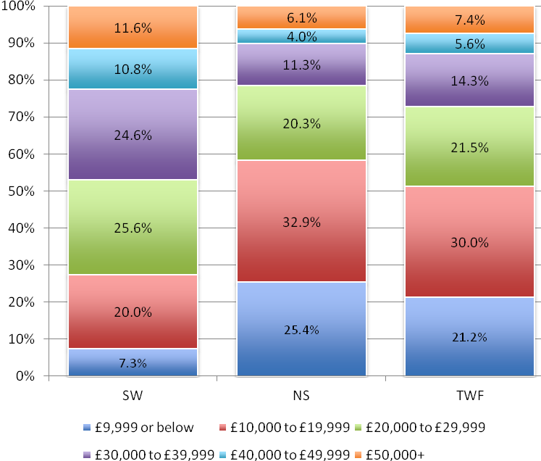
£9,999 or below£10,000 to £19,999£20,000 to £29,999£30,000 to £39,999£40,000 to £49,999£50,000+TotalSW7.3%20.0%25.6%24.6%10.8%11.6%100.0%NS25.4%32.9%20.3%11.3%4.0%6.1%100.0%TWF21.2%30.0%21.5%14.3%5.6%7.4%100.0%

Overall, scientific workers earn higher wages than non-science workers. 47.0% of the scientific workforce earn within the top 3 wage bands (£30,000 to £39,999, £40,000 to £49,999, and £50,000+), compared with 21.4% of the non-scientific and 27.3% of the total workforces. This is likely due to the higher proportion of the scientific workforce in SEC 1 and 2, compared with the non-science and total workforces.
Figure 2. WB.T1. Scientific, non-scientific and total workforce, by wage band
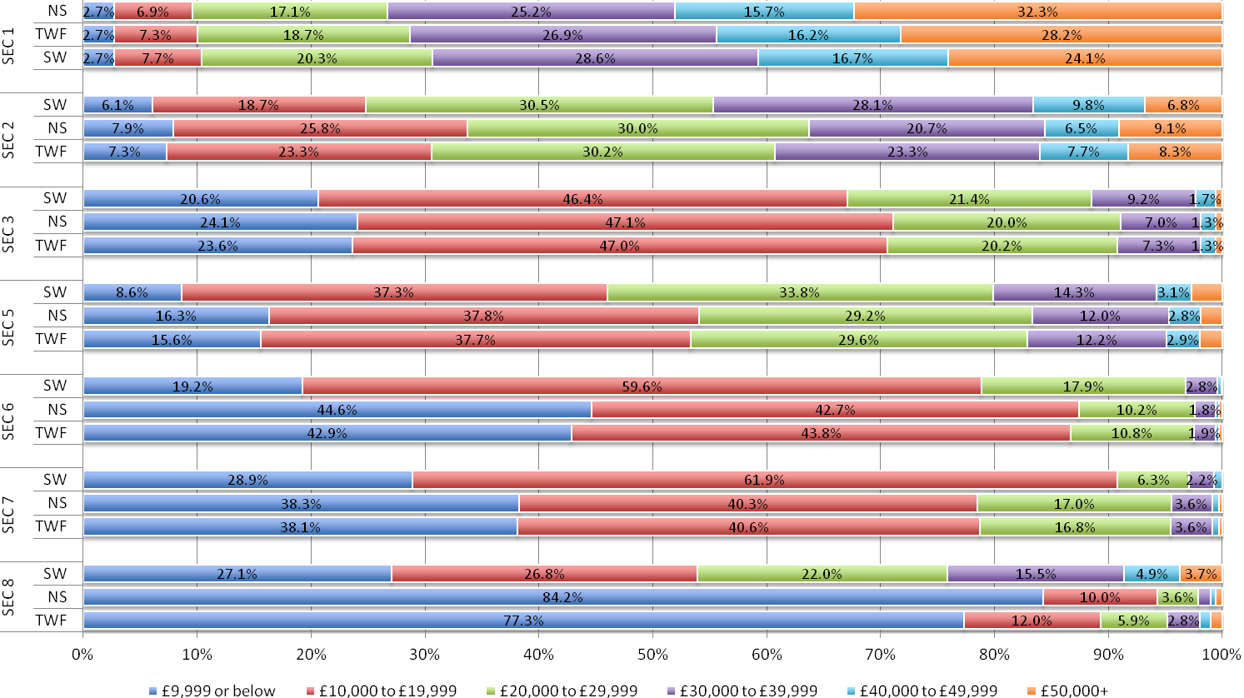
Figure 3. WB.T2. SEC categories by wage band (scientific, non-scientific and total workforce comparisons)
 |  | £9,999 or below | £10,000 to £19,999 | £20,000 to £29,999 | £30,000 to £39,999 | £40,000 to £49,999 | £50,000+
SEC 1 | NS | 2.7% | 6.9% | 17.1% | 25.2% | 15.7% | 32.3%
SEC 1 | TWF | 2.7% | 7.3% | 18.7% | 26.9% | 16.2% | 28.2%
SEC 1 | SW | 2.7% | 7.7% | 20.3% | 28.6% | 16.7% | 24.1%
SEC 2 | SW | 6.1% | 18.7% | 30.5% | 28.1% | 9.8% | 6.8%
SEC 2 | NS | 7.9% | 25.8% | 30.0% | 20.7% | 6.5% | 9.1%
SEC 2 | TWF | 7.3% | 23.3% | 30.2% | 23.3% | 7.7% | 8.3%
SEC 3 | SW | 20.6% | 46.4% | 21.4% | 9.2% | 1.7% | 0.6%
SEC 3 | NS | 24.1% | 47.1% | 20.0% | 7.0% | 1.3% | 0.6%
SEC 3 | TWF | 23.6% | 47.0% | 20.2% | 7.3% | 1.3% | 0.6%
SEC 5 | SW | 8.6% | 37.3% | 33.8% | 14.3% | 3.1% | 2.7%
SEC 5 | NS | 16.3% | 37.8% | 29.2% | 12.0% | 2.8% | 1.9%
SEC 5 | TWF | 15.6% | 37.7% | 29.6% | 12.2% | 2.9% | 2.0%
SEC 6 | SW | 19.2% | 59.6% | 17.9% | 2.8% | 0.3% | 0.1%
SEC 6 | NS | 44.6% | 42.7% | 10.2% | 1.8% | 0.3% | 0.3%
SEC 6 | TWF | 42.9% | 43.8% | 10.8% | 1.9% | 0.3% | 0.3%
SEC 7 | SW | 28.9% | 61.9% | 6.3% | 2.2% | 0.7% | 0.0%
SEC 7 | NS | 38.3% | 40.3% | 17.0% | 3.6% | 0.6% | 0.3%
SEC 7 | TWF | 38.1% | 40.6% | 16.8% | 3.6% | 0.6% | 0.3%
SEC 8 | SW | 27.1% | 26.8% | 22.0% | 15.5% | 4.9% | 3.7%
SEC 8 | NS | 84.2% | 10.0% | 3.6% | 1.1% | 0.4% | 0.6%
SEC 8 | TWF | 77.3% | 12.0% | 5.9% | 2.8% | 1.0% | 1.0%

Figure 4. WB.T2. (continued)
However, it is not the case that the scientific workforce is better paid than the non-science workforce in every SEC category.

As a general trend, in higher level categories (SEC 1 and 2), scientific workers are concentrated in the mid-range wage bands and are less likely to be on the extreme ends of the pay scale. However, in lower level SEC categories (SEC 3, 5, and 6) science workers are better paid than non-science workers.

SEC 7 is the exception, with a smaller proportion of its scientific workers in both the lowest and highest wage bands compared with the non-scientific workforce, following a similar pattern as SEC categories 1 and 2.

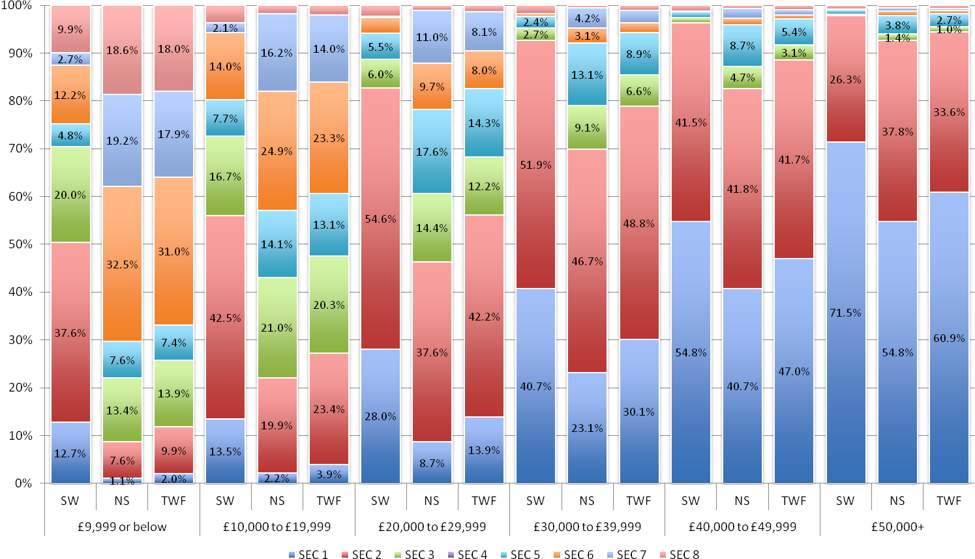
Figure 5. WB.T3. Wage band by SEC category (scientific, non-scientific and total workforce comparisons)
 |  | SEC 1 | SEC 2 | SEC 3 | SEC 4 | SEC 5 | SEC 6 | SEC 7 | SEC 8
£9,999 or below | SW | 12.7% | 37.6% | 20.0% | 0.0% | 4.8% | 12.2% | 2.7% | 9.9%
£9,999 or below | NS | 1.1% | 7.6% | 13.4% | 0.0% | 7.6% | 32.5% | 19.2% | 18.6%
£9,999 or below | TWF | 2.0% | 9.9% | 13.9% | 0.0% | 7.4% | 31.0% | 17.9% | 18.0%
£10,000 to £19,999 | SW | 13.5% | 42.5% | 16.7% | 0.0% | 7.7% | 14.0% | 2.1% | 3.6%
£10,000 to £19,999 | NS | 2.2% | 19.9% | 21.0% | 0.0% | 14.1% | 24.9% | 16.2% | 1.8%
£10,000 to £19,999 | TWF | 3.9% | 23.4% | 20.3% | 0.0% | 13.1% | 23.3% | 14.0% | 2.1%
£20,000 to £29,999 | SW | 28.0% | 54.6% | 6.0% | 0.0% | 5.5% | 3.3% | 0.2% | 2.3%
£20,000 to £29,999 | NS | 8.7% | 37.6% | 14.4% | 0.0% | 17.6% | 9.7% | 11.0% | 1.0%
£20,000 to £29,999 | TWF | 13.9% | 42.2% | 12.2% | 0.0% | 14.3% | 8.0% | 8.1% | 1.4%
£30,000 to £39,999 | SW | 40.7% | 51.9% | 2.7% | 0.0% | 2.4% | 0.5% | 0.1% | 1.7%
£30,000 to £39,999 | NS | 23.1% | 46.7% | 9.1% | 0.0% | 13.1% | 3.1% | 4.2% | 0.6%
£30,000 to £39,999 | TWF | 30.1% | 48.8% | 6.6% | 0.0% | 8.9% | 2.1% | 2.6% | 1.0%
£40,000 to £49,999 | SW | 54.8% | 41.5% | 1.1% | 0.0% | 1.2% | 0.1% | 0.0% | 1.2%
£40,000 to £49,999 | NS | 40.7% | 41.8% | 4.7% | 0.0% | 8.7% | 1.3% | 2.1% | 0.6%
£40,000 to £49,999 | TWF | 47.0% | 41.7% | 3.1% | 0.0% | 5.4% | 0.8% | 1.2% | 0.9%
£50,000+ | SW | 71.5% | 26.3% | 0.4% | 0.0% | 0.9% | 0.0% | 0.0% | 0.8%
£50,000+ | NS | 54.8% | 37.8% | 1.4% | 0.0% | 3.8% | 1.1% | 0.6% | 0.6%
£50,000+ | TWF | 60.9% | 33.6% | 1.0% | 0.0% | 2.7% | 0.7% | 0.4% | 0.7%

Figure 6. WB.T3. (continued)

As might be expected, given the overall profile of the scientific workforce as compared with the non-science and total workforces, in every wage band a higher proportion of the scientific workforce are in SEC 1-2 and a lower proportion in SEC 6-7 compared with the non-science total workforces.

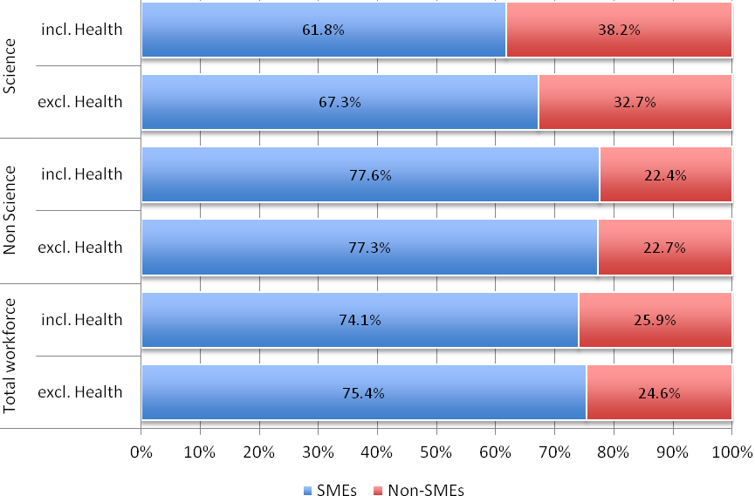
 | Science |  | Non Science |  | Total workforce
 | incl. Health | excl. Health | incl. Health | excl. Health | incl. Health | excl. Health
SMEs | 61.8% | 67.3% | 77.6% | 77.3% | 74.1% | 75.4%
Non-SMEs | 38.2% | 32.7% | 22.4% | 22.7% | 25.9% | 24.6%

The majority of both the science and non-science workforce work in small and medium enterprises (SMEs). However, the proportion of those in SMEs is smaller in the science workforce than in the non-science workforce.

This also remains the case when the Health sector is excluded, although for the science workforce there is a slight increase in those working in SMEs. This indicates that more of the science workforce in the Health sector work in non-SMEs compared to the overall science workforce.
Figure 7. FS.T1. Scientific, non-scientific and total workforce, by firm size (including and excluding Health sector)
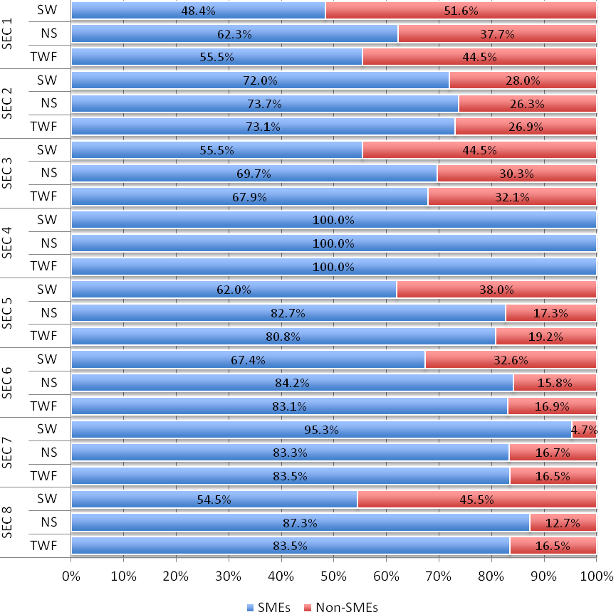
 |  | SMEs | Non-SMEs
SEC 1 | SW | 48.4% | 51.6%
SEC 1 | NS | 62.3% | 37.7%
SEC 1 | TWF | 55.5% | 44.5%
SEC 2 | SW | 72.0% | 28.0%
SEC 2 | NS | 73.7% | 26.3%
SEC 2 | TWF | 73.1% | 26.9%
SEC 3 | SW | 55.5% | 44.5%
SEC 3 | NS | 69.7% | 30.3%
SEC 3 | TWF | 67.9% | 32.1%
SEC 4 | SW | 100.0% | 0.0%
SEC 4 | NS | 100.0% | 0.0%
SEC 4 | TWF | 100.0% | 0.0%
SEC 5 | SW | 62.0% | 38.0%
SEC 5 | NS | 82.7% | 17.3%
SEC 5 | TWF | 80.8% | 19.2%
SEC 6 | SW | 67.4% | 32.6%
SEC 6 | NS | 84.2% | 15.8%
SEC 6 | TWF | 83.1% | 16.9%
SEC 7 | SW | 95.3% | 4.7%
SEC 7 | NS | 83.3% | 16.7%
SEC 7 | TWF | 83.5% | 16.5%
SEC 8 | SW | 54.5% | 45.5%
SEC 8 | NS | 87.3% | 12.7%
SEC 8 | TWF | 83.5% | 16.5%

A slight majority of the scientific workforce in SEC 1 work in non-SME firms (51.6%). For all other SEC categories, the majority work in SMEs. This is starkest within SEC 7 and SEC 2, where 95.3% and 72.0%, respectively, work in SMEs.

In comparison, within every SEC category the majority of the non-science and total workforces work in SMEs.
Figure 8. FS.T2. SEC categories by firm size (scientific, non-scientific and total workforce comparisons)
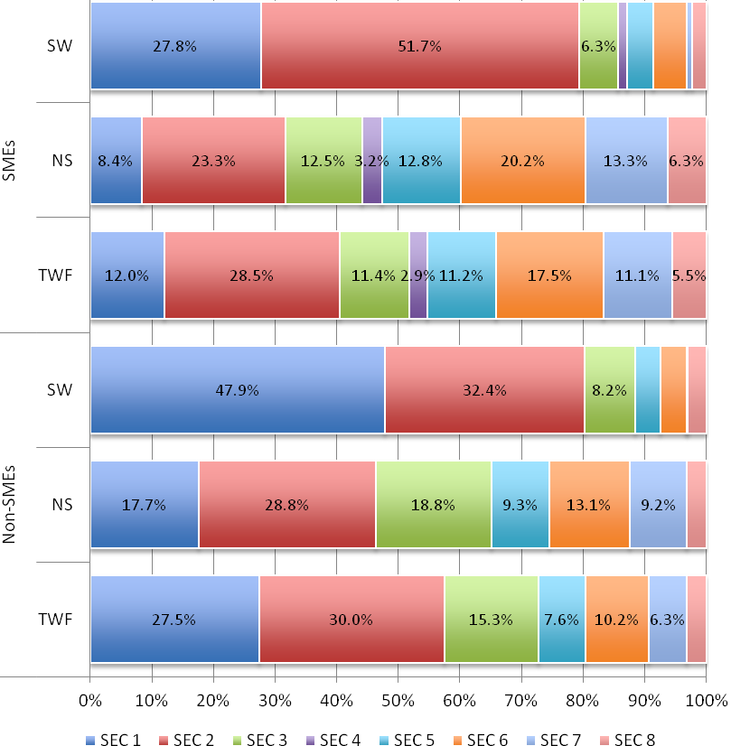
 | SMEs |  |  | Non-SMEs
 | SW | NS | TWF | SW | NS | TWF
SEC 1 | 27.8% | 8.4% | 12.0% | 47.9% | 17.7% | 27.5%
SEC 2 | 51.7% | 23.3% | 28.5% | 32.4% | 28.8% | 30.0%
SEC 3 | 6.3% | 12.5% | 11.4% | 8.2% | 18.8% | 15.3%
SEC 4 | 1.4% | 3.2% | 2.9% | 0.0% | 0.0% | 0.0%
SEC 5 | 4.2% | 12.8% | 11.2% | 4.1% | 9.3% | 7.6%
SEC 6 | 5.4% | 20.2% | 17.5% | 4.2% | 13.1% | 10.2%
SEC 7 | 1.0% | 13.3% | 11.1% | 0.1% | 9.2% | 6.3%
SEC 8 | 2.3% | 6.3% | 5.5% | 3.0% | 3.1% | 3.1%

Reflecting the fact the scientific workforce is concentrated in SEC 1 and 2, the majority of scientific workers in both SMEs and non-SMEs are in these categories. However, a higher proportion of science workers in non-SMEs are in SEC 1 than those in SMEs (47.9% c.f. 27.8%). Conversely, a higher proportion of science workers in SMEs are in SEC 2 than those in non-SMEs (51.7% c.f. 32.4%).

This is observed to a lesser extent in the non-scientific and total workforces. However, in the non-science and total workforces, a larger proportion of non-SME workers are in SEC 2 occupations than SME workers.

The proportion of scientific workers in lower level SEC categories (5, 6 and 7) is roughly the same in SMEs as non-SMEs, but for the non-science and total workforce a higher proportion of workers in these categories work in SMEs than non-SMEs.
Figure 9. FS.T3. SME/non-SME workforce by SEC categories (scientific, non-scientific and total workforce)
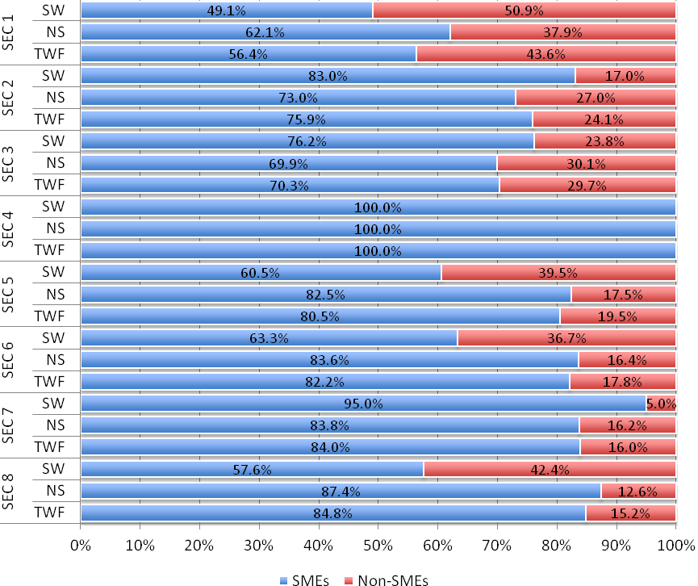
 |  | SMEs | Non-SMEs
SEC 1 | SW | 49.1% | 50.9%
SEC 1 | NS | 62.1% | 37.9%
SEC 1 | TWF | 56.4% | 43.6%
SEC 2 | SW | 83.0% | 17.0%
SEC 2 | NS | 73.0% | 27.0%
SEC 2 | TWF | 75.9% | 24.1%
SEC 3 | SW | 76.2% | 23.8%
SEC 3 | NS | 69.9% | 30.1%
SEC 3 | TWF | 70.3% | 29.7%
SEC 4 | SW | 100.0% | 0.0%
SEC 4 | NS | 100.0% | 0.0%
SEC 4 | TWF | 100.0% | 0.0%
SEC 5 | SW | 60.5% | 39.5%
SEC 5 | NS | 82.5% | 17.5%
SEC 5 | TWF | 80.5% | 19.5%
SEC 6 | SW | 63.3% | 36.7%
SEC 6 | NS | 83.6% | 16.4%
SEC 6 | TWF | 82.2% | 17.8%
SEC 7 | SW | 95.0% | 5.0%
SEC 7 | NS | 83.8% | 16.2%
SEC 7 | TWF | 84.0% | 16.0%
SEC 8 | SW | 57.6% | 42.4%
SEC 8 | NS | 87.4% | 12.6%
SEC 8 | TWF | 84.8% | 15.2%

Exclusion of the health sector decreases the proportion of the scientific workforce in non-SMEs from 38.2% to 32.7%. As with the overall science workforce, when the health sector is excluded the majority of scientific workers in every SEC category are still found in SMEs (with the exception of SEC 1). However, this becomes more pronounced in SEC categories 2 and 3 when the health sector is excluded.

Excluding the health sector also changes the profile of the science workforce within firm sizes. For example, within non-SMEs, the proportion working in SEC 1 increases and the proportion in SEC 2 decreases. This suggests that health workers – who have a more diverse profile than the rest of the scientific workforce – are more likely to be concentrated in SEC 2 than in SEC 1.

Figure 10. FS.T4. SEC categories by firm size (scientific, non-scientific and total workforce comparisons) - without Health
 | Science | Non-Science | Total workforce
NQF Level 1 | 2.1% | 5.3% | 4.6%
NQF Level 2 | 9.7% | 26.8% | 23.3%
NQF Level 3 | 11.3% | 23.7% | 21.1%
NQF Level 4 | 11.2% | 5.7% | 6.8%
NQF Level 5 | 30.9% | 16.0% | 19.1%
NQF Level 6 | 1.9% | 1.1% | 1.3%
NQF Level 7 | 1.9% | 0.4% | 0.7%
NQF Level 7&8 | 24.0% | 4.8% | 8.8%
Other | 4.6% | 7.8% | 7.2%
No Qualifications | 2.3% | 8.2% | 7.0%

The scientific workforce has higher levels of formal qualifications than the non-science workforce. The majority of science workers have a highest qualification of Level 5 or above (i.e. graduate and postgraduate qualifications) compared with less than 1 in 4 of the non-science workforce (58.7% SW cf. 22.3% NS and 29.9% TWF).

Furthermore, 24.0% of the scientific workforce have the highest possible qualification (‘NQF Level 7&8’ – i.e. postgraduate degrees), compared with only 4.8% of the non-science workforce (and 8.8% of the total workforce). By comparison, only 2.3% of the scientific workforce have no qualifications, compared with 8.2% of the non-science and 7.0% of the total workforce.
Figure 11. HQ.T1. Scientific, non-scientific and total workforce, by highest qualification
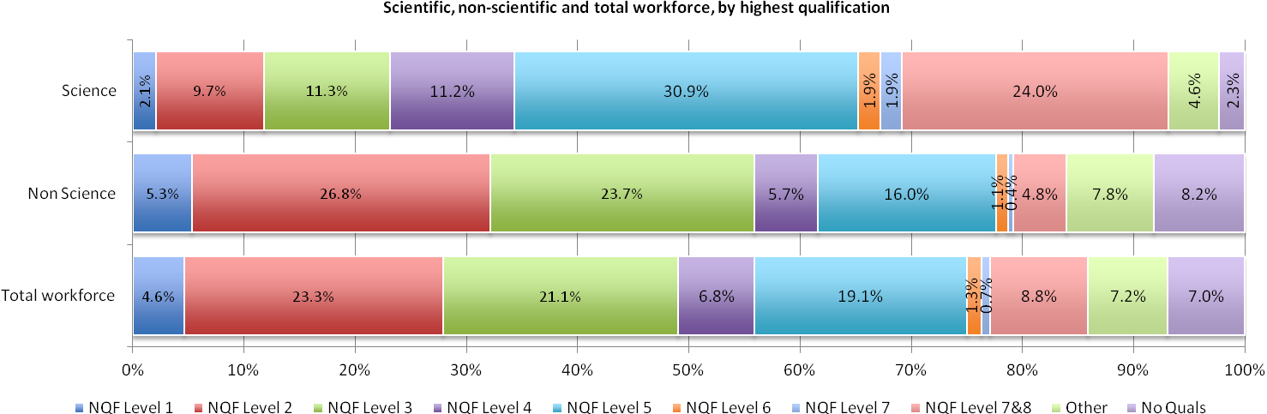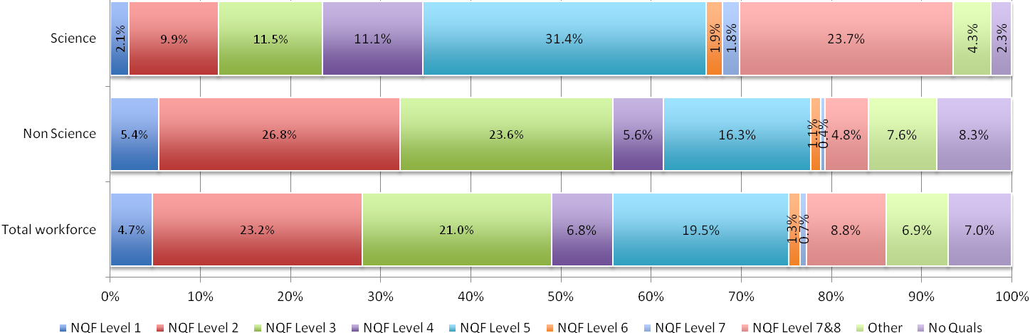
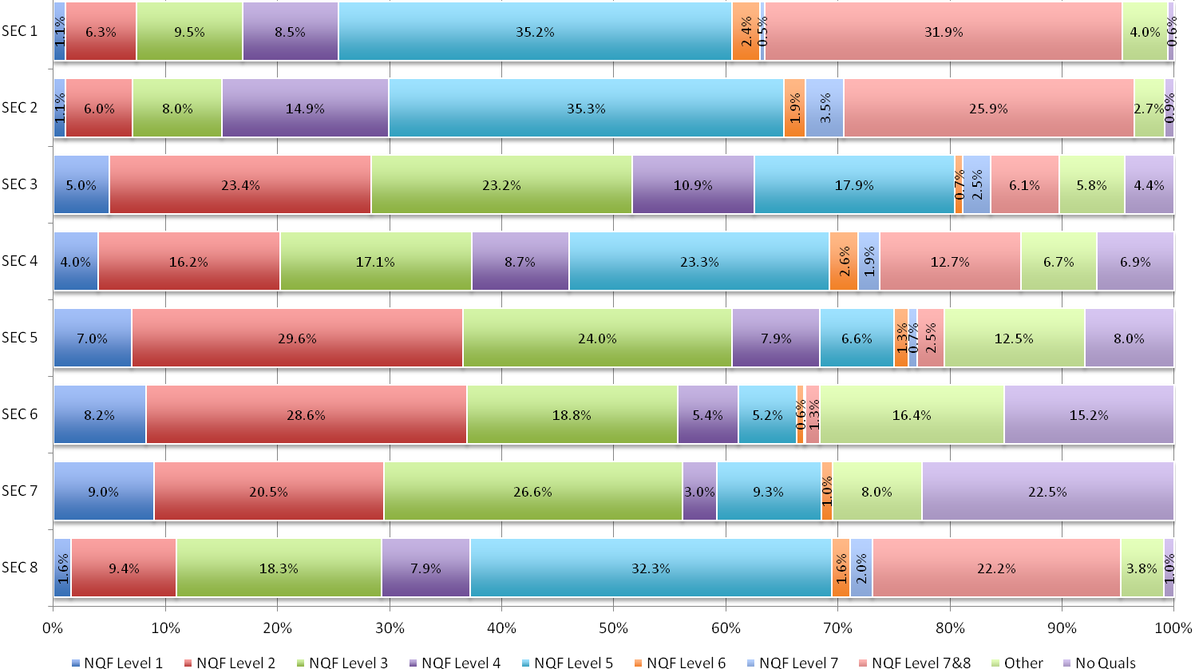
Figure 12. HQ.T2a. SEC categories by highest qualification (scientific workforce)
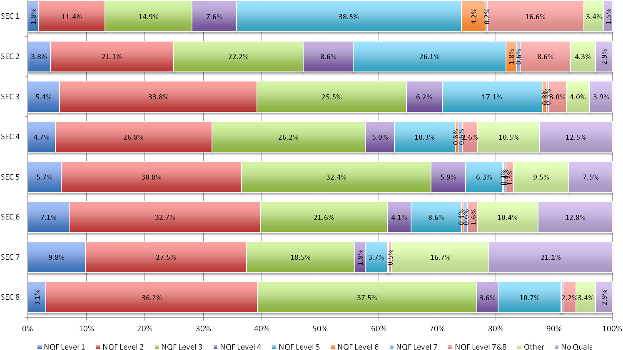
Figure 13. HQ.T2b. SEC categories by highest qualification (non-scientific workforce)
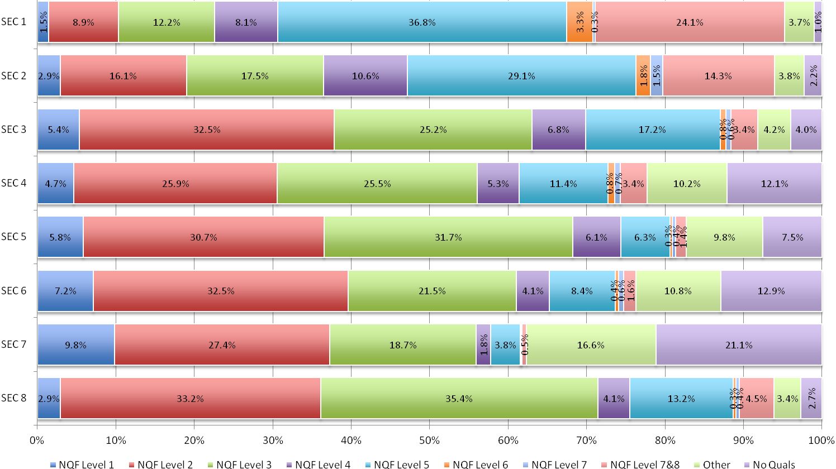
Figure 14. HQ.T2c. SEC categories by highest qualification (total workforce)
 |  | NQF Level 1 | NQF Level 2 | NQF Level 3 | NQF Level 4 | NQF Level 5 | NQF Level 6 | NQF Level 7 | NQF Level 7&8 | Other | No Quals
SEC 1 | SW | 1.1% | 6.3% | 9.5% | 8.5% | 35.2% | 2.4% | 0.5% | 31.9% | 4.0% | 0.6%
SEC 1 | NS | 1.8% | 11.4% | 14.9% | 7.6% | 38.5% | 4.2% | 0.2% | 16.6% | 3.4% | 1.5%
SEC 1 | TWF | 1.5% | 8.9% | 12.2% | 8.1% | 36.8% | 3.3% | 0.3% | 24.1% | 3.7% | 1.0%
SEC 2 | SW | 1.1% | 6.0% | 8.0% | 14.9% | 35.3% | 1.9% | 3.5% | 25.9% | 2.7% | 0.9%
SEC 2 | NS | 3.8% | 21.1% | 22.2% | 8.6% | 26.1% | 1.8% | 0.6% | 8.6% | 4.3% | 2.9%
SEC 2 | TWF | 2.9% | 16.1% | 17.5% | 10.6% | 29.1% | 1.8% | 1.5% | 14.3% | 3.8% | 2.2%
SEC 3 | SW | 5.0% | 23.4% | 23.2% | 10.9% | 17.9% | 0.7% | 2.5% | 6.1% | 5.8% | 4.4%
SEC 3 | NS | 5.4% | 33.8% | 25.5% | 6.2% | 17.1% | 0.8% | 0.3% | 3.0% | 4.0% | 3.9%
SEC 3 | TWF | 5.4% | 32.5% | 25.2% | 6.8% | 17.2% | 0.8% | 0.6% | 3.4% | 4.2% | 4.0%
SEC 4 | SW | 4.0% | 16.2% | 17.1% | 8.7% | 23.3% | 2.6% | 1.9% | 12.7% | 6.7% | 6.9%
SEC 4 | NS | 4.7% | 26.8% | 26.2% | 5.0% | 10.3% | 0.6% | 0.6% | 2.6% | 10.5% | 12.5%
SEC 4 | TWF | 4.7% | 25.9% | 25.5% | 5.3% | 11.4% | 0.8% | 0.7% | 3.4% | 10.2% | 12.1%
SEC 5 | SW | 7.0% | 29.6% | 24.0% | 7.9% | 6.6% | 1.3% | 0.7% | 2.5% | 12.5% | 8.0%
SEC 5 | NS | 5.7% | 30.8% | 32.4% | 5.9% | 6.3% | 0.2% | 0.4% | 1.3% | 9.5% | 7.5%
SEC 5 | TWF | 5.8% | 30.7% | 31.7% | 6.1% | 6.3% | 0.3% | 0.4% | 1.4% | 9.8% | 7.5%
SEC 6 | SW | 8.2% | 28.6% | 18.8% | 5.4% | 5.2% | 0.6% | 0.1% | 1.3% | 16.4% | 15.2%
SEC 6 | NS | 7.1% | 32.7% | 21.6% | 4.1% | 8.6% | 0.4% | 0.6% | 1.6% | 10.4% | 12.8%
SEC 6 | TWF | 7.2% | 32.5% | 21.5% | 4.1% | 8.4% | 0.4% | 0.6% | 1.6% | 10.8% | 12.9%
SEC 7 | SW | 9.0% | 20.5% | 26.6% | 3.0% | 9.3% | 1.0% | 0.0% | 0.0% | 8.0% | 22.5%
SEC 7 | NS | 9.8% | 27.5% | 18.5% | 1.8% | 3.7% | 0.1% | 0.1% | 0.5% | 16.7% | 21.1%
SEC 7 | TWF | 9.8% | 27.4% | 18.7% | 1.8% | 3.8% | 0.1% | 0.1% | 0.5% | 16.6% | 21.1%
SEC 8 | SW | 1.6% | 9.4% | 18.3% | 7.9% | 32.3% | 1.6% | 2.0% | 22.2% | 3.8% | 1.0%
SEC 8 | NS | 3.1% | 36.2% | 37.5% | 3.6% | 10.7% | 0.2% | 0.2% | 2.2% | 3.4% | 2.9%
SEC 8 | TWF | 2.9% | 33.2% | 35.4% | 4.1% | 13.2% | 0.3% | 0.4% | 4.5% | 3.4% | 2.7%

Figure 15. HQ.T2d. Highest Qualification level workforces by SEC categories (scientific, non-scientific and total workforce)
As a general trend, the higher level the SEC category, the greater the proportion of the scientific workforce with the highest possible qualification, NQF Level 7&8. The exception to this is SEC 4, which has a greater proportion of workers with NQF Level 7&8 than SEC 3 (12.7% c.f. 6.1%). 31.9% of scientific workers in SEC 1 hold a highest qualification of NQF Level 7&8, compared to just 1.3% of those in SEC 6 and 0% in SEC 7. This trend is also observed for the non-science workforce, though the proportions of those with NQF Level 7&8 are markedly lower than in the scientific workforce. 16.6% of non-science workers in SEC 1 hold a highest qualification of NQF Level 7&8, compared with 0.5% in SEC 7.

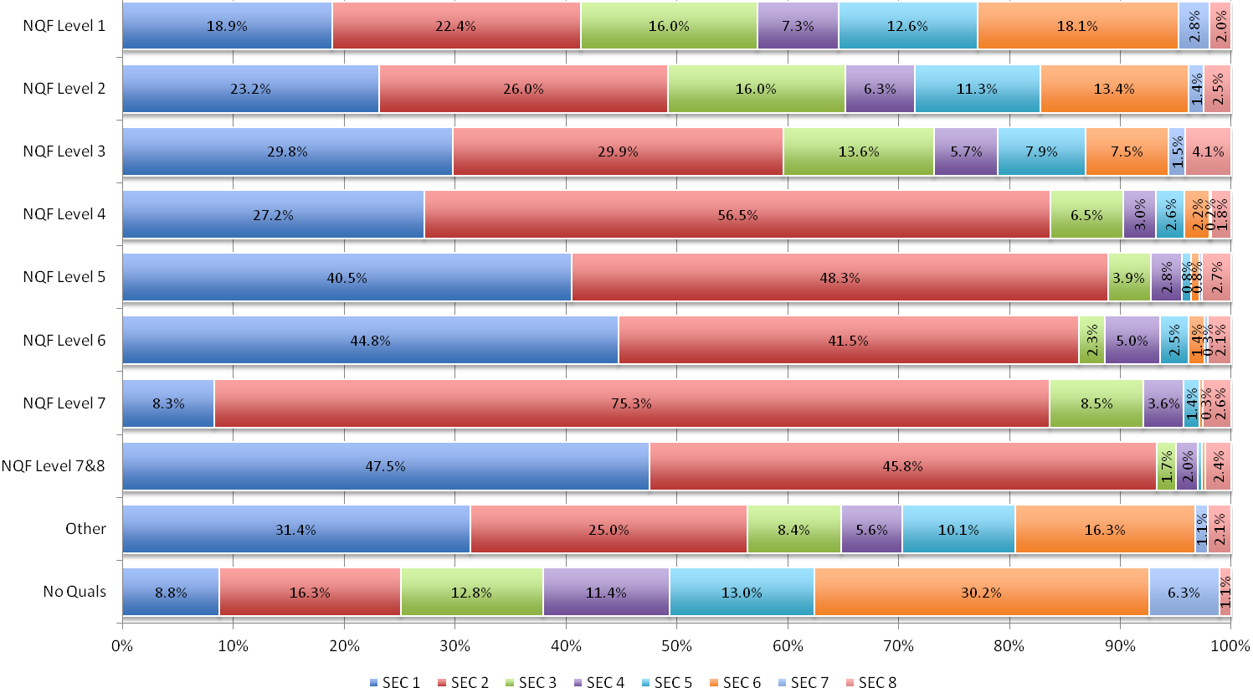
Figure 16. HQ.T3a. Highest Qualification level workforces by SEC categories (scientific workforce)
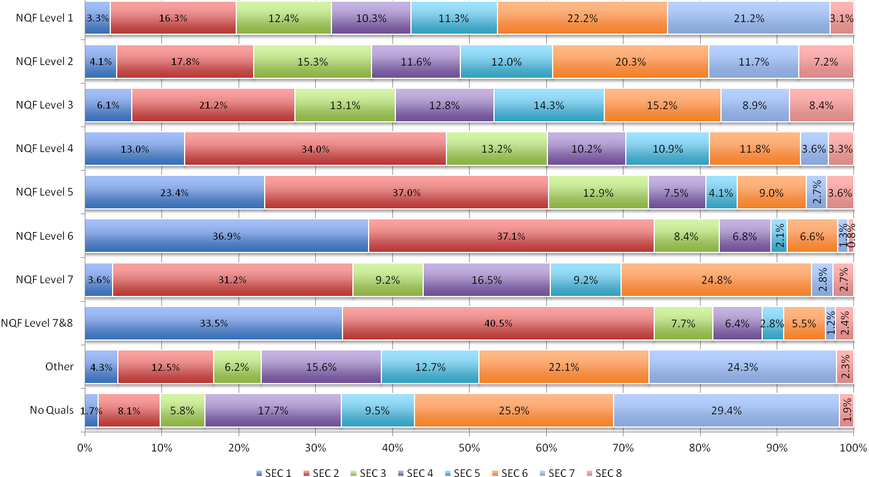
Figure 17. HQ.T3b. Highest Qualification level workforces by SEC categories (non-scientific workforce)
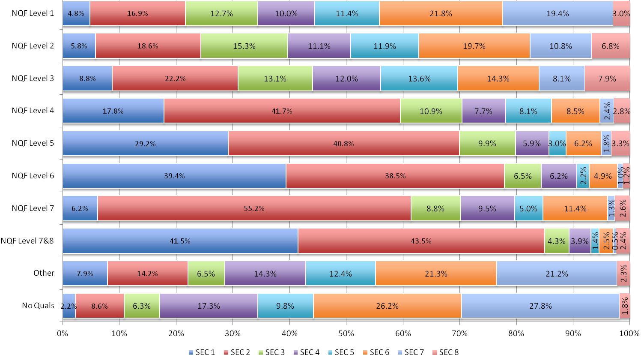
Figure 18. HQ.T3a. Highest Qualification level workforces by SEC categories (total workforce)
 |  | SEC 1 | SEC 2 | SEC 3 | SEC 4 | SEC 5 | SEC 6 | SEC 7 | SEC 8
NQF Level 1 | SW | 18.9% | 22.4% | 16.0% | 7.3% | 12.6% | 18.1% | 2.8% | 2.0%
NQF Level 1 | NS | 3.3% | 16.3% | 12.4% | 10.3% | 11.3% | 22.2% | 21.2% | 3.1%
NQF Level 1 | TWF | 4.8% | 16.9% | 12.7% | 10.0% | 11.4% | 21.8% | 19.4% | 3.0%
NQF Level 2 | SW | 23.2% | 26.0% | 16.0% | 6.3% | 11.3% | 13.4% | 1.4% | 2.5%
NQF Level 2 | NS | 4.1% | 17.8% | 15.3% | 11.6% | 12.0% | 20.3% | 11.7% | 7.2%
NQF Level 2 | TWF | 5.8% | 18.6% | 15.3% | 11.1% | 11.9% | 19.7% | 10.8% | 6.8%
NQF Level 3 | SW | 29.8% | 29.9% | 13.6% | 5.7% | 7.9% | 7.5% | 1.5% | 4.1%
NQF Level 3 | NS | 6.1% | 21.2% | 13.1% | 12.8% | 14.3% | 15.2% | 8.9% | 8.4%
NQF Level 3 | TWF | 8.8% | 22.2% | 13.1% | 12.0% | 13.6% | 14.3% | 8.1% | 7.9%
NQF Level 4 | SW | 27.2% | 56.5% | 6.5% | 3.0% | 2.6% | 2.2% | 0.2% | 1.8%
NQF Level 4 | NS | 13.0% | 34.0% | 13.2% | 10.2% | 10.9% | 11.8% | 3.6% | 3.3%
NQF Level 4 | TWF | 17.8% | 41.7% | 10.9% | 7.7% | 8.1% | 8.5% | 2.4% | 2.8%
NQF Level 5 | SW | 40.5% | 48.3% | 3.9% | 2.8% | 0.8% | 0.8% | 0.2% | 2.7%
NQF Level 5 | NS | 23.4% | 37.0% | 12.9% | 7.5% | 4.1% | 9.0% | 2.7% | 3.6%
NQF Level 5 | TWF | 29.2% | 40.8% | 9.9% | 5.9% | 3.0% | 6.2% | 1.8% | 3.3%
NQF Level 6 | SW | 44.8% | 41.5% | 2.3% | 5.0% | 2.5% | 1.4% | 0.3% | 2.1%
NQF Level 6 | NS | 36.9% | 37.1% | 8.4% | 6.8% | 2.1% | 6.6% | 1.3% | 0.8%
NQF Level 6 | TWF | 39.4% | 38.5% | 6.5% | 6.2% | 2.2% | 4.9% | 1.0% | 1.2%
NQF Level 7 | SW | 8.3% | 75.3% | 8.5% | 3.6% | 1.4% | 0.3% | 0.0% | 2.6%
NQF Level 7 | NS | 3.6% | 31.2% | 9.2% | 16.5% | 9.2% | 24.8% | 2.8% | 2.7%
NQF Level 7 | TWF | 6.2% | 55.2% | 8.8% | 9.5% | 5.0% | 11.4% | 1.3% | 2.6%
NQF Level 7&8 | SW | 47.5% | 45.8% | 1.7% | 2.0% | 0.4% | 0.3% | 0.0% | 2.4%
NQF Level 7&8 | NS | 33.5% | 40.5% | 7.7% | 6.4% | 2.8% | 5.5% | 1.2% | 2.4%
NQF Level 7&8 | TWF | 41.5% | 43.5% | 4.3% | 3.9% | 1.4% | 2.5% | 0.5% | 2.4%
Other | SW | 31.4% | 25.0% | 8.4% | 5.6% | 10.1% | 16.3% | 1.1% | 2.1%
Other | NS | 4.3% | 12.5% | 6.2% | 15.6% | 12.7% | 22.1% | 24.3% | 2.3%
Other | TWF | 7.9% | 14.2% | 6.5% | 14.3% | 12.4% | 21.3% | 21.2% | 2.3%
No Quals | SW | 8.8% | 16.3% | 12.8% | 11.4% | 13.0% | 30.2% | 6.3% | 1.1%
No Quals | NS | 1.7% | 8.1% | 5.8% | 17.7% | 9.5% | 25.9% | 29.4% | 1.9%
No Quals | TWF | 2.2% | 8.6% | 6.3% | 17.3% | 9.8% | 26.2% | 27.8% | 1.8%

Figure 19. HQ.T3d. Highest Qualification level workforces by SEC categories (scientific, non-scientific and total workforce)

However, that is not to say that the top two SEC categories (SEC 1 and 2) are limited to only those with high level qualifications.

In fact, 41.3% of scientific workers with a highest qualification of NQF Level 1 (the lowest possible qualification) are in SEC 1 or 2, compared with only 19.7% of the non-science workforce and 21.7% of the total workforce.

This demonstrates that “although those in the science workforce are more likely to fall into the top two SEC categories if they have higher level qualifications, those in the science workforce with lower qualifications are still more likely to fall into these groups than they would be in the total workforce.”

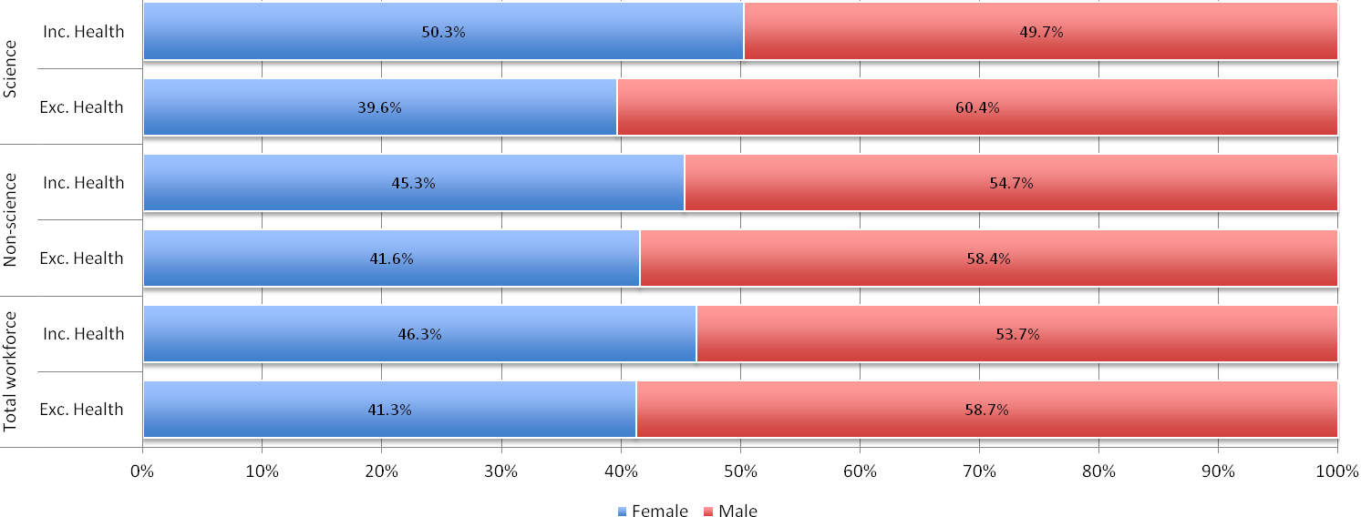
 |  | Female | Male
Science workforce | Inc. Health | 50.3% | 49.7%
Science workforce | Exc. Health | 39.6% | 60.4%
Non-science workforce | Inc. Health | 45.3% | 54.7%
Non-science workforce | Exc. Health | 41.6% | 58.4%
Total workforce | Inc. Health | 46.3% | 53.7%
Total workforce | Exc. Health | 41.3% | 58.7%

Women comprise a slight majority of the scientific workforce (50.3%). This is not the case for the non-scientific workforce and the total workforce as a whole (45.3% and 46.3%, respectively).

However, when the health sector is excluded, the proportion who are women falls to 39.6%.

Figure 20. G.T1. Scientific, non-scientific and total workforce, by gender (including and excluding Health sector)
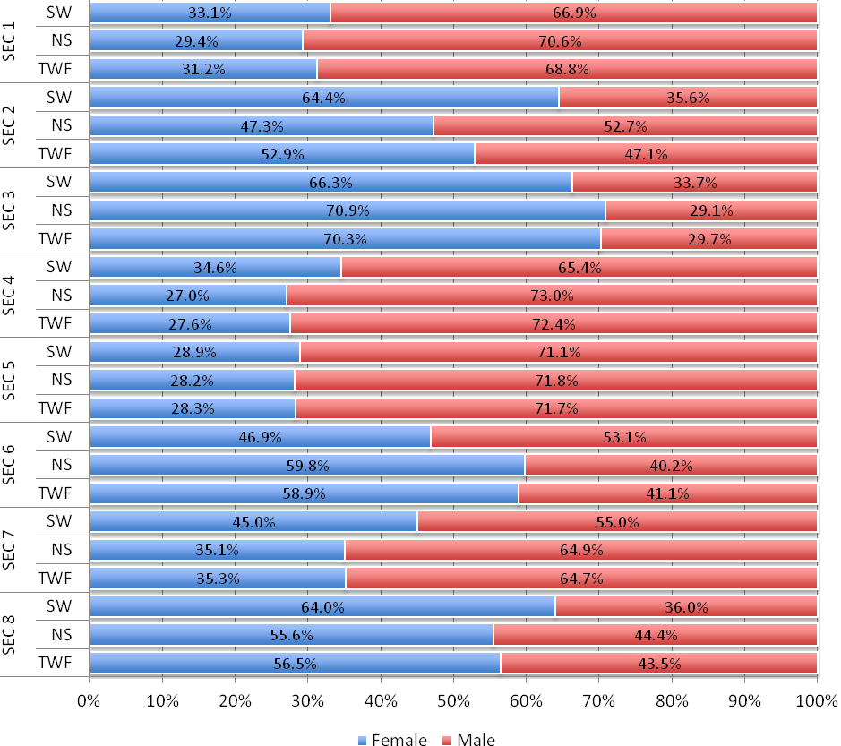
 |  | Female | Male
SEC 1 | SW | 33.1% | 66.9%
SEC 1 | NS | 29.4% | 70.6%
SEC 1 | TWF | 31.2% | 68.8%
SEC 2 | SW | 64.4% | 35.6%
SEC 2 | NS | 47.3% | 52.7%
SEC 2 | TWF | 52.9% | 47.1%
SEC 3 | SW | 66.3% | 33.7%
SEC 3 | NS | 70.9% | 29.1%
SEC 3 | TWF | 70.3% | 29.7%
SEC 4 | SW | 34.6% | 65.4%
SEC 4 | NS | 27.0% | 73.0%
SEC 4 | TWF | 27.6% | 72.4%
SEC 5 | SW | 28.9% | 71.1%
SEC 5 | NS | 28.2% | 71.8%
SEC 5 | TWF | 28.3% | 71.7%
SEC 6 | SW | 46.9% | 53.1%
SEC 6 | NS | 59.8% | 40.2%
SEC 6 | TWF | 58.9% | 41.1%
SEC 7 | SW | 45.0% | 55.0%
SEC 7 | NS | 35.1% | 64.9%
SEC 7 | TWF | 35.3% | 64.7%
SEC 8 | SW | 64.0% | 36.0%
SEC 8 | NS | 55.6% | 44.4%
SEC 8 | TWF | 56.5% | 43.5%

Women in the scientific workforce are under-represented in SEC 1, 4, 5, 6 and 7 and over-represented in SEC 2, 3 and 8.
Figure 21. G.T2. SEC categories by gender (scientific, non-scientific and total workforce comparisons)
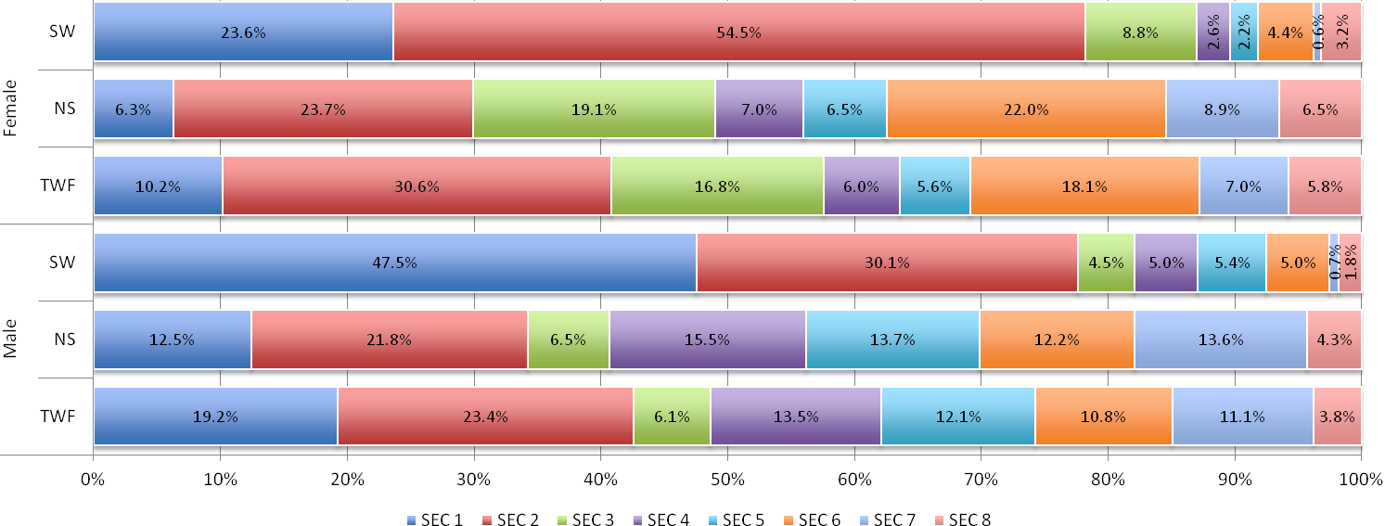
 | Female |  |  | Male
 | SW | NS | TWF | SW | NS | TWF
SEC 1 | 23.6% | 6.3% | 10.2% | 47.5% | 12.5% | 19.2%
SEC 2 | 54.5% | 23.7% | 30.6% | 30.1% | 21.8% | 23.4%
SEC 3 | 8.8% | 19.1% | 16.8% | 4.5% | 6.5% | 6.1%
SEC 4 | 2.6% | 7.0% | 6.0% | 5.0% | 15.5% | 13.5%
SEC 5 | 2.2% | 6.5% | 5.6% | 5.4% | 13.7% | 12.1%
SEC 6 | 4.4% | 22.0% | 18.1% | 5.0% | 12.2% | 10.8%
SEC 7 | 0.6% | 8.9% | 7.0% | 0.7% | 13.6% | 11.1%
SEC 8 | 3.2% | 6.5% | 5.8% | 1.8% | 4.3% | 3.8%

Men in the scientific workforce are twice as likely to be in the highest SEC category than women: nearly 1 in 2 (47.5%) are in SEC 1, compared with only 23.6% of women. Women are instead concentrated in the lower SEC 2 (54.5% of women, compared with 30.1% of men). There is also a slightly higher proportion of women in SEC 3 than men (8.8% c.f. 4.5%).

The spread across all other SEC categories is relatively similar for men and women in the scientific workforce. Higher proportions of men are in SEC 5 and SEC 4 than women, but the differences are small (3.2% and 2.4% gaps, respectively). For all other SEC categories, the gender gap is 1.4% or less.

Figure 22. G.T3. Female/Male workforce by SEC categories (scientific, non-scientific and total workforce comparisons)
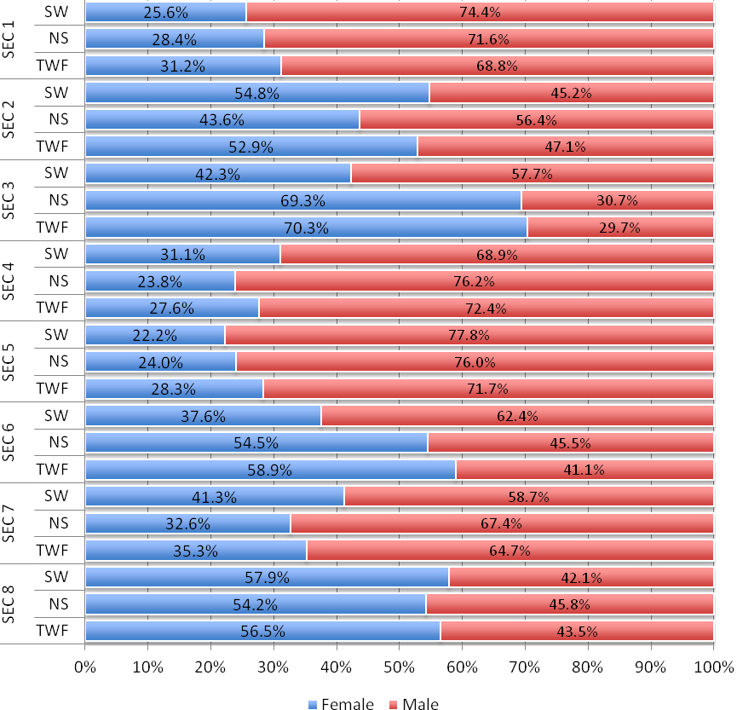
 |  | Female | Male
SEC 1 | SW | 25.6% | 74.4%
SEC 1 | NS | 28.4% | 71.6%
SEC 1 | TWF | 31.2% | 68.8%
SEC 2 | SW | 54.8% | 45.2%
SEC 2 | NS | 43.6% | 56.4%
SEC 2 | TWF | 52.9% | 47.1%
SEC 3 | SW | 42.3% | 57.7%
SEC 3 | NS | 69.3% | 30.7%
SEC 3 | TWF | 70.3% | 29.7%
SEC 4 | SW | 31.1% | 68.9%
SEC 4 | NS | 23.8% | 76.2%
SEC 4 | TWF | 27.6% | 72.4%
SEC 5 | SW | 22.2% | 77.8%
SEC 5 | NS | 24.0% | 76.0%
SEC 5 | TWF | 28.3% | 71.7%
SEC 6 | SW | 37.6% | 62.4%
SEC 6 | NS | 54.5% | 45.5%
SEC 6 | TWF | 58.9% | 41.1%
SEC 7 | SW | 41.3% | 58.7%
SEC 7 | NS | 32.6% | 67.4%
SEC 7 | TWF | 35.3% | 64.7%
SEC 8 | SW | 57.9% | 42.1%
SEC 8 | NS | 54.2% | 45.8%
SEC 8 | TWF | 56.5% | 43.5%

When health workers are excluded, gender disparities within SEC categories become much more pronounced (compare G.T4 to G.T2). In all but SEC 2 and SEC 3, men comprise a majority.

Figure 23. G.T4. SEC categories by gender (scientific, non-scientific and total workforce comparisons) - without Health
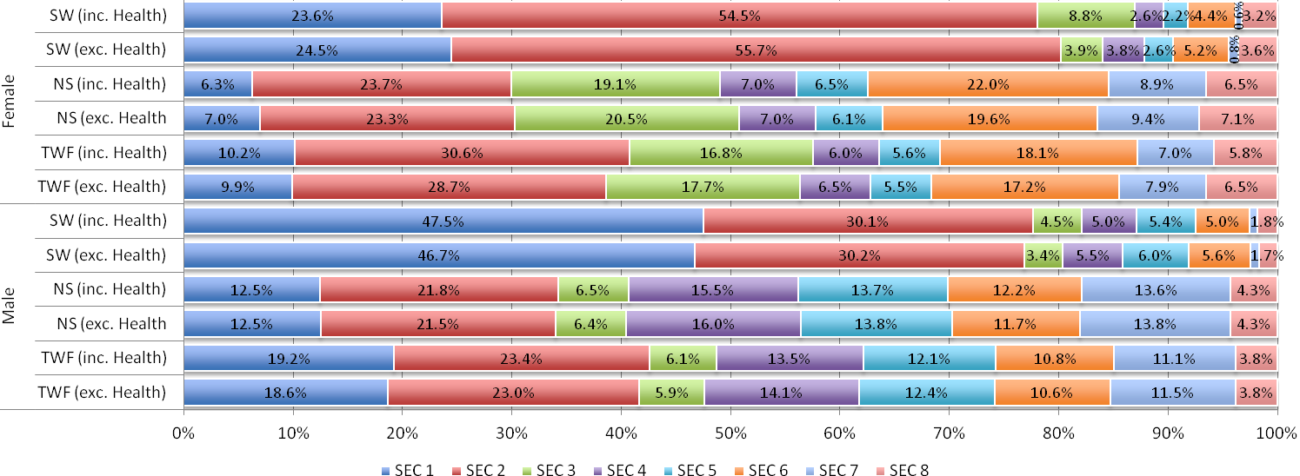
 | Female |  |  |  |  |  | Male
 | SW (inc. Health) | SW (exc. Health) | NS (inc. Health) | NS (exc. Health | TWF (inc. Health) | TWF (exc. Health) | SW (inc. Health) | SW (exc. Health) | NS (inc. Health) | NS (exc. Health | TWF (inc. Health) | TWF (exc. Health)
SEC 1 | 23.6% | 24.5% | 6.3% | 7.0% | 10.2% | 9.9% | 47.5% | 46.7% | 12.5% | 12.5% | 19.2% | 18.6%
SEC 2 | 54.5% | 55.7% | 23.7% | 23.3% | 30.6% | 28.7% | 30.1% | 30.2% | 21.8% | 21.5% | 23.4% | 23.0%
SEC 3 | 8.8% | 3.9% | 19.1% | 20.5% | 16.8% | 17.7% | 4.5% | 3.4% | 6.5% | 6.4% | 6.1% | 5.9%
SEC 4 | 2.6% | 3.8% | 7.0% | 7.0% | 6.0% | 6.5% | 5.0% | 5.5% | 15.5% | 16.0% | 13.5% | 14.1%
SEC 5 | 2.2% | 2.6% | 6.5% | 6.1% | 5.6% | 5.5% | 5.4% | 6.0% | 13.7% | 13.8% | 12.1% | 12.4%
SEC 6 | 4.4% | 5.2% | 22.0% | 19.6% | 18.1% | 17.2% | 5.0% | 5.6% | 12.2% | 11.7% | 10.8% | 10.6%
SEC 7 | 0.6% | 0.8% | 8.9% | 9.4% | 7.0% | 7.9% | 0.7% | 0.8% | 13.6% | 13.8% | 11.1% | 11.5%
SEC 8 | 3.2% | 3.6% | 6.5% | 7.1% | 5.8% | 6.5% | 1.8% | 1.7% | 4.3% | 4.3% | 3.8% | 3.8%

The exclusion of health does not significantly alter how female and male science workers are distributed across SEC categories. Perhaps the most notable change is a small decrease in women falling into the SEC3 category (3.9% of women when health is excluded, compared with 8.8% when it is included). However, all variance falls within a 5.0% range.
Figure 24. G.T5. Female/Male workforce by SEC category (workforce comparisons) - includes and excludes Health
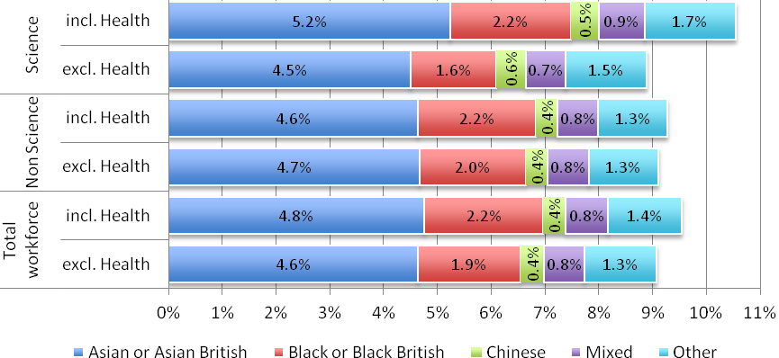
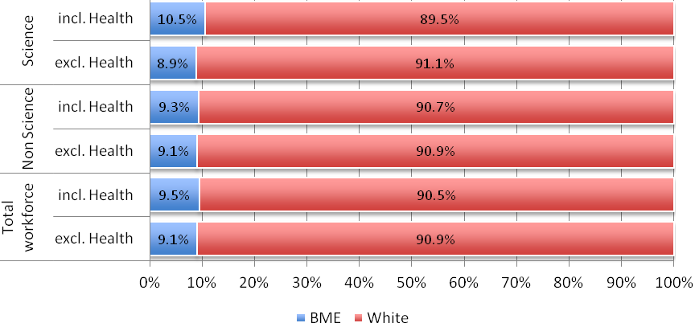
 | Science |  | Non Science |  | Total workforce
 | inc. H | exc.H | inc. H | exc.H | inc. H | exc.H
BME | 10.5% | 8.9% | 9.3% | 9.1% | 9.5% | 9.1%
Asian or Asian British | 5.2% | 4.5% | 4.6% | 4.7% | 4.8% | 4.6%
Black or Black British | 2.2% | 1.6% | 2.2% | 2.0% | 2.2% | 1.9%
Chinese | 0.5% | 0.6% | 0.4% | 0.4% | 0.4% | 0.4%
Mixed | 0.9% | 0.7% | 0.8% | 0.8% | 0.8% | 0.8%
Other | 1.7% | 1.5% | 1.3% | 1.3% | 1.4% | 1.3%
White | 89.5% | 91.1% | 90.7% | 90.9% | 90.5% | 90.9%

The distribution of ethnicity groups in the science workforce is similar to that of the non-science and total workforce. The largest ethnic group is White (89.5% SW, 90.7% NS, 90.5% TWF). When the health sector is excluded, the proportion of science workforce who are White slightly increases from 89.5% to 91.1%. This indicates that the health sector is more ethnically diverse than the rest of the scientific workforce.

See the next chart (E.T1b) for a clearer breakdown of the groups Asian or Asian British, Black or Black British, Chinese, Mixed and Other.
Figure 25. E.T1a. Scientific, non-scientific and total workforce by ethnicity (including and excluding Health sector)
Figure 26. E.T1b. BME scientific, non-scientific and total workforce by ethnicity (including and excluding Health sector)
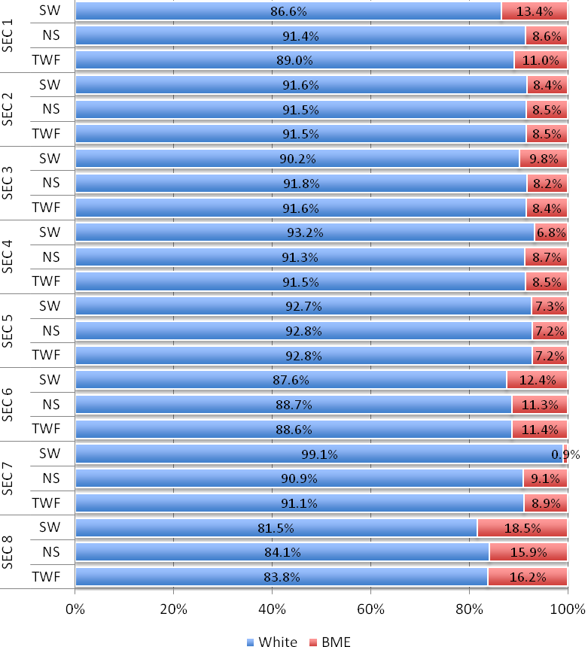
 |  | BME | Asian/ Asian British | Black/ Black British | Chinese | Mixed | Other | White
SEC 1 | SW | 13.4% | 7.3% | 1.8% | 1.0% | 1.1% | 2.2% | 86.6%
SEC 1 | NS | 8.6% | 4.6% | 1.5% | 0.6% | 0.8% | 1.1% | 91.4%
SEC 1 | TWF | 11.0% | 5.9% | 1.7% | 0.8% | 1.0% | 1.6% | 89.0%
SEC 2 | SW | 8.4% | 3.7% | 2.4% | 0.3% | 0.8% | 1.2% | 91.6%
SEC 2 | NS | 8.5% | 4.0% | 2.1% | 0.4% | 0.9% | 1.1% | 91.5%
SEC 2 | TWF | 8.5% | 3.9% | 2.2% | 0.3% | 0.9% | 1.2% | 91.5%
SEC 3 | SW | 9.8% | 4.2% | 3.5% | 0.2% | 0.6% | 1.3% | 90.2%
SEC 3 | NS | 8.2% | 4.2% | 2.1% | 0.4% | 0.6% | 0.9% | 91.8%
SEC 3 | TWF | 8.4% | 4.2% | 2.3% | 0.4% | 0.6% | 0.9% | 91.6%
SEC 4 | SW | 6.8% | 3.1% | 1.4% | 0.0% | 0.3% | 1.9% | 93.2%
SEC 4 | NS | 8.7% | 5.0% | 1.4% | 0.5% | 0.4% | 1.3% | 91.3%
SEC 4 | TWF | 8.5% | 4.9% | 1.4% | 0.5% | 0.4% | 1.4% | 91.5%
SEC 5 | SW | 7.3% | 3.2% | 0.8% | 0.2% | 0.2% | 2.9% | 92.7%
SEC 5 | NS | 7.2% | 3.1% | 2.0% | 0.2% | 0.9% | 1.1% | 92.8%
SEC 5 | TWF | 7.2% | 3.1% | 1.9% | 0.2% | 0.8% | 1.2% | 92.8%
SEC 6 | SW | 12.4% | 9.0% | 1.4% | 0.1% | 0.2% | 1.6% | 87.6%
SEC 6 | NS | 11.3% | 5.7% | 3.1% | 0.5% | 0.6% | 1.5% | 88.7%
SEC 6 | TWF | 11.4% | 5.9% | 3.0% | 0.4% | 0.5% | 1.5% | 88.6%
SEC 7 | SW | 0.9% | 0.3% | 0.0% | 0.0% | 0.6% | 0.0% | 99.1%
SEC 7 | NS | 9.1% | 4.5% | 2.1% | 0.1% | 0.7% | 1.7% | 90.9%
SEC 7 | TWF | 8.9% | 4.4% | 2.1% | 0.1% | 0.7% | 1.7% | 91.1%
SEC 8 | SW | 18.5% | 6.1% | 7.1% | 0.4% | 1.6% | 3.2% | 81.5%
SEC 8 | NS | 15.9% | 7.6% | 3.7% | 0.6% | 1.7% | 2.3% | 84.1%
SEC 8 | TWF | 16.2% | 7.5% | 4.0% | 0.6% | 1.7% | 2.4% | 83.8%

The ethnic composition within SEC categories generally reflects that of the scientific workforce as a whole. However, as a group, BME workers (who make up 10.5% of the scientific workforce) are over-represented in SEC 1, 6 and 8 and under-represented in SEC 2, 4, 5 and 7. These findings are relatively consistent with that of the non-science and total workforce, with the exception of SEC 1 and 7.

Figure 27. E.T2a. SEC categories by White/BME identity (scientific, non-scientific and total workforce comparisons)
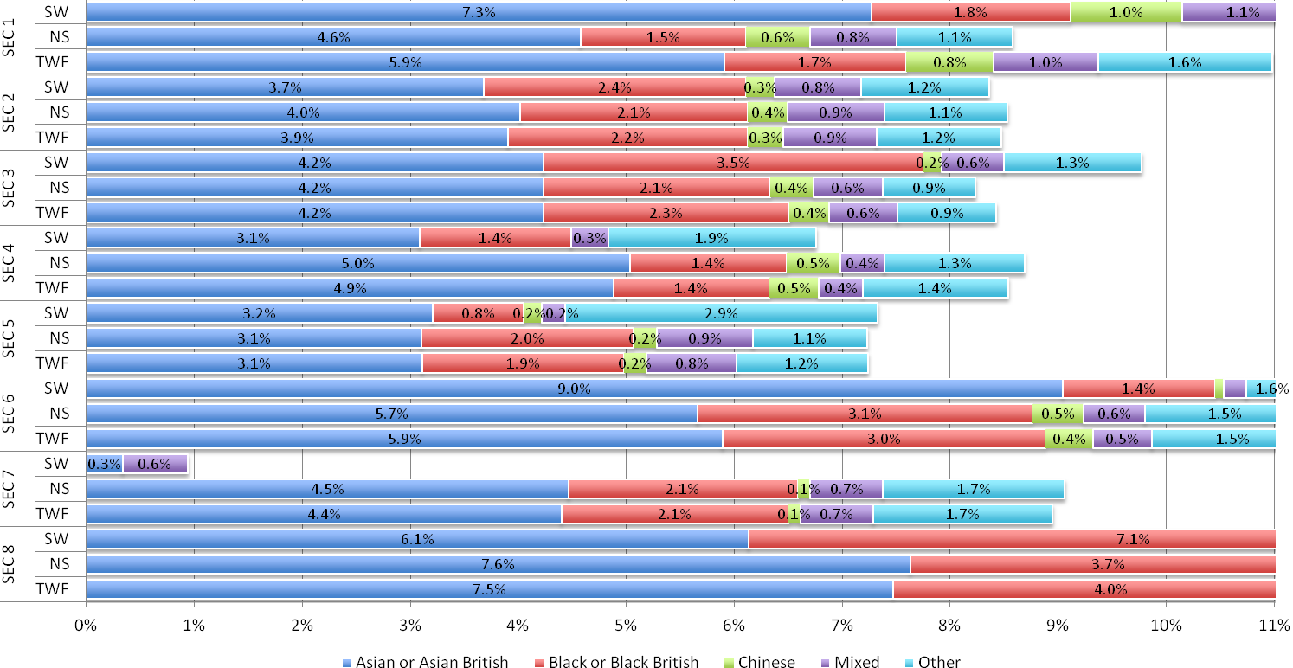
In contrast, BME workers in the non-scientific workforce are not over-represented in SEC 1 or under-represented in SEC 7 (as is the case for the science workforce).

Figure 28. E.T2b. SEC categories by BME ethnic group (scientific, non-scientific and total workforce comparisons)
Figure 29. E.T3a. Ethnicity group workforces by SEC categories (scientific, non-scientific and total workforce)
Given that the vast majority of the scientific workforce is White, it is perhaps expected that the distribution of SEC roles within the White ethnicity group closely follows the overall distribution for the total science workforce (compare to SEC.T1). There are, however, significant variations within other ethnicities, the majority of which occur at the SEC 1 and 2 categories.

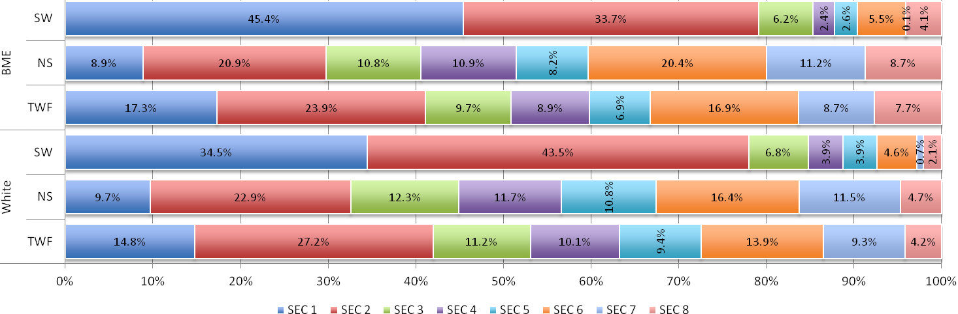
 | BME |  |  | White
 | SW | NS | TWF | SW | NS | TWF
SEC 1 | 45.4% | 8.9% | 17.3% | 34.5% | 9.7% | 14.8%
SEC 2 | 33.7% | 20.9% | 23.9% | 43.5% | 22.9% | 27.2%
SEC 3 | 6.2% | 10.8% | 9.7% | 6.8% | 12.3% | 11.2%
SEC 4 | 2.4% | 10.9% | 8.9% | 3.9% | 11.7% | 10.1%
SEC 5 | 2.6% | 8.2% | 6.9% | 3.9% | 10.8% | 9.4%
SEC 6 | 5.5% | 20.4% | 16.9% | 4.6% | 16.4% | 13.9%
SEC 7 | 0.1% | 11.2% | 8.7% | 0.7% | 11.5% | 9.3%
SEC 8 | 4.1% | 8.7% | 7.7% | 2.1% | 4.7% | 4.2%

Figure 30. E.T3b. BME ethnic workforces by SEC categories (scientific, non-scientific and total workforce)
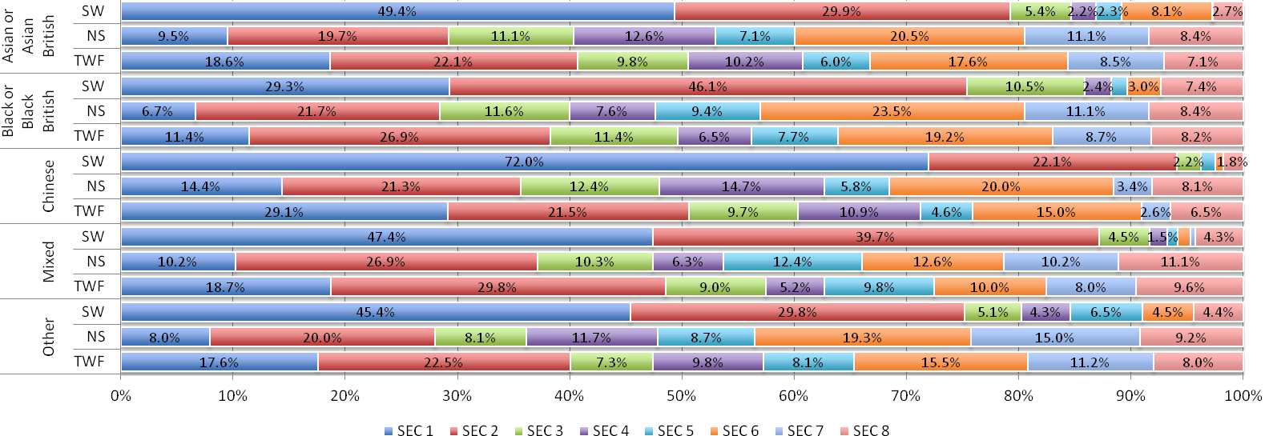
 | Asian or Asian British |  |  | Black or Black British |  |  | Chinese |  |  | Mixed |  |  | Other
 | SW | NS | TWF | SW | NS | TWF | SW | NS | TWF | SW | NS | TWF | SW | NS | TWF
SEC 1 | 49.4% | 9.5% | 18.6% | 29.3% | 6.7% | 11.4% | 72.0% | 14.4% | 29.1% | 47.4% | 10.2% | 18.7% | 45.4% | 8.0% | 17.6%
SEC 2 | 29.9% | 19.7% | 22.1% | 46.1% | 21.7% | 26.9% | 22.1% | 21.3% | 21.5% | 39.7% | 26.9% | 29.8% | 29.8% | 20.0% | 22.5%
SEC 3 | 5.4% | 11.1% | 9.8% | 10.5% | 11.6% | 11.4% | 2.2% | 12.4% | 9.7% | 4.5% | 10.3% | 9.0% | 5.1% | 8.1% | 7.3%
SEC 4 | 2.2% | 12.6% | 10.2% | 2.4% | 7.6% | 6.5% | 0.0% | 14.7% | 10.9% | 1.5% | 6.3% | 5.2% | 4.3% | 11.7% | 9.8%
SEC 5 | 2.3% | 7.1% | 6.0% | 1.4% | 9.4% | 7.7% | 1.3% | 5.8% | 4.6% | 0.9% | 12.4% | 9.8% | 6.5% | 8.7% | 8.1%
SEC 6 | 8.1% | 20.5% | 17.6% | 3.0% | 23.5% | 19.2% | 0.7% | 20.0% | 15.0% | 1.1% | 12.6% | 10.0% | 4.5% | 19.3% | 15.5%
SEC 7 | 0.0% | 11.1% | 8.5% | 0.0% | 11.1% | 8.7% | 0.0% | 3.4% | 2.6% | 0.4% | 10.2% | 8.0% | 0.0% | 15.0% | 11.2%
SEC 8 | 2.7% | 8.4% | 7.1% | 7.4% | 8.4% | 8.2% | 1.8% | 8.1% | 6.5% | 4.3% | 11.1% | 9.6% | 4.4% | 9.2% | 8.0%

A much higher proportion of both Chinese and Mixed science workers are in SEC 1 and 2 than is the case for all other ethnic groups (94.1% and 87.2% respectively, compared with 75.2% - 79.2%).
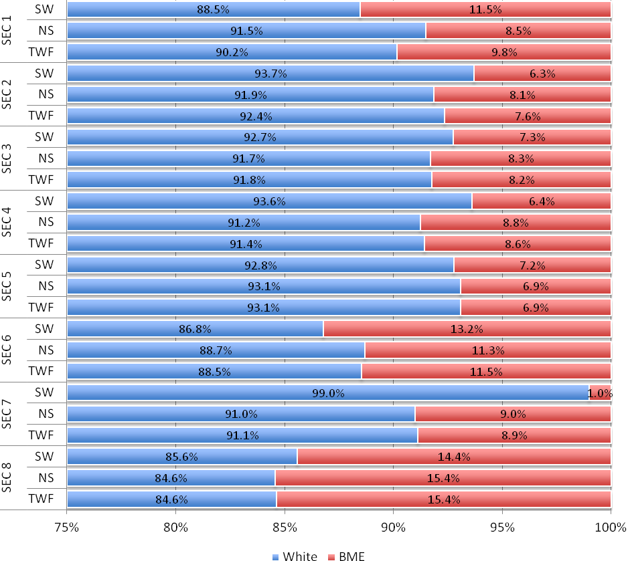
 |  | White | BME
SEC 1 | SW | 88.5% | 11.5%
SEC 1 | NS | 91.5% | 8.5%
SEC 1 | TWF | 90.2% | 9.8%
SEC 2 | SW | 93.7% | 6.3%
SEC 2 | NS | 91.9% | 8.1%
SEC 2 | TWF | 92.4% | 7.6%
SEC 3 | SW | 92.7% | 7.3%
SEC 3 | NS | 91.7% | 8.3%
SEC 3 | TWF | 91.8% | 8.2%
SEC 4 | SW | 93.6% | 6.4%
SEC 4 | NS | 91.2% | 8.8%
SEC 4 | TWF | 91.4% | 8.6%
SEC 5 | SW | 92.8% | 7.2%
SEC 5 | NS | 93.1% | 6.9%
SEC 5 | TWF | 93.1% | 6.9%
SEC 6 | SW | 86.8% | 13.2%
SEC 6 | NS | 88.7% | 11.3%
SEC 6 | TWF | 88.5% | 11.5%
SEC 7 | SW | 99.0% | 1.0%
SEC 7 | NS | 91.0% | 9.0%
SEC 7 | TWF | 91.1% | 8.9%
SEC 8 | SW | 85.6% | 14.4%
SEC 8 | NS | 84.6% | 15.4%
SEC 8 | TWF | 84.6% | 15.4%

When the health sector is excluded, the proportion of science workforce who are White slightly increases from 89.5% to 91.1% (compare to E.T2a).
Figure 31. E.T4a. SEC categories by White/BME identity (scientific, non-scientific and total workforce comparisons) - without Health
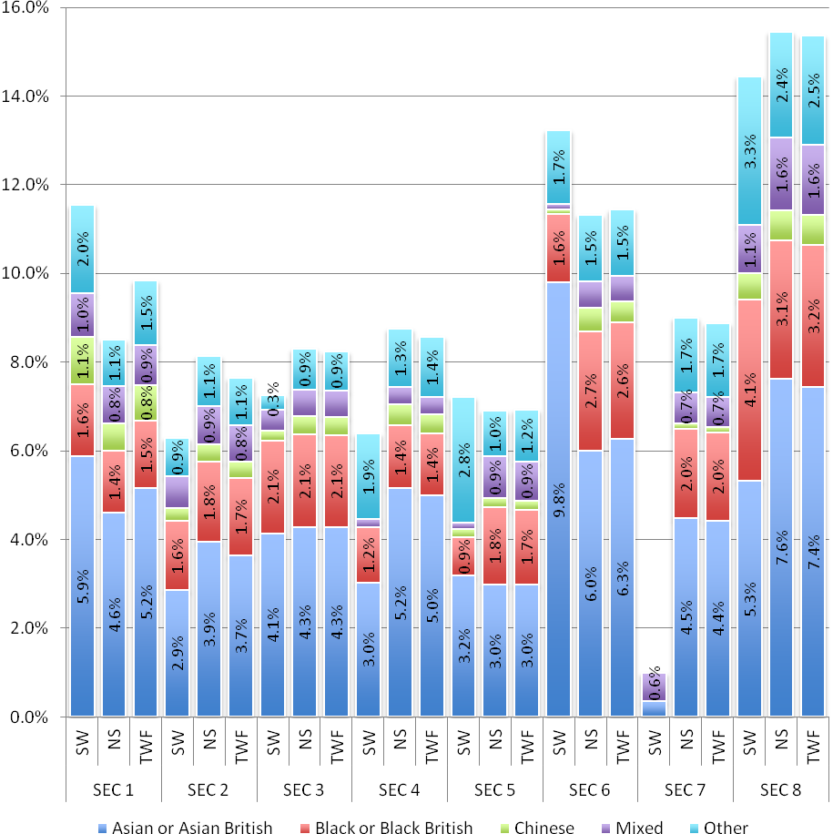
 |  | BME | Asian or Asian British | Black or Black British | Chinese | Mixed | Other
SEC 1 | SW | 11.5% | 5.9% | 1.6% | 1.1% | 1.0% | 2.0%
SEC 1 | NS | 8.5% | 4.6% | 1.4% | 0.6% | 0.8% | 1.1%
SEC 1 | TWF | 9.8% | 5.2% | 1.5% | 0.8% | 0.9% | 1.5%
SEC 2 | SW | 6.3% | 2.9% | 1.6% | 0.3% | 0.7% | 0.9%
SEC 2 | NS | 8.1% | 3.9% | 1.8% | 0.4% | 0.9% | 1.1%
SEC 2 | TWF | 7.6% | 3.7% | 1.7% | 0.4% | 0.8% | 1.1%
SEC 3 | SW | 7.3% | 4.1% | 2.1% | 0.2% | 0.5% | 0.3%
SEC 3 | NS | 8.3% | 4.3% | 2.1% | 0.4% | 0.6% | 0.9%
SEC 3 | TWF | 8.2% | 4.3% | 2.1% | 0.4% | 0.6% | 0.9%
SEC 4 | SW | 6.4% | 3.0% | 1.2% | 0.0% | 0.2% | 1.9%
SEC 4 | NS | 8.8% | 5.2% | 1.4% | 0.5% | 0.4% | 1.3%
SEC 4 | TWF | 8.6% | 5.0% | 1.4% | 0.4% | 0.4% | 1.4%
SEC 5 | SW | 7.2% | 3.2% | 0.9% | 0.2% | 0.1% | 2.8%
SEC 5 | NS | 6.9% | 3.0% | 1.8% | 0.2% | 0.9% | 1.0%
SEC 5 | TWF | 6.9% | 3.0% | 1.7% | 0.2% | 0.9% | 1.2%
SEC 6 | SW | 13.2% | 9.8% | 1.6% | 0.1% | 0.1% | 1.7%
SEC 6 | NS | 11.3% | 6.0% | 2.7% | 0.5% | 0.6% | 1.5%
SEC 6 | TWF | 11.5% | 6.3% | 2.6% | 0.5% | 0.6% | 1.5%
SEC 7 | SW | 1.0% | 0.3% | 0.0% | 0.0% | 0.6% | 0.0%
SEC 7 | NS | 9.0% | 4.5% | 2.0% | 0.1% | 0.7% | 1.7%
SEC 7 | TWF | 8.9% | 4.4% | 2.0% | 0.1% | 0.7% | 1.7%
SEC 8 | SW | 14.4% | 5.3% | 4.1% | 0.6% | 1.1% | 3.3%
SEC 8 | NS | 15.4% | 7.6% | 3.1% | 0.7% | 1.6% | 2.4%
SEC 8 | TWF | 15.4% | 7.4% | 3.2% | 0.7% | 1.6% | 2.5%

Figure 32. E.T4b. SEC categories by ethnicity (BME scientific, non-scientific and total workforce comparisons) - without Health
The overall proportion of Black or Black British science workers decreases with the exclusion of the health sector (from 2.2% to 1.6%).This suggests that the proportion of Black or Black British health workers in SEC 1 is lower than average and reduces SEC 1 levels overall in the science workforce.

Figure 33. E.T5a. White/BME workforce by SEC categories (scientific, non-scientific and total workforce) - without Health
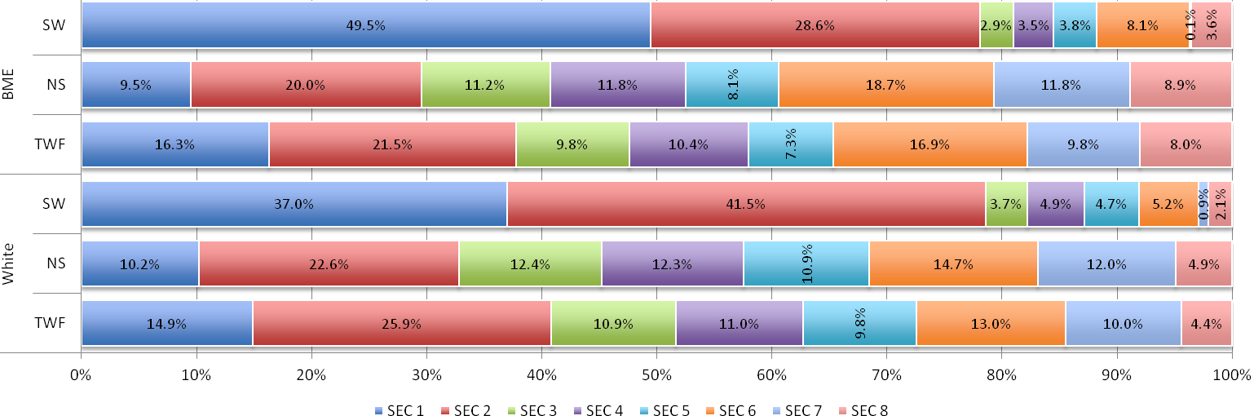
 | BME |  |  | White
 | SW | NS | TWF | SW | NS | TWF
SEC 1 | 49.5% | 9.5% | 16.3% | 37.0% | 10.2% | 14.9%
SEC 2 | 28.6% | 20.0% | 21.5% | 41.5% | 22.6% | 25.9%
SEC 3 | 2.9% | 11.2% | 9.8% | 3.7% | 12.4% | 10.9%
SEC 4 | 3.5% | 11.8% | 10.4% | 4.9% | 12.3% | 11.0%
SEC 5 | 3.8% | 8.1% | 7.3% | 4.7% | 10.9% | 9.8%
SEC 6 | 8.1% | 18.7% | 16.9% | 5.2% | 14.7% | 13.0%
SEC 7 | 0.1% | 11.8% | 9.8% | 0.9% | 12.0% | 10.0%
SEC 8 | 3.6% | 8.9% | 8.0% | 2.1% | 4.9% | 4.4%

For the most part, excluding the health sector does not greatly affect SEC category in relation to its distribution across ethnic groups. However, there is a slight change in the Black or Black British scientific workers group, which is discussed in E.T5b on the following page.
Figure 34. E.T5b. BME ethnic workforces by SEC categories (scientific, non-scientific and total workforce) - without Health
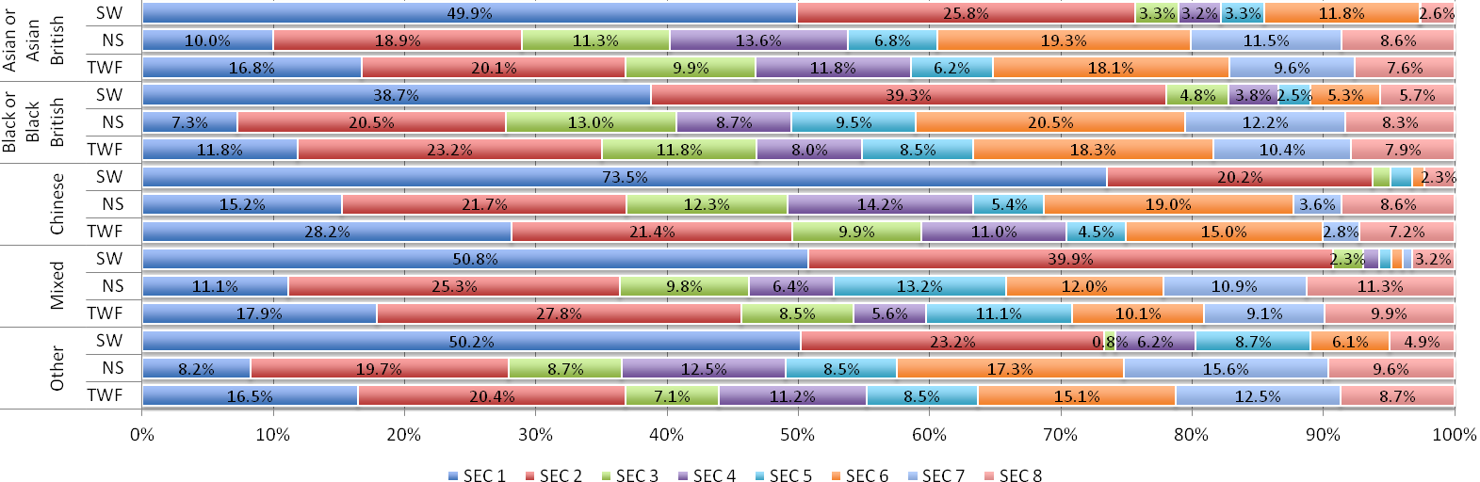
 | Asian or Asian British |  |  | Black or Black British |  |  | Chinese |  |  | Mixed |  |  | Other
 | SW | NS | TWF | SW | NS | TWF | SW | NS | TWF | SW | NS | TWF | SW | NS | TWF
SEC 1 | 49.9% | 10.0% | 16.8% | 38.7% | 7.3% | 11.8% | 73.5% | 15.2% | 28.2% | 50.8% | 11.1% | 17.9% | 50.2% | 8.2% | 16.5%
SEC 2 | 25.8% | 18.9% | 20.1% | 39.3% | 20.5% | 23.2% | 20.2% | 21.7% | 21.4% | 39.9% | 25.3% | 27.8% | 23.2% | 19.7% | 20.4%
SEC 3 | 3.3% | 11.3% | 9.9% | 4.8% | 13.0% | 11.8% | 1.4% | 12.3% | 9.9% | 2.3% | 9.8% | 8.5% | 0.8% | 8.7% | 7.1%
SEC 4 | 3.2% | 13.6% | 11.8% | 3.8% | 8.7% | 8.0% | 0.0% | 14.2% | 11.0% | 1.3% | 6.4% | 5.6% | 6.2% | 12.5% | 11.2%
SEC 5 | 3.3% | 6.8% | 6.2% | 2.5% | 9.5% | 8.5% | 1.6% | 5.4% | 4.5% | 0.9% | 13.2% | 11.1% | 8.7% | 8.5% | 8.5%
SEC 6 | 11.8% | 19.3% | 18.1% | 5.3% | 20.5% | 18.3% | 0.9% | 19.0% | 15.0% | 0.9% | 12.0% | 10.1% | 6.1% | 17.3% | 15.1%
SEC 7 | 0.1% | 11.5% | 9.6% | 0.0% | 12.2% | 10.4% | 0.0% | 3.6% | 2.8% | 0.7% | 10.9% | 9.1% | 0.0% | 15.6% | 12.5%
SEC 8 | 2.6% | 8.6% | 7.6% | 5.7% | 8.3% | 7.9% | 2.3% | 8.6% | 7.2% | 3.2% | 11.3% | 9.9% | 4.9% | 9.6% | 8.7%

For the most part, excluding the health sector does not greatly affect SEC category in relation to its distribution across ethnic groups. However, the proportion of Black or Black British scientific workers who are in SEC 1 increases to the average level for the science workforce (despite a decrease in the overall proportion of Black or Black British scientific workers when the health sector is excluded).

 | Science |  | Non Science |  | Total workforce
 | excl. Health | incl. Health | excl. Health | incl. Health | excl. Health | incl. Health
Disabled | 12.8% | 13.5% | 14.4% | 14.7% | 14.1% | 14.5%
Non Disabled | 87.2% | 86.5% | 85.6% | 85.3% | 85.9% | 85.5%

The proportions of workers who are disabled and non-disabled in the science workforce (13.5%, 86.5%) are similar to the non-science workforce (14.7%, 85.3%) and total workforce (14.5%, 85.5%). There is very little variance for all workforces when the Health sector is excluded.
Figure 35. D.T1. Scientific, non-scientific and total workforce, by disability (including and excluding Health sector)
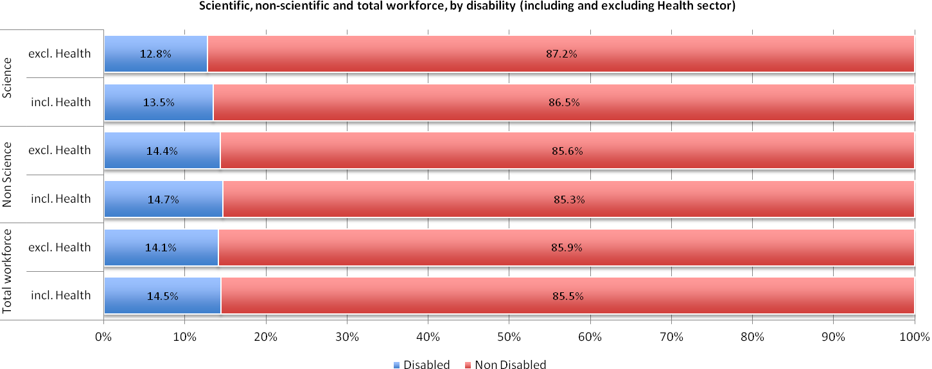
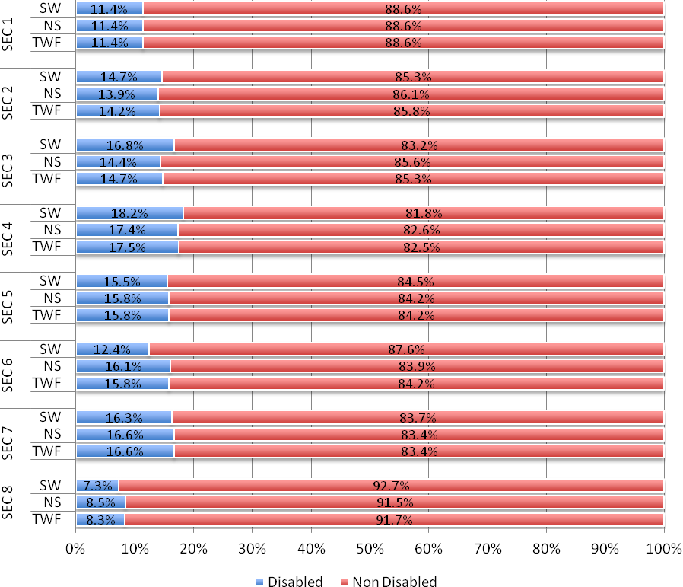
 |  | Disabled | Non Disabled
SEC 1 | SW | 11.4% | 88.6%
SEC 1 | NS | 11.4% | 88.6%
SEC 1 | TWF | 11.4% | 88.6%
SEC 2 | SW | 14.7% | 85.3%
SEC 2 | NS | 13.9% | 86.1%
SEC 2 | TWF | 14.2% | 85.8%
SEC 3 | SW | 16.8% | 83.2%
SEC 3 | NS | 14.4% | 85.6%
SEC 3 | TWF | 14.7% | 85.3%
SEC 4 | SW | 18.2% | 81.8%
SEC 4 | NS | 17.4% | 82.6%
SEC 4 | TWF | 17.5% | 82.5%
SEC 5 | SW | 15.5% | 84.5%
SEC 5 | NS | 15.8% | 84.2%
SEC 5 | TWF | 15.8% | 84.2%
SEC 6 | SW | 12.4% | 87.6%
SEC 6 | NS | 16.1% | 83.9%
SEC 6 | TWF | 15.8% | 84.2%
SEC 7 | SW | 16.3% | 83.7%
SEC 7 | NS | 16.6% | 83.4%
SEC 7 | TWF | 16.6% | 83.4%
SEC 8 | SW | 7.3% | 92.7%
SEC 8 | NS | 8.5% | 91.5%
SEC 8 | TWF | 8.3% | 91.7%

A higher proportion of workers in middling and lower level SEC categories (SEC 3, 4, 5, and 7) are disabled compared with SEC 1, 2, 6 and 8. However, relative to the non-science workforce, disabled science workers are slightly better represented in higher level SEC categories (ie. SEC 2, 3, 4) and less so in lower level SEC categories (5, 6, 7, 8).
Figure 36. D.T2. SEC categories by disability (scientific, non-scientific and total workforce comparisons)
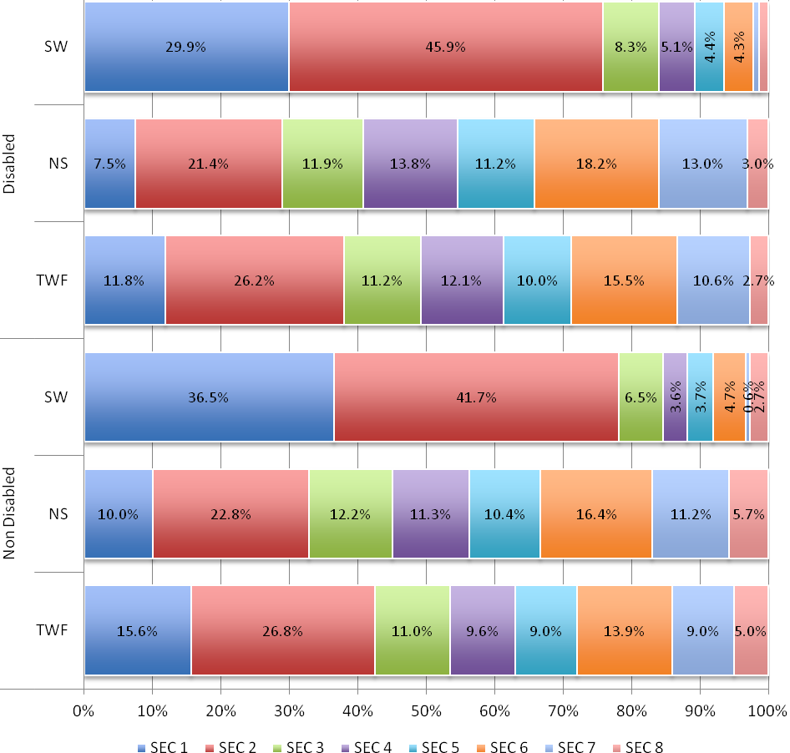
 | Disabled |  |  | Non Disabled
 | SW | NS | TWF | SW | NS | TWF
SEC 1 | 29.9% | 7.5% | 11.8% | 36.5% | 10.0% | 15.6%
SEC 2 | 45.9% | 21.4% | 26.2% | 41.7% | 22.8% | 26.8%
SEC 3 | 8.3% | 11.9% | 11.2% | 6.5% | 12.2% | 11.0%
SEC 4 | 5.1% | 13.8% | 12.1% | 3.6% | 11.3% | 9.6%
SEC 5 | 4.4% | 11.2% | 10.0% | 3.7% | 10.4% | 9.0%
SEC 6 | 4.3% | 18.2% | 15.5% | 4.7% | 16.4% | 13.9%
SEC 7 | 0.8% | 13.0% | 10.6% | 0.6% | 11.2% | 9.0%
SEC 8 | 1.4% | 3.0% | 2.7% | 2.7% | 5.7% | 5.0%

A lower proportion of disabled workers in the science workforce are in SEC 1 compared to non-disabled workers (29.9% disabled cf. 36.5%). However, there are proportionately almost three times as many disabled scientific workers in SEC 1 (29.9%) compared to the non-science (7.5%) and total workforce (11%).

The largest group of disabled scientific workers is in SEC 2 where they are slightly over-represented compared to non-disabled scientific workers (45.9% cf. 41.7%). Again, there is a much larger proportion of disabled workers in SEC 2 (45.6%) than in the non-science (21.4%) and total workforce (26.2%).
Figure 37. D.T3. Disabled/Non Disabled workforce by SEC categories (scientific, non-scientific and total workforce)
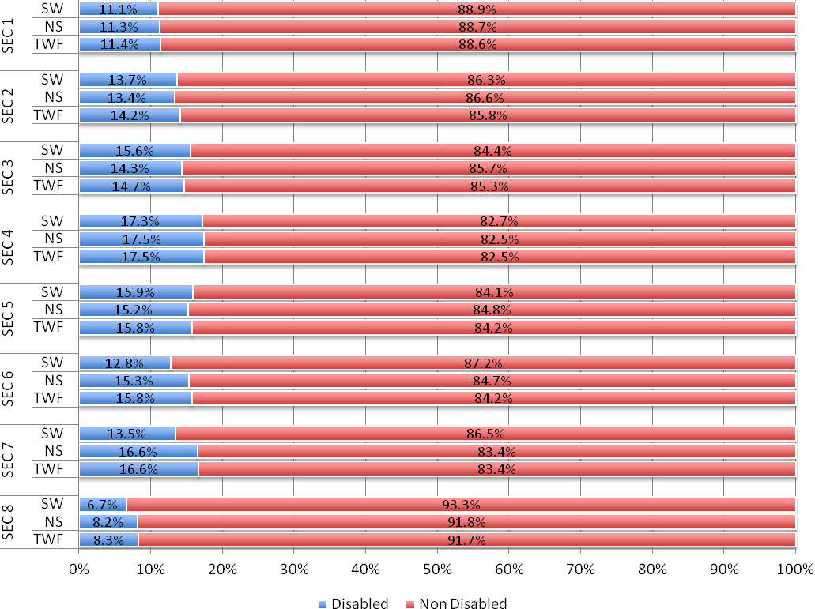
 |  | Disabled | Non Disabled
SEC 1 | SW | 11.1% | 88.9%
SEC 1 | NS | 11.3% | 88.7%
SEC 1 | TWF | 11.4% | 88.6%
SEC 2 | SW | 13.7% | 86.3%
SEC 2 | NS | 13.4% | 86.6%
SEC 2 | TWF | 14.2% | 85.8%
SEC 3 | SW | 15.6% | 84.4%
SEC 3 | NS | 14.3% | 85.7%
SEC 3 | TWF | 14.7% | 85.3%
SEC 4 | SW | 17.3% | 82.7%
SEC 4 | NS | 17.5% | 82.5%
SEC 4 | TWF | 17.5% | 82.5%
SEC 5 | SW | 15.9% | 84.1%
SEC 5 | NS | 15.2% | 84.8%
SEC 5 | TWF | 15.8% | 84.2%
SEC 6 | SW | 12.8% | 87.2%
SEC 6 | NS | 15.3% | 84.7%
SEC 6 | TWF | 15.8% | 84.2%
SEC 7 | SW | 13.5% | 86.5%
SEC 7 | NS | 16.6% | 83.4%
SEC 7 | TWF | 16.6% | 83.4%
SEC 8 | SW | 6.7% | 93.3%
SEC 8 | NS | 8.2% | 91.8%
SEC 8 | TWF | 8.3% | 91.7%

The proportion of the science workforce who are disabled decreases slightly when the health sector is excluded, falling from 13.5% to 12.8%. Excluding the health sector increases the proportion of disabled scientific workers in all SEC categories but SEC 2, 3 and 8. While all differences are small, the most notable are found in SEC 1-3.
Figure 38. D.T4. SEC categories by disability (scientific, non-scientific and total workforce comparisons) - without Health
Figure 39. D.T5 Disabled/Non-disabled workforce by SEC categories - without Health
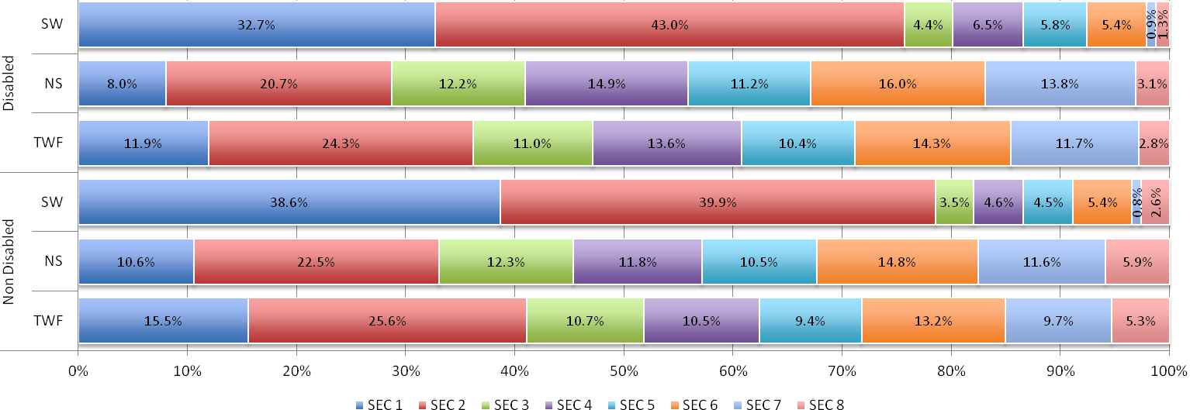
Within disabled scientific workers, excluding the health sector increases the proportion in all SEC categories but SEC 2, 3 and 8. The largest changes are observed in SEC 1-3:

- SEC 1 (+): SW exc. health – 32.7% disabled c.f. 29.9% SW.
- SEC 2 (-): SW exc. health – 43.0% disabled c.f. 45.9% SW.
- SEC 3 (-): SW exc. health – 4.4% disabled c.f. 8.3% SW.

 | Disabled |  |  | Non Disabled
 | SW | NS | TWF | SW | NS | TWF
SEC 1 | 32.7% | 8.0% | 11.9% | 38.6% | 10.6% | 15.5%
SEC 2 | 43.0% | 20.7% | 24.3% | 39.9% | 22.5% | 25.6%
SEC 3 | 4.4% | 12.2% | 11.0% | 3.5% | 12.3% | 10.7%
SEC 4 | 6.5% | 14.9% | 13.6% | 4.6% | 11.8% | 10.5%
SEC 5 | 5.8% | 11.2% | 10.4% | 4.5% | 10.5% | 9.4%
SEC 6 | 5.4% | 16.0% | 14.3% | 5.4% | 14.8% | 13.2%
SEC 7 | 0.9% | 13.8% | 11.7% | 0.8% | 11.6% | 9.7%
SEC 8 | 1.3% | 3.1% | 2.8% | 2.6% | 5.9% | 5.3%

 | Science |  | Non Science |  | Total workforce
 | incl. Health | excl. Health | incl. Health | excl. Health | incl. Health | excl. Health
DDA disabled | 6.0% | 5.8% | 5.7% | 5.6% | 5.8% | 5.6%
DDA disabled and work-limiting disabled | 4.9% | 4.5% | 5.8% | 5.7% | 5.6% | 5.5%
Work-limiting disabled only | 2.6% | 2.5% | 3.2% | 3.1% | 3.0% | 3.0%
Not disabled | 86.5% | 87.2% | 85.3% | 85.6% | 85.5% | 85.9%

The proportions of workers who are disabled and non-disabled in the science workforce (13.5%, 86.5%) are similar to the non-science workforce (14.7%, 85.3%) and total workforce (14.5%, 85.5%).

Within disability groups, the two largest and usually similarly sized groups are DDA disabled (6.0% SW, 5.7% NS, 5.8% TWF) and DDA disabled and work-limiting disabled (4.9% SW, 5.8% NS, 5.6% TWF). The smallest group is Work-limiting disabled only (2.6% SW. 3.2% NS, 3.0% TWF).

There is very little overall variance for all workforces when the Health sector is excluded.
Figure 40. D.T6. Scientific, non-scientific and total workforce, by disability groups (including and excluding Health sector)
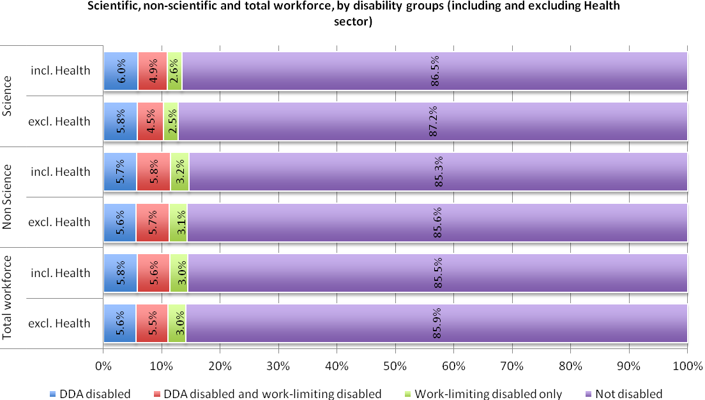
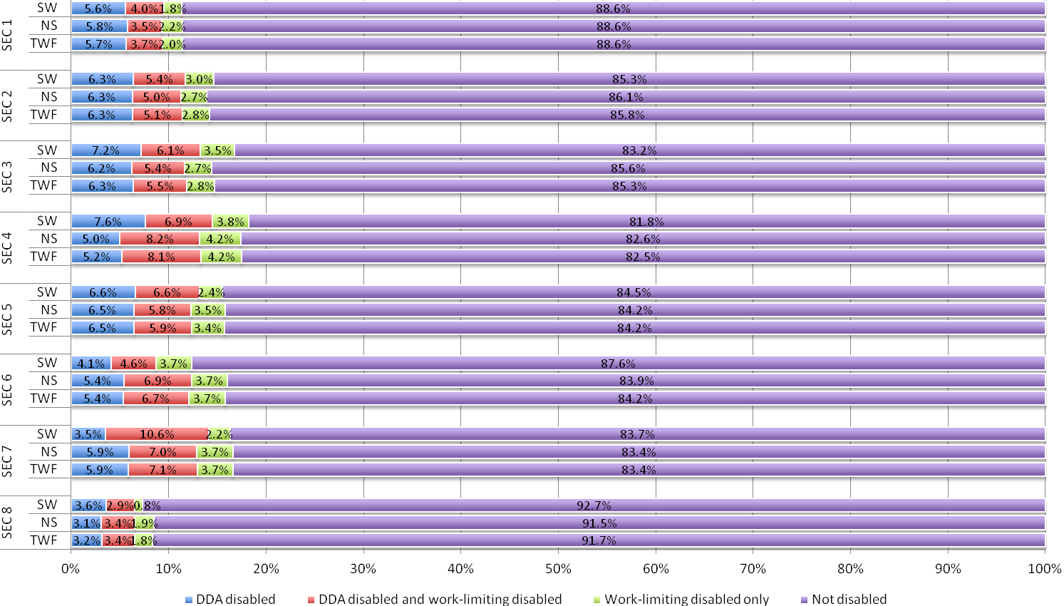
Figure 41. D.T7. SEC categories by disability groups (scientific, non-scientific and total workforce comparisons)
 |  | DDA disabled | DDA disabled and work-limiting disabled | Work-limiting disabled only | Not disabled
SEC 1 | SW | 5.6% | 4.0% | 1.8% | 88.6%
SEC 1 | NS | 5.8% | 3.5% | 2.2% | 88.6%
SEC 1 | TWF | 5.7% | 3.7% | 2.0% | 88.6%
SEC 2 | SW | 6.3% | 5.4% | 3.0% | 85.3%
SEC 2 | NS | 6.3% | 5.0% | 2.7% | 86.1%
SEC 2 | TWF | 6.3% | 5.1% | 2.8% | 85.8%
SEC 3 | SW | 7.2% | 6.1% | 3.5% | 83.2%
SEC 3 | NS | 6.2% | 5.4% | 2.7% | 85.6%
SEC 3 | TWF | 6.3% | 5.5% | 2.8% | 85.3%
SEC 4 | SW | 7.6% | 6.9% | 3.8% | 81.8%
SEC 4 | NS | 5.0% | 8.2% | 4.2% | 82.6%
SEC 4 | TWF | 5.2% | 8.1% | 4.2% | 82.5%
SEC 5 | SW | 6.6% | 6.6% | 2.4% | 84.5%
SEC 5 | NS | 6.5% | 5.8% | 3.5% | 84.2%
SEC 5 | TWF | 6.5% | 5.9% | 3.4% | 84.2%
SEC 6 | SW | 4.1% | 4.6% | 3.7% | 87.6%
SEC 6 | NS | 5.4% | 6.9% | 3.7% | 83.9%
SEC 6 | TWF | 5.4% | 6.7% | 3.7% | 84.2%
SEC 7 | SW | 3.5% | 10.6% | 2.2% | 83.7%
SEC 7 | NS | 5.9% | 7.0% | 3.7% | 83.4%
SEC 7 | TWF | 5.9% | 7.1% | 3.7% | 83.4%
SEC 8 | SW | 3.6% | 2.9% | 0.8% | 92.7%
SEC 8 | NS | 3.1% | 3.4% | 1.9% | 91.5%
SEC 8 | TWF | 3.2% | 3.4% | 1.8% | 91.7%

A higher proportion of workers in middling and lower level SEC categories (SEC 3, 4, 5, and 7) are disabled compared with SEC 1, 2, 6 and 8.

The distribution of disability groups in the science workforce changes greatly between SEC 6 and 7.

In SEC 6, there are 4.1% DDA disabled (cf. 5.4% NS, 5.4% TWF), 4.6% DDA disabled and work-limiting disabled (6.9% NS, 6.7% TWF) and 3.7% Work-limiting disabled only (c.f. 3.7% NS & TWF).

In SEC 7, DDA disabled and work-limiting disabled rises to 10.6% (cf. 7.0% NS, 7.1% TWF), DDA disabled is 3.5% (cf. 5.9% NS, 5.9% TWF) and Work-limiting disabled is 2.2% (cf. 3.7% NS. 3.7% TWF).
Figure 42. D.T7. (continued)
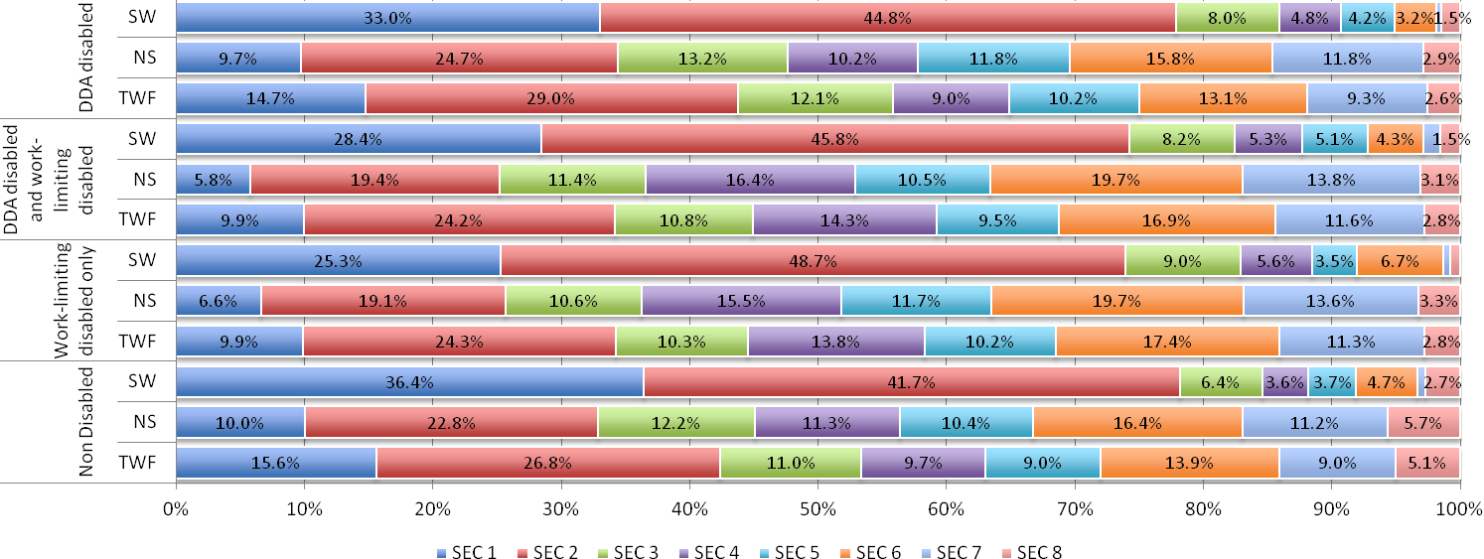
 | DDA disabled |  |  | DDA disabled and work-limiting disabled |  |  | Work-limiting disabled only |  |  | Non Disabled
 | SW | NS | TWF | SW | NS | TWF | SW | NS | TWF | SW | NS | TWF
SEC 1 | 33.0% | 9.7% | 14.7% | 28.4% | 5.8% | 9.9% | 25.3% | 6.6% | 9.9% | 36.4% | 10.0% | 15.6%
SEC 2 | 44.8% | 24.7% | 29.0% | 45.8% | 19.4% | 24.2% | 48.7% | 19.1% | 24.3% | 41.7% | 22.8% | 26.8%
SEC 3 | 8.0% | 13.2% | 12.1% | 8.2% | 11.4% | 10.8% | 9.0% | 10.6% | 10.3% | 6.4% | 12.2% | 11.0%
SEC 4 | 4.8% | 10.2% | 9.0% | 5.3% | 16.4% | 14.3% | 5.6% | 15.5% | 13.8% | 3.6% | 11.3% | 9.7%
SEC 5 | 4.2% | 11.8% | 10.2% | 5.1% | 10.5% | 9.5% | 3.5% | 11.7% | 10.2% | 3.7% | 10.4% | 9.0%
SEC 6 | 3.2% | 15.8% | 13.1% | 4.3% | 19.7% | 16.9% | 6.7% | 19.7% | 17.4% | 4.7% | 16.4% | 13.9%
SEC 7 | 0.4% | 11.8% | 9.3% | 1.4% | 13.8% | 11.6% | 0.6% | 13.6% | 11.3% | 0.6% | 11.2% | 9.0%
SEC 8 | 1.5% | 2.9% | 2.6% | 1.5% | 3.1% | 2.8% | 0.8% | 3.3% | 2.8% | 2.7% | 5.7% | 5.1%

Figure 43. D.T8. Disability Group workforces by SEC categories (scientific, non-scientific and total workforce)
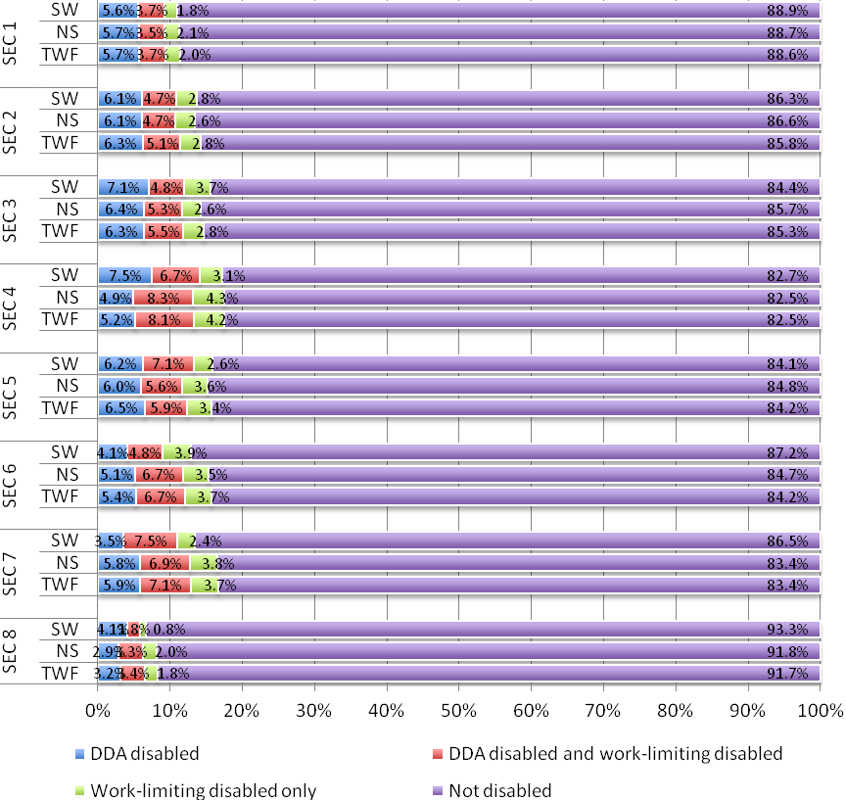
 |  | DDA disabled | DDA disabled & work-limiting disabled | Work-limiting disabled only | Not disabled
SEC 1 | SW | 5.6% | 3.7% | 1.8% | 88.9%
SEC 1 | NS | 5.7% | 3.5% | 2.1% | 88.7%
SEC 1 | TWF | 5.7% | 3.7% | 2.0% | 88.6%
SEC 2 | SW | 6.1% | 4.7% | 2.8% | 86.3%
SEC 2 | NS | 6.1% | 4.7% | 2.6% | 86.6%
SEC 2 | TWF | 6.3% | 5.1% | 2.8% | 85.8%
SEC 3 | SW | 7.1% | 4.8% | 3.7% | 84.4%
SEC 3 | NS | 6.4% | 5.3% | 2.6% | 85.7%
SEC 3 | TWF | 6.3% | 5.5% | 2.8% | 85.3%
SEC 4 | SW | 7.5% | 6.7% | 3.1% | 82.7%
SEC 4 | NS | 4.9% | 8.3% | 4.3% | 82.5%
SEC 4 | TWF | 5.2% | 8.1% | 4.2% | 82.5%
SEC 5 | SW | 6.2% | 7.1% | 2.6% | 84.1%
SEC 5 | NS | 6.0% | 5.6% | 3.6% | 84.8%
SEC 5 | TWF | 6.5% | 5.9% | 3.4% | 84.2%
SEC 6 | SW | 4.1% | 4.8% | 3.9% | 87.2%
SEC 6 | NS | 5.1% | 6.7% | 3.5% | 84.7%
SEC 6 | TWF | 5.4% | 6.7% | 3.7% | 84.2%
SEC 7 | SW | 3.5% | 7.5% | 2.4% | 86.5%
SEC 7 | NS | 5.8% | 6.9% | 3.8% | 83.4%
SEC 7 | TWF | 5.9% | 7.1% | 3.7% | 83.4%
SEC 8 | SW | 4.1% | 1.8% | 0.8% | 93.3%
SEC 8 | NS | 2.9% | 3.3% | 2.0% | 91.8%
SEC 8 | TWF | 3.2% | 3.4% | 1.8% | 91.7%

Excluding the health sector decreases the proportion of disabled scientific workers from 13.5% to 12.8%. It also changes the distribution of the disabled/non-disabled science workforce across SEC categories. Excluding the health sector increases the proportion of disabled scientific workers in all SEC categories but SEC 2, 3 and 8. While all differences are small, the most notable are found in SEC 1-3.
Figure 44. D.T9. SEC categories by disability groups (scientific, non-scientific and total workforce comparisons) - without Health
Figure 45. D.T10. Disability groups by SEC categories - without Health
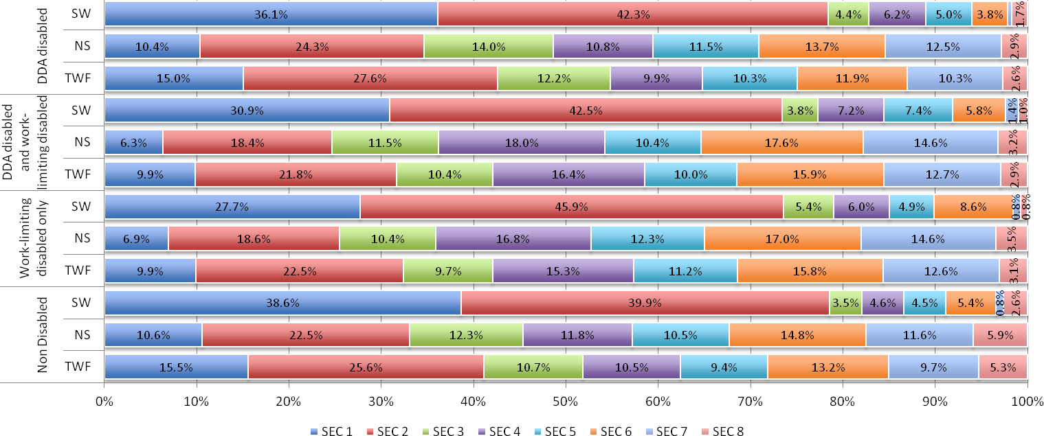
Excluding the health sector does not greatly affect the distribution of disabled and non-disabled scientific workers for any SEC category. All changes are less than 2 per cent.
 | DDA disabled |  |  | DDA disabled and work-limiting disabled |  |  | Work-limiting disabled only |  |  | Non Disabled
 | SW | NS | TWF | SW | NS | TWF | SW | NS | TWF | SW | NS | TWF
SEC 1 | 36.1% | 10.4% | 15.0% | 30.9% | 6.3% | 9.9% | 27.7% | 6.9% | 9.9% | 38.6% | 10.6% | 15.5%
SEC 2 | 42.3% | 24.3% | 27.6% | 42.5% | 18.4% | 21.8% | 45.9% | 18.6% | 22.5% | 39.9% | 22.5% | 25.6%
SEC 3 | 4.4% | 14.0% | 12.2% | 3.8% | 11.5% | 10.4% | 5.4% | 10.4% | 9.7% | 3.5% | 12.3% | 10.7%
SEC 4 | 6.2% | 10.8% | 9.9% | 7.2% | 18.0% | 16.4% | 6.0% | 16.8% | 15.3% | 4.6% | 11.8% | 10.5%
SEC 5 | 5.0% | 11.5% | 10.3% | 7.4% | 10.4% | 10.0% | 4.9% | 12.3% | 11.2% | 4.5% | 10.5% | 9.4%
SEC 6 | 3.8% | 13.7% | 11.9% | 5.8% | 17.6% | 15.9% | 8.6% | 17.0% | 15.8% | 5.4% | 14.8% | 13.2%
SEC 7 | 0.5% | 12.5% | 10.3% | 1.4% | 14.6% | 12.7% | 0.8% | 14.6% | 12.6% | 0.8% | 11.6% | 9.7%
SEC 8 | 1.7% | 2.9% | 2.6% | 1.0% | 3.2% | 2.9% | 0.8% | 3.5% | 3.1% | 2.6% | 5.9% | 5.3%

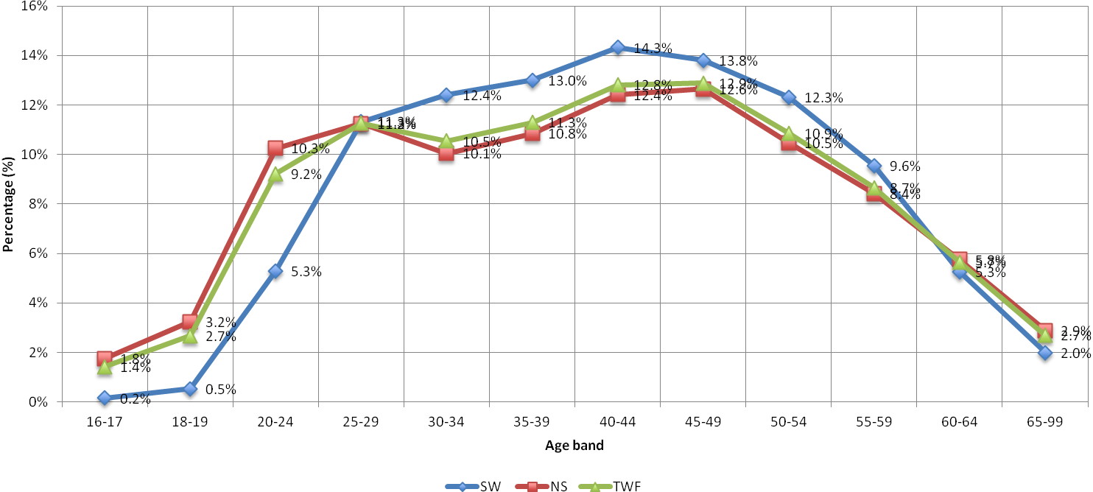
Overall, the age profile of the scientific workforce is older than that of the non-science and total workforces.

16-1718-1920-2425-2930-3435-3940-4445-4950-5455-5960-6465-99TotalSW0.2%0.5%5.3%11.3%12.4%13.0%14.3%13.8%12.3%9.6%5.3%2.0%100.0%NS1.8%3.2%10.3%11.2%10.1%10.8%12.4%12.6%10.5%8.4%5.8%2.9%100.0%TWF1.4%2.7%9.2%11.3%10.5%11.3%12.8%12.9%10.9%8.7%5.7%2.7%100.0%
Figure 46. A.T1. Scientific, non-scientific and total workforce, by age
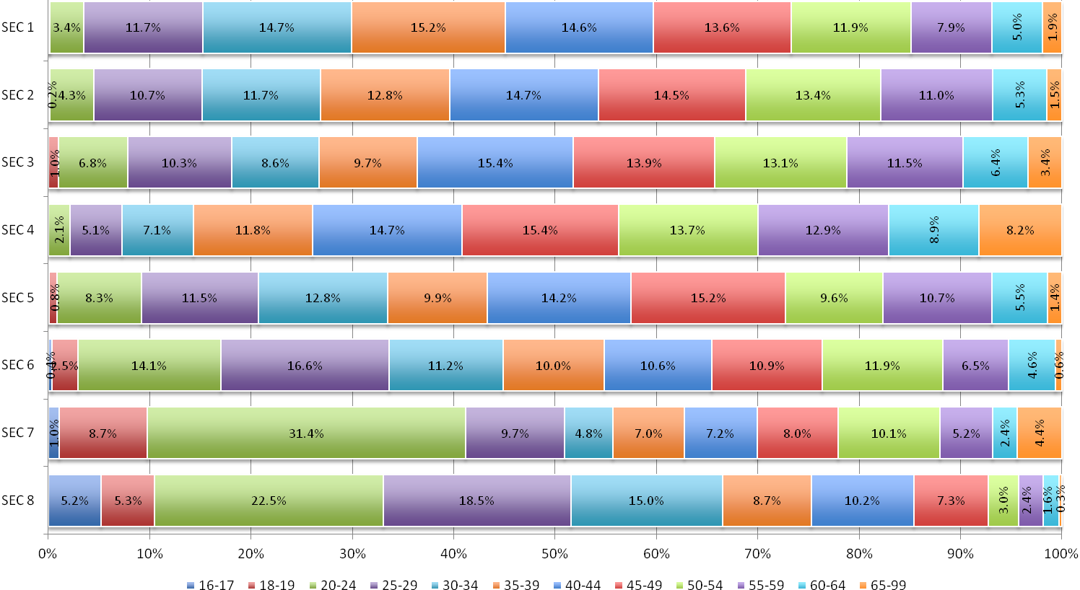
Figure 47. A.T2a. SEC category by age band (scientific workforce)
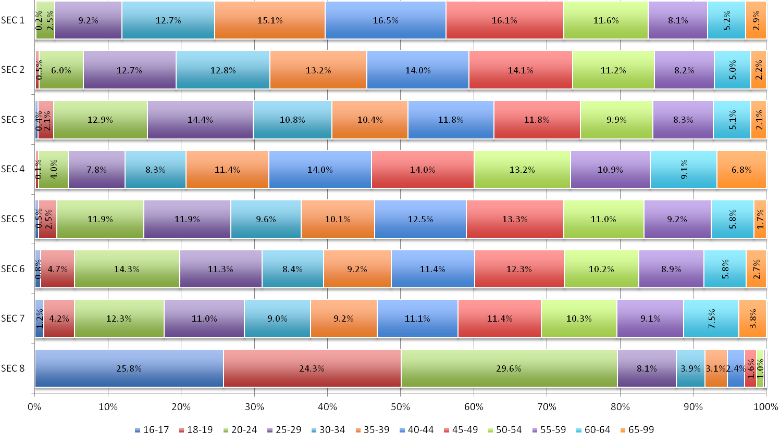
Figure 48. A.T2b. SEC category by age band (non-scientific workforce)
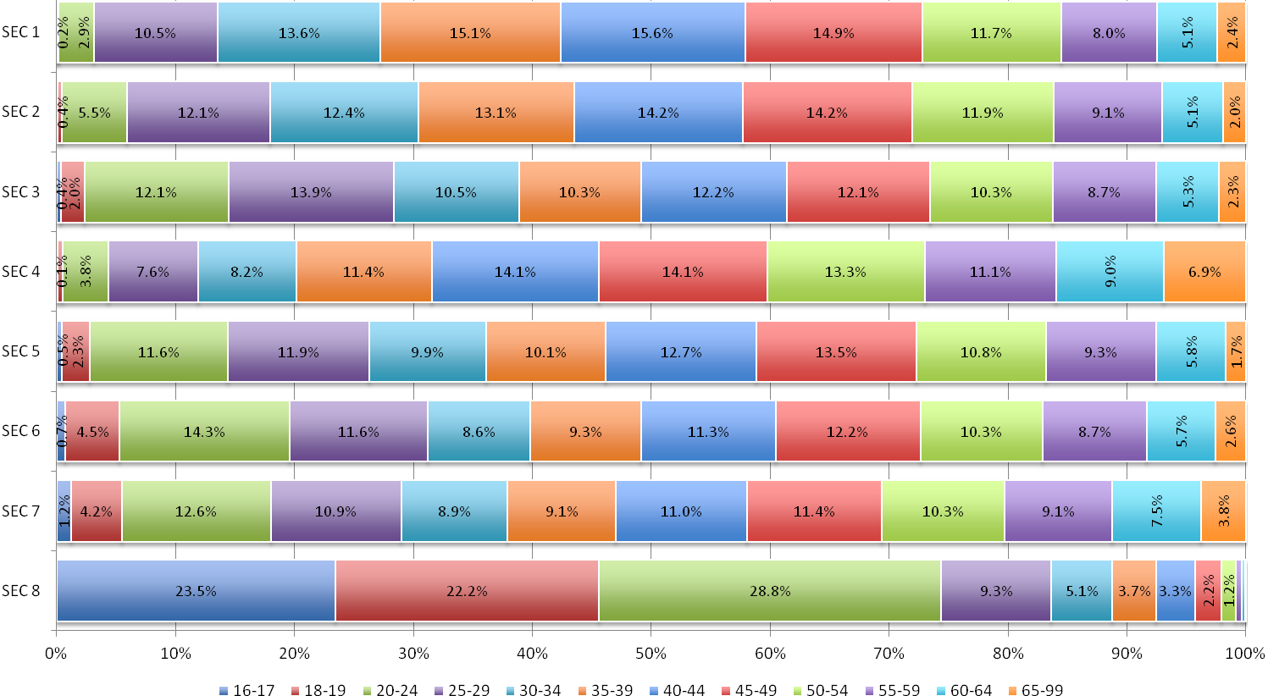
Figure 49. A.T2c. SEC category by age band (total workforce)
 |  | 16-17 | 18-19 | 20-24 | 25-29 | 30-34 | 35-39 | 40-44 | 45-49 | 50-54 | 55-59 | 60-64 | 65+
SEC 1 | SW | 0.0% | 0.1% | 3.4% | 11.7% | 14.7% | 15.2% | 14.6% | 13.6% | 11.9% | 7.9% | 5.0% | 1.9%
SEC 1 | NS | 0.0% | 0.2% | 2.5% | 9.2% | 12.7% | 15.1% | 16.5% | 16.1% | 11.6% | 8.1% | 5.2% | 2.9%
SEC 1 | TWF | 0.0% | 0.2% | 2.9% | 10.5% | 13.6% | 15.1% | 15.6% | 14.9% | 11.7% | 8.0% | 5.1% | 2.4%
SEC 2 | SW | 0.0% | 0.2% | 4.3% | 10.7% | 11.7% | 12.8% | 14.7% | 14.5% | 13.4% | 11.0% | 5.3% | 1.5%
SEC 2 | NS | 0.1% | 0.5% | 6.0% | 12.7% | 12.8% | 13.2% | 14.0% | 14.1% | 11.2% | 8.2% | 5.0% | 2.2%
SEC 2 | TWF | 0.0% | 0.4% | 5.5% | 12.1% | 12.4% | 13.1% | 14.2% | 14.2% | 11.9% | 9.1% | 5.1% | 2.0%
SEC 3 | SW | 0.0% | 1.0% | 6.8% | 10.3% | 8.6% | 9.7% | 15.4% | 13.9% | 13.1% | 11.5% | 6.4% | 3.4%
SEC 3 | NS | 0.4% | 2.1% | 12.9% | 14.4% | 10.8% | 10.4% | 11.8% | 11.8% | 9.9% | 8.3% | 5.1% | 2.1%
SEC 3 | TWF | 0.4% | 2.0% | 12.1% | 13.9% | 10.5% | 10.3% | 12.2% | 12.1% | 10.3% | 8.7% | 5.3% | 2.3%
SEC 4 | SW | 0.0% | 0.0% | 2.1% | 5.1% | 7.1% | 11.8% | 14.7% | 15.4% | 13.7% | 12.9% | 8.9% | 8.2%
SEC 4 | NS | 0.1% | 0.5% | 4.0% | 7.8% | 8.3% | 11.4% | 14.0% | 14.0% | 13.2% | 10.9% | 9.1% | 6.8%
SEC 4 | TWF | 0.1% | 0.4% | 3.8% | 7.6% | 8.2% | 11.4% | 14.1% | 14.1% | 13.3% | 11.1% | 9.0% | 6.9%
SEC 5 | SW | 0.0% | 0.8% | 8.3% | 11.5% | 12.8% | 9.9% | 14.2% | 15.2% | 9.6% | 10.7% | 5.5% | 1.4%
SEC 5 | NS | 0.5% | 2.5% | 11.9% | 11.9% | 9.6% | 10.1% | 12.5% | 13.3% | 11.0% | 9.2% | 5.8% | 1.7%
SEC 5 | TWF | 0.5% | 2.3% | 11.6% | 11.9% | 9.9% | 10.1% | 12.7% | 13.5% | 10.8% | 9.3% | 5.8% | 1.7%
SEC 6 | SW | 0.4% | 2.5% | 14.1% | 16.6% | 11.2% | 10.0% | 10.6% | 10.9% | 11.9% | 6.5% | 4.6% | 0.6%
SEC 6 | NS | 0.8% | 4.7% | 14.3% | 11.3% | 8.4% | 9.2% | 11.4% | 12.3% | 10.2% | 8.9% | 5.8% | 2.7%
SEC 6 | TWF | 0.7% | 4.5% | 14.3% | 11.6% | 8.6% | 9.3% | 11.3% | 12.2% | 10.3% | 8.7% | 5.7% | 2.6%
SEC 7 | SW | 1.0% | 8.7% | 31.4% | 9.7% | 4.8% | 7.0% | 7.2% | 8.0% | 10.1% | 5.2% | 2.4% | 4.4%
SEC 7 | NS | 1.2% | 4.2% | 12.3% | 11.0% | 9.0% | 9.2% | 11.1% | 11.4% | 10.3% | 9.1% | 7.5% | 3.8%
SEC 7 | TWF | 1.2% | 4.2% | 12.6% | 10.9% | 8.9% | 9.1% | 11.0% | 11.4% | 10.3% | 9.1% | 7.5% | 3.8%
SEC 8 | SW | 5.2% | 5.3% | 22.5% | 18.5% | 15.0% | 8.7% | 10.2% | 7.3% | 3.0% | 2.4% | 1.6% | 0.3%
SEC 8 | NS | 25.8% | 24.3% | 29.6% | 8.1% | 3.9% | 3.1% | 2.4% | 1.6% | 1.0% | 0.3% | 0.1% | 0.0%
SEC 8 | TWF | 23.5% | 22.2% | 28.8% | 9.3% | 5.1% | 3.7% | 3.3% | 2.2% | 1.2% | 0.5% | 0.3% | 0.1%

Figure 50. A.T2d. SEC category by age band (scientific, non-scientific and total workforce)
The age profile of the science workforce varies by SEC category.

Within SEC 3 and SEC 8, the scientific workforce has a markedly older age profile than that of the non-science and total workforces.

In contrast, within SEC 7, the scientific workforce has a younger age profile than the non-science and total workforces. The scientific workforce is also very slightly younger than the non-science and total workforces within SEC 1 and SEC 6, though these differences are small.

For all other SEC categories, the scientific workforce has an older profile than the total workforce, though once again the differences are small (<6%).

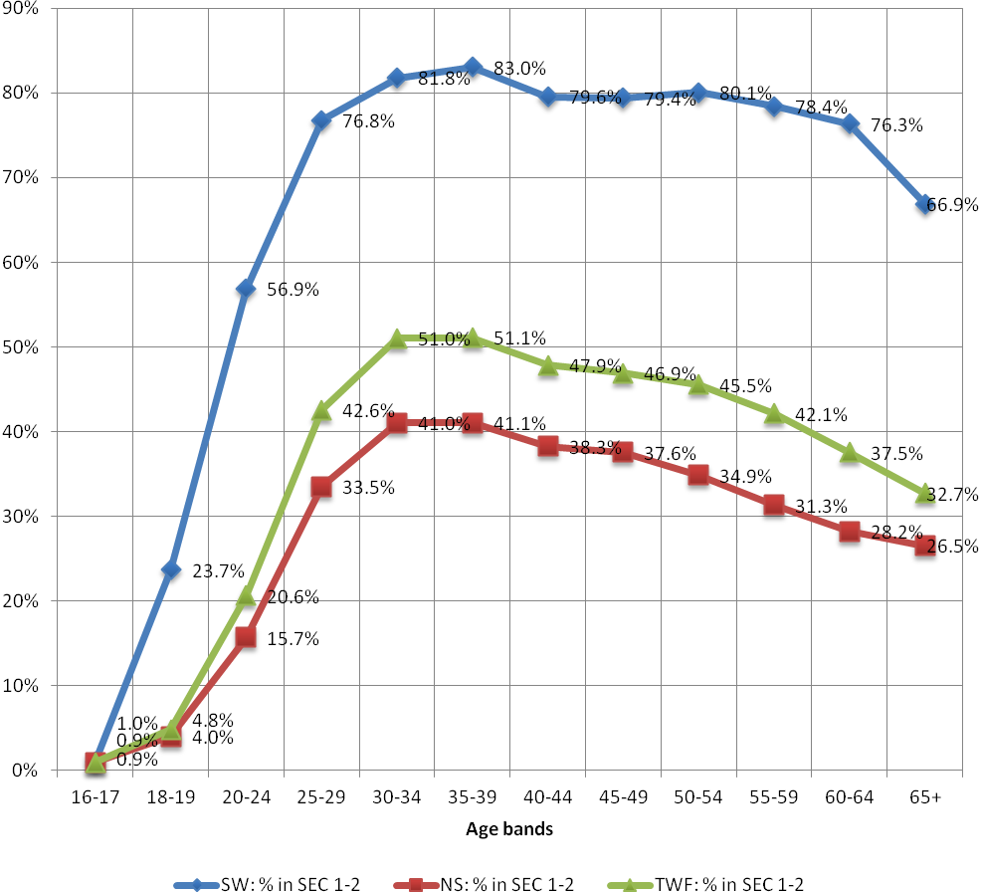
 | SW: % in SEC 1-2 | NS: % in SEC 1-2 | TWF: % in SEC 1-2
16-17 | 1.0% | 0.9% | 0.9%
18-19 | 23.7% | 4.0% | 4.8%
20-24 | 56.9% | 15.7% | 20.6%
25-29 | 76.8% | 33.5% | 42.6%
30-34 | 81.8% | 41.0% | 51.0%
35-39 | 83.0% | 41.1% | 51.1%
40-44 | 79.6% | 38.3% | 47.9%
45-49 | 79.4% | 37.6% | 46.9%
50-54 | 80.1% | 34.9% | 45.5%
55-59 | 78.4% | 31.3% | 42.1%
60-64 | 76.3% | 28.2% | 37.5%
65+ | 66.9% | 26.5% | 32.7%

As age increases, so does the proportion of those in SEC 1 and categories. However, the incline is steeper for the scientific workforce compared with the total workforce.

By age group 25-29, 76.8% of the scientific workforce are in SEC 1-2, compared with only 42.6% of the total workforce.
Figure 51. A.T3. Proportion of workforce in SEC 1-2, over age band
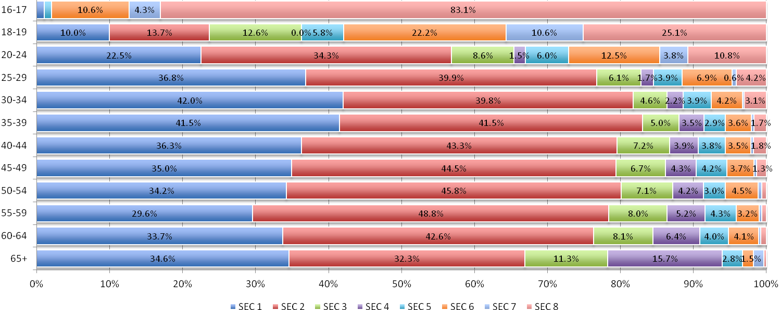
 | 16-17 | 18-19 | 20-24 | 25-29 | 30-34 | 35-39 | 40-44 | 45-49 | 50-54 | 55-59 | 60-64 | 65+ | Total
SEC 1 | 1.0% | 10.0% | 22.5% | 36.8% | 42.0% | 41.5% | 36.3% | 35.0% | 34.2% | 29.6% | 33.7% | 34.6% | 35.6%
SEC 2 | 0.0% | 13.7% | 34.3% | 39.9% | 39.8% | 41.5% | 43.3% | 44.5% | 45.8% | 48.8% | 42.6% | 32.3% | 42.3%
SEC 3 | 0.0% | 12.6% | 8.6% | 6.1% | 4.6% | 5.0% | 7.2% | 6.7% | 7.1% | 8.0% | 8.1% | 11.3% | 6.7%
SEC 4 | 0.0% | 0.0% | 1.5% | 1.7% | 2.2% | 3.5% | 3.9% | 4.3% | 4.2% | 5.2% | 6.4% | 15.7% | 3.8%
SEC 5 | 1.0% | 5.8% | 6.0% | 3.9% | 3.9% | 2.9% | 3.8% | 4.2% | 3.0% | 4.3% | 4.0% | 2.8% | 3.8%
SEC 6 | 10.6% | 22.2% | 12.5% | 6.9% | 4.2% | 3.6% | 3.5% | 3.7% | 4.5% | 3.2% | 4.1% | 1.5% | 4.7%
SEC 7 | 4.3% | 10.6% | 3.8% | 0.6% | 0.2% | 0.3% | 0.3% | 0.4% | 0.5% | 0.3% | 0.3% | 1.4% | 0.6%
SEC 8 | 83.1% | 25.1% | 10.8% | 4.2% | 3.1% | 1.7% | 1.8% | 1.3% | 0.6% | 0.6% | 0.8% | 0.4% | 2.5%
Total | 100.0% | 100.0% | 100.0% | 100.0% | 100.0% | 100.0% | 100.0% | 100.0% | 100.0% | 100.0% | 100.0% | 100.0% | 100.0%

Figure 52. A.T4a. Age band by SEC category (scientific workforce)
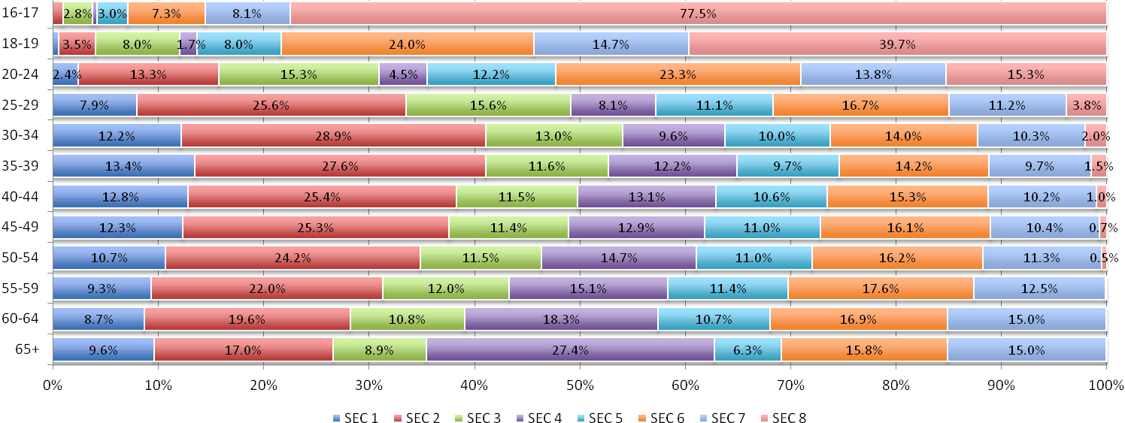
 | 16-17 | 18-19 | 20-24 | 25-29 | 30-34 | 35-39 | 40-44 | 45-49 | 50-54 | 55-59 | 60-64 | 65+ | Total
SEC 1 | 0.0% | 0.5% | 2.4% | 7.9% | 12.2% | 13.4% | 12.8% | 12.3% | 10.7% | 9.3% | 8.7% | 9.6% | 9.7%
SEC 2 | 0.9% | 3.5% | 13.3% | 25.6% | 28.9% | 27.6% | 25.4% | 25.3% | 24.2% | 22.0% | 19.6% | 17.0% | 22.6%
SEC 3 | 2.8% | 8.0% | 15.3% | 15.6% | 13.0% | 11.6% | 11.5% | 11.4% | 11.5% | 12.0% | 10.8% | 8.9% | 12.2%
SEC 4 | 0.4% | 1.7% | 4.5% | 8.1% | 9.6% | 12.2% | 13.1% | 12.9% | 14.7% | 15.1% | 18.3% | 27.4% | 11.6%
SEC 5 | 3.0% | 8.0% | 12.2% | 11.1% | 10.0% | 9.7% | 10.6% | 11.0% | 11.0% | 11.4% | 10.7% | 6.3% | 10.5%
SEC 6 | 7.3% | 24.0% | 23.3% | 16.7% | 14.0% | 14.2% | 15.3% | 16.1% | 16.2% | 17.6% | 16.9% | 15.8% | 16.6%
SEC 7 | 8.1% | 14.7% | 13.8% | 11.2% | 10.3% | 9.7% | 10.2% | 10.4% | 11.3% | 12.5% | 15.0% | 15.0% | 11.5%
SEC 8 | 77.5% | 39.7% | 15.3% | 3.8% | 2.0% | 1.5% | 1.0% | 0.7% | 0.5% | 0.2% | 0.1% | 0.1% | 5.3%
Total | 100.0% | 100.0% | 100.0% | 100.0% | 100.0% | 100.0% | 100.0% | 100.0% | 100.0% | 100.0% | 100.0% | 100.0% | 100.0%

Figure 53. A.T4b. Age band by SEC category (non-scientific workforce)
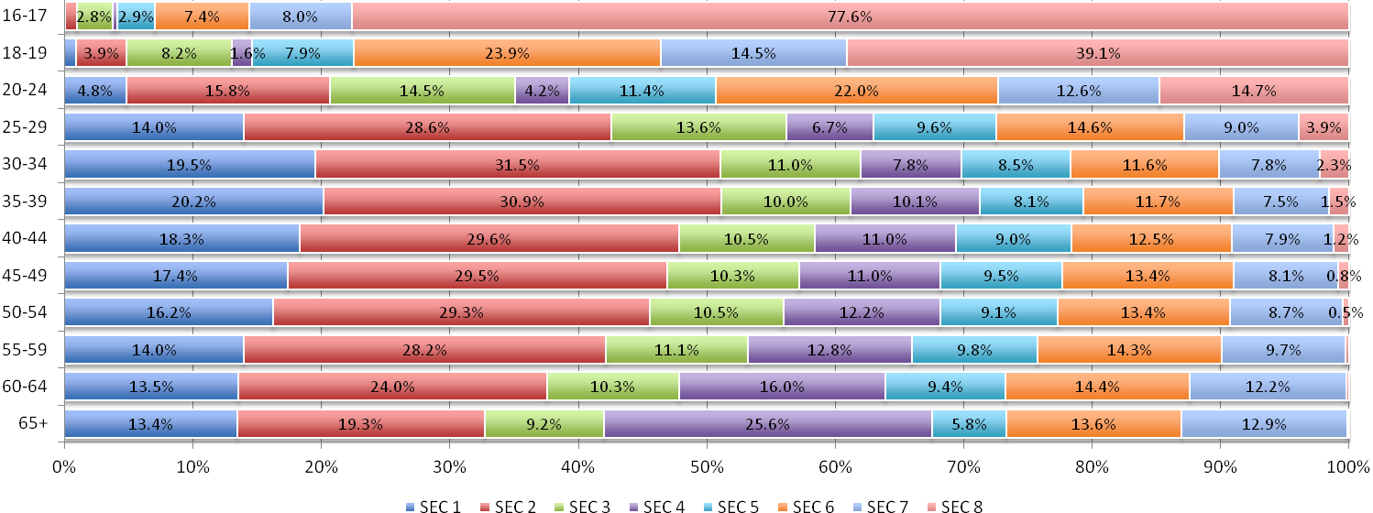
 | 16-17 | 18-19 | 20-24 | 25-29 | 30-34 | 35-39 | 40-44 | 45-49 | 50-54 | 55-59 | 60-64 | 65+ | Total
SEC 1 | 0.0% | 0.9% | 4.8% | 14.0% | 19.5% | 20.2% | 18.3% | 17.4% | 16.2% | 14.0% | 13.5% | 13.4% | 15.1%
SEC 2 | 0.9% | 3.9% | 15.8% | 28.6% | 31.5% | 30.9% | 29.6% | 29.5% | 29.3% | 28.2% | 24.0% | 19.3% | 26.7%
SEC 3 | 2.8% | 8.2% | 14.5% | 13.6% | 11.0% | 10.0% | 10.5% | 10.3% | 10.5% | 11.1% | 10.3% | 9.2% | 11.0%
SEC 4 | 0.4% | 1.6% | 4.2% | 6.7% | 7.8% | 10.1% | 11.0% | 11.0% | 12.2% | 12.8% | 16.0% | 25.6% | 10.0%
SEC 5 | 2.9% | 7.9% | 11.4% | 9.6% | 8.5% | 8.1% | 9.0% | 9.5% | 9.1% | 9.8% | 9.4% | 5.8% | 9.1%
SEC 6 | 7.4% | 23.9% | 22.0% | 14.6% | 11.6% | 11.7% | 12.5% | 13.4% | 13.4% | 14.3% | 14.4% | 13.6% | 14.2%
SEC 7 | 8.0% | 14.5% | 12.6% | 9.0% | 7.8% | 7.5% | 7.9% | 8.1% | 8.7% | 9.7% | 12.2% | 12.9% | 9.2%
SEC 8 | 77.6% | 39.1% | 14.7% | 3.9% | 2.3% | 1.5% | 1.2% | 0.8% | 0.5% | 0.3% | 0.2% | 0.1% | 4.7%
Total | 100.0% | 100.0% | 100.0% | 100.0% | 100.0% | 100.0% | 100.0% | 100.0% | 100.0% | 100.0% | 100.0% | 100.0% | 100.0%

Figure 54. A.T4c. Age band by SEC category (total workforce)
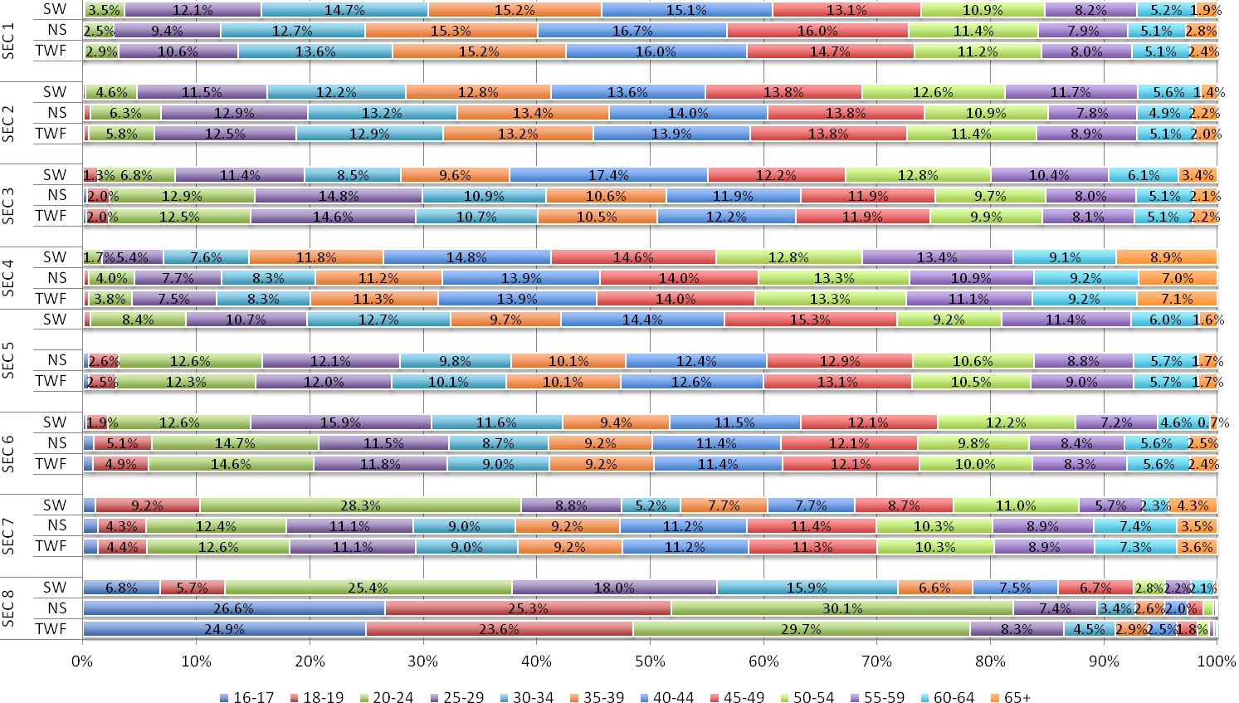
Figure 55. A.T5. SEC category by age band (scientific, non-scientific and total workforce comparisons) – without Health
 |  | SEC 1 | SEC 2 | SEC 3 | SEC 4 | SEC 5 | SEC 6 | SEC 7 | SEC 8
16-17 | SW | 1.1% | 0.0% | 0.0% | 0.0% | 1.2% | 7.8% | 4.7% | 85.2%
16-17 | NS | 0.0% | 1.0% | 2.2% | 0.4% | 3.1% | 7.4% | 8.2% | 77.7%
16-17 | TWF | 0.0% | 0.9% | 2.2% | 0.4% | 3.0% | 7.4% | 8.2% | 77.8%
18-19 | SW | 11.3% | 17.1% | 8.7% | 0.0% | 5.2% | 19.1% | 13.4% | 25.2%
18-19 | NS | 0.6% | 3.6% | 7.2% | 1.8% | 8.2% | 22.7% | 15.1% | 40.7%
18-19 | TWF | 0.9% | 4.1% | 7.3% | 1.7% | 8.1% | 22.6% | 15.1% | 40.2%
20-24 | SW | 24.4% | 33.9% | 4.5% | 1.5% | 7.3% | 12.6% | 4.3% | 11.5%
20-24 | NS | 2.5% | 13.4% | 15.2% | 4.7% | 12.9% | 21.2% | 14.2% | 15.9%
20-24 | TWF | 4.7% | 15.4% | 14.1% | 4.4% | 12.3% | 20.4% | 13.3% | 15.4%
25-29 | SW | 38.9% | 39.4% | 3.5% | 2.2% | 4.2% | 7.4% | 0.6% | 3.8%
25-29 | NS | 8.5% | 25.4% | 16.0% | 8.3% | 11.3% | 15.2% | 11.8% | 3.6%
25-29 | TWF | 14.0% | 27.9% | 13.8% | 7.2% | 10.1% | 13.8% | 9.8% | 3.6%
30-34 | SW | 43.5% | 38.3% | 2.4% | 2.9% | 4.6% | 4.9% | 0.3% | 3.0%
30-34 | NS | 12.7% | 28.7% | 13.1% | 10.0% | 10.2% | 12.8% | 10.6% | 1.8%
30-34 | TWF | 19.2% | 30.7% | 10.8% | 8.5% | 9.0% | 11.2% | 8.4% | 2.1%
35-39 | SW | 44.2% | 39.6% | 2.7% | 4.4% | 3.5% | 3.9% | 0.5% | 1.2%
35-39 | NS | 14.3% | 27.3% | 11.9% | 12.6% | 9.8% | 12.6% | 10.1% | 1.3%
35-39 | TWF | 20.3% | 29.8% | 10.1% | 11.0% | 8.5% | 10.9% | 8.2% | 1.3%
40-44 | SW | 40.6% | 38.9% | 4.5% | 5.1% | 4.8% | 4.4% | 0.4% | 1.3%
40-44 | NS | 13.7% | 24.9% | 11.7% | 13.7% | 10.6% | 13.7% | 10.8% | 0.9%
40-44 | TWF | 18.9% | 27.6% | 10.3% | 12.0% | 9.5% | 11.9% | 8.8% | 1.0%
45-49 | SW | 37.3% | 42.0% | 3.3% | 5.3% | 5.4% | 4.9% | 0.5% | 1.2%
45-49 | NS | 13.1% | 24.6% | 11.7% | 13.7% | 10.9% | 14.5% | 10.9% | 0.6%
45-49 | TWF | 17.6% | 27.8% | 10.1% | 12.2% | 9.9% | 12.7% | 9.0% | 0.7%
50-54 | SW | 35.7% | 44.1% | 4.0% | 5.4% | 3.7% | 5.7% | 0.8% | 0.6%
50-54 | NS | 11.3% | 23.6% | 11.6% | 15.9% | 10.9% | 14.3% | 11.9% | 0.5%
50-54 | TWF | 16.0% | 27.5% | 10.1% | 13.9% | 9.6% | 12.6% | 9.8% | 0.5%
55-59 | SW | 31.4% | 47.8% | 3.8% | 6.6% | 5.4% | 4.0% | 0.5% | 0.6%
55-59 | NS | 9.9% | 21.3% | 12.0% | 16.5% | 11.5% | 15.5% | 13.1% | 0.2%
55-59 | TWF | 14.3% | 26.7% | 10.4% | 14.5% | 10.2% | 13.2% | 10.5% | 0.2%
60-64 | SW | 35.7% | 41.2% | 4.0% | 8.0% | 5.2% | 4.6% | 0.3% | 0.9%
60-64 | NS | 9.2% | 19.0% | 11.0% | 19.9% | 10.6% | 14.8% | 15.4% | 0.1%
60-64 | TWF | 13.6% | 22.8% | 9.8% | 17.9% | 9.7% | 13.1% | 12.9% | 0.2%
65-99 | SW | 36.1% | 28.8% | 6.2% | 21.4% | 3.7% | 1.8% | 1.7% | 0.3%
65-99 | NS | 9.9% | 17.2% | 9.0% | 29.7% | 6.1% | 13.1% | 14.8% | 0.1%
65-99 | TWF | 13.3% | 18.7% | 8.6% | 28.7% | 5.8% | 11.7% | 13.1% | 0.1%

The impact of excluding health workers from the science workforce is marginal on its age profile.

Students, occupations not stated or inadequately described, and/or not classifiable for other reasons are added as ‘not classified.’ ‘Does not apply’ also includes methodological inaccuracies and coding issues.
Highest qualification was measured using the National Qualifications Framework (NQF) which incorporates academic and vocational qualifications from GCSE or apprenticeship to doctorate level. The framework is developed by Ofqual. Further details can be found at their website: http://ofqual.gov.uk/qualifications-and-assessments/qualification-frameworks/
No data available for SEC4 (small employers and own account workers). As previous, all percentages have been recalculated from counts in S9.1 to exclude for ‘amount not known’ band.
Leading the way: increasing the diversity of the UK Science workforce. TBR, 2013. Page 89.
Percentages recalculated from rounded counts to exclude ‘not known’ SEC (19.4% SW, 18.6% NS and 18.8% TWF). See S1.
Percentages recalculated from unrounded counts to exclude ‘amount not known’ wage band (27.5% SW, 35.1% NS, 33.5% TWF) and ‘not known’ SEC (19.4% SW, 18.6% NS, 18.8% TWF). See S9.1.
No data available for SEC4 (small employers and own account workers). As previous, all percentages have been recalculated from counts in S9.1 to exclude for ‘amount not known’ band.
Percentages recalculated from rounded counts to exclude ‘not known’ SEC (19.4% of SW, 18.6% NS and 18.8% of TWF), ‘unknown’ firm size (7.4% SW, 12.1% NS, 11.1% TWF) and ‘no answer’ firm size (0.8% SW, 1.2% NS, 1.2% TWF). See S7a.1, S7b.1.
Leading the way: increasing the diversity of the UK Science workforce. TBR, 2013. Page 26.
Ibid. Pages 26-27.
Percentages recalculated from unrounded counts to exclude ‘not known’ SEC (19.4% of SW, 18.6% NS and 18.8% of TWF) and ‘not known’ highest qualification (0.9% SW, 1.7% NS, 1.5% TWF). See S8.1.
The exceptions are in SEC 6 and 7 where there is a difference of .5 or less compared to the science workforce.
Ibid. Page 89.
Percentages recalculated from rounded counts to exclude for ‘not known’ SEC (19.4% of SW, 18.6% NS and 18.8% of TWF). See S4a.1, S4b.1.
Percentages recalculated from rounded counts to exclude ‘not known’ SEC (19.4% of SW, 18.6% NS and 18.8% of TWF) and ‘not known’ ethnicity (1.5% SW, 1.4% NS and 1.4% TWF). See S3a.1, S3b.1.
BME aggregates the following groups: Asian or Asian British, Black or Black British, Chinese, Mixed and Other.
All percentages recalculated from rounded counts to exclude ‘not known’ SEC (19.4% of SW, 18.6% NS and 18.8% of TWF), except disability status breakdowns which use exact counts.
Percentages recalculated from rounded counts to exclude ‘not known’ SEC (19.4% of SW, 18.6% NS and 18.8% of TWF). No ‘unknown’ age band. See S2a.1, S2b1.

