Leading the way: increasing the diversity of the UK Science workforce
For The Royal Society






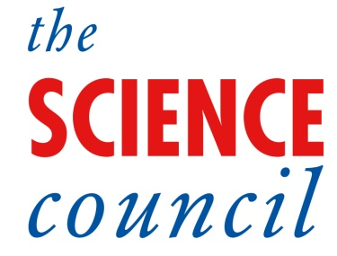
tbr knows… economics, creative, skills, environment

economic research & business intelligence



Leading the way: increasing the diversity of the UK Science workforce
For The Royal Society
Prepared by TBR’s Skills and Labour Market Team and The Science Council

Enquiries about this report can be addressed to:
- Michael Johnson, TBR, Senior Researcher
- Jonathan Guest, TBR, Research Consultant
- Nicola Hannam, Science Council, Director, Education & Skills
- Diana Garnham, Science Council, Chief Executive
28 July 2026

Suite One Top Floor, Burgess House,  93-105 St James Boulevard,  Newcastle upon Tyne, NE1 4BW  Telephone: +44 (0) 191 279 0900  Fax: +44 (0) 191 221 2220  Email: info@tbr.co.uk  www.tbr.co.uk | The Science Council,  32 - 36 Loman Street,  London, SE1 0EH  Telephone: +44 (0) 20 7922 7888  Fax: +44 (0) 20 7922 7879  Email: info@sciencecouncil.org  www.sciencecouncil.org

P/R Number | PN01012R
File Name | input.doc
Title | Leading the way: increasing the diversity of the UK Science workforce
Version number | V3
Last update | 28/07/2026
Author | MJ/JG/ME/NH
Reviewer | AG/DG
Status | Commercially Sensitive
Review Status | Final
Approval Status | Complete
Document Information

Table of Contents
1. Executive Summary 1
1.1 Literature Review 1
1.2 Data findings 2
1.3 Science workforce: perceptions, experience and interventions 4
1.4 Suggested Actions 7
2. Introduction 10
2.1 Methodology 10
3. Literature Review 12
3.1 Definition of Science workforce 12
3.2 Diversity in the science workforce 16
4. Definitions 20
4.1 Science workforce Definition 20
4.2 Socio-Economic Status Definition 20
4.3 Other variables 22
5. Science Workforce 24
5.1 Issues presented by the analysis 24
6. Science workforce: Perceptions, Experience and Interventions 28
6.1 Perceptions of the current workforce 28
6.2 Organisational culture 30
6.3 Understanding of diversity characteristics and monitoring 35
6.4 The business case for diversity 38
6.5 Participation and access routes 42
6.6 The role of recruitment in encouraging diversity 46
6.7 Training and progression 50
6.8 Retention and returning to work 53
6.9 Supporting aspirations 55
7. Suggested Actions 58
7.1 Suggested actions for the Royal Society 58
7.2 Wider actions 62
8. Acknowledgements 65
9. Appendix 66
9.1 Socio-Economic Status 66
9.2 Ethnicity 71
9.3 Gender 76
9.4 Disability 82
9.5 Highest Qualification 87
9.6 Firm Size 90
9.7 Broad Sector 93
9.8 Wage Band 96
9.9 Comparison 106
9.10 Deriving Socio Economic Status 108
9.11 Science Workforce Definition 108

Executive Summary
TBR and the Science Council were commissioned by the Royal Society in 2012 to undertake research to provide an understanding of diversity and socio-economic status within the whole scientific workforce. The research provides a comparative analysis of the composition of the science workforce and describes historical change of the scientific workforce.
This document sets out the findings from research to support the Royal Society in defining and understanding the science workforce, identify the barriers to entry and progression within the scientific workforce, and support the design and implementation of interventions that will drive increased diversity in the scientific workforce, particularly with reference to socio economic status.

Literature Review
The review of literature examined all existing reports, evidence and information pertinent to the project in order to ‘take stock’ of current knowledge on definitions of the science workforce, diversity in the science workforce and socio-economic background and status.
The process demonstrated that different research studies use different definitions of the science workforce and a key precursor to considering definitions of the Science, Technology, Engineering and Maths (STEM) workforce is to consider definitions of STEM education. However, STEM jobs do not always require STEM skills/education and in order to investigate the science workforce, an approach which uses occupation and industry classifications together is needed. There are also challenges when looking at the definition of the science workforce and as a result, to capture the whole of the science workforce, there is a necessity to undertake an industry/occupational analysis.
Integral to the purpose of this report are the definitions of the science workforce and socio-economic status, which would enable the investigation of the diversity of the science workforce and make historical and comparative analysis possible. Many definitions of socio-economic status exist and these are largely based on education background or use other secondary data to provide a relative measure of the position of an individual or household within society. However, there is a lack of focus on socio-economic status or backgrounds within the workforce and this is largely due to the lack of data. Furthermore, very few studies exist regarding socio-economic background or status of the scientific workforce. The majority of work that does exist explores the socio-economic background/status of students and graduates.
Defining science workforce and socio-economic status
The National Statistics Socio-economic Classification (NS-SEC) is the most robust data source for exploring socio-economic status and the different variables that are set out in the project brief.
The science workforce definition in this research makes use of the work previously undertaken for the Science Council. The definitions are:
Workforce | Description
Primary Science Workers: | Workers in occupations that are purely science based and require the consistent application of scientific knowledge and skills in order to execute the role effectively. E.g. Chemists, Science & Engineering Technicians, Pharmacists & Pharmacologists or Bio Scientists and Biochemists.
Secondary Science Workers: | Workers in occupations that are science related and require a mixed application of scientific knowledge and skills alongside other skill sets, which are often of greater importance to executing the role effectively. E.g. Civil and Mechanical Engineers, Conservation & Environmental Protection Officers, Environmental Health Officers, Teaching Professionals
Non Science Worker: | Workers in occupations that are not science based and have no requirement for science based knowledge or skills. E.g. Travel Agents, Town Planners, Musicians, Legal Professionals, and Housing & Welfare Officers.
Science workforce: | Primary and Secondary workforce combined
Total Workforce: | Total workforce of the UK
The research made use of data from the Office for National Statistics (ONS) Annual Population Survey (APS), which defines socio-economic status by Socio-Economic Classification (SEC). The classifications are:
- Higher managerial and professional occupations
- Lower managerial and professional occupations
- Intermediate occupations
- Small employers and own-account workers
- Lower supervisory and technical occupations
- Semi-routine occupations
- Routine occupations
- Never worked and long-term unemployed
In addition, the report uses other variables in the Annual Population Survey to examine the diversity of the science workforce. Furthermore, a comparison is made with the legal workforce. The variables investigated were:
- Ethnicity
- Gender
- Disability
- Firm size
- Broad Sector (Public, Private & Education)
- Highest qualification
- Wage band

Data findings
Data findings key messages
- The socio-economic status composition of the science workforce is characterised by high proportions of employees in the managerial and professional classifications, relative to the total UK workforce. This is the most distinct aspect of the science workforce.
- Although the science workforce is highly qualified relative to the total workforce, this does not satisfactorily explain the overrepresentation of these classifications; the role of qualifications in science appears complex.
- Levels of diversity within the science workforce (in terms of ethnicity, disability and gender) tend not to be radically dissimilar to the total UK workforce, and trends between 2005 and 2011 have been comparable, with diversity increasing at a similar rate across both respective workforces.
- However, the exclusion of the health sector reduces the diversity of the science workforce across most characteristics. Indeed, the inclusion/exclusion of the health workforce can be decisive in determining whether or not the science workforce is more or less diverse than the total UK workforce.
- The primary science workforce is less diverse than the overall science workforce across a range of indicators. Restricting analysis to the primary science workforce and excluding the health workforce has a compound impact; levels of diversity in this restricted cohort are often appreciably lower.
- Although women working in science are more likely to be in higher socio-economic status groupings than women in the total UK workforce, the representation of females in the workforce is lower in the primary science workforce and when the Health sector is removed from the analysis. Furthermore, the socio-economic relationship between men and women in science and the overall science workforce mirrors that between men and women in the total UK workforce and the total UK workforce.
- People with disabilities and Black or Black British workers are underrepresented in the managerial and professional segments of the science workforce.
- A large proportion of the total science workforce works for SMEs. This has implications for policy recommendations, which must recognise that smaller firms often do not have the resources to interact with public policy in the way that they might like to.

Science provides around 20% of the total workforce and the science workforce is dominated by people employed in the top two socio-economic status groups:
- Almost 50% of the workforce in the Higher Managerial and Professional socio-economic group are science workers.
- A lower but still noteworthy proportion (32.9%) of all Lower Managerial and Professional classification are science workers.
This demonstrates that the science workforce provides work which is more likely to give employment in roles that are in the highest socio economic status groups.
The overall science workforce is generally more ethnically diverse than the total UK workforce. However, it is still overwhelming ‘white’ (83.4% of the workforce are white). All ethnic groups are overrepresented in the top two socio-economic classifications but the findings suggest that the primary science workforce is currently failing to attract a similar level of ethnic diversity in those outside the top two socio-economic groupings. The inclusion of health is influential as the data shows that Black/British employees in the science workforce without health are underrepresented (1.6% in the science workforce compared with 2.1% in the total workforce). Therefore, increasing the representation of Black/Black British people in the science workforce and particularly the primary workforce outside health is imperative.
A slight majority of employees in the overall science workforce were female (50.3%) in 2011 (a reversal of the 2005 position) but female workers still constitute proportionally less than the total workforce (55%) and are underrepresented in the primary science workforce (38%). However, high proportions of women are employed in the Higher managerial and professional socio-economic status group, suggesting that women in the primary science workforce are able to prosper to a greater extent than they might elsewhere in the science workforce.
People with disabilities are still marginally underrepresented in the science workforce (13.5% compared to 14.3% in total workforce). There is underrepresentation of disabled workers in the Higher managerial and professional socio-economic classifications in the primary science workforce and overrepresentation in the primary science workforce in the Intermediate occupations and Lower supervisory and technical classifications. The analysis suggests that disabled workers might face challenges in career progression and reaching the top managerial positions within science organisations. To address this, activity to promote the employment of disabled people in the science workforce and specific attention to the primary science workforce is needed.
A large proportion (54%) of the total science workforce works in SMEs and almost 11% work in micro-businesses (those with 1-10 employees). There is a clear need to consider where people are employed and the size of the business, particularly because qualitative research shows that SMEs find it more difficult to engage with the diversity agenda.
Employees with graduate and postgraduate qualifications (NQF Level 5 and above) are overrepresented in the science workforce; almost 59% of employees fall into this category, compared to just over 30% of the total workforce. There is also overrepresentation of the top two socio-economic status groups in the science workers with higher level qualifications. However, this is not just limited to higher qualifications. In the total workforce, just over 20% of those whose highest level of qualification is NQF Level 1 are employed in the top two socio-economic status groups whilst in the science workforce, the proportion is over 40% (although only 50,000 people). The relationship between qualifications and the composition of socio-economic status groups in the science workforce is complex and the investigations suggest a number of different hypotheses but do not establish causation.
The majority of science workers in the private sector (55.8%) are within the top two socio-economic status groupings. This figure is higher than that in the public sector (45%) but lower than the science workforce in education (75%). The comparative lack of lower socio-economic status groups in the public sector and education workforces may restrict the ability of people to enter the science workforce. This suggests that entry points revolve around higher socio-economic status groups. There is scope therefore to look at more routes into science for those who are not qualified to enter directly into one of the top two socio-economic status groups.
Those members of the science workforce who are able to achieve employment in the Higher managerial and professional socio-economic status group were more likely to achieve a salary of £50k than in the same socio-economic status group in the total workforce (58.5% compared with 49%). However, there were mixed messages on wages in other socio-economic groups and within the primary and secondary workforce. The data suggest that people pursuing careers in science are not especially financially motivated or rewarded. Growth in higher wages in the top two socio-economic status groups between 2005 and 2011 supports the notion that the science workforce needs to review entry points and progression routes, to avoid an impenetrable tier of employment.

Science workforce: perceptions, experience and interventions
Drawing upon qualitative research from the focus groups and interviews as well as a mapping exercise, this section of the report identifies nine issues relevant to the research. The full report also identifies interventions and actions which are relevant to each issue.
- Perceptions of the current workforce
The research confirmed that socio-economic background is the ‘hidden’ issue within equality and diversity. This supports the findings from the literature review which showed that previous research face challenges in defining the socio-economic status of the workforce. This ‘hidden’ element was particularly apparent as many focus group and interview participants were more comfortable discussing gender and racial inequality whereas discussion on socio-economic status tended to be less fluid and more uncomfortable.
Interview respondents from lower socio-economic backgrounds described how socio-economic background was no longer visible and background was not discussed when in a role. However, some respondents found that their ‘lack of fit’ had encouraged them to leave research or academia. There was a strong desire for a working environment that did ‘fit’, contained a more diverse team and provided a better work/life balance. This sense of a ‘lack of fit’ may be influenced by the fact that there are few roles which fall outside of the top two socio-economic status classifications and workplaces are relatively homogeneous. Within the science community, it is recognised that these issues have not been addressed, with some accepting that the science workforce was ‘like this’, and others referencing how different academia was to other work environments.
- Organisational culture
The organisational culture is important for achieving a diverse science workforce and helping the economy compete in a global market for science and technical skills. There is a strong commitment to the principles of diversity across the science community but also recognition that science employers have yet to either translate or develop programmes designed for gender diversity across to other diversity characteristics.
High value is placed on employer led systems and policies such as the provision of training in areas such as assertiveness, strong leadership, transparency in recruitment processes and unconscious bias.
There was a general consensus both amongst interviewees and focus group participants that legislation was important in achieving attitudinal and practical changes (such as providing impartial source of information and guidance on how to introduce good practice). However, legislation was not sufficient on its own to drive future change.
Other findings connected to organisational culture are:
- SME employment is considerable in the science workforce so it will be important that any actions take account of differences across the size bands.
- All sectors of the science community are not starting from the same point as some have more diversity than others.
- Understanding of diversity characteristics and monitoring
Arrangements for monitoring diversity within firms and organisations is unclear and this suggests that individuals and organisations find the diversity landscape complex to monitor and that collection of consistent and comparable diversity data is difficult.
The NHS was seen as a good example of monitoring diversity (particularly age, ethnicity and gender), although socio-economic diversity was not captured and as with many other monitoring activities in firms across the UK, monitoring of ethnicity did not differentiate between UK nationals and immigrant workers. Throughout the data analysis it is clear without the health sector included in the analysis, the science workforce is often less diverse.
Monitoring of socio-economic background of an existing workforce would largely be dependent on self-classification (and voluntary input) as relevant data is not available to employers. The legal profession is leading the way in monitoring this aspect of diversity whilst in Higher Education institutions, with the drive towards widening participation, all institutions collect data on proxies for socio-economic status and background. There is a desire for better data and guidance for employers to enable them to focus their efforts appropriately and to benchmark progress. There was also benefit from the existence of committees, groups or networks in providing qualitative input on the barriers to diversity and equality.
- The business case for diversity
Unsurprisingly, businesses that participated in the qualitative research stages were invariably comfortable talking about the financial benefits of a diverse workforce. Policies that have been adopted in respect to equality and diversity are often generic and tend not to be specifically linked to science as a sector.
Multinational firms manage multinational workforces and recruit from a global labour market. These firms often have procedures in place to ensure that people from different backgrounds can assimilate into their workforce. However, smaller firms are less likely to have dedicated members of staff working on recruitment policies and strategies and are also more difficult to engage with. This presents a challenge due to the relatively high proportion (54%) of the science workforce employed in SMEs.
Reputation for fairness, equality, career development and retention of staff from less represented groups at a firm or institution is important. A good reputation fosters diverse recruitment and helps to retain talent in competitive environments.
There is an inconsistency where STEM employers report a lack of graduates with STEM skills whilst restricting their potential labour intake (often limited to a small number of universities).
Charters or other models that exist already (for example the Athena SWAN Charter) are highly important in generating interest and creating competition between institutions seeking to achieve various classifications. Few interview and focus group participants were in favour of quotas, although some showed benefits which could arise from them, particularly when positioned as ‘targets’ (e.g. more women on boards). This could have positive impacts on the amount of women in the highest socio-economic grouping, particularly in the primary science workforce. However, none reported experience of professional or occupational advancement arising from positive discrimination.
- Participation and access routes
Outside of science, other sectors that are historically less knowledge intensive have tended to display greater variety in terms of the levels of education they recruit at, with progression opportunities perhaps favouring those that enter at graduate level, but not excluding those that do not. As a result, education and qualifications are vital to a career in science, and students are required to make their learning choices at a relatively young age. The importance of education and qualifications in science is supported through the data findings which show that those attaining NQF level 5-8 more likely to be within the top socio-economic groupings.
Many science employers and science professional bodies note that education and teaching are important to social mobility and support school science during the primary and secondary stages. A minority of those who participated in the research had had a non-traditional route into a science career, with the majority progressing from secondary school through to Higher Education. Those who had taken non-traditional routes illustrated the strong role of the public sector, enabling them to gain qualifications post 16 and then progress on to Higher Education through part-time study.
Interview findings showed that a career in research or academia was not always sought by individuals. It is important for academics to understand the wider employer demand for science graduates and to incorporate and recognise wider skills sets and options for students as well as the different types of science employment which are less focused on a core discipline. The data analysis showed that just over a quarter of the science workforce work in education (25.4%) and many scientists are employed in the private sector (46.9%) and other areas of the public sector (27.5%). This is important as there is a perception that science roles in education have a higher status which is also supported by the data.
- The role of recruitment in encouraging diversity
Participants agreed that recruitment was an important activity through which a more diverse workforce could be achieved. Larger employers considered that a diversity of behaviours and attitudes is part of a desirable skills mix for their science and technical divisions. However, employers and managers emphasised that their first priority was to recruit individuals with the knowledge, skills and competencies for the roles. This was criticised as recruitment practices would inevitably introduce some element of subjective assessment strengthening the case for more interventionist policies. The reported lack of monitoring of socio-economic diversity also contributes to a lack of awareness of the impact of recruitment and promotion practices on diversity in the workforce and the ability of certain groups to reach the top two socio economic groups.
One specific area of recruitment that was discussed within the focus groups was the emphasis by many leading STEM employers on the 2:1 degrees from selected universities. Employers also sought additional demonstration of characteristics such as leadership, which were unlikely to promote diversity and such practices were considered to be an example of unconscious bias.
Higher Education Institutions were noted as actively committed to widening participation but admissions tutors needed to be more open about accepting candidates with different backgrounds who have the drive and determination to succeed. There was also concern about the progression from undergraduate to PhD by individuals who felt excluded and uncomfortable about the process.
- Training and progression
It was reported that those who had followed a non-traditional qualification route were restricted in their opportunities for progression and mobility due to the narrow experience of those recruiting. The NHS was praised for its support for non-traditional educational routes to science careers. Furthermore, there was a perception that roles that combined science with other skills (for example in policy, armed services or regulation) appeared to have achieved greater diversity, perhaps because the roles required a mix of science and other skills and attributes.
Training in areas such as assertiveness was considered valuable and increasing the accessibility of training and other opportunities for those with disabilities was seen as important. Training and access to training would help to address the low representation of certain groups (E.g. females and disabled) in the highest socio-economic groupings in the primary science workforce.
Many people working in key employment sectors such as health, commercial sectors and the armed services do not primarily describe themselves as scientists and would choose another professional descriptor. This means that their science background is often much less visible and these career options for scientists are not understood.
- Recruitment and Retention
One of the key issues affecting the diversity of the science workforce was that individuals from some diversity groupings appeared not to apply for science roles. It was therefore a common theme that there was a need to reach young people regarding the potential of careers in science and that careers information needs to be broader and role models appeal to a diverse range of backgrounds.
There are challenges associated with juggling different responsibilities with gaining additional qualifications and training, and several interview respondents referenced the need for support and understanding. There is a need for further work to understand how part-time working occurs in the sector and how support can best be offered to maintain diversity in areas of the workforce. Issues such as career breaks can restrict development in science and practices such as late meetings, weekend events, and meetings at short notice also made science careers difficult for certain groups.
- Supporting aspirations
The research showed a very wide range of early influences on career choices, some negative towards science and some positive. Those from minority ethnic backgrounds as well as lower socio-economic backgrounds commented that parents and families rarely see science as a well paid, stable career and that careers that resonate with these communities and those that are seen as achieving social status are more highly desired. This is in contrast to the data on the scientific workforce which shows that a high proportion of science workers outside of the health sector are in the top socio-economic groupings.
The quality of education available to those from disadvantaged communities is recognised as a key factor in progression to STEM study post-16. Those with one or more parents in a science or engineering occupation appear to have clearer ambitions when they are younger and are confident about making clear choices about degree options. In contrast, those who are first in the family to go to university or first in the family to study science post-18 often make both subject and institution choice with little guidance. Academia was also perceived as an unstable career option in comparison with others and similarly financial stability was often a key driver in career choice.
Good careers advice is also important for individuals to get on the right path, and in particular to the right degree course. This is supported by the data analysis which shows how important qualifications are to an individual’s career. A lack of ‘social capital’ and ‘science capital’ was identified by several participants as a factor. In order to overcome this, professional bodies were seen as another route towards recognition and inclusion. Involvement with a professional body or learned society had provided many with networking opportunities and opportunities to gain skills and confidence.

Suggested Actions
Building upon the qualitative research, example interventions and analysis of the data, a number of suggested actions are proposed.

Providing Leadership
There is a need for leadership of the science community, drawing together its constituents to illuminate the issues and facilitate further learning. In order to do so, there is a need to:
- Benchmark the science workforce and disseminate intelligence on it. Differences that exist within the science workforce (between the total, primary, secondary and including and excluding health) need to be highlighted. This allows work to be evaluated and develops the dialogue around the issues.
- Monitor socio-economic diversity and explore how targets, quotas and timelines might achieve diversity in the workforce. This would respond to the lack of evaluation and data collection on diversity that occurs.
- Raise awareness of the complexity and inter-relationship of diversity characteristics. This is particularly important given the ‘dual’ impact of many diversity characteristics. For example, coming from a Black or minority ethnic background and low socio-economic status doubles the social mobility challenges for an individual.
- Work to draw education and employers together and improve employability. This would address the predominance of high qualifications in the workforce and seek to highlight the variety of employment options and routes into employment across all sectors.
- Encourage good recruitment practices across science employers to increase diversity, particularly groups under-represented across the workforce like disabled workers and Black or Black British workers in the primary workforce.
In providing leadership, there are also many other organisations, partners and stakeholders who need to commit to actions and deliver on them.

Establishing an overarching diversity policy framework
The science community must move beyond gender diversity to focus on achieving an inclusive workforce. The report therefore suggests the development of a diversity framework that embraces all diversity characteristics and enables sub-sectors or individual employers to develop their own diversity action plans. This would provide an overarching structure in which organisations can work effectively, encourage each sub-sector to identify priorities (E.g. different priorities for the health sector and academia) and ensure that no single characteristic is ignored.
The diversity framework will need to emphasise the importance of high level strategic leadership in setting the values and ambitions of organisations, and the role of visible diversity champions. There will be an option for a model where the management of the organisation publically sign up to the framework and interpret it for their own action plan. It should build upon what already exists to address the diversity challenges that have been identified in this report. The framework would be applicable across the science workforce and suitable for all science employers, taking into account the composition of the workforce and the challenges that different firms (E.g. SMEs) and sectors (E.g. academia) face in engaging with the diversity agenda.

Further research
Throughout the research it has been noted that further analysis and research would be of value to the science community to advance the dialogue around socio-economic status and background, as well as helping to incentivise change (through making people aware of the research/findings/issues). Another topic for additional research is understanding and monitoring ethnic diversity in more detail. This would provide better understanding of cultural drivers, whether ethnic diversity is driven by migrant workers and to consider trends across time.
There are also other potential research topics which have been identified throughout the research, these include:
- Diversity in academia and how the lack of diversity in academia impacts upon student’s choices, routes into the workforce (particularly the primary science workforce) and competitive recruitment.
- Mapping of the supply of skills would help to understand the role that short or evening courses play in diversity. This would also identify where courses are available to identify geographic disparities and the provision of private training available.
- Exploring the incidence and role of part-time working and how this impacts on diversity and routes into the science workforce.
- Recruitment to postgraduate positions is clearly important given the qualification profile of the workforce. Research around what could promote diversity in academia and postgraduate recruitment could help to increase understanding and shape future work.
- Exploring the support available to workers and monitoring schemes which seek to address diversity issues.
Further analysis of the Annual Population Survey dataset is also possible and this can be used to understand links between different variables and explore findings in more detail. There are a number of data findings which can be investigated in more detail; for example if people from Asian or Asian British backgrounds possess higher qualifications than other ethnic groups.

Wider actions
There are a number of actions which would be best driven forward by other organisations, partners and stakeholders. The role of leadership in coordinating this is still important but these actions require stimulus from other organisations. One key action is to raise the profile of the science workforce through professional advancement, supporting volunteer and outreach activities, developing appropriate messages to inspire young scientists, mapping routes into science occupations and supporting the monitoring of diversity.
Furthermore, there is a need to change the culture and behaviour of businesses, organisations and educational institutions to encourage diversity and the practices which promote it. This can be done through:
- Encouraging conscientious procurement, this could also be included in the diversity framework and would benefit firms (and particularly SMEs) in engaging with the diversity agenda.
- Widening access to internships and work experience for groups under-represented to support the diverse routes into the science workforce.
- Addressing sub-conscious bias, particularly where groups have a relative under-representation in the top socio-economic groupings (E.g. Black or Black British, females and disabled in primary workforce).
- Supporting recruitment transparency to address diversity issues identified in the qualitative and quantitative data.
- Encouraging recruitment from a wider pool of graduates, since qualifications are an important element of the prevalence of higher socio-economic status groups in the workforce.
- Investigating non-graduate opportunities and non-traditional pathways into the science workforce and therefore responding to findings in the research around progression routes and entry points in the workforce.
- Providing assertiveness training to individuals that require it and training for scientists with disabilities to address a lack of progression, particularly in the primary workforce.
- Exploring the quality, accessibility and provision of careers advice.
- Increasing the representation of the workforce from lower socio-economic groupings by offering mentoring schemes and networking to those to m these groupings.

Introduction
The Royal Society was commissioned by the Department for Business, Innovation and Skills (BIS) in 2011 to deliver a four year programme of work to remove the barriers to increasing diversity in the Scientific Workforce. The programme will focus on gender, ethnicity, disability and socio-economic status as key diversity characteristics and seeks to:
- Define and understand the scientific workforce.
- Identify the barriers to entry and progression within the scientific workforce, with a view to removing them.
- Support the design and implementation of interventions that will drive increased diversity in the scientific workforce.
A variety of work exists addressing each of the diversity areas, gender being the characteristic that has been subject to the most attention, whilst little information on other characteristics such as ethnicity, disability and socio-economic status exists, socio-economic status is an area of very low understanding.
In 2012, The Royal Society commissioned TBR and the Science Council to undertake research to provide an understanding of socio-economic status within the whole scientific workforce. In order to deliver this, the project objectives were to:
- Undertake a comparative analysis of the composition of scientific workforce in terms of socio-economic status.
- Understand historical change in the composition of scientific workforce in terms of socio-economic status.
- Identify opportunities and interventions to increase diversity in terms of socio-economic status.

Methodology
The research study consisted of the following components:
- Literature Review: The literature review gathered together all existing reports, evidence and information pertinent to the project in order to ‘take stock’ of current knowledge. This process looked across the key research objectives and previous definitions of the scientific workforce, definitions of socio-economic status (SES) and other studies that have investigated the relationship between these characteristics and any element of the workforce. The literature review also examined the findings of existing research on the socio-economic status of the scientific workforce, including drivers for change across diversity characteristics, previous attempts to define and sample the SES of the overall and scientific workforce in the UK and also review existing strategies/interventions for increasing socio-economic diversity.
- Definition agreement and data analysis: Following the literature review, TBR and the Science Council made a recommendation on the best approach to take forward for the data analysis and the use of a standard definition for SES. The secondary data analysis used a definition of the scientific workforce based on the Standard Industrial and Occupational Classifications (SIC/SOC) that permeate through the majority of UK sectoral analyses. This employed work published by The Science Council in 2011 and recognises that science workers transcend traditional sectoral definitions and tackles this by integrating occupational definitions to create a two dimensional analysis.
- Interviews: Building on findings from the literature review and data analysis, the research team undertook 28 interviews to gather examples of initiatives which have sought to increase diversity, particularly examples which have undergone evaluation or have some evidence of success. The interviews also provided deeper insight into the perspectives of individuals on diversity issues within the workforce and interventions that have worked in other sectors. These were undertaken with (private and public sector) employers of scientists, researchers interested in social mobility, individuals chosen because of their own background and career path, representatives from a key employer and the science workforce and organisations that have undertaken their own initiatives around diversity.
- Focus Groups: Following the interviews, two focus groups took place on 19th July 2012 involving a total of 22 participants. The two groups involved two groups of people that play key roles in the diversity of the workforce. The groups were of equal size, one consisting of employers and employee organisations and the second group drawn from a broad range of stakeholders (policy makers, employer bodies, sector bodies, etc), with a strong representation from academia.
- Report and Workbook: The outputs of the research include this report and an accompanying analysis file, which breaks down the scientific workforce into more detail and can be used as an evidence base for further work.

Literature Review
In producing this research, a literature review was undertaken to understand how other research had defined Socio-Economic Status and the science workforce. This was necessary to understand whether there were approaches which could be used or modified which would be of use for the research. The outcomes of this literature review were then used to take the project forward to the data analysis and ensure that the project’s outcomes were valuable, accessible and comparable.

Definition of Science workforce
Research studies currently use different definitions of the science workforce, including those with a background in, those with knowledge/skills of, or those currently with jobs in any of the following:
- Science, technology, engineering, and mathematics (STEM)
- Science and technology (S&T)
- Science, Engineering and Technology (SET)
- Science sectors including Engineering, Advanced Manufacturing, and Healthcare
The UK Government focuses on prioritising STEM skills as vital for economic growth. STEM issues are cross-cutting, and affect many areas including: education policy development (Department for Education); Higher Education policy (BIS); STEM workforce and skills (BIS); and research funding (BIS). STEM education and training is seen as particularly important for the UK, because of their contribution to high-quality jobs and economic growth. The Higher Education Funding Council for England (HEFCE) recognises STEM as strategically important and vulnerable subjects. Furthermore, The Leitch Review highlighted the importance of STEM careers and STEM skills which are both vital to the health of our economy and in great demand from employers.
A common feature of STEM studies is a variation between describing a person as ‘STEM’ based on skills/education or work/occupation.

STEM education definitions
A key precursor to considering definitions of the STEM workforce is to consider definitions of STEM education. STEM education is often defined by the subject studies at GCSE & A-Level or at Higher Education level.
Through applying this subject of study definition, the understanding is that those who have participated in these courses are STEMN. The government refers to “hard STEM” and “soft STEM” (or ‘core’ and ‘non-core’). There is no agreed definition of these:
- Hard or core STEM will generally include: Chemistry, Physics, Biology, Maths, some Engineering subjects.
- Soft STEM will then also vary, but tend to include the newer STEM subjects such as Sports Science and Forensic Science.
STEM degree courses have become key to policy making and the focus on STEM courses has seen a number of studies in the UK utilise educational background data to build an understanding of the science workforce, particularly supply of labour into the workforce. The Roberts Review investigates the workforce supply through graduates (and postgraduates) from Higher Education because “they are most likely to be at the forefront of businesses’ R&D activities” and notes that there are difficulties that employers face in recruiting highly skilled scientists and engineers.
Recognising that STEM graduates do not automatically go into STEM jobs, BIS undertook a study in 2011 exploring STEM graduates in non-STEM jobs (which draws on work from a BIS study in 2009 on the demand for STEM skills that used Labour Force Survey (LFS) data on STEM educational backgrounds).

STEM Workers
The study proposes a typology of STEM employers and jobs as follows. The ‘employer’ definitions include:
- ‘STEM Specialist’ employers: recruit graduates for roles where a degree in a certain STEM subject or group of STEM subjects is required for entry to a graduate programme or direct to appropriate job.
- ‘STEM Generalist’ employers: recruit STEM graduates or consider them to be potentially suitable candidates within graduate programmes or roles which are open to holders of a range of degree subjects. Although they do not list a STEM subject as a requirement for entry, they see the skills or knowledge gained from study of STEM courses as an advantage for the jobs being filled.
- ‘Non-STEM’ employers: make no distinction by degree subject at recruitment (at least in relation to STEM subjects) and have no specific demand for STEM graduates, but may still recruit them into graduate programmes or directly to jobs.
The ‘jobs’ definitions include:
- STEM Core jobs, where STEM degree disciplines are closely related to the type of work; for example, scientific, research and development professionals, engineering and IT professionals and a range of other associate scientific professional and technical jobs (such as lab technicians, surveyors, ophthalmic opticians etc.).
- STEM-Related jobs, where some STEM degree disciplines are more loosely related to the type of work; for example, certain business professionals (such as auditors, financial consultants, underwriters, also some marketing, sales and legal roles relating to STEM Specialist businesses), certain associate health professionals, but also science administrators and policy advisers, some education professionals (secondary science teachers), and business managers in relevant sectors (healthcare, conservation).
- All other jobs were classified as ‘Unrelated’ (to STEM) jobs.
This serves to demonstrate that STEM jobs do not always require STEM skills/education. Therefore the fact that someone has STEM skills does not make them a STEM worker. The Robert’s Review and BIS work also show the centrality of STEM definitions and SOC and SIC classifications to labour market information in the UK.
In investigating skills issues in the labour market, some studies such as the skills investigation into science, engineering and IT graduates by Mason (1999) utilise primary research in an effort to understand the workforce and its characteristics. Mason’s (1999) work use surveys of science employers of graduates in three areas of manufacturing (electronics, machinery and pharmaceuticals) and three service industries (computer services, financial services and R&D services).
A study by the Institute of Education investigates the labour market value of STEM qualifications and occupations (2011). Using the Labour Force Survey data, the research broke down information by subject area of qualifications held and their occupation. STEM courses were identified when Science, Technology, Engineering or Mathematics feature in learning objectives. Occupations were coded as STEM according to a “panel drawn from across the Science, Technology and Engineering subjects and disciplines and convened by The Royal Academy of Engineering”. This involved identifying whether each SOC code was Science, Technology and Engineering related. Examples are given in Table 1 below:
Table 1: Example STEM SOC Codes
SOC 2000 CODE | Science, Technology or Engineering
2112 Biological scientists and biochemists | Science
2132 Software professionals | Technology
2123 Electrical engineers | Engineering
Source: Adapted from Greenwood et al 2011

International definitions
The approach to defining the science workforce adopted by international organisations, such as the OECD, is particularly relevant. This is due to the comparability of the data sources and the focus of the research (much of the OECD’s research focuses upon increasing diversity in the science workforce). The main source of information is the OECD’s Science, Technology and Industry Scoreboard 2011 on human resources in science and technology (HRST).
HRST is defined as individuals who have successfully completed education at a tertiary level in a Science and Technology field or are employed in a Science and Technology occupation for which such a qualification would be required and is necessary. This definition is in-line with the Canberra Manual (OECD and Eurostat, 1995) and largely uses information on occupations available from labour force surveys from the OECD countries. It also categorises workers that correspond to professionals and technicians as defined in the International Standard Classification of Occupations (ISCO-88) major groups 2 and 3:
- Professionals (ISCO group 2) includes: physical, mathematical and engineering science professionals (physicists, chemists, mathematicians, statisticians, computing professionals, architects, engineers); life science and health professionals (biologists, agronomists, doctors, dentist, veterinarians, pharmacists, nursing); teaching professionals; and other professionals (business, legal, information, social science, creative, -religious, public service administrative).
- Technicians and associate professionals (ISCO group 3) includes: physical and engineering science associate professionals; life science and health associate professionals; teaching associate professionals; other associate professionals (finance, sales, business services, trade brokers, administrative, government, police inspectors, social work, artistic entertainment and sport, religious).
The HRST work by the OECD looks at both educational attainment and occupations. In order to do so, cross-tabulations of both variables are available from labour force surveys in many countries. The methodology for the OECD investigations notes that when the industry dimension is added to the breakdown, sample sizes become smaller and the representativeness of the data can be weakened.
The use of labour force survey tabulations and a focus upon occupations is mainly motivated by the availability and comparability of such data across countries. Research into the science workforce in the USA by Stine and Mathews (2009) and Babco and Jesse (2003) also notes that labour force surveys can be used, but notes that workforce estimates vary according to what definition is used. For example, drawing upon data from the US National Science Foundation (NSF) can create a number of different statistics on the workforce.
The NSF collects detailed data on the Science and Engineering workforce. This includes educational backgrounds, earnings, places of employment, occupations, and the use of training. These data are collected through the National Science Foundation’s surveys of Science & Engineering degree holders, the National Survey of College Graduates, the National Survey of Recent College Graduates, and the Survey of Doctorate Recipients. Together these surveys form a single profile called the Scientists and Engineers Statistical Data System. The work uses multiple definitions to define the Scientific Workforce, including:
- Occupation - “individuals having an occupational classification that matches some list of S&E occupations”.
- Degree – “the field of their highest (or most recent) degree”.
- Knowledge – “The need for science and engineering knowledge in their job”.
These three definitions provide different sizes of the Science and Technology workforce in the USA and demonstrate the difficulty in determining the workforce (Table 2). The NSF report uses all definitions to demonstrate that the workforce is between the highest and lowest number:
“Estimates of the size of the S&E workforce in 2006 ranged from approximately 5 million to more than 17 million individuals, depending on the definition and perspective used”.
Table 2: US Science workforce in 2008 by definition
Definition |  | Source | Number
Occupation | Employment in S&E occupations | 2006 BLS Occupational and Employment Statistics Survey | 5,408,000
Occupation | Employment in S&T or “STEM”  occupations | 2006 BLS Occupational and Employment Statistics Survey | 7,442,000
Education | Highest degree in S&E field | 2006 NSF Scientists and Engineers Statistical Data | 14,531,000
Education | Any degree in S&E field | 2006 NSF Scientists and Engineers Statistical Data | 17,034,000
Need for S&E knowledge | At least bachelor’s degree-level  knowledge in S&E | 2006 NSF Scientists and Engineers Statistical Data | 12,851,000
Source: Adapted from National Science Foundation’s Science and Engineering Indicators 2008, available at: http://www.nsf.gov/statistics/seind08/pdf/c03.pdf

Other definitions of the science workforce
Research into the UK Science workforce by TBR for the Science Council in 2011, provides the most comprehensive understanding of the science workforce to date. The work builds the research on Science, Engineering and Technology based technicians by the Institute of Employment Studies (IES).
The TBR research used a new methodology considering the science workforce across the entire economy, rather than looking at total employees within science based industries or with science qualifications. The definition is based on occupations rather than education which has proved to be difficult to capture the science workforce, whilst this definition classifies those as primary, secondary, and non science workers.
The research uses data from the Annual Population Survey (APS) in an ‘industry/occupation matrix’ to identify the sector in which a scientist is most likely to work for each science occupation. This allows the size and scope of the science workforce across the economy to be understood. The definitions of the science workforce that the research used are:
- Primary science workers: workers in occupations that are purely science based and require the consistent application of scientific knowledge and skills in order to execute the role effectively.
- Secondary science workers: workers in occupations that are science related and require a mixed application of scientific knowledge and skills alongside other skill sets, which are often of greater importance to executing the role effectively.
- Non-science workers: workers in occupations that are not science based and have no requirement for science based knowledge or skills.
Table 3: Example Science workforce SOC Codes
SOC Code | Designation
2321 Scientific researchers | Primary Science
1123 Managers in mining and energy | Secondary Science
1132 Marketing and sales managers | Non-Science
Source: Science Council 2011
These are established in a matrix and are set against sectors, which are defined similarly:
- Core science sectors: sectors that are primarily science based in their core activity.
- Related science sectors: sectors in which the primary activity is not necessarily science based, but has a strong relationship to science.
- Non-science sectors: sectors which have no science based or related activity.
Table 4: Example Science workforce SIC Codes
SIC Code | Sector | Designation
51.22 Space transport | Aerospace | Core
42.99 Construction of other civil eng projects, not elsewhere classified | Construction | Related
17: Manufacture of paper and paper products | Manufacturing | Non-Science
Source: Science Council 2011
Sectors for the industry and occupations were categorised using desk research and the Science Council’s knowledge of the workforce. This approach has the advantage of understanding the whole science workforce and ensures that the research does not just consider scientists working in a narrow band of science sectors. It has been used in other workforce studies, where the focus of study is not confined to sectoral definitions. The definition is also straightforward and replicable and allows for much more information than was available previously available

The research emphasises the inter-connected nature of science and how scientists and those with science knowledge and skills are found in sectors as diverse as health and social care, education, food and farming, communications, finance, retail and public sector services.

Science workforce definition findings
There are challenges when looking at the definition of the science workforce;
- Definition’s based on qualifications exclude people who are working in STEM jobs without STEM qualifications.
- When looking at people that work in STEM industries, this includes all non-stem workers in those industries and excludes STEM workers in Non Stem Industries.
As a result, to capture the whole of the science workforce, there is a necessity to have an industry/occupational analysis.

Diversity in the science workforce
In investigating existing research on the socio-economic status of the science workforce, there are a number of definitions which exist, many rely on education background. Many research projects also use other secondary sources because of a scarcity of available statistics on people’s socio economic status.

Definitions of Socio-economic status and socio-economic background
Socio-economic status is a relative measure of the position of an individual or household within society. It typically considers three characteristics; income, education and occupation. It is sometimes expanded to include wealth as a variable separate from income. Wealth encapsulates the ownership of financial resources that are not income, such as property assets, intergenerational endowments, and individual savings.
These measures are unlikely to be wholly independent variables (i.e. they will influence each other) but they provide a composite indicator that has various uses. Many empirical studies have sought to explore the significance of the relationship between socio-economic status and other outcomes, such as the likelihood of attending university or the incidence of illegal drug use. Work by Professor Michael Marmot (2004) has extensively explored the relationship between socio-economic status, mortality and morbidity for example.
Public policy seeks increasingly to recognise socio-economic status alongside other protected characteristics (such as gender, ethnicity and sexuality) as part of a drive to encourage greater diversity in various tiers of the UK workforce. This sits within a broader policy ambition to encourage greater social mobility. In January 2010, the UK National Equality Panel, chaired by Professor John Hills, published its Anatomy of Economic Inequality in the UK. The core convictions of this report withstood a change of Government in May 2010 and former MP Alan Milburn was appointed as the Government’s social mobility tsar in August of the same year.
Social mobility considers socio-economic background as well as socio-economic status. Socio-economic background has many different definitions, although many link back to parents' income status, as well as educational and professional background. Socio-economic status provides a snapshot of an individual’s (or family’s) position at a particular point in time. An individual has scope to alter this position through the acquisition of Further Education or changing jobs; this is known as intra-generational mobility. In aggregate, over the course of a working life, an individual’s socio-economic status may vary considerably; their employment status will have a considerable impact, but other factors, such as marital status can also be influential. Their socio-economic background will always remain the same.
However, recent research has displayed a greater interest in the extent to which an individual’s ability to maximise their socio-economic status is determined before they enter adulthood. What impact does where people are born, the characteristics of their neighbourhood as a child, their access to education, and the socio-economic status of their parents have on their ability to achieve their potential for example. This is an inter-generational approach to analysing social mobility.

Existing research on the SEB and SES of the scientific workforce
Very few studies exist on the socio-economic background or status of the scientific workforce. The majority of work that does exist explores the socio-economic background/status of students and graduates.
The lack of focus on socio-economic backgrounds within the workforce is largely due to the lack of data. Data on socio-economic background of students in Higher Education is more available. For example, UCAS holds and publishes information on Higher Education applications. The data categorises applicants as coming from small areas that are characterised as having either high or low rates of young Higher Education participants. Data shows that there are differences in application choices, with around 2% of applicants making STEM subject choices from the lowest participation neighbourhoods compared with 6% of applicants from the highest participation neighbourhoods (UCAS 2011).
Due to the lack of data on socio-economic background in the workforce, diversity research often focuses on other demographics. Work for the National Science Foundation (NSF) on the scientific workforce in the USA shows demographic factors influence employment patterns in the science workforce. Findings show:
- Age and stage in career in turn influence such employment related factors as salary, position, tenure, and work activity
- Female scientists and engineers earned a lower median annual salary than the median annual salary of male scientists and engineers
- Women constituted more than one-fourth (26%) of the college-educated workforce in Science and Engineering occupations but close to half (47%) of the total U.S. college-educated labour force in 2005.
- On average, women in the S&E workforce are younger than men.
- Asian/Pacific Islander, black, and American Indian/Alaska Native scientists and engineers tend to work in different fields than their white and Hispanic counterparts.
- Ethnic minorities represent only a small proportion of those employed in S&E occupations in the United States. Collectively, blacks, Hispanics, and other ethnic groups constitute 24% of the total U.S. population, 13% of college graduates, and 10% of the college educated in S&E occupations.

Within the UK, studies such as the work for the Science Council and the investigation into the science technician workforce by the IES also provide an understanding of the demographics of the workforce. For example, findings about the Level 4 SET based technician show that this occupation:
- Is more likely to be male (apart from laboratory technicians and medical and dental technicians).
- Has different age characteristics within it, with IT user support technicians often younger than quality assurance technicians.
- Is often ethnically white. However, computer engineers, installation and maintenance and the IT operations technicians contain greater proportions of non-white workers.

Longitudinal research by the Institute of Physics (over 5 years) following physics graduates for the first four years of their careers also collected information on the respondent’s parents’ occupation to help analyse the data by socio-economic status. This primary research found that higher socio-economic groups were more likely to be employed and less likely to be continuing education than respondents from lower groups.

Data available on Socio-Economic Status and Socio-Economic Background.
In order to define socio-economic status, the National Statistics Socio-economic Classification (NS-SEC) classification was introduced following a major review of government social classification in 2001 by the Office for National Statistics. This definition is commonly used in the research and national statistics. However, there are also difficulties in grouping certain occupations, for example; those with less fixed patterns of employment.
The categories within NS-SEC represent a variety of labour market positions and employment statuses and use information using a combination of:
- Information about occupation coded to occupational unit group level of the Standard Occupational Classification 2000.
- Information about employment status and size of organisation in the form of an employment status variable.
This is the most useful data source and variable for investigating workforce socio-economic status, although it is linked to occupation. In work by Goldthorpe and McKnight (2004) which draws upon NS-SEC classification, they seek to show how class positions are seen as deriving from employment relations. The table below is adapted from this work and shows how national statistics on socio-economic occupation can be aligned with other terms to make it more accessible.

Table 5: NS-SEC 2000 and descriptive terms
NS-SEC | Descriptive Terms
1 Higher managerial and professional occupations | Salariat (or service class)
2 Lower managerial and professional occupations | Salariat (or service class)
3 Intermediate occupations | Intermediate white collar
4 Small employers and own account workers | Independents (or petty bourgeoisie)
5 Lower supervisory and technical occupations | Intermediate blue collar
6 Semi-routine occupations | Working class
7 Routine occupations | Working class
8 Never worked and long-term unemployed | Working class
Source: Adapted from Goldthorpe & McKnight (2004): http://eprints.lse.ac.uk/6312/1/The_Economic_Basis_of_Social_Class.pdf

Diversity definition findings
The above information shows that data is available from the Annual Population Survey or Labour Force Survey to investigate Socio-Economic Status.
Very little data exists to provide a detailed examination of Socio-Economic Background and as such, more exploratory work and analysis is needed, particularly those which uses longitudinal data sources and family studies.
Developing empirical evidence specifically linked to the relationship between socio-economic background and socio-economic status falls outside the scope of this project. However, this project will incorporate an assessment of the potential to develop data that would meet this requirement.

Definitions
Following the literature review, the definition of the science workforce and Socio-Economic Status were agreed with the Royal Society. These are integral to investigating the diversity of the workforce and were chosen because the definitions:
- Make use of Government data which is robust enough for an investigation of this complexity.
- Are replicable (can be used in subsequent studies) and can be used for comparisons.
The following sections outline the definition of the science workforce, Socio-Economic Status and the other variables in included for analysis in the project.

Science workforce Definition
The definition used in this research of the science workforce uses work previously completed for the Science Council. The definition comprises of:
- Primary science workers: workers in occupations that are purely science based and require the consistent application of scientific knowledge and skills in order to execute the role effectively. E.g. Chemists, Science & Engineering Technicians, Pharmacists & Pharmacologists or Bio Scientists and Biochemists.
- Secondary science workers: workers in occupations that are science related and require a mixed application of scientific knowledge and skills alongside other skill sets, which are often of greater importance to executing the role effectively. E.g. Civil and Mechanical Engineers, Conservation & Environmental Protection Officers, Environmental Health Officers, Teaching Professionals.
- Science workforce: Primary and Secondary Science Workers combined.
The final definition – non-science workers – comprises workers in occupations that are not science based and have no requirement for science based knowledge or skills: e.g. Travel Agents, Town Planners, Musicians, Legal Professionals, and Housing & Welfare Officers. For more information on the definition please go to the appendix (Section 9.11).

Socio-Economic Status Definition
In order to investigate the socio-economic status of the scientific workforce, this research makes use of data from the Office for National Statistics’ (ONS) Annual Population Survey. Within national government statistics, socio-economic status is defined by the Socio Economic Classification (SEC) in the Annual Population Survey. The SEC coverage of socio-economic status is most useful for investigations into socio-economic status and background. The classification classifies people into eight groups:
- Higher managerial and professional occupations
- Lower managerial and professional occupations
- Intermediate occupations
- Small employers and own-account workers
- Lower supervisory and technical occupations
- Semi-routine occupations
- Routine occupations
- Never worked and long-term unemployed
These groups are more closely aligned to occupations than skills. This is a result of changes made to the SEC due to methodological developments which note that the concept of skill does not resonate with the way in which the SEC is compiled or distinguished. The SEC grouping provides an accessible and measurable tool for research and policy analyses. Furthermore, they are based on routinely and widely collected data and ‘also because it remains the case that a person’s employment situation is a key determinant of life chances’ .

In order to enable readers of this report to understand how these SEC grouping relate to the scientific workforce, the table below (Table 6) outlines examples in each of the groupings. This is useful for some groupings more than others as the ONS provides examples, but these are not always sector specific or linked to science occupations.
Table 6: NS-SEC with Occupation Examples
NS-SEC | ONS | Industry Examples | Education Examples | Public Sector Examples
Higher managerial and professional | - Chief executives and senior officials  - Production managers and directors in manufacturing | - Managing Director  - Chief Executive | - Vice Chancellor  - Head of Departments and Faculties in Higher Education | - Senior Government Official  - Head of Health Department or Public Health Director
Lower managerial and professional | - Chemical scientists  - Biological scientists and biochemists  - Physical scientists  - Medical practitioners  - Environment professionals  - Senior professionals of educational establishments | - Veterinarians  - Physicists, geologists and meteorologist  - Research or Company Scientist | - Head Teacher  - Higher Education Lecturer or Researcher | - General practitioner  - Environmental Health officer
Intermediate occupations | - Teaching and other educational professionals - not elsewhere classified (n.e.c.)  - Paramedics  - Nurses  - Physiotherapists  - IT engineers  - Waste disposal and environmental services managers | - Engineering Technicians  - Software engineer | - School and Further Education Teachers  - Higher Education Teaching assistant and technicians | - Health & Safety Officer  - Medical secretaries  - Dental technicians
Small employers and own account workers | - Construction and building trades - not elsewhere classified (n.e.c.)  - Product, clothing and related designers | - Micro business owner  - Business consultants | - Educational Consultants | - Consultants to public sector
Lower supervisory and technical | - Routine inspectors and testers  - Skilled construction and building trades supervisors  - Precision instrument makers and repairers  - TV, video and audio engineers  - Chemical and related process operatives | - Health and safety inspector  - Concrete building supervisor  - Electricians & mechanic | - School and Further Education technicians | - Health and safety inspector  - Staff nurse  - Quality assurance technicians
Semi-routine occupations | - Educational support assistants  - Veterinary nurses  - Dental nurses  - Pharmacy and other dispensing assistants  - Hospital porters | - Electronic Production Assembler  - Metalworking machine operator  - Power plant operator | - Learning Support Assistants  - Teaching Assistant | - Care assistants  - Home carers  - Receptionists
Routine occupations | - Smiths and forge workers  - Metal plate workers, and riveters  - Welding trades  - Textile process operatives  - Coal mine operatives | - Sheet metal worker  - Scientific glass blower | - Caretaker  - School crossing patrol attendants  - School mid-day assistants | - Hospital cleaner  - Administrator
Never worked, unemployed, and n.e.c. | Students; Occupations not stated or inadequately described; and Not classifiable for other reasons, are added as ‘Not classified’. Does not apply also includes methodological inaccuracies and coding issues.
Source: ONS (2012)
As is clear from Table 6 and the eight classification groups, the SES is occupationally based. This is due to the way in which it is derived, which draws upon Standard Occupational Classification and details of employment status (whether an employer, self-employed or employee; whether a supervisor; number of employees at the workplace). For more detail on how this is derived, please view section 9.10 in the Appendix. There are likely to be some difficulties with certain occupations
The analysis has excluded ‘Unknown’ and ‘Does not apply’ responses. These are a result of coding errors or are not classifiable for other reasons (respondents are students, occupation was not stated or occupations where self-employment is deemed not to occur but where labour market changes have created a new combination).

Socio-Economic Background
Throughout this investigation the research team have been aware of the need to investigate socio-economic background. As discussed in the literature review, there is paucity of data on socio-economic background of the workforce. The data that does exist for Socio-Economic Background is education based and is not sufficient to support action or policy on social mobility or diversity. The government is currently exploring the need to ‘generate greater insight’ into socio-economic background and social mobility through the linking of datasets and the improved availability of data to support evidence for policy.
Many investigations that seek to investigate socio-economic background do not rely on secondary data. Throughout the research process it has been observed that research by other bodies or agencies to investigate socio-economic background often draws upon primary data (for example through surveys) and this was seen as one way in which socio-economic background could be accessed.

Other variables
In investigating the diversity of the scientific workforce, the research also investigated other variables through the ONS Annual Population Survey (APS), including those presented in Table 7.
It should be noted that sexual orientation is not a variable in this research. Currently, the APS does not capture information on this.
Table 7: Variable category table
Variable | Categories
Ethnicity | - Mixed, Asian or Asian British, Black or Black British, Chinese, Other ethnic group, White
Gender | - Male or Female
Disability | - Those currently disabled as defined by the Disability Discrimination Act. Definitions are split into;  - DDA refers to the Disability Discrimination Act, and covers a ‘long term health problem or disability that substantially limits a person’s ability to carry out normal day-to-day activities’  - Work-Limiting Disability covers a long-term health problem or disability that affects the amount or type of work a person can do.
Firm size | - Firm size by employment size grouping; 1-10, 11-19, 20-24, 25-49, 50-249, 500 or more. Small and Medium Sizes Enterprises (SMEs) refers to units sized between 1 and 250 employees.
Broad sector | - One analysis looks at whether respondent works in Public, Private and Academe (all levels of education in both public and private sector) and the other analysis looks at the other broad sectors within the economy.
Highest qualification | - The highest qualification gained by the respondent – NVQ.
Wage band | - Average wages by grouping; £0-£9,9999, £10,000 to £19,999, £20,000 to £29,999, £30,000 to £39,999, £40,000 to £49,999, £50,000+
Legal workforce (comparison) | - Legal definition provided used by The Law Society.
In exploring these in connection with socio-economic status, a short note should be provided to explain how these are defined. These investigations draw upon variables which exist through the Annual Population Survey.

Science Workforce
The quantitative data analysis element of this research focuses upon the primary, secondary and total science workforce. This is to provide the research with a better understanding of the elements within the science workforce and help to focus efforts on interventions. We have presented the key messages here, but would direct those interested in the detail of the quantitative analysis to go to the Appendix which has more detail about the socio-economic status of the science workforce and the assessment of the workforce by ethnicity, gender, disability, firm size, broad sector, highest qualification, wage band and a comparison against the legal workforce.

Issues presented by the analysis
The socio-economic status composition of the science workforce is characterised by high proportions of employees in the managerial and professional classifications, relative to the total UK workforce. This is the most distinct aspect of the science workforce.
Although the science workforce is highly qualified relative to the total workforce, this does not satisfactorily explain the overrepresentation of these classifications; the role of qualifications in science appears complex.
Levels of diversity within the science workforce (in terms of ethnicity, disability and gender) tend not to be radically dissimilar to the total UK workforce, and trends between 2005 and 2011 have been comparable, with diversity increasing at a similar rate across both respective workforces.
However, the exclusion of the health sector reduces the diversity of the science workforce across most characteristics. Indeed, the inclusion/exclusion of the health workforce can be decisive in determining whether or not the science workforce is more or less diverse than the total UK workforce.
The primary science workforce is less diverse than the overall science workforce across a range of indicators. Restricting analysis to the primary science workforce and excluding the health workforce has a compound impact; levels of diversity in this restricted cohort are often appreciably lower.

The science workforce is dominated by people employed in the top two socio-economic status groups. Data presented in section 9.1 provide compelling evidence that this is true across the primary, secondary and overall science workforces and also that the inclusion or exclusion of the health sector has very little impact on the overall trend. Exploring the causes and consequences of this trend is complex; even separating the two can present a challenge. The balance between employment in Higher managerial and professional and Lower managerial and professional varies depending on the precise classification adopted, but this is not a principal concern for this section.
Section 9.5 demonstrates that the qualifications profile of the science workforce contains far higher proportions of employees with higher level (degree and above) qualifications. The dominance of the higher socio-economic status groups could be caused by high concentrations of people with higher level qualifications. This would be consistent with more generic labour market studies, which find empirical evidence of wage and status premiums available for most additional levels of qualification, albeit at a diminishing rate for the highest levels of qualification.
If qualifications are genuinely what drives the prevalence of employment in higher socio-economic status groups, the existing focus on education is correct. Recognising that people will in adulthood struggle to enter the science workforce with few qualifications or irrelevant qualifications validates the current policy focus on promoting the benefits of studying science to people currently in secondary, and indeed primary, education.
However, this is currently inconclusive. Do people pursue qualifications with a view to entering the science workforce, or do people instead pursue qualifications for some exogenous reason and find that once they have acquired the qualifications, the science workforce offers opportunities that meet their needs/aspirations? Anecdotally, primary qualitative research within this project suggests that people in the science workforce tend to have pursued qualifications because of a passionate interest in science, and that very few ended up pursuing qualifications/careers in science ‘by accident/coincidence’. Testing this hypothesis empirically would require further work.
If we assume – and at this stage it remains an assumption – that pursuing advanced qualifications in science is the most productive pathway into sustainable employment within the science workforce, then theories of pedagogy become directly relevant. The significance of parental influence, social norms, and education choices that are applicable within education more generally would increase. This remains an assumption because, although we have established a strong correlation between the socio-economic status profile and qualifications profile of the science workforce relative to the total workforce (see Figure 23), we have not established causation. It could be that the relationship is instead coincidental.
Furthermore, breaking down the socio-economic status profile of the science workforce by different levels of qualification presents a serious challenge to this hypothesis. If the overrepresentation of the top two socio-economic status groups in the science workforce was simply a compositional effect it would look something like this: the socio-economic profiles of the workforce at different levels of qualification would be broadly similar, with the distortion in the science workforce simply being caused by a higher proportion of the workforce having higher level qualifications. Figure 24 would support this hypothesis, because the distribution across socio-economic status groups of those with higher level qualifications is similar in the science workforce to the total workforce. However, Figure 25 suggests that we should reject this hypothesis. The distribution of people with elementary (NQF Level 1) qualifications across socio-economic status groups is radically different in the science workforce relative to the total workforce. Even those with elementary qualifications are, in the science workforce, much more likely to fall into the top two socio-economic status groups. We should therefore reject the compositional effect as a sole explanation for the divergence in the profile of socio-economic status groups between the science workforce and the total workforce.
Lastly, it is always possible that higher level qualifications proliferate in science because of a subconscious continuation of tradition. It may be that some of the roles that employ people with higher level qualifications do not actually require the individual to hold an advanced qualification, but rather that they are appointed into post because previous incumbents have held similarly higher level qualifications. This is compatible with analysis elsewhere in this study that explores the notion that senior employees within the science sector are prone to recruiting people ‘in their own image’.
Insofar as it may lay claim to be a cause of higher proportions of the science workforce being employed in the top two socio-economic status groups, qualifications appear to offer an unconvincing, partial explanation. The relationship between qualifications and the composition of socio-economic status groups in the science workforce is complex.
Although women working in science are more likely to be in higher socio-economic status groupings than women in the total UK workforce, the representation of females in the workforce is lower in the primary science workforce and when the Health sector is removed from the analysis. Furthermore, the socio-economic relationship between men and women in science and the overall science workforce mirrors that between men and women in the total UK workforce and the total UK workforce.

There is noticeable recent interest and investment in increasing the representation of women in science occupations. In 2011 the majority of employees in the overall science workforce were female, a reversal of the position in 2005 and a clear indication of progress. However, women now constitute 55% of the total workforce and therefore – at 50.3% – remain relatively underrepresented in the science workforce.
This underrepresentation is more apparent in the primary science workforce than in the secondary and overall science workforce. Only 38% of the primary science workforce is female. If one removes the health sector from this classification, only 25% of the primary science workforce is female. However, of this small number, 57% are employed in the Higher managerial and professional socio-economic status group. This suggests that women who are able to find a route into the primary science workforce are able to prosper to a greater extent than they might elsewhere in the science workforce.
The trends that dominate analysis of women in the science workforce duplicate those of the science workforce irrespective of gender, namely there is an overrepresentation in the top two socio-economic status groups. Figure 14 moves analysis beyond this to compare and contrast, in terms of distribution across socio-economic status groups, the experience of women in the science workforce relative to the experience of women in the total workforce. This shows that the compositional trends – underrepresentation and overrepresentation – are almost identical for women in the science workforce as in the total workforce.
People with disabilities and Black or Black British workers are underrepresented in the managerial and professional segments of the science workforce.

The overall science workforce is generally more ethnically diverse than the total UK workforce and has increased its diversity at a faster rate between 2005 and 2011. Non-white employees constitute 15.7% of the total workforce and 16.6% of the overall science workforce; removing health sees this proportion of the overall science workforce fall to 15.1%. Within the science workforce, the employment levels of Chinese and Mixed ethnicities are consistent across the total workforce, overall science workforce, and overall science workforce without health. The impact on Asian/Asian British and Black/Black British is more evident. Asian/Asian British employees comprise a similar proportion of the science workforce without health and the total workforce. When health is included, representation increases above the rate of the total workforce (Table 13). In contrast, when health is included, the representation of Black/British employees in the science workforce is equivalent to the total workforce; removing health means that this group are underrepresented. Therefore, increasing the representation of Black/Black British people in the science workforce outside health is a pressing objective.
As with gender, the representation of disabled people in the science workforce reduces if analysis in restricted to the primary science workforce. In particular, if health is excluded, the proportion of the disabled primary science workforce employed in the Higher managerial and professional socio-economic status group falls to 35.8%; for non-disabled employees this remains 44.6%. In the overall science workforce, the lowest three socio-economic status groups employ a greater proportion of non-disabled people than disabled people; this suggests that achieving roles within higher status socio-economic groups is possible for disabled people. In addition to general activity to promote the employment of disabled people in the science workforce, specific attention is required in the primary science workforce.
A large proportion of the total science workforce works for SMEs. This has implications for policy recommendations, which must recognise that smaller firms often do not have the resources to interact with public policy in the way that they might like to.

A generally received wisdom is that small and medium sized enterprises (SMEs) find it more difficult to engage with the diversity agenda. This is most often driven by resources available. Within the science workforce, the impact of the health sector on representation across different firm sizes is particularly influential. Removing large firms from the analysis also removes large health sector employers whom, as previous analysis has demonstrated, tend to have more diverse workforces across a range of protected characteristics. Therefore small firms face a compound impact in this sense. The role of contracting and the specificity of the operational area of some small firms can also be influential. In the primary science workforce, employees in the Routine occupations and Semi-routine occupations socio-economic status groups are almost all employed by SMEs. This concentration might determine that occupations (driven by business function) are more influential on diversity within the SME sector than the actual size of the firm itself. SMEs tend to conduct recruitment exercises more locally and often more informally; this observation needs to be recognised in respect of suggestions around promoting different recruitment methods within the science community.
The public sector is overrepresented in all classifications of the science workforce (primary, secondary and overall), but particularly amongst the primary science workforce. The education sector is heavily overrepresented in the secondary science workforce, where the private sector is more noticeably underrepresented. Within the primary science workforce, the public and education sectors concentrate employment in the top two socio-economic status groups; whilst this observation can also be made of the private sector, there is a more even distribution across other groups. This is perhaps a result of public agencies contracting out the less knowledge-intensive aspects of their activities. The relative absence of lower socio-economic status groups in the public sector and education workforces may restrict the ability of people to enter the science workforce and develop careers; it may be that the only entry points are at the higher socio-economic status groups. Public policy can typically have more impact on the public and education sectors, and creating more routes into science for those who are not qualified to enter directly into one of the top two socio-economic status groups could be a worthwhile ambition.
Salaries of over £50,000 per annum are almost restricted to those in the Higher managerial and professional socio-economic status group within the science workforce. This suggests that people pursuing careers in science are not especially financially motivated; salaries in their range were more readily available to those outside the Higher managerial and professional socio-economic status in the total workforce. However, those members of the science workforce who are able to achieve employment in the Higher managerial and professional socio-economic status group were more likely to achieve a salary in this range than in the same socio-economic status group in the total workforce. The concentration of higher wages in the top two socio-economic status groups appears to have intensified between 2005 and 2011; this supports the notion that the science workforce needs to review entry points and progression routes, to avoid an impenetrable tier of employment.

Science workforce: Perceptions, Experience and Interventions
This section of the study presents results from the mapping exercise to identify existing interventions and strategies and the qualitative research phase of the project.
The mapping exercise uncovered a vast range of existing interventions although there are very few that specifically focus on socio-economic background or status and, for science, the majority target school age students. It is noticeable that schemes are not being evaluated although there is some monitoring of participation and feedback; some schemes are planning evaluation but these are at an early stage of implementation.
The qualitative research involved discussion, both through semi structured interviews and during facilitated focus groups, of how participants felt that diversity is being managed/promoted within their organisation, how it had affected them as individuals, the role of recruitment and other strategies in achieving greater diversity, and examples of successful initiatives and interventions.
The qualitative research shows that there is recognition that a key issue in achieving diversity of the science workforce is the education pipeline. However, this project did not explore education related issues but retains references to education in the context of reporting on the interviews.

Perceptions of the current workforce
The most striking observation to emerge from the qualitative research activity was the extent to which socio-economic background is the ‘hidden’ issue within equality and diversity. Research participants were invariably comfortable discussing equality and diversity, but given the opportunity, were more inclined to focus on the more established aspects.
Participants were most comfortable discussing gender inequality and made reference to legislation and to various publications and initiatives dating from the 2002 report by Baroness Greenfield, SET Fair: A Report on Women in Science, Engineering, and Technology through to the Royal Society of Edinburgh’s 2012 report, Tapping All Our Talents. For Higher Education the Athena SWAN Charter and the role of the Vitae initiative were specifically referenced.
Participants were comfortable discussing ethnicity and disability, although specific information pertaining to these characteristics was volunteered less frequently. Many anecdotal references were made to the impact of the health sector on ethnic diversity, with respondents making reference to the popularity of medical sciences amongst British Chinese and British Asian students. This anecdotal evidence is corroborated by the quantitative evidence located in section 9.2 (page 87) of this report.
However, discussing socio-economic status tended to be less fluent and required a greater degree of prompting. There were examples of research into socio-economic status that were readily provided, such as work at Sheffield Hallam University that explored the impact that a pupil’s parents’ socio-economic status might have on the likelihood of them pursuing non-compulsory science subjects. When these observations did emerge, however, discussants were always inclined to shift emphasis back towards more established equality and diversity issues quickly.
There is a strong commitment to the principles of encouraging greater diversity within the science workforce and a general awareness of the challenges and the need for progress. Participants were most commonly comfortable classifying their science workforce environment in colloquial terms such as ‘white, male, middle-class’ but less inclined to develop this into a substantive analysis. There was an acceptance that the science workforce was ‘like this’, and an expectation from some interviewees that this is what they had expected to find. Some younger interviewees however, stressed the diverse nature of the environments that they had chosen to work in and others referenced how strikingly different from academia they had found other work environments, such as the NHS or commercial laboratories.
There is a perception that other professions have made more progress than science although many feel that the science workforce is much more diverse than in engineering. It is considered that while the science community recognises the issues, the community had not yet properly addressed implementation of solutions and monitoring.
During structured interviews individuals were encouraged to describe their own backgrounds including socio-economic circumstances and educational pathways. A minority of interviewees described their backgrounds in terms of class, but those from lower socio-economic groups and disabled backgrounds tended to describe themselves as being the ‘odd one out’, expressing a feeling of isolation in being the one to be different or to do it differently.
Socio-economic diversity is much less visible than gender or ethnicity. Several interviewees described a sense of not fitting in, particularly as undergraduates at university where they found their interests and backgrounds had set them apart in many ways. Those from lower socio-economic backgrounds described that once they have achieved a role in science, this disadvantage is often no longer visible, their background not discussed, and agreed that colleagues were probably unaware of it. There was a reluctance to speak openly to colleagues: One interviewee captured this:
“I rarely speak about my upbringing. I am not ashamed of my background, quite the opposite, it’s just that I’ve always wanted to be taken for who I am and I dread being thought of as someone who milks the ‘working class hero’ cliché.”
Clinical academic
While some indicated that a ‘lack of fit’ had encouraged them to leave research or academia, others looked for a new discipline where they could find their niche within a new team. These individuals believed that they brought valuable experience and perspectives to their chosen fields and almost all were actively engaged in outreach programmes that aimed to encourage others from similar backgrounds. Several interviewees described moving from one field to another (particularly from research or academia) to improve their working environment whether it was to be within a more diverse team, or to achieve a better work/life balance.
There was a widely held understanding that in almost all science based organisations the gender diversity reduced as you went higher in the organisation. While at junior levels in science there had been much progress in creating a more diverse workforce, employers had notably failed to maintain this at senior levels.
One professional body felt that people were generally entering the workforce later and this was having an impact on culture, but in biosciences there was a perception that the workforce was getting younger. There was recognition that particularly in chemical and biosciences, it was noticeable that there was an increase in numbers of younger women entering the workforce.

Organisational culture

Description of the issue
The research found a strong commitment to the principles of diversity across the science community but also recognition that science employers have largely failed to either translate or develop programmes designed for gender diversity across to other diversity characteristics. The perception is that the commitment to diversity is fragmented with little or no attention paid to many characteristics other than gender. There are indications that younger entrants to the workforce expect to find, and are more attracted to, a more generally inclusive work environment and that gender is not the only characteristic that influences employment choices.
There was a clear theme that the organisational culture was at least as important as individual ambition if the UK is to achieve a diverse science workforce and compete in a global market for science and technical skills. There is also recognition that achieving equality and diversity in organisations requires explicit leadership and long term commitments.
A high value was placed on employer led systems and policies designed to recognise and promote individuals with talent, including the provision of training in areas such as assertiveness as these determined the culture and strategies for the workplace. The public sector employers were praised for establishing mechanisms for showing strong leadership in promoting diversity, including increased transparency in recruitment processes. There were also several examples from FTSE 250 companies of entire boards undertaking training in unconscious bias.
There was recognition that very many individuals, and in particular women and those with a disability, may not have the confidence to push themselves forward for promotion or recognition. It was also shown that it can be very uncomfortable to always have to seek special treatment or facilities: in such situations employer led mechanisms were welcomed by individuals as helping to make the environment more welcoming. One interviewee reported that she often has to explain the impact of her disability before long meetings because the issues were not anticipated in advance.
There are some issues that still need to be tackled, such as a continuing tendency in some cultures (in particular in academia) to equate long hours with effectiveness or success even though everyone was well aware that the long hours in the lab culture was not compatible with family life. There was frustration that over almost 30 years of various initiatives, little seemed to have changed in some areas of science employment and that daughters still faced the same obstacles their mothers had.
There was a general consensus both amongst interviewees and focus group participants that legislation, whilst vital in many respects and influential historically in achieving attitudinal and practical changes, was not on its own sufficient to drive future change. The foundations may have been provided by legislation, but further progress will be dependent on achieving greater cultural commitment.
One interesting perspective on legislation was that its true effectiveness was achieved not through mandating organisations to comply (although clearly this will have had some impact), but instead by acting as a respected and impartial source of information and guidance on how to introduce good practice. Although it might be perceived as a means of enforcement, it acted in some senses as a source of enlightenment.
Whilst organisational culture is seen as a key factor in achieving a diverse workforce, the characteristics of employment sectors differ markedly. All sectors of the science community are not starting from the same point: biosciences was cited as already having a more diverse pool of talent, and academia over all was the most criticised, even though in comparison to some parts of manufacturing and engineering, there were greater numbers of both women and ethnic minorities. Apprenticeships and technician careers were also sectors identified for poor overall diversity.
Higher education and research sectors have focussed almost exclusively on gender diversity and have failed to translate mechanisms across to other diversity characterises. This has led both to a multiplicity of schemes and programmes tailored to specific industry or employment sectors or diversity characteristics, but as the data shows, it has meant that the science sector has underperformed in many areas.
Organisations that employ scientists vary from large multinational corporations to small niche (sometimes lifestyle) businesses, and from organisations responsible for delivering frontline medical care to university departments focusing on theoretical scientific research. Given the significance of SME employment to the science sectors it will be important that any recommendations take account of these differences.

Example interventions
A number of separate schemes seek to drive change across organisations, covering various aspects that impact on diversity but focusing on one diversity characteristic.

GeCo European Toolkit
The GeCo European toolkit provides a set of case studies which can be interrogated by size of organisation and sector. The case studies cover areas such as recruitment, career development, organisational culture and assessment tools. The GeCo toolkit’s case studies outline good practice in companies and Higher Education institutions for increasing gender equality, giving simple models and practices that you may easily be able to incorporate into organisations. These have included HR management practices such as increasing the recruitment and retention of women, improving work-life balance, making the organisation appealing to both women and men.

Athena SWAN Charter
Launched in 2005 the Athena SWAN Charter recognises good employment practice for women working in science, engineering and technology Higher Education and research institutions. A total of 124 awards have been achieved and the Charter now has 81 member institutions. To ensure organisational support and buy-in the senior management of institutions must first commit to the Charter and the institution as a whole must achieve a Bronze award before individual departments can apply through the self-assessment process. The scheme is run by the Equality Challenge Unit.
The Athena SWAN Charter was recognised by participants from the Higher Education but not in other sectors. Those that recognised it saw it as a key aspect in illustrating organisational commitment. Individual interviewees did not make any specific reference to how they had benefited, or how they understood others to have benefited from the programme.

UKRC CEO Charter
The UKRC’s CEO Charter asks senior management or CEO’s to commit to increasing the participation of women in science, engineering and technology. Signatories are expected to develop and communicate the business case for gender equality across their own organisation and those they work with. They must develop clearly defined strategies, promote and showcase their approach to equality and demonstrate their progress. Over 100 organisations across the public and private sector have signed the charter.

Project Juno
Juno awards recognise and reward physics departments that can demonstrate they have taken action to address the under-representation of women in physics. The Institute of Physics scheme was launched in 2007 and has three levels; Supporter, Practitioner and Champion.

Arup Women’s Network
The network has been running since 2008 and almost 800 staff and 200 non-staff have attended events. The network has strong support from Arup’s Board and is used for discussion, sharing ideas and influencing business practices. The network members drive the direction and content of the activities, events are open to all staff and this is sometimes facilitated by inviting women first and then opening it up to others. The network has clear terms of reference and is resourced with time and budget.
Arup offer the advice that such a network should not be allowed to become a forum for complaints and that it is unrealistic to expect buy-in from everyone. The network should be inclusive to avoid reinforcing the view that women are different.

Equality and Diversity Charter for Music
The Equality & Diversity Charter for Music is the industry’s own ‘light touch’ plan to gain a reputation for actively improving equality and diversity, and to benefit creatively and commercially from the inclusion of a diverse range of innovative creative and business talent. Companies sign a charter that calls on them to select two areas of the four listed below and to decide on their own specific action plan to improve equality and diversity. In addition to the action plan companies must also track and report on their progress. The four areas are:
- Recruit from a wide talent pool. Adopt practices to welcome employees, partners and suppliers from the widest possible talent pool, reducing possible exclusion.
- Improve equality and diversity at senior decision making levels. Identify talented individuals and help them to make progress in their careers at all levels of the industry, including participation on boards, in senior management and as business owners.
- Participate in or run activities that promote equality and diversity in the music industry.
- Share methods of increasing equality and diversity. Share best-practice, tools, opportunities and training with other businesses and individuals in order to more easily increase equality and diversity in the industry.

Stonewall Diversity Champions
This example is included to illustrate that models of good practice on different diversity characteristics are commonly developed around similar principles, mechanisms and processes, and often it is the same leading employers that are involved.
Interviews and focus group discussions were very wide-ranging but it is interesting to note that the diversity characteristics of religion or sexual orientation were not mentioned. It was therefore surprising to find that several of the employers represented in the survey were participants in the Stonewall Diversity programme.
This programme is a good practice employers’ forum on sexual orientation with over 600 organisations signed up. Member organisations pay to gain access to a benchmarking tool and follow up advice to create an action plan. The Workplace Equality Index benchmarking tool is also used annually to compile a Top 100 Employers list and a number of Higher Education institutions are already in the top 100. The Diversity Champions programme offers a dedicated client account manager, seminars, resources, networking and advertising. Stonewall report that employers join in order to:
- Demonstrate their commitment to diversity to staff, community and service users.
- Demonstrate their diversity credentials to secure public sector contracts.
- Ensure that their workforce reflect the diversity of the population to serve the needs of customers and service users.
- Recruit and retain the best staff.

Equality and Diversity: CIH charter for housing
The Chartered Institute of Housing’s equality and diversity charter is a flexible framework that helps organisations identify what outcomes a fair and accessible housing service can deliver. As part of this charter, the housing sector is striving for a better balance in opportunities, resources, and decision-making processes for staff, customers and communities. Being more aware of and proactive about the diversity of customer’s aims to ensure housing organisations provide the right services and meet the right needs and aspirations.
The charter includes a set of commitments which are underpinned by a range of outcomes – together, the commitments and outcomes provide a framework against which organisations can assess where they are now and where they aspire to be. The charter consists of 2 core elements: 1) Who we are: inclusive leadership and organisational culture; 2) Who we serve: involved and empowered customers in the communities where we work. There are 6 core principles underpinning the equality and diversity charter for housing:
- Sign up is voluntary and based on self assessment
- It has been developed using sector expertise
- It is flexible and can be tailored to suit the outcomes that matter to you and your tenants
- It is focused on outcomes, nor processes
- It drives sector led improvement
- It complements existing frameworks or initiatives

Suggested actions
Culture is sometimes very hard to change. To do so requires both strategic leadership and the development of practices and monitoring that ensure that organisations are transparent and accountable and achieves its diversity goals.

A new diversity framework
The development of a new science community diversity framework or charter could achieve joined up diversity policy across all diversity characteristics. It would also need to be applicable across the science workforce and all science employers.
The science community must move beyond gender diversity to focus on achieving an inclusive and diverse workforce. A framework will therefore need to embrace all diversity characteristics, providing an overarching structure in which organisations can work effectively to bring different projects and mechanisms together and ensuring that no single characteristic is ignored.
The variety of diversity schemes across academia should be joined up and would be consistent with and link to diversity characteristic specific initiatives within the wider UK workforce (such as disability and sexual orientation).
- The framework would provide the capacity and incentives for sub-sectors to develop and build upon current gender based systems and experience (for example the Athena SWAN Charter in Higher Education) and allow employment sectors to adjust to specific circumstances.
- Professional bodies would have a role in developing a programme appropriate for professional registration schemes and to provide other data for evaluation.
- Employer associations would have roles to play in developing sub-sectoral schemes and in promoting adoption.
- Government and research funders would have a role to play in establishing benchmarks for grant-giving, in encouraging adoption of the framework or charter, and in evaluation of impact.

Benchmarking the science workforce
The science sector should be more aware of how diverse it is in relation to the UK workforce. The data from this report should be made widely available to the community. There could also be a central benchmarking service or programme to help disseminate material.

Diversity champions
A new framework or ‘charter’ will need to emphasise the importance of high level strategic leadership in setting the values and ambitions of organisations, and the role of visible diversity champions.

Flexibility to adjust to different sector needs and history
The framework and ‘charter’ would build upon what already exists and should both enable and encourage each sub-sector to identify priorities and adjustments to the over-arching goals that are appropriate for its needs.

Understanding of diversity characteristics and monitoring

Description of the issue
Not all interviewees were aware of the arrangements for monitoring diversity in their organisations. The research suggests that individuals and organisations find the diversity landscape complex to monitor and that collection of consistent and comparable diversity data is difficult, especially for large organisations. Employers reported that their HR departments monitor the workforce to ensure they comply with policies and regulation, but also to review the skills mix and to assess how well they are managing talent and their pipeline. Areas of diversity that are monitored include age, ethnicity and gender. Many employers have diversity monitoring processes led by HR departments in place for recruitment (diversity monitoring forms). For one professional body, bullying and harassment, which was often well monitored, was reportedly a bigger issue for BME groups.
The NHS has well established systems in place but as with other monitoring systems socio-economic diversity was not captured. Several contributors identified that ethnic diversity in more senior positions was often achieved through employment of highly skilled immigrant workers and that most monitoring of ethnicity did not differentiate between UK nationals and immigrant workers: it was reported that in academia and clinical medicine in particular this may be an unrepresentative picture.
There was also feedback that monitoring of socio-economic background of an existing workforce would be dependent on self-classification as relevant data is not available to employers and any monitoring is largely voluntary. The legal profession is leading the way in monitoring this aspect of diversity (see the Legal Services Board example below). In Higher Education, with the drive towards widening participation, Higher Education Institutions have collected data on students such as free school meals, receipt of Education Maintenance Allowance and first-in-family to attend university full-time: these data are a useful proxy for socio-economic status and background.
Employers agree that better data would enable them to focus their efforts appropriately and to benchmark progress: they would welcome guidance in both getting started and where and how to focus efforts. There was recognition, for example, that there was a great diversity within ethnic groups (geography and religion, in addition to ethnicity) and that these issues often overlapped with socio-economic diversity and gender issues: participants acknowledged that they should seek ways to address this complexity in their activities but did not have a good understanding about implementation.
A number of organisations also reported the use of committees, groups or networks to provide qualitative input on the barriers to diversity and equality. Often these groups have a dual purpose, providing networking opportunities for individuals as well as feedback for the organisation. Arup provides a good example of this from the engineering sector (see section 6.2.2.5).

Example interventions

Legal Services Board
In recent years the legal sector has been active in developing and implementing monitoring procedures which include measures to monitor the socio-economic background of the workforce. In 2011 the Legal Services Board (LSB) reported on progress toward equality and diversity and consulted on a set of equality objectives; “Increasing diversity and social mobility in the legal workforce: transparency and evidence”. Many of the issues being tackled by the LSB will be familiar to the science community:
“Whilst there has been a significant investment of resources and effort in diversity initiatives, particularly at entry level, there is no systematic evaluation of their impact and effectiveness.”
“We recognise the good work undertaken by approved regulators through their specific diversity initiatives. However, while these are having an impact on diversity at entry level, the same cannot be said in terms of progression and retention at the higher levels of the profession, where we think that transparency through firm/chambers level publication will help drive progress. It is in this respect that we suggested that there had been a lack of progress in certain parts of the profession.”
From 2012 the Legal Services Board requires firms and chambers to publish information about the economic background of their workforce, as well as statistics on gender, disability, ethnic group and caring responsibilities. They recognise the need for regulators and professional bodies to show leadership by monitoring their own diversity and have developed a model questionnaire freely available to any organisation. The questionnaire uses the following questions as a proxy for socio-economic background:
(a) If you went to University (to study a BA, BSc course or higher), were you part of the first generation of your family to do so?
Yes, No, Did not attend university, Prefer not to say
(b) Did you mainly attend a state or fee paying school between the ages of 11-18?
UK state school, UK independent/fee-paying school, Attended school outside the UK, Prefer not to say
In addition, some legal firms have added questions to ascertain whether individuals qualified for free school meals although this has met with some disquiet as data on socio-economic background is viewed by many as more sensitive than areas such as gender, ethnicity and disability.
The model questionnaire also includes questions relating to:
- Age
- Caring responsibilities
- Disability
- Ethnic Group
- Gender
- Religion or belief
- Sexual orientation
It is important to note that the LSB states:
“We agree that monitoring data alone will not necessarily reveal all the barriers faced by individuals with one or more protected characteristics. Additional attitudinal surveys and qualitative research may be required and we encourage approved regulators to pursue these options.”

Department for Business, Innovation and Skills voluntary employee profiling
The Department for Business, Innovation and Skills is encouraging individuals to record their diversity data (ethnic origin, disability status, sexual orientation and religion or belief) on a voluntary basis with the aim of assisting HR to better understand the diversity profile of the department, and how HR policies and practice within the Department affect staff at different stages of their career (e.g. annual performance appraisal, promotions).

Standardised analysis of medical school admissions
A paper published in the British Medical Journal in 2004 looked at quantitative measures used to assess the impact of widening participation programmes. The authors found that statistics describing the entry profile of UK medical schools usually expressed the selection ratio as the proportion of admissions to applications. The paper instead proposed a standardised admission ratio which expresses the number of pupils admitted to medical school as a proportion of the number who would do so if places were allocated equitably across all socio-economic and ethnic groups and equally by gender.

Institute of Physics
The Institute of Physics has undertaken a five year longitudinal study following physics graduates for the first four years of their careers. Between 2006 and 2010 5,737 final year students completed an annual survey; this represents a response rate of 35-40% across 55 Higher Education institutions in UK and Ireland. The research team used the respondent’s parents’ occupation to analyse the data by socio-economic status. They found that higher socio-economic groups were more likely to be employed and less likely to be continuing education than respondents from lower groups.

Suggested actions
Further research on methodologies for capturing socio-economic diversity are needed as there are no established monitoring mechanisms in place for the workforce as a whole. Few examples of monitoring for socio-economic status and background were identified in the mapping exercise but there was also some scepticism expressed about the value of ‘self-assessment’ for these characteristics. Differences in class and socio-economic background also remain difficult issues for individuals to raise within the workplace, so other mechanisms (such as networks and special interest groups) may be inappropriate for this aspect of diversity.

Monitoring socio-economic diversity
There is a need to develop guidance on how to implement monitoring of all diversity characteristics, building on existing mechanisms.

Monitoring diversity
Many professional bodies or registers exist and the potential for monitoring diversity across these registers should be explored further. How data is collected and what data is available needs to be mapped.
For example, Science Council member bodies have over 400,000 individual members drawn from across the practice of science. Approximately 75,000 are also on science professionals on a number of different subject specific registers or as Chartered Scientists. There will be some overlap with engineering, and the Engineering Council has a further 235,000 on its registers.

Monitoring ethnic diversity
The monitoring of ethnic diversity which addresses concerns that current mechanisms may give a more positive picture of progress as it rarely distinguishes UK nationals and migrant workers would provide a more detailed understanding.

Raising awareness of the complexity and inter-relationship of diversity characteristics
There is a need for guidance within the science community to increase understanding of the complexity of some diversity characteristics, in particular in relation to ethnicity.

The business case for diversity

Description of the issue
Businesses that participated in the qualitative research stages were invariably comfortable talking about the financial benefits of a diverse workforce. However, it was often difficult to discern the extent to which an empirical, quantified understanding was present; the tenor of the discussion would often suggest that this was something driven principally by ideological commitment, with the financial return sometimes more of a welcome consequence. Occasionally, participating businesses would embellish their rationale for embracing greater diversity – suggesting that teams that lacked diversity tended to tolerate working practices that were sub-optimal because there was insufficient internal challenge, for example. These examples were relatively rare, however, and the majority of participants were more inclined simply to reinforce their principled commitment.
The qualitative research stages interacted with individuals, employers and businesses from both core and related science sectors. This precludes comparisons between the responses of the science sectors and non-science sectors. Nevertheless, during focus group discussion participants often recognised that the challenges they faced and the policies they subsequently adopted in respect of equality and diversity were often generic and tended not to be specifically linked to science as a sector. This was an observation that recurred frequently during the research process.
“Diversity is an opportunity, not a threat”
Representative of leading SET employer
As with many other lines of enquiry, participants rarely of their own volition introduced socio-economic status as a specific consideration within equality and diversity. When they did introduce or highlight particular considerations in terms of business performance, they either referred to aspects of equality and diversity in aggregate or alternatively gravitated inexorably back towards gender.
Multinational firms are, almost by definition, accustomed to managing multinational workforces and recruiting from a global pool of labour. They were perhaps more inclined to have procedures in place to ensure that people from different backgrounds can assimilate into their workforce as seamlessly as possible. However, smaller firms are less likely to have dedicated members of staff working on recruitment policies and strategies. These smaller firms are more difficult to engage in research such as this, as their allocated capacity to participate in non-essential activities is limited.
Almost all recognised the advantages of working in a diverse environment and that there were problems for everyone in facing discreet and hidden forms of discrimination. The important role legislation had played in demystifying the issues was raised and it had also raised the awareness and expectation of the younger workforce.
“Legislation plays an important role in driving cultural change, but it is not sufficient in isolation; it can act as an effective genesis for change, but requires greater interest to snowball around it, for it to be truly transformational. The Equality Act is a good example of legislation that drives compliance.”
Professional body representative
Harnessing procurement to further diversity was one of the strategies identified. The important contribution of strategic leadership from a committed board was also referenced by those from multi-national organisations.
“Our vision on gender diversity is led from the top”
Senior technical manager from multi-national business
One focus group discussion identified that young people choosing a company or employer now needed to see others like them at every level in the company, and some of the younger interviewees indicated that this is one of the issues they took into account when applying for jobs. Where an institution or employer has developed a reputation for fairness and equality or as a good place to work for graduates, it is important that they retain that focus by encouraging career development and retention of staff from less represented groups throughout the organisation.
It was recognised that academia can be a demanding and competitive with a great deal of uncertainty both in terms of research and career, and therefore not an environment for everyone, though interviewees would encourage talented scientists to at least try it. It was also suggested that science research would benefit from more broadly based and diverse academic departments, with many citing impacts upon the student base as a result.
There was a repeated view that academia and research loses talent. Several interviewees did describe the need to move from one field to another (particularly from research or academia) to improve their working environment whether it was to be within a more diverse team, or to achieve a better work/life balance. Some, who had felt a poor fit in one field, sought out opportunities in new and emerging areas where they believed perceptions were less entrenched and they would be welcomed.
However, it was clear from the research that given the level of competition for staff with STEM skills, most commercial organisations understood the need to be perceived as a good place to work as it fostered strong recruitment and helped to retain talent in competitive environments. Such companies tended to have a clear set of values and ambitions that included diversity goals and often also diversity champions for both gender and ethnicity, a practice welcomed by interviewees. They are not afraid to make their diversity policies and ambitions very visible. On the other hand, one focus group discussion identified the inconsistency of several leading STEM employers complaining about a lack of graduates with STEM skills but they often also restricting the pool from which they are recruiting (mainly a limited number of Russell Group universities).
Where charters or other models exist already, for example the Athena SWAN Charter, they can serve to both generate interest and a degree of competition between institutions seeking to achieve various classifications. However, a more widely applied mechanism may need to be simplified to enable more organisations to take part.

Quotas
One focus group agreed strongly that the UK needed to tackle diversity in the science workforce if it was to remain competitive. However few participants were in favour of quotas and none of the interviewees reported an example of professional or occupational advancement arising from positive discrimination.
One employer reported that their senior women were very against quotas but that younger women were less resistant to the idea. While acknowledging the potential value of targets, there was strong feedback that individuals would prefer to achieve their position through merit.
While quotas and targets could drive change forward more quickly, many participants worried about any shift away from the recruitment of the best people for the task, something that is felt to be hugely important in science-based industries. Some argued that targets can be helpful for an employer if presented in the right way, such as in driving forward cultural change or as a public statement of ambition that helps to illustrate the values of the organisation.

Example interventions

Department of Health - Procurement
In a letter to the Medical Schools Council on 29 July 2011, the Chief Medical Officer, Professor Dame Sally C Davies outlined her intention that all medical schools who wish to apply for NIHR Biomedical Research Centres and Units funding need to have achieved an Athena SWAN Charter for women in science Silver Award.

Law Society, Procurement Protocol
The Law Society operates a Diversity and Inclusion Charter which is a public commitment by providers of legal services to develop and implement best practice in equality, diversity and inclusion – as employers, as providers of legal services, as purchasers of goods and services and in their wider roles in society. Their Protocol on the Procurement of Legal Services was launched in 2009 and is a related initiative where purchasers of legal services are invited to support and promote supplier diversity. Many partners will already have diversity policies and slot the Protocol in to this. Signatories commit to:
- Conduct procurement processes in an open, fair and transparent manner to promote best practice in equality amongst our suppliers.
- As part of the selection process for suppliers of legal services, we will collect and consider the information that is captured by the model questionnaire.
- Ask suppliers for key indicators of their commitment and progress in implementing effective equality policies and take those into account in the supplier selection process.
- Support actions by our suppliers to safeguard equality and promote diversity and inclusion among those with whom they engage, including when instructing counsel or within partnership projects.
- Review and monitor the equality, diversity and inclusion work and performance of any providers, contractors or businesses we use, to ensure that they are meeting acceptable standards. This can be on the basis of annual reports produced by providers of legal services.
- Adopt procurement policies that give a clear commitment to equality of opportunity, to tackling discrimination and disadvantage and to promoting diversity and inclusion.
The Law Society lists benefits to signatories as:
- Demonstrate leadership and drive change
- Support supplier diversity with simple practical action
- Help with assessing supplier commitment and performance
- Access to case studies, tools and resources
- Annual impact reports from the Law Society
A review of the protocol was published in August 2011 and notes that a general perception existed that UK law firms currently demonstrated disappointingly slow and limited progress in their diversity figures. However, purchasers of legal services are increasingly moving towards selection (and de-selection) decisions based on sustained diversity improvements and initiatives. At the time of the review there were 33 Protocol partners from a variety of sectors.

The Protocol review provides a number of recommendations including a suggestion that the monitoring should include questions on flexible working covering both policies and take-up and that this should be tracked year-on-year. The report also suggests increased transparency or monitoring questions around exit data for the target diversity populations and evidence of more integrated use of this data within diversity retention strategies.

London Organising Committee of the Olympic Games and Paralympic Games
The London Organising Committee of the Olympic Games and Paralympic Games set out its ambition to deliver an Olympic Games and Paralympic Games for everyone stating that diversity and inclusion were central to the success of London 2012, with a strap line: LOCOG is open for business to everyone. Together we will stage a Games for everyone. Its vision is to set new standards for best practice in this area with the aim of using the power of the Games to inspire lasting change. In particular LOCOG wished to work with its suppliers and partners to help deliver a great Games. The principles of the Charter covered all diversity characteristics and are:
- To make our own business opportunities accessible to a diverse range of suppliers.
- To encourage organisations to whom we award business to publicise related opportunities to a diverse range of suppliers.
- To ensure that successful bidders are aware of our aims for diversity and inclusion and that they seek to enhance their own performance in this area.
The Charter outlines the methods used as LOCOG worked towards its objectives including how it would track and report on progress.

CIPD Tool for Diversity
The CIPD has a tool to help build the business case for diversity and inclusion; however, it is only available to their members. They also have a series of factsheets but, again, many of these are only available to their members.

Suggested actions

For academia
There is a need for research to explore the potential gain to research and academia in increasing diversity of the workforce. One potential area for research would be to explore young people’s expectations of inclusion in the workplace and the potential impact on the competition for young talent.

The wider science workforce
The data arising from this project on diversity of the current UK science workforce should be published and widely disseminated. Concurrently, there is also a need to develop and articulate the business case for wider diversity in the science workforce.

The tool of procurement
Government, research funders and research user organisations should be encouraged to use procurement policies as drivers for change.

Quotas and targets
There is a need for a wider discussion (through symposium or workshop) to consider how targets and timelines might be established for achieving diversity in the UK science workforce.

Tackling the issues, social responsibility and competition to be ‘the best’
A science sector charter would strengthen the business case for action and these schemes can serve to create interest and wider involvement as well as encourage employers to benchmark themselves against competitors or to shape targets or ambitions of being in the ‘top 100’.

Participation and access routes

Description of the issue
Focus group participants were keen to discuss the points at which individuals are typically recruited into the science workforce. Other sectors that have historically been less knowledge intensive have tended to display greater variety in terms of which levels of education they recruit at, with progression opportunities perhaps favouring those that enter at graduate level, but not excluding those that do not. One discernable impact of this is that education and qualifications are vital to a career in science, and students are required to make their learning choices at a relatively young age.
The Equality and Human Rights Commission identified that the quality of education and teaching is a key factor in social mobility. Many science employers and science professional bodies recognise this issue and have responded by supporting school science during the primary and secondary stages in a variety of ways: during interviews they referenced the fact that supporting the ‘pipeline’ of young people who might study science has been a core objective of the STEM agenda for some time. There is also recognition that the issues are not just around progression to university but include making the right qualification choice and preferences.
Some individuals also recognised that their schooling had played a key part in opening up opportunity, for example the opportunity to attend a newly opened, less competitive local grammar school or being encouraged at the right time by a particular teacher. For others it was clear that it had been their individual drive and ambition to achieve that had enabled them to become a scientist.
A minority of those who participated in the research had had a non-traditional route into a science career, with the majority progressing from secondary school through to Higher Education: in general this was the well-understood pathway by the employers interviewed and few could describe the less-traditional routes or qualifications. For those who had taken the non-traditional routes, the public sector had played a key role in enabling them to gain qualifications post 16 and then on to Higher Education by enabling part-time study (employers included the NHS, National Blood Transfusion Service, Royal Navy). Part-time courses, particularly post-graduate courses, also enabled individuals to combine work and education and sometimes family as well. The examples of part-time undergraduate and post-graduate education given were all non-Russell group universities.
A further observation from the research is that academic departments can often see themselves as only producing researchers and primarily look for these qualities when recruiting students. It is important for academics to understand the wider demand for science graduates and to incorporate and recognise wider skills sets and options for students as well as the different types of science employment less focussed on a core discipline. There is a potential role for professional bodies in working with academic departments to articulate more fully the range of different types of science graduates needed in the science workforce.
Also identified in the research was the potential issue created by the lack of regional availability of science degrees, especially because a higher percentage of ethnic minority and poorer students study closer to home. Availability of the options for part-time study for science degree is a related factor. A key factor for the science community to address will be to enable re-entry to science education should someone subsequently decide after the age of 16, and having dropped out of school or studied unrelated subjects hitherto, that they would like to pursue a career in later life where science is a core component. This would require a lot of retraining to achieve their ambition and there is limited availability to support this diversity of opportunity.
A concern was expressed with regard to a growing trend for poorer students to hide the fact that they are working alongside their degrees. This is perhaps because of a belief that some universities and employers had a negative attitude towards working while you study, or that it may be a subtle indication that they came from a “poorer” background, rather than promoting the valuable experience gained from subsistent employment.
The armed services were also able to show how they supported a very wide range of different entry level recruits to attain a science qualification. They stressed the fact that their science and technical divisions recruited trainees from the general service intake.
One focus group discussed the discontinuation of senior executives being able to secure preferential consideration for their children or friends’ children when it came to work experience opportunities. This was one of very few examples of socio-economic status and its impact/relevance volunteered by participants.

Example interventions
The provision of non-graduate entry routes to the professions has been identified as an important factor in enabling participation by those from lower socio-economic backgrounds. Science is currently viewed by many as a graduate entry profession and while there are relatively few science apprenticeships available the Science Council has been piloting additional levels of professional registration, Registered Scientist and Registered Science Technician, and the pilot licensed bodies are assessing the access routes to these awards and therefore the science profession. For example, the Society of Biology have been working with a Sector Skills Council, Cogent, to develop a Life Sciences Higher Apprenticeship. Examples from other professions are provided below.

Chartered Institute of Public Relations, Internships
The CIPR aims to develop an inclusive culture within its industry. As part of their diversity work they have produced a freely available toolkit for public relations practitioners to create internships or work experience programmes that provide opportunity for as much practical experience as possible. The toolkit is a short document providing advice on how to plan a placement, recruit participants, set objectives and evaluate. The toolkit highlights ways to ensure there is equal opportunity for all and legal and CIPR guidance on paying participants is also included.

Common Best Practice Code for High Quality Internships
The Gateways to the Professions Collaborative Forum has published Common Best Practice Code for High Quality Internships. The Code is supported by BIS and is part of a scheme to support and encourage actions by the professions themselves to remove the barriers to professional careers, especially for people from disadvantaged groups. Key tasks identified by the Forum include: identifying and expanding the routes into the professions, particularly non-university routes; internships and work opportunities; information, advice and guidance on professional careers; and broadening the criteria for acceptance into university courses feeding into key professions.

Chartered Surveyors Training Trust (CSTT)
This apprenticeship scheme provides an entry point for those unable to start a career in surveying without additional support whether that is for financial, academic or other reasons. The CSTT is aimed at 16-24 year olds, with a focus on 16-18 year olds in London area, and provides two years of training and employment. The scheme has been running for 26 years and has supported over 500 trainees. In 2010 there were 36 trainees.
The CSTT is reliant on government funding through the Skills Funding Agency and there is no formal evaluation available other than an Ofsted report which states:
“Learners’ progression rates are high. Most learners move into Higher Education to achieve full chartered membership of the Royal Institute of Chartered Surveyors (RICS). Previous learners have moved into management positions, have their own practices, and are now board members of the Trust.”
“Clear targets are set annually to increase the percentage of learners who are women, from minority ethnic backgrounds or who have a disability. The organisation has been very successful and exceeded its target for learners from minority ethnic groups, but has yet to reach targets set for participation by women and learners with disabilities.”

Manchester Access Programme (MAP)
Designed to recruit students from backgrounds which are currently under-represented at the University of Manchester, MAP is a structured scheme for post-16 students. The students complete a portfolio of work demonstrating specific knowledge and skills through activities such as:
- A series of personal development/skills workshops;
- A three-day University Life Conference;
- Online e-mentoring from undergraduate students;
- One-to-one UCAS application guidance interviews with University staff.
Students also complete an academic assignment under the guidance of an academic tutor and benefit from individual support through the UCAS application process. The programme results in 40 UCAS points towards their University of Manchester offer and an annual scholarship if they take up a place.

Professional Services Higher Apprenticeship
Other professions are also seeking to expand their access routes. PricewaterhouseCoopers LLP is working in partnership with the Association of Taxation Technicians and others to develop and deliver a new Higher Apprenticeship Framework. This will include a combination of on and off the job training, coaching and assessment. The new programme is due to be available from Autumn 2012 and is expected to deliver 1,500 Higher Apprenticeships across the professional services sector and beyond over the period to March 2015. In April 2012 the programme framework was put out for consultation.

Suggested actions

Access to internships and work experience
To ensure that those with the lowest levels of ‘social capital’ have access to work experience and work placements opportunities in leading STEM companies, there is a need for Governmental bodies to encourage science employers to endorse the Common Best Practice Code for High Quality Internships. Professional bodies can also explore ways to showcase work experience and internship opportunities that meet these criteria. Leading science organisations should consider whether it would be possible to take account of internship practices when considering key partnerships with science employers.

Recognition of non-traditional pathways
The science community generally has low awareness of non-traditional or vocational pathways and technical routes into science careers. Alternative routes to science careers should be more widely publicised and case studies of successful scientists that had alternative routes into their careers should be made available.
Professional registration provides an existing and respected mechanism for recognising diversity in training and qualification pathways and should be explicitly encouraged as mechanism for increasing diversity.
Government and other leading science employers should promote professional registration as a route towards greater diversity.
Employer and professional bodies should:
- Work with partner organisations, employers, Further Education and apprenticeship schemes to develop further opportunities and entry routes.
- Ensure that alternative access routes genuinely exist in their professions and should ensure that information is widely available to relevant audiences.

Many types of scientist
Professional advancement outside academia often comes from combining science and technical skills with other employability and management skills. This mix is crucial for the delivery of science.
- The science community should work collectively to increase awareness and information of the different types of roles that scientists undertake and the different routes to working in science.
- The Higher Education sector should address the perception that only a small number of elite institutions train scientists.
- Professional bodies work with Higher Education Institutions to increase their awareness of the wide range of different types of scientist roles within the wider workforce. (E.g. The Science Council and its 10 types of scientist work). This should also inform sources of careers information and the availability of case studies and role models.
- There needs to be consideration of options for continued improvement in the links between education and a wider range of employers will also help to improve diversity.
- Science communication also has a role to play in increasing diversity by developing ways to communicate the breadth of the science workforce, drawing on both the excitement and challenge of science research as well as the application of everyday science.

Availability of degree level courses in science
The availability of high quality part-time and access courses in science plays a key role in widening participation, particularly for those who have already entered the workforce and are seeking a second chance for a science career. Research is needed to better understand the availability and funding of part-time science degrees and training for returners, including geographic availability.

Raising the profile of socio-economic diversity in the science workforce
Professional bodies should build on its experience of raising awareness of career options and work with organisation like STEMNET to explore subtle ways of supporting volunteer and outreach activities that draw on the experience of those from disadvantaged communities and develop appropriate messages to inspire young scientists to follow similar pathways.

The role of recruitment in encouraging diversity

Description of the issue
Participants were asked directly during interviews about their experience of recruitment policies and practices within their organisation. There was an implicit agreement that recruitment was an important activity through which a more diverse workforce could be achieved. Furthermore, there was broad agreement that workforce evolution, caused by those leaving the workforce and those joining it, contributed to increased diversity. However, utilising recruitment as a means of increasing diversity often required specific steps to ensure that the desired effect was achieved.
Larger employers considered that a diversity of behaviours and attitudes is part of a desirable skills mix for their science and technical divisions
Some employers reported success from the introduction of proactive diversity recruitment policies but for the most part the employers and managers emphasised that their first priority was to recruit individuals with the knowledge, skills and competencies for the roles.
Focus group participants also critiqued the aphorism ‘the right person for the job’ and that recruitment always depends on the pool of candidates available. Some participants claimed that this was, in fact, a misnomer and that those responsible for recruitment would inevitably introduce some element of subjective assessment. Rejecting the notion of ‘the right person for the job’ would be a powerful statement in this policy area, because opposition to the introduction of quotas is often ignited by a desire to see appointments made in an entirely meritocratic way. If the notion of a wholly meritocratic appointment is undermined, this strengthens the case for more interventionist policies that seek to achieve greater representation of groups that are currently underrepresented in the workforce. A further issue identified by one focus group was a perception that ethnic minority candidates acquire more and more qualifications in an effort to gain employment or advancement and are often overqualified for the roles they apply for or take up.
Others reported finding it difficult to accommodate widening diversity issues citing size, location, business motivations, supply and recruitment practices (use of consultants or retaining family-owned identity) but the differing view was that SMEs were generally finding it hard to compete for talent and in such circumstances could be more flexible and willing to change.
One specific area of recruitment that was discussed by focus groups was the emphasis by many leading STEM employers on the 2:1 degrees from specific universities, usually Russell Group. They often also sought additional characteristics such as learning leadership through sport, which were unlikely to promote diversity and such practices were considered to be an example of unconscious bias. Such employers are also disseminating mixed messages in their recruitment. It was also noted that while some progress may have been made on gender, other aspects of diversity have not been addressed.

Higher Education
Recruitment bias was raised as a key concern, particularly in relation to Higher Education, of which there is a mixed picture for the impact of current recruitment practices.
One interviewee, who was heading up student admissions, considered that her own non-traditional educational background had enabled her to recognise talent and commitment in others from similar backgrounds. She noted that even in an institution that was deeply and actively committed to widening participation, admissions tutors needed to be more open about accepting candidates with different background who have the drive and determination to succeed. A couple of interviewees from Higher Education suggested that more vocationally based courses and the new universities were often better than the sciences at recognising such candidates. It was suggested by some interviewees and in the focus groups that because these students did not come with the same ‘qualifications’ data or wider experience (A levels and UCAS points, Duke of Edinburgh award, overseas travel) admissions tutors found them harder to assess. When one interviewee had suggested that her institution should be more flexible in recognising that science occupations needed a range of skills and attributes, she was told that the widening participation agenda was “the tail wagging the dog.”
With regard to research in Higher Education, concerns were raised about the progression from undergraduate to PhD and feedback from some individuals suggested that they felt excluded from the process which seemed to be very informal and opaque. A tendency for academia and academic medicine to recruit in their own image at this stage of education and training was a common concern, and one of the most common reasons cited by individuals for choosing to move to other sectors, for example the NHS, or outside science.
An established researcher described a tendency towards biased recruiting for both PhDs and other appointments, even though there were institutional requirements for department leads to have training to increase awareness of unconscious bias. In addition the researcher noted that there seemed to be a reluctance of the ‘old guard’ to attended this training and reluctance on the part of the institution to make it mandatory. The same researcher reported a much more positive experience of being a researcher in the US, and on returning to the UK had carefully selected the institution where she was now employed as being the closest in culture to that that she had experienced in the US. It was noted that the US system of GRE was a more transparent process for postgraduate opportunities and was much less dependent on “who you know”.
Medical schools were understood to have done much in recent years to widen participation in medicine, but one interviewee suggested that this was slipping backwards having faced a ‘backlash’ from academic scientists who only wanted to teach students with A grades: he believed that the Foundation degree route might help widen participation but that route alone would be too slow to bring about change in his lifetime.

Example interventions
In recognition of the fact that there can be a tendency for individuals to recruit in their own image, a range of employers have started to provide unconscious bias training for their boards and senior management, these include global businesses and university departments. However, some contacts report a resistance to participate amongst some established staff and therefore are considering making this less explicit through inclusion in other training activities such as leadership training.

Job Centre Plus, Two Ticks Scheme
The Two Ticks symbol is awarded by Job Centre Plus to employers who have committed to employ, keep and develop the abilities of disabled staff. For the Civil Service this is operated through a commitment that if an applicant declares a disability and meets the minimum person specification they will be offered an interview.

Atkins
Atkins, a FTSE 250 Company, recently invested in training for its board of directors in understanding and counteracting unconscious bias, with a view to reinforcing senior executive commitment to a diverse workforce. The training was very well received and provided genuine insight for those who participated. Although this activity is something that could be replicated by a non-science business, the motivations behind the training appeared to be an acknowledgment that recruiting underrepresented groups into science occupations could sometimes be more challenging than into non-science occupations.

Feasibility of anonymous applicant short-listing, Leeds Medical School
This study assessed the feasibility of assessing application forms anonymously within the UCAS system and the effect of anonymous applications on Leeds school of medicine’s own short-listing system. Two different admissions tutors scored each application, one as a blind application and one open, the data was then used to look for indications of discrimination against applicants with non-European names. In total 2,047 applications were included in the analysis.
The study found that anonymising forms was difficult and tutors were often still able to identify that applicants were from ethnic minority groups. Effective anonymisation would require the omission of extra-curricular activities. The only component with a statistically significant difference between blind and open assessment indicated positive discrimination although the researchers concede that the results may be influenced by the tutors’ awareness of the study. However, the results and the practical issues uncovered mean that the study authors do not recommend blind application processes.

PRIME, Work Experience
A number of leading law firms recognised the need to provide fair access to work experience opportunities for school students and, working with the Sutton Trust, have established a ‘commitment’ which firms sign up to. The PRIME scheme aims to provide 2,500 quality work experience placements by 2015 and will be subject to independent evaluation. PRIME firms commit to providing 50% of their placements to students who attend a non-fee paying school, have been eligible for free school meals or would be the first generation in their immediate family to attend university. The commitment also covers a number of aspects designed to encourage high quality placements

Employer’s Forum on Disability (EFD) Recruitment Protocol
The EDF’s Recruitment Protocol was developed in response to concern that recruitment agencies fail to provide employers with suitable disabled candidates, which in turn exposes the employer to legal and reputational risk. The Protocol includes an Executive Declaration and a list of ten key requirements for barrier-free recruitment which can be provided to recruitment agencies. Companies such as Deloitte, Reed and NHS Employers have signed the Protocol.

Women in Technology
womenintechnology.co.uk is committed to increasing the number of women working and achieving in the UK’s technology profession. WIT works with companies to put diversity at the forefront of their recruitment and employment policies, in part by helping them recruit more female technologists. They provide a recruitment service, offer a dedicated online IT job board, regularly host and co-host networking events, run personal development and career orientated training courses and provide in-depth news and information about key matters affecting the IT industry and the people who work within it. The organisation also helps job seekers make their next career move and can offer advice on getting back into work after a career break, putting together a CV and handling interviews successfully.

Suggested actions

Valuing different backgrounds and experience
A number of factors may be discouraging those from disadvantaged communities from applying for some types of university/university courses and to some employers. Messages on the types of candidates welcomed are not currently aligned with recruitment practices and in the culture of the organisation (i.e. diversity needs to be visible throughout the organisation at all levels, entry requirements and expectations adjusted to cultural differences and opportunities).
Students from poorer backgrounds might be encouraged to apply for roles with leading STEM employers if those employers showed that they also valued the experience gained from subsistence and part-time work and that recruitment was not determined solely on the type of university attended. This messages needs to be conveyed and reinforced.

Sub-conscious bias and recruitment transparency
Policies and training on unconscious bias for all managers should become a requirement within a diversity charter and employers should be required to report on this as well as transparency in recruitment practices as part of any monitoring and assessment process.
Research funders should consider introducing requirements for the award of grants, particularly with regard to the transparent and competitive award of PhD studentships.
There is scope for research to explore whether the introduction of a US style open and transparent post-graduate recruitment process would help to increase diversity and accountability in the UK.

Recruiting from a wider pool of graduates
Employer bodies and networks (e.g. CIHE) should work with leading STEM employers to review their recruitment practices in the light of the significant changes in Higher Education over recent years, making it clear that they will recruit from non-Russell Group universities, with the aim of diversifying their workforce.

Non-graduate opportunities
Professional bodies should work with employers to align roles to professional registration standards to avoid the advertising of vacancies for ‘graduates’ as a short-hand for describing the skills required.

Comparative levels of qualifications
There is a need for research to test whether ethnic minorities within the science workforce have more or higher levels of qualifications than other employee groups.

Training and progression

Description of the issue
The research showed a wide range of educational and training pathways into science but the majority of the discussions focussed on a traditional pathway to gaining a science degree.
One of the key issues affecting the diversity of the science workforce was that many groups appeared not to apply for science roles. It was therefore a common theme that there was a need to reach young people to get over the message about the potential of careers in science and that all those providing careers information needed to be aware of the need to use a range of diverse case studies and role models. There was a particular concern that there were few female role models or case studies for non-traditional pathways to science careers.
Some women described the barriers as ‘perceived’ rather than ‘real’ but acknowledged that they would be described by colleagues as pushy’ or ‘determined’ and ‘driven’: this group of women tended to the position that women in particular should ‘get over this’ and deal with the issues they faced rather than seek special treatment. For the most part, individuals did not perceive any barriers to their career advancement but many of the women accepted that they would have to make choices with regard to family life and work/life balance. A common view was held that there was often a limit to progression in roles that were solely ‘scientific’ in both commercial and public sector organisations (including NHS, government and armed services), and that this often meant developing other skills and doing less science.
One woman interviewed described how she had benefitted from a more formalised appraisal process which had created the opportunity for a discussion about promotion and suggested that if introduced more widely into academia it would help women through this barrier.
The NHS was praised for its support for non-traditional educational routes to science careers which had enabled one working mother to pick up her education again at 30 and go on to achieve a PhD. There was a perception that roles that combined science with other skills (for example in policy, armed services or regulation) appeared to have achieved greater diversity, perhaps because the roles required a mix of science and other skills and attributes.
Some individuals reported moving occupations in order to seek advancement and/or recognition, to find a more diverse team of colleagues, or to achieve improved work/life balance or a more flexible work environment to accommodate family commitments. Again, this was particularly true for those leaving academia. Many other employers were reported to be more supportive with well established mechanisms in place for flexible and part-time working. Although not restricted to working mothers, it was commented that in many environments it was often harder for others, such as working fathers, to achieve support for flexible working from employers and colleagues. One interviewee recognised that there was still an element of resentment from other colleagues to this.
It was reported that those who had followed a non-traditional qualification route were restricted in their opportunities for progression and mobility due to the narrow experience of those recruiting. ‘On the job experience’, while seen as important, is often described as hard to quantify. Those working without formal qualifications recognise that they need a supportive employer. One interviewee who had entered a technical role after completing A levels had received good training within the company, and they had identified his talent and had supported his progression over 17 years. However, he was concerned such opportunities would be less common today and that there would be an expectation now that anyone doing his job would have been to university.
While a few interviewees reported that they had benefited from specific training in areas such as assertiveness; others who felt they had not needed the training for themselves, recognised the value in it being available to others, particularly for women working in male dominated environments.
In some settings, disabled scientists miss out on training and other opportunities because of access issues around the workplace.
As discussed in other sections, being a research scientist is only one potential science occupation. Interviewees described the particular discipline and focus which can be both uncertain and also narrow, often with no clear progress over a number of years. Some people need more variety in their lives but there should still be encouragement for good graduates to give research a try and the community should be supportive and proud of them moving on elsewhere if research is not for them.
Many people employed in key employment sectors such as the NHS and armed services do not primarily describe themselves as scientists and would choose another professional descriptor. This means that their science background is often much less visible and these career options for scientists are not understood.

Example interventions
Some organisations see their networking and mentoring groups as supporting progression and a couple of initiatives specifically focus these on progression. Business in the Community provides targeted mentoring under its “Race for Opportunity” banner including Board Mentoring Circles and the Women Mentoring Circles.
Increasing the visibility of women is another action seen to support progression and inspire ambition; this section includes examples of such an approach.

Business in the Community
Board Mentoring Groups: The mentoring groups meet with a board leader for a one off meeting which usually lasts 1-1 ½ hours. The leader would share his/her experience and their journey, highlighting tips/advice for the audience (usually 20-25 participants with a BAME background) and thereafter have a networking session for an informal chat.
Women’s Mentoring Circles: These are a series of meetings with one dedicated group consisting of a mentor and 6-8 mentees. There is a set agenda and each mentee gets an opportunity to discuss their personal development plans.
No formal evaluation is available for either of these schemes but participant feedback is reported and shows that a large majority found the sessions useful and inspiring. Business in the Community is producing a detailed toolkit to enable other organisations to run similar events.

Biochemical Society, speaker quotas
The Biochemical Society has recognised that women are failing to reach senior positions and have introduced a quota for female speakers at their conferences. A minimum of 25% of conference speakers must be female and they have introduced a target of 40% to reflect the female proportion of their overall membership.

Suggested actions

Assertiveness training
Assertiveness training should be available and managers should be encouraged to identify those who might benefit from this, as well as enabling individuals to self select because talent will be overlooked if the science sectors continue to depend only on those with the overwhelming drive and determination to succeed.

Unconscious bias in selection for promotion
Policies and training on unconscious bias for all managers should become a requirement within a diversity framework and employers should be required to report on this as well as transparency in promotion practices as part of any monitoring and assessment process.

Access to training for scientists with disabilities
Diversity champions in employer organisations should ensure that disabled scientists do not miss out on training opportunities because of access issues or an unsupportive and reactive environment.

Celebration of the non-academic scientists
Science research in academia may have several special characteristics as a career but is should be clearer that there are other routes to science careers and that these are of equal value. Academia should do more to celebrate those who move on to other sectors.

Retention and returning to work

Description of the issue
Many interviewees described difficulties juggling family responsibilities with gaining additional qualifications and training, and several referenced the need for a support and understanding. There was particular attention paid to the experiences of women scientists in keeping up to date with developments in their field if they take a career break, and hard to get back into the same science and technical path without some re-training. Women that do return to work often go back to different roles with the same employer, an option that appears to be more readily available in non-academic settings.
Several interviewees reported a perception that part-time working in science leads to a dead-end, particularly in academia and was seen as a soft option by colleagues. Reference was made to employers that continued with practices such as late meetings, weekend events, and meetings at short notice that all made working life very difficult for working parents. This issue was often linked by interviewees when describing the move to a different employer or field of work, in order to improve their working environment, find a more diverse team or achieve a better work/life balance.

Example interventions
Some of the most effective strategies that were highlighted were not necessarily designed or badged explicitly as policies designed to improve diversity within the workplace or retention of workers. Subsidised childcare offered by the National Physical Laboratory provides a good example of this; it has increased the rate of maternity returns and was introduced alongside a commitment to career breaks that were made available providing employees made an equivalent commitment to the business.
It is widely acknowledged that flexible working is important to support the progression and retention of staff. A good example of a wholesale implementation of flexible working is Ashurst LLP.

Ashurst LLP, Work Life Fit
Ashurst have recently upgraded their technology to allow London area staff working remotely to access company information securely using an online banking style fob which provides a changing security access code. More significantly they have used an external consultant, Talking Talent, and internal focus groups to develop a series of e-modules for three audiences; these are listed below with example content for each:
- Staff considering submitting applications for flexible working: What are the options, issues to make sure the application covers e.g. how they will manage client meetings, how will they stay in touch with their colleagues etc.
- Line managers of flexible workers: Guidance on considering applications, how to communicate with the staff member, how to manage the transition and new mode of working with other staff members
- Staff working flexible hours: Best practice information on what works

Ashurst has also run workshops for Partners and managers on the benefits of flexible working, how to work with those on flexible hours and how to handle applications for flexible working. Staff are able to book emergency childcare through a contracted provider and a maternity transition coaching programme is being introduced in 2012.

Daphne Jackson Trust
The Daphne Jackson Trust offers flexible, part-time, paid fellowships to scientists, engineers and technologists who have taken a career break of two or more years for family, caring or health reasons. The fellowships are based at universities and industrial laboratories throughout the UK, they include a research project and retaining programme and are normally two years in length. The Trust tracks the progress of its fellows and has found that 96% return to careers in science, engineering and technology.

Atkins, Colleague Support Scheme
This new scheme utilises the personalisation features of the company’s intranet to encourage employees to volunteer to share their insights. Individuals sign up to share their experiences and insight with others facing similar issues; this could be for issues such as: returning from a career break; juggling family responsibilities; requesting flexible working; or applying for a Board position. Employees hoping to find informal advice are able to search the intranet and find a list of volunteers, which they can then approach for “out of hours” and off the record advice. This is much less formal than a mentoring scheme and so does not require training or the same levels of time commitment. This model also allows people to find their own pairings based on the experience they seek.
Atkins’ HR team have needed to consider various issues including ensuring that there is no impact on line manager relations and that contact is outside of chargeable hours. Volunteers are given advice on where to refer individuals for more in depth support.

Suggested actions

Part-time working
Research should be commissioned to assess the availability of part-time working for the science workforce and to raise awareness of good practice. This is an issue that extends beyond individuals with childcare responsibilities; an ageing population means that increasing numbers of individuals may well be assuming caring responsibilities for elderly relatives.

Atkins
Learning from the experience of others can be very valuable and Atkins’ Colleague Support Scheme is a new, light-touch approach to facilitating this sharing in relation to specific career issues. The Royal Society should maintain contact with Atkins to monitor the progress of this scheme and consider the potential for a similar scheme to be made available to a wider audience.

Supporting aspirations

Description of the issue
The research showed a very wide range of early influences on career choices, some negative towards science and some positive. Those from minority ethnic backgrounds as well as lower socio-economic groups commented that parents and families rarely see science as a well paid, stable career or as well respected as other professions, such as a lawyer or doctor – careers that resonate with these communities and are seen as achieving social status. Where individuals were first in the family to attend university, academic attainment was less common and often not expected of them personally: academia was also perceived as an unstable career option in comparison with others and similarly financial stability was often a key driver in career choice.
One interviewee reported that she had wanted to be a doctor but her family had considered that as a girl she was not clever enough, and that her responsibility was to get out, earn some money and have a family. Even when she did then return to education and into a science career in academia, she felt that her family still did not consider this as ‘good’ as if you went to university straight from school.
An interviewee from the armed services described a very different environment where he had the responsibility to create science technicians from the recruits available, regardless of their social or educational background. This was often very successful and in his field they were able to motivate and enthuse young people who had not previously had an opportunity to explore a science or technical career option.
The quality of education available to those from disadvantaged communities is recognised as a key factor in progression to STEM study post 16. One interviewee described how his school lost its only biology teacher the Christmas before his A levels, so the three remaining pupils got together and taught themselves. He went on to study medicine.
Those with one or more parents in a science or engineering occupation appear to have clearer ambitions when they are younger and are confident about making clear choices about degree options. In contrast, those who are first in the family to go to university or first in the family to study science post-18 often make both subject and institution choice with little guidance.
Good careers advice is also important for individuals to get on the right path, and in particular to the right degree course. A lack of ‘social capital’ and ‘science capital’ was identified by several participants as a factor. It was often those from disadvantaged communities who had least knowledge or connection to the science workforce that were the ones who suffered most from a lack of good quality careers information, advice and guidance.
“Not knowing what you don’t know makes it difficult to find the information you need.”
Recently retired Laboratory Director
Several of the interviewees from lower socio-economic backgrounds reported the significance of an individual supporter or ‘mentor’ at a key decision time in their education or careers. Examples include:
- A maths teacher from an inner-city 6th Form College who encouraged an application to Cambridge to read science.
- A psychiatry lecturer who made a ‘mis-fit’ working class boy at medical school have a pride in his background and perspective.
- The head of a public sector laboratory who encouraged someone who had left school at 16 without qualifications to begin the journey towards qualification to be a laboratory scientist.
- An inspirational female NHS manager who showed that it was possible for women to become leaders in the NHS.
- Two interviewees were encouraged by mentors to publish a research paper as undergraduates that gave them the necessary confidence to pursue an academic career.
For those who do not want to work in science research, gaining the first science job can be difficult. Many interviewees described their own strong drive and commitment to succeed.
“I am always the only one”
Biomedical scientist who had moved into academia
Professional bodies were seen as another route towards recognition and inclusion. Several women reported that their involvement with their professional body or learned society had given them networking opportunities and other skills that had been useful in their jobs and had increased their confidence. Professional bodies are also perceived as having a different culture, which although often still male dominated, values experience and expertise in addition to formal qualifications.
“The different ethos is important and creates a wider range of opportunities.”
Biomedical scientist

Example interventions
There are several examples of initiatives such as mentoring schemes and networking groups being deployed to support different diversity groups, some of these have been described previously. The global engineering firm, Atkins, is about to implement a new type of scheme which is deliberately more light-touch than mentoring.

British Ecological Society Mentoring Scheme
The British Ecological Society Mentoring Scheme targets retention of women in ecology and matches women at an early stage in their career with those at a more senior stage and includes training for mentors. The scheme was initiated in 2009 and is facilitated by the UK Resource Centre for Women in Science, Engineering and Technology who also support mentoring schemes for organisations such as the Geological Society and the British Pharmacological Society.

GlaxoSmithKline, Women in Science
This initiative promotes the visibility of senior women within the organisation by arranging for them to speak to more junior staff. The aim is to inspire others, share their experiences, encourage others to recognise their potential and be willing to take a risk by trying something new and challenging themselves. This is viewed as very successful in motivating staff.

Suggested actions

Careers advice
Good quality careers advice is crucially important for those with less ‘social’ and ‘science’ capital.
- There is a need for the science community to do more to ensure that the case studies and role models, mentors and other schemes to attract young people into science are appropriate for all audiences. All organisations should urgently reassess their careers awareness and information resources and work towards meeting god practice.

Mentoring schemes and networking
Individual mentors and supporters play an important role in fostering talent and maintaining commitment. Employers and other organisations all have a role to play in providing informal support mechanisms for individuals.
- Professional bodies should play a key role in offering a welcoming and more inclusive environment and opportunities for networking and skills development.
- Outreach and mentoring schemes need to make efforts to ensure they resonate with specific audiences, particularly with regard to socio-economic factors, and are using role models that people can relate to.

Suggested Actions
The main objective of this research project was to provide an analysis of the diversity of the science workforce in terms of socio-economic status, identify the barriers to entry and progression within the scientific workforce and identify evidence and opportunities for interventions that will increase the diversity of the scientific workforce in terms of socio-economic status.
In conclusion, the research presented in this report shows that there are many opportunities for increasing the diversity of the science workforce. In order to take advantage of these, this section contains suggested actions arising from the research. These are split into suggested actions for the Royal Society and wider actions which can be taken forward by other organisations, stakeholders and influencers.

Suggested actions for the Royal Society

Leadership
The Royal Society is in a position to provide leadership for the science community, drawing together its constituents to illuminate the issues and facilitate further learning. Many of these issues can be connected to some of the missing groups, such as Black or Black British people in the science workforce without health. Particular issues to be taken forward in this way are suggested in Table 8 below.
Table 8: Leadership actions
Action | Description
Benchmarking the science workforce | The science sector should be more aware of how diverse it is in relation to the UK workforce. The data from this report on diversity of the current UK science workforce should be published and widely disseminated. Sharing data can create discussions and generate interest which can help to develop the broader dialogue.
Monitoring socio-economic diversity. | Develop guidance on how to implement monitoring of all diversity characteristics, building on mechanisms that currently exist. If needed, working with employers and bodies to capture data efficiently.
Quotas and targets | There is scope for a wider discussion around diversity (by hosting a symposium or workshop) to consider how targets, quotas and timelines might be established for achieving diversity in the UK science workforce.
Science and employability | Professional advancement outside academia often comes from combining science and technical skills with other employability and management skills. This mix is crucial for the delivery of science. It is also important to:  - Consider the options for continued improvement in the links between education and a wider range of employers will also help to improve diversity.  - Develop the way in which the breadth of the science workforce is communicated, drawing on both the excitement and challenge of science research as well as the application of everyday science.
Raising awareness of the complexity and inter-relationship of diversity characteristics | In sharing the information and data, there is also a need to develop guidance for the science community to increase understanding of the complexity of some diversity characteristics, in particular in relation to ethnicity.
Recruitment practices | Encouraging good recruitment practices across science employers beyond the framework. Encouraging transparency for promotions, exploring the potential for ‘blind’ applications (those that remove any reference to ethnicity or personal information irrelevant to the job), recognising experience alongside qualifications, recognising value of part-time courses and commitment demonstrated.  There is particular scope for recruitment and promotion in SMEs to be better understood.

Establishing an overarching diversity policy framework
Another key action identified is the need for the development of a new science community broad based diversity policy framework, to achieve joined up diversity policy across all diversity characteristics. Throughout the research it is clear that the science community must move beyond gender diversity to focus on achieving an inclusive workforce.
Table 9 explores this in more detail, identifying the different elements which could contribute to establishing this framework.
Table 9: Actions in establishing an overarching diversity policy framework
Action | Description
A policy framework across diversity characteristics | In establishing the framework, there will need to be provision of an overarching structure in which organisations can work effectively to bring different projects and mechanisms together and ensuring that no single characteristic is ignored.  A framework for employers of science workers would strengthen the business case for action and these schemes can serve to create interest and wider involvement as well as encourage employers to benchmark themselves against competitors or to shape targets or ambitions of being in the ‘top 100’.  The variety of diversity schemes across academia should be joined up and would be consistent with and link to diversity characteristic specific initiatives within the wider UK workforce (such as disability and sexual orientation).
Diversity champions | A new framework will need to emphasise the importance of high level strategic leadership in setting the values and ambitions of organisations, and the role of visible diversity champions. Champions for females, BME groups and disabilities are important. However, the research has shown that it would be difficult to create a socio-economic champion. It is thought that there is benefit in making people aware that any ‘disadvantage’ can be overcome to forge a career in science.
Flexibility to adjust to different sector needs and history | Developing a framework would build upon what already exists and should both enable and encourage each sub-sector to identify priorities and adjustments to the over-arching goals that are appropriate for its needs.
In establishing the diversity framework, it would need to be applicable across the science workforce and all science employers. It is therefore important that the framework:
- Provides the capacity and incentives for sub-sectors to develop and build upon current gender based systems and experience (for example the Athena SWAN Charter in Higher Education) and allow employment sectors to adjust to specific circumstances.
- Encourages professional bodies to have a role in developing a programme appropriate for professional registration schemes and to provide other data for evaluation.
- Supports employer associations in developing sub-sectoral schemes and in promoting adoption and allows the Government and research funders to play a role in establishing benchmarks for grant-giving, in encouraging adoption of the charter, and in evaluation of impact.

Further research
This research project has explored an extensive series of existing data sources and developed new data that augment the secondary data. These data have been thoroughly interpreted and inform the recommendations contained within the report. Evidence gaps remain, however, and there is the opportunity to conduct further analysis of the science workforce. Further detailed data on the diversity of the science workforce could include picking up important variables like region, religion, country of birth, full-time/part-time working patterns, employment pathways, and more details around unemployment. However, there are a number of other important issues to highlight which are relevant to further research. These are outlined in Table 10 below. The research has been categorised into primary research and secondary research, whilst also providing comments on the actions and their outputs.
Table 10: Further research actions
Action | Description | Comment on Delivery
Monitoring ethnic diversity | Monitoring of ethnic diversity needs to address concerns that current mechanisms may give a more positive picture of progress as it rarely distinguishes between UK nationals and migrant workers. Understanding ethnic diversity in more detail would provide evidence to change cultural attitudes towards certain roles in science. | This is hugely important to better understand the ethnic diversity of the workforce and the impact of migrant workers on the science workforce. A number of secondary data sources could be investigated, although primary data collection would provide better understanding of the dynamics and drivers.
Investigating studying of science and socio-economic status. | Research which explores the reasons why people study science and the drivers of this can provide better understanding of the link between qualifications and socio-economic status. There is also scope for understanding how qualifications and socio-economic status interact in more detail. | This would require a large consultation exercise with potential and current science students. Collecting information on the individual would provide better linkages to socio-economic background and status.
Diversity in academia | The role that careers in academia might play in increasing the diversity of the workforce is currently under researched. One potential option would be to explore young peoples’ expectations of the workplace and the potential impact on competition for young talent. | Investigating this can build upon the data within this report to understand how diversity in education and academia affects choices, expectations and progression.
Availability of degree level courses in science | The availability of high quality part-time and access courses plays a key role in widening participation, particularly for those who have already entered the workforce and are seeking a second chance for a science career. Research is needed to better understand the availability and funding of part-time science degrees and training for those seeking to return to work in disciplines where they have no previous experience, including geographic coverage. | For this action to provide value there would need to be a mapping of current training, funding routes and training by private trainers and the geographic coverage. This would need to be updated and maintained if made available for people searching for courses.
Part-time working | Research is needed to assess the availability of part-time working for the science workforce and to raise awareness of good practice. This is an issue that extends beyond individuals with childcare responsibilities; an ageing population means that increasing numbers of individuals may well be assuming caring responsibilities for elderly relatives. | Secondary data is available on the incidence of part-time working. However, further detail is needed to understand the specific causes and the challenges facing those seeking to work flexibly.
Recruitment to post-graduate positions | There is a need for research to explore whether the introduction of a US style open and transparent post-graduate recruitment process would help to increase diversity and accountability in the UK. | The research would have to involve committed bodies and organisation but would be a worthwhile investment given the relative importance of high-level qualifications in the science workforce.
Further comparative analysis | Following on from some of the cross tabulations undertaken in this research, it would be possible to further interrogate the data. For example, this could provide an understanding of whether ethnic minorities within the science workforce have more or higher levels of qualifications than other employee groups. | This is comparatively easy to establish, although the detail within this report may be insufficient. The data table exists and could be provided to the client. A data tool could be established to allow analysis on a range of topics. This would also allow for updates to occur in subsequent years.
Approaches to individual support | Learning from the experience of other individuals can be very valuable and Atkins’ Colleague Support Scheme is an example of a new, light-touch approach to facilitating this sharing in relation to specific career issues. It is therefore important to maintain a relationship with Atkins to monitor the progress of this scheme and consider the potential for a similar scheme to be made available to a wider audience. | This will require working with Atkins to understand the scheme in more detail. An evaluation of the support scheme would provide a good foundation upon which to build further evidence.
There is also a need to investigate the socio-economic background of the science workforce. Within this project there will also be an exploration exercise to explore the potential to develop data that could link socio-economic status and the socio-economic background. This analysis will report separately, but will consider the potential uses of three leading UK longitudinal datasets.

Wider actions
These actions are outlined for bodies and organisations with a vested interest in the science workforce and its development. The actions fall under the headings of:
- Illuminating the nature of the workforce
- Changing culture and behaviour

Illuminating the nature of the workforce
These actions refer to the profile, acknowledgment and observance of the science workforce and how these can be developed for the benefit of the workers and science. These are presented in Table 11.
Table 11: Illuminating the workforce actions
Action | Description
Many types of scientist | Professional advancement outside academia often comes from combining science and technical skills with other employability and management skills. This mix is crucial for the delivery of science.  - The science community should work collectively to increase awareness and information of the different types of roles that scientists undertake and the different routes to working in science.  - The Higher Education sector should address the perception that only a small number of elite institutions train scientists.  - Professional bodies to work with Higher Education Institutions to increase their awareness of the wide range of different types of scientist roles within the wider workforce. This should also inform sources of careers information and the availability of case studies and role models.
Raising the profile of socio-economic diversity in the science workforce | There is scope for organisations to build on past experience of raising awareness of career options. There is also scope for bodies and networks (e.g. STEMNET) to explore subtle ways of supporting volunteer and outreach activities that draw on the experience of those from disadvantaged communities to develop appropriate messages to inspire young scientists to follow similar pathways.
Celebration of the non-academic scientists | Science research in academia may have several special characteristics as a career but it should be clearer that there are other routes to science careers and that these are of equal value. Academia should do more to celebrate those who move on to other sectors.
Monitoring diversity | Many professional bodies and registers exist (E.g. Science Council member bodies have over 400,000 individual members drawn from across the practice of science and the Engineering Council has a further 235,000 on its registers) and the potential for monitoring diversity across these registers should be explored further. How data is collected and what data is available needs to be mapped.

Changing culture and behaviour
There is a need to change culture and behaviour within businesses, organisations and educational institutions to encourage diversity and practices which promote it. The actions required to change culture and behaviour are outlined in Table 12.
Table 12: Culture and behaviour actions
Action | Description
Procurement tools | Government, research funders and research user organisations should be encouraged to use procurement policies as drivers for change.
Access to internships and work experience | To ensure that those with the lowest levels of ‘social capital’ have access to work experience and work placements opportunities in STEM companies, there is a need for Governmental bodies to encourage science employers to endorse the Common Best Practice Code for High Quality Internships. Professional bodies can also explore ways to showcase work experience and internship opportunities that meet these criteria. Leading science organisations should consider whether it would be possible to take account of internship practices when considering key partnerships with science employers.
Recognition of non-traditional pathways | The science community generally has low awareness of non-traditional or vocational pathways and technical routes into science careers (and particularly those in the primary science workforce). Alternative routes to science careers should be more widely publicised and case studies of successful scientists that had alternative routes into their careers should be made available.  Through this research, it is clear that professional registration provides an existing and respected mechanism for recognising diversity in training and qualification pathways and should be explicitly encouraged as a mechanism for increasing diversity. There is scope for further promotion (from Government and other leading science employers) of professional registration as a route towards greater diversity. Opportunities exist for professional and employer bodies to:  - Work with partner organisations, employers, Further Education and apprenticeship schemes to develop further opportunities and entry routes.  - Ensure that alternative access routes genuinely exist in their professions and that information is widely available to relevant audiences.
Sub-conscious bias and recruitment transparency | Policies and training on unconscious bias for all managers should become a requirement within a diversity framework and employers should be required to report on this as well as transparency in recruitment practices as part of any monitoring and assessment process.  Research funders should consider introducing requirements for the award of grants, particularly with regard to the transparent and competitive award of PhD studentships.
Recruiting from a wider pool of graduates | Employer bodies and employer networks (such as CIHE) should work with leading STEM employers to review their recruitment practices in the light of the significant changes in Higher Education over recent years, making it clear that recruitment from non-Russell Group universities is an option, with the aim of diversifying their workforce.
Non-graduate opportunities | Professional bodies should work with employers to align roles better (for example, through professional registration standards) to avoid the advertising of vacancies for ‘graduates’ as a short-hand for describing the skills required.  There is also a need for advice and guidance for individuals to support recognition for experience and skills gained during employment and to facilitate transfer between fields.
Assertiveness training | Assertiveness training should be made available and managers should be encouraged to identify those who might benefit from this, as well as enabling individuals to self select. This would overcome issues of talent being overlooked and support the recruitment of those with overwhelming drive and determination to succeed.
Unconscious bias in selection for promotion | Policies and training on unconscious bias for all managers could become a requirement (especially within a diversity policy framework) and employers should be required to report on this as well as transparency in promotion practices as part of any monitoring and assessment process. Exploring how unconscious bias connects to the over and under representation of women in the workforce is also important.
Access to training for scientists with disabilities | Diversity champions in employer organisations should ensure that disabled scientists do not miss out on training opportunities because of access issues. The data analysis shows that promoting disabled people in the workforce, and particularly the primary workforce is important. Support for individuals needs to be more proactive, allowing difficulties or challenges to training or working to be resolved and fostering a more supportive environment for those with disabilities.
Careers advice | Good quality careers advice is crucially important for those with less ‘social’ and ‘science’ capital. The science community must do more to ensure that the case studies and role models, mentors and other schemes to attract young people into science are appropriate for all audiences. Considering where careers advice is delivered (School or Job Centre Plus) and who receives it (young people or those looking for a career change) will ensure that careers advice is high quality and suitable. All organisations should urgently reassess their careers awareness and information resources and work towards delivering good practice.
Mentoring schemes and networking | Individual mentors and supporters play an important role in fostering talent and maintaining commitment. Employers and other organisations all have a role to play in providing informal support mechanisms for individuals.  Professional bodies should play a key role in offering a welcoming and more inclusive environment and opportunities for networking and skills development.  Outreach and mentoring schemes need to make efforts to ensure they resonate with specific audiences, particularly with regard to socio-economic factors, and are using role models that people relate to.

Acknowledgements
TBR and the Science Council would like to thank all who supported this research and made its completion possible. Gratitude is expressed to those people who gave up their time to take part in interviews and/or focus groups to provide the invaluable information that underpins the comments in this report.

Appendix

Socio-Economic Status
The science workforce is characterised by a large proportion of workers in the top two socio-economic groups; Higher managerial and professional and Lower managerial and professional. The total workforce has higher concentrations in all other SES groupings. There are very low proportions of the bottom three socio-economic status groups in Science compared with the total workforce. This is thought to be driven by the type of jobs, firms and institutions which exist within the science industries as well as those outside the science industries that employ scientists.
The presence of the health sector in the overall science workforce classification is considerable and has the potential to distort its profile. Anecdotal evidence tends to suggest that the health workforce is more diverse than the overall science workforce; throughout this section, secondary data will be presented to test this hypothesis and analyse the impact of the health sector on the overall science workforce. Where possible, these have been illuminated by evidence generated by the primary qualitative research activities.

Primary Science Workforce
The primary science workforce replicates the overall trend across the science workforce, with high concentrations of employees in the highest two socio-economic groups, relative to the total workforce. However, the balance within these two socio-economic groups is distinct; Figure 1 shows that well over half of the primary science workforce is employed in Higher managerial and professional disciplines (compared to approximately one sixth of the total workforce). A corollary of this is that all eight other socio-economic groups are underrepresented in the primary science workforce relative to the total workforce.
Figure 1: Comparative composition of primary science workforce and total workforce
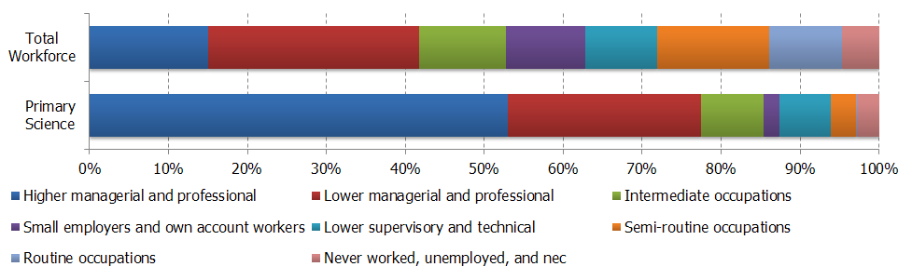
Source: APS 2010 (TBR Ref: W1.2/C1a)
The primary science workforce comprises just over one million employees; the health sector accounts for almost 40% of these. This represents a substantial component and validates the rationale for considering the science workforce inclusive and exclusive of health. Figure 2 demonstrates the impact of removing employees in the health sector from the primary science workforce. Two socio-economic statuses are appreciably less prominent in the lowest bar than in the middle bar; Higher managerial and professional, and Semi-routine occupations. This suggests that the health sector employs people in these statuses in disproportionate numbers. Closer interrogation of the data supports this; we already know that the health sector employs 40% of the primary science workforce, it actually employs just over 50% of Higher managerial and professional staff in the primary science workforce and 93% of staff performing Semi-routine occupations in the primary science workforce. It is difficult to interpret the cause of this overrepresentation.
Figure 2: The impact of the health sector on the composition of the primary science workforce
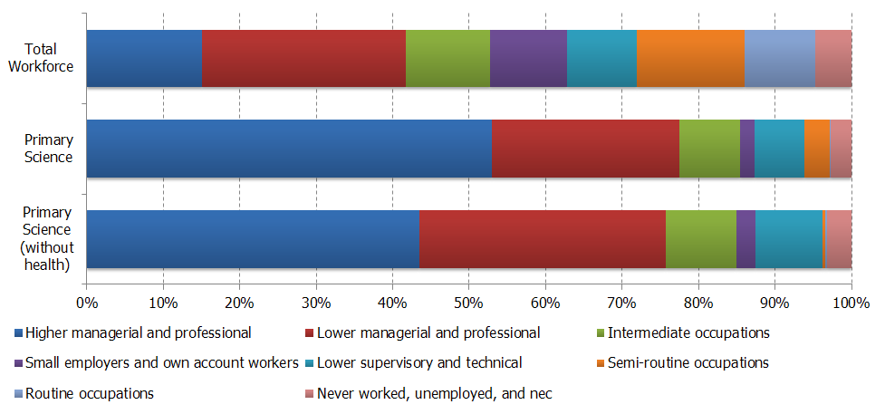
Source: APS 2010 (TBR Ref: W1.2/C1d)

Secondary Science Workforce
The secondary science workforce also replicates the overall trend across the science workforce, with high concentrations of employees in the highest two socio-economic groups, relative to the total workforce. However, the balance within these two socio-economic groups is distinct; Figure 3 shows that almost half (47%) of the secondary science workforce is employed in Lower managerial and professional disciplines (compared to approximately one quarter of the total workforce). A corollary of this is that all eight other socio-economic groups are underrepresented in the secondary science workforce relative to the total workforce.
Figure 3: Comparative composition of secondary science workforce and total workforce
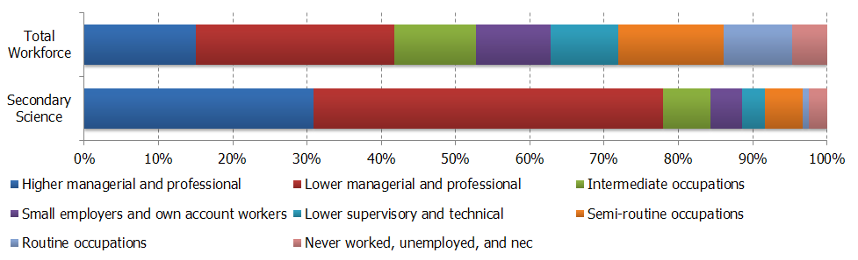
Source: APS 2010 (TBR Ref: W1.2/C1b)
The secondary science workforce comprises 3.83 million employees; the health sector this time accounts for just under 25% of these, an appreciably smaller proportion than in the primary science workforce. Figure 4 demonstrates the impact of removing employees in the health sector from the secondary science workforce.
The Higher managerial and professional socio-economic status provides an interesting contrast between the primary and secondary health sector workforce. Within the primary science workforce, the health sector was responsible for over 50% of employment in this socio-economic status; within the secondary science workforce, the health sector provides employment for just over 10% of these employees. Removing health increases the proportion of the secondary science workforce in Higher managerial and professional statuses, the opposite impact that it had when health was removed from the primary science workforce.
Conversely, Intermediate occupations are appreciably less prominent in the lowest bar than in the middle bar of Figure 4. This suggests that the health sector employs this classification in disproportionate numbers. Closer interrogation of the data supports this; we already know that the health sector employs just under 25% of the secondary science workforce, it actually employs 71% of staff in Intermediate occupations in the secondary science workforce. It is difficult to interpret the cause of this overrepresentation.
Figure 4: The impact of the health sector on the composition of the secondary science workforce
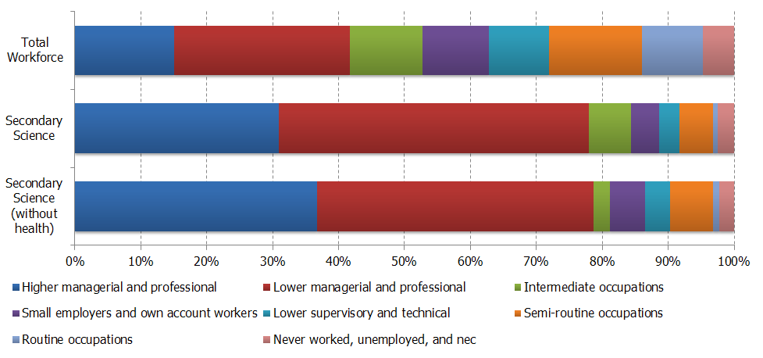
Source: APS 2010 (TBR Ref: W1.2/C1e)

Overall Science Workforce
The UK workforce employs just over 3.5 million people in the Higher managerial and professional socio-economic status. Despite the science workforce accounting for only 21% of overall employment, it accounts for almost half (49.2%) of those employed within the Higher Managerial and Professional socio-economic group (Figure 5).
Figure 5: Higher managerial and professional classification split by workforce
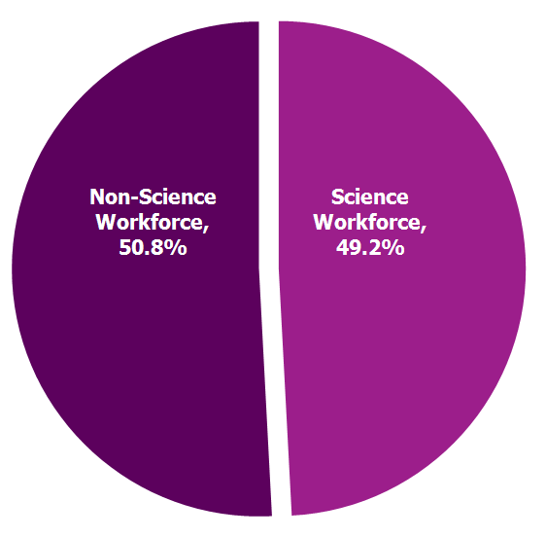
Source: APS 2011 (TBR Ref: W1/C1)
Similarly, the UK workforce employs just over 6.2 million people in the Lower managerial and professional socio-economic status. The overrepresentation of science workers in this group is less pronounced, but they nevertheless account for 32.9% of all workers in this classification. The prevalence of science workers within the top two socio-economic status classifications is supported by previous academic studies,. During the course of the primary qualitative research, interviewees and focus group participants recognised this observation, but felt that advanced and sometimes niche skills are often required in science occupations.
Figure 6 displays the composition of the overall science workforce relative to the total workforce; this reinforces the dominance of the Higher managerial and professional and Lower managerial and professional socio-economic statuses in the overall science workforce. The overall science workforce is an aggregation of the primary and secondary science workforce. Based on this relationship, we would expect one or two of the contrasting observations made in the preceding sections (the overrepresentation of Higher Managerial and professional employees in the primary science workforce and of Lower managerial and professional employees in the secondary science workforce, for example) to effectively cancel one another out. This is very much what is in evidence; the combined proportion of the top two socio-economic statuses is consistent with both the primary and secondary science workforces, with the composition reflecting conciliation between the two statuses.
Figure 6: Comparative composition of overall science workforce and total workforce
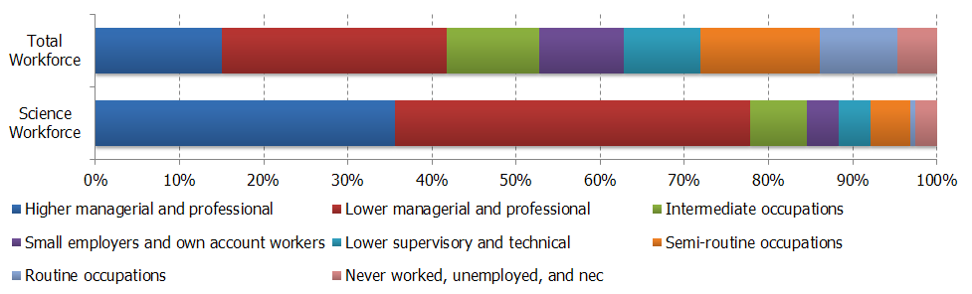
Source: APS 2010 (TBR Ref: W1.2/C1c)
When looking at the science workforce without health there are similar trends; large proportions of the science workforce fall into the Higher managerial and professional and Lower managerial and professional groups and low proportions of the workforce fall within the bottom three socio-economic status groups. Without health, the science workforce accounts for 37.9% of all Higher managerial and professional workers within the science workforce. This demonstrates that the health workforce appears to be similar in structure to the scientific workforce. However, when broken down by other variables, it is apparent that the Health Workforce has nuances which make it different to the overall workforce. These nuances will be explored in subsequent sections.
Figure 7: The impact of the health sector on the composition of the overall science workforce
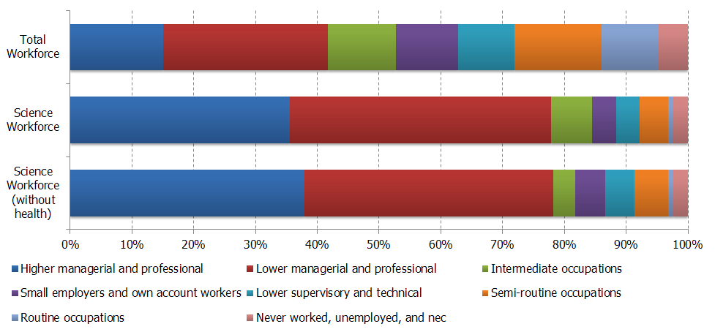
Source: APS 2010 (TBR Ref: W1.2/C1f)

Ethnicity
Ethnicity is a key variable to be explored across this research, with the role of black and minority ethnic (BME) science workers and their socio-economic status an important consideration. This section investigates ethnicity within the science workforce against the different socio-economic status groupings in the definition.
It is clear that the Science workforce is a fundamentally of white ethnicity; the total workforce is 84.3% white and the Science workforce is 83.4% (and 84.9% without health). At present, the workforce lacks diversity and some interview respondents classified the science workforce in colloquial terms, such as ‘white, male, middle-class’.
It is important to consider the impact of the inclusion of health in the statistics; health and social care (particularly the NHS) employ large numbers of BME workers and foreign nationals. This is shown in Table 13 below which demonstrates the reduction in the proportion of the different BME groupings when health is excluded.
Table 13: Distribution of Science Workforce, Total workforce and Science Workforce (without health) for each broad Ethnic Group
 | Science Workforce | Science Workforce  (without Health) | Total Workforce
Asian or Asian British | 5.1% | 4.4% | 4.5%
Black or Black British | 2.2% | 1.6% | 2.1%
Chinese | 0.4% | 0.5% | 0.4%
Mixed | 0.8% | 0.7% | 0.7%
Other | 1.6% | 1.4% | 1.3%
Source: APS 2011 (TBR Ref: W1.1/S3a)

Primary Science Workforce
The primary science workforce has an appreciably higher proportion of Asian or Asian British ethnicity that are in Higher Managerial and Professional socio-economic groupings (11%) when compared with the total workforce (5.8%) (Figure 8). Evidence from the primary research shows that family pressure and expectation to pursue a career in science, and particularly health, does sometimes exist within Asian and Chinese cultures. Furthermore, the demographic and societal changes have enhanced the visibility and encouraged more workers from Asian or Asian British and Chinese backgrounds to find employment in the science sector.
Figure 8: Primary, Science and Total Workforce – higher managerial and professional
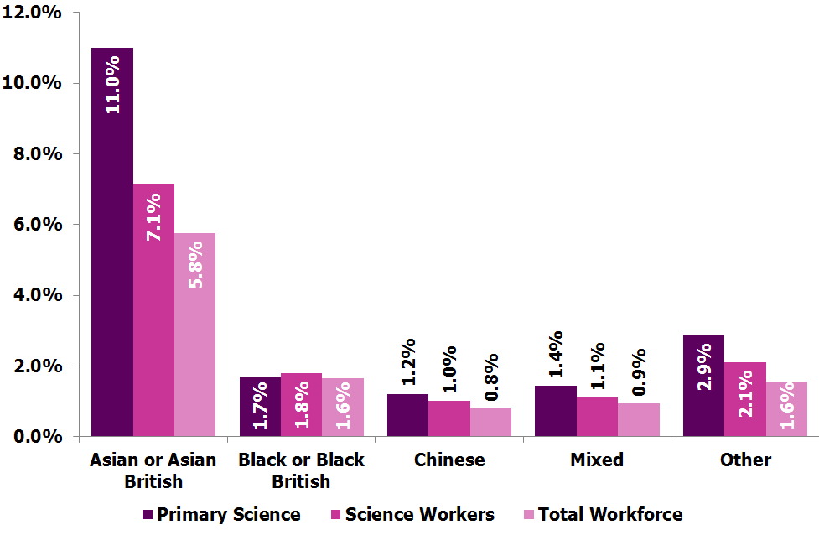
Source: APS 2011 (TBR Ref: W1.1/C3a)
Looking outside of the top two socio-economic groupings, there are very low proportions of primary science workers in all BME groups at the other levels. This is shown below in reference to Black or Black British (Table 14). This finding suggests that the primary science workforce is currently failing to attract a similar level of ethnic diversity in those outside the top two socio- economic groupings. It also shows the difficulties that ethnic minorities face in finding employment in science. In discussion with interview consultees, there was seen to be a double burden of being from a disadvantaged socio-economic background and being of BME group.
Table 14: Black or Black British; comparison between primary workforce and total workforce.
 | Black or Black British
 | Primary | Total
Intermediate occupations | 7.4% | 11.4%
Small employers and own account workers | 1.1% | 6.5%
Lower supervisory and technical | 0.0% | 7.7%
Semi-routine occupations | 1.9% | 19.2%
Routine occupations | 0.0% | 8.7%
Never worked, unemployed, and n.e.c. | 11.8% | 8.2%
Source: APS 2011 (TBR Ref: W1.1/C3a)
The primary workforce has a high proportion of BME workers in the top two socio-economic groupings from all BME groups. Figure 9 demonstrates in all ethnic categories there is a higher proportion in Higher Managerial and Professional occupations in the primary science workforce in comparison to the total workforce. Every ethnic identity, apart from white, has over 50% of the workforce working in Higher Managerial and Professions occupations.
Figure 9: Higher managerial and professional – primary science and total workforce
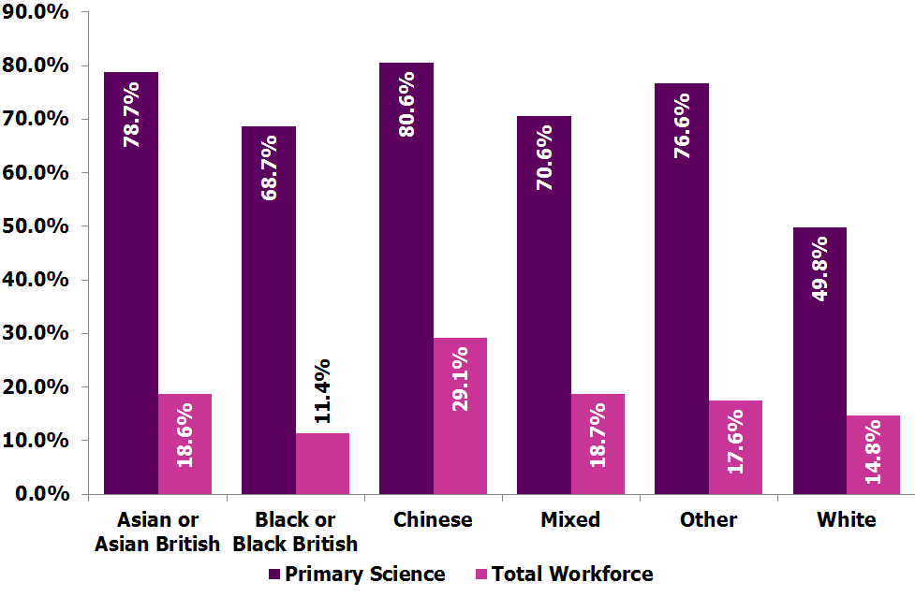
Source: APS 2011 (TBR Ref: W1.1/C3b)

Secondary Science Workforce
Overall, the secondary science workforce has a similar ethnic composition to both the science workforce and the total workforce, when consider BME ethnic identities (Figure 10). There is a lower proportion of Asian or Asian British workers in the Secondary Science workforce compared with the Science workforce overall and the total workforce. When looking at the socio-economic status groupings for Asian or Asian British workers, over 70% of workers are likely to be in the top two socio-economic groupings, with a surprisingly high proportion in semi-routine occupations (11%). Similar to the primary workforce there are very low proportions of all BME workers in all socio-economic groupings outside of the top two.
Figure 10: Secondary, science and total workforce
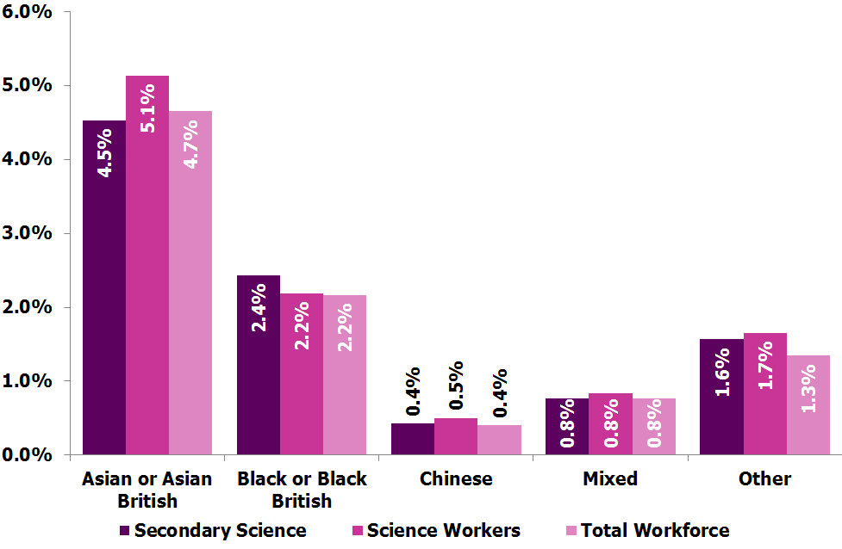
Source: APS 2011 (TBR Ref: W1.1/C3c)
Specifically looking at Higher Managerial and Professional occuptions, the secondary science workforce has a higher proportion of all ethnic identities in these occupations than the total workforce but lower than primary and science workforce overall (see Table 15).
Within the secondary workforce, White, Black or Black British and Mixed ethnicity workers have higher proportions of their workforce which are at lower managerial and professional occupations than higher managerial. Asian or Asian British workers in secondary science are found almost equally at higher managerial or lower managerial. Those from Chinese ethnicity in the secondary workforce are more likely to be at higher managerial and professional than lower managerial and professional socio-economic status.
Table 15: Higher managerial and professional comparison across science and total workforces
 | Asian or Asian British | Black or Black British | Chinese | Mixed | Other | White
Total | 18.6% | 11.4% | 29.1% | 18.7% | 17.6% | 14.8%
Science | 49.4% | 29.3% | 72.0% | 47.4% | 45.4% | 34.5%
Secondary Science | 36.6% | 23.7% | 67.7% | 38.7% | 34.9% | 30.5%
Primary | 78.7% | 68.7% | 80.6% | 70.6% | 76.6% | 49.8%
Source: APS 2011 (TBR Ref: W1.1/C3c)

Overall Science Workforce
The overall science workforce has increased diversity at a faster rate between 2005 and 2011. The presence of the health sector has an appreciable impact both on ethnic diversity within the science workforce and the rate at which diversity increased between 2005 and 2011.
As Figure 11 illustrates, the science workforce has a similar ethnic composition compared to the total workforce. In general, the science workforce has slightly higher levels of the ethnic groups of Asian or Asian British, Black or Black British, Chinese, Mixed and Other than the total workforce. However, without health, the science workforce has a smaller proportion of Asian or Asian British, Black or Black British and Mixed ethnicities in comparison to the total workforce.
Figure 11 – Ethnicity of the Science, Total Workforce and Science without health Workforce (2011)
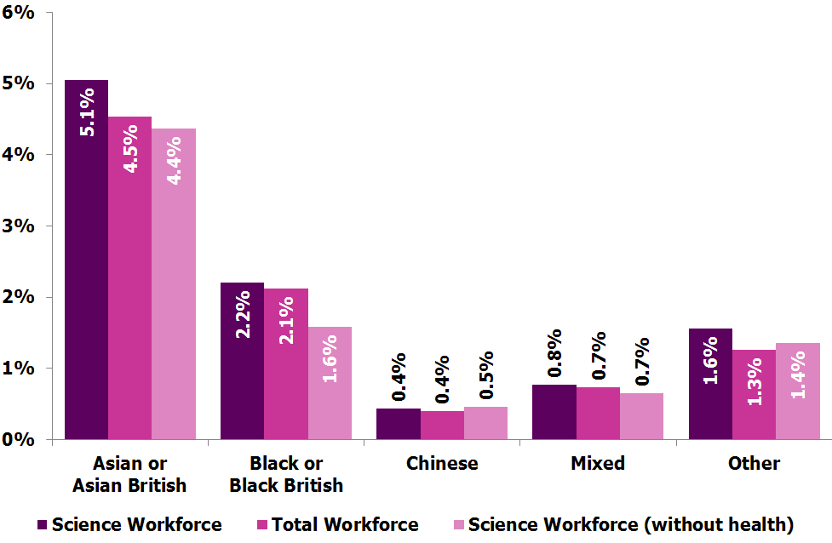
Source: APS 2011 (TBR Ref: W2/C2)
There is more ethnic diversity in the science workforce when compared with the overall ethnic diversity of the total workforce, with a higher proportion of Asian or Asian British, Black or Black British, Mixed, or other ethnic identities in the science workforce than the total workforce. In addition, the science workforce has a slightly lower proportion of people from a white ethnic background (83.4%) than in the total workforce (84.3%).
A high proportion (64.9%) of Asians or Asian British in the science workforce are from higher managerial and professional or lower managerial and professional status groupings, compared with 33.9% in the total Asian or Asian British workforce. Overall, those of Chinese ethnicity compose the smallest proportion of the science workforce (0.4%). However, persons of Chinese ethnicity, in the science workforce, are the most likely to be within higher managerial and professional socio-economic status groupings than any other ethnic classification (67.4%).
There is a low degree of ethnic diversity in the science workforce in routine occupations; 95.1% of the science workforce with routine occupations has a white ethnic identity. This is higher than the total workforce, with 89.1% of persons within routine occupation socio-economic status grouping having a white ethnic identity. The data suggests that while the overall science workforce is ethnically more diverse than the overall workforce, there is an issue with certain occupations in the science workforce (i.e. routine occupation) failing to reflect the overall workforce. This may be linked to the expectation and drive found within certain ethnic backgrounds but also that certain occupations have barriers for entry for people of BME backgrounds.

Gender
This section will explore the distribution of the primary science, secondary science and overall workforce by gender. It will consider the gender composition of the science workforce at each of the three classifications, and provide comparison at each stage with the total workforce. Consistently cross-referencing the three science classifications to the total workforce helps establish whether or not observations are specific/unique to science or simply consistent with overall labour market trends.

Primary Science Workforce
Table 16 demonstrates a clear difference between the gender composition of the primary science workforce relative both to the overall science workforce and to the total workforce. Women are underrepresented in the science workforce relative to the total workforce, and this underrepresentation is particularly pronounced in primary science occupations. Interviews with employers and individuals in the sector support a gender divide in the workplace, with occupations seen as particularly attractive for women including those that support flexible working or are within teams in which females are employed already.
Table 16: Relative gender differences in the primary science workforce
Workforce | Male | Female | Count
Primary Science | 62% | 38% | 1,245,290
Science Workforce | 50% | 50% | 6,015,890
Total Workforce | 45% | 55% | 28,693,810
Despite the underrepresentation of women in the primary workforce, Figure 12 shows that those who are employed within primary science disciplines are more likely than men to be employed in the Higher managerial and professional socio-economic classification. This is a reversal of trend in the total workforce. In another reversal of trend relative to the total workforce, women in the primary science workforce are less likely to fulfil Intermediate occupations. Lastly, women employed in the primary science workforce are more likely to fill Semi-routine occupations, relative to men; this observation is consistent with the total workforce.
Figure 12: Comparative representation of females in the primary science workforce and in the total workforce
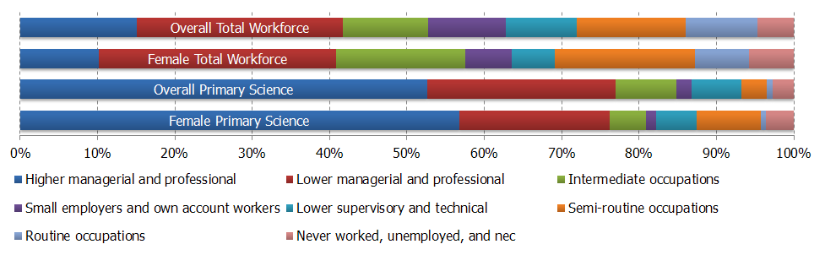
Source: APS 2010 (TBR Ref: W1.2/C4a)
Table 17 shows the impact of excluding health sector employees from the analysis. The representation of women in the primary science workforce plummets to just 25%. The total workforce comprises 55% women. A decrease in the presence of women when health sector employees are removed is a recurring feature of this analysis, and it tends to ‘swing’ the balance by approximately twenty percentage points (with women decreasing by ten points and men increasing by ten points). In the primary workforce this observation is even more stark, with a swing of twenty-six percentage points. It is difficult to attribute this to specific causes, but the dramatic figures suggest that women seeking careers in primary science occupations are drawn strongly towards the health sector. It is unclear whether this is a pull factor (i.e. there is some element of employment in the health sector that is decisively more desirable to women than men) or a push factor (i.e. primary science opportunities in sectors other than health repel women and they seek employment within the health sectors as a consequence).
Table 17: Relative gender differences in the primary science workforce, removing health
Workforce | Male | Female | Count
Primary Science (without health) | 75% | 25% | 758,600
Primary Science | 62% | 38% | 1,245,290
Science Workforce | 50% | 50% | 6,015,890
Total Workforce | 45% | 55% | 28,693,810

Secondary Science Workforce
Table 18 shows that, although women remain underrepresented in the secondary science workforce relative to the total workforce, the distribution is closer to the total workforce distribution than the overall science workforce and much closer than the primary science workforce.
Table 18: Relative gender differences in the secondary science workforce
Workforce | Male | Female | Count
Secondary | 47% | 53% | 4,770,600
Science Workforce | 50% | 50% | 6,015,890
Total Workforce | 45% | 55% | 28,693,810
Figure 13 introduces a comparison between the socio-economic status profiles of women employed in the secondary science workforce and women in the total workforce. Two observations are worth drawing attention to. Firstly, women are noticeably overrepresented in the Lower managerial and professional classification. While this is consistent with the trend observed in the total workforce, it is more pronounced, accounting for 61.2% of employment of women in the secondary science workforce. Secondly, women are underrepresented in Semi-routine occupations; this contrasts with the trend in the total workforce and with the trend in the primary science workforce.
Figure 13: Comparative representation of females in the secondary science workforce and in the total workforce
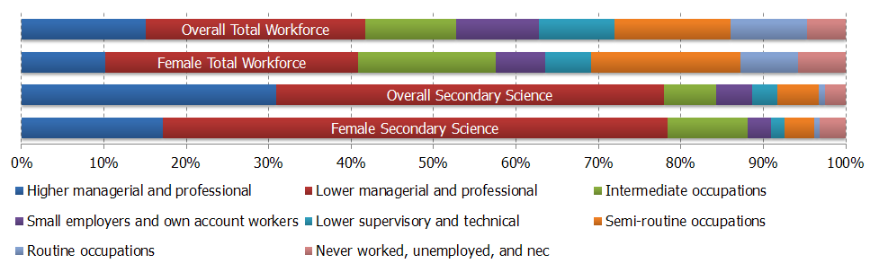
Source: APS 2010 (TBR Ref: W1.2/C4b)
Table 19 shows the impact of excluding health sector employees from the analysis of the secondary health workforce. The representation of women in the primary science workforce reduces to 43%. A decrease in the presence of women when health sector employees are removed is a recurring feature of this analysis, and it tends to ‘swing’ the balance by approximately twenty percentage points (with women decreasing by ten points and men increasing by ten points). In this case, it swings by exactly twenty points.
Table 19: Relative gender differences in the secondary science workforce, removing health
Workforce | Male | Female | Count
Secondary Science (without health) | 57% | 43% | 3,535,000
Secondary Science | 47% | 53% | 4,770,600
Science Workforce | 50% | 50% | 6,015,890
Total Workforce | 45% | 55% | 28,693,810

Overall Science Workforce
The gender split within the scientific workforce in 2011 is balanced between males and females. Investigating this in more detail shows that it is largely driven by the health sector, which contains a large proportion of female staff, especially in roles within nursing and social care. Furthermore, interviews conducted for this research and previous research have found that there are also increasing numbers of females entering historically male occupations (such as physicians) within the health sector, although some health occupations continue to be dominated by men, such as surgery or cardiology.
The data contained within Table 20 has been discussed in the preceding sections. The gender balance within the overall science workforce sees women underrepresented relative to the total workforce. This headline figure masks substantial variation between the primary science workforce and the secondary science workforce, however. It also masks the impact of the health sector on gender representation. Explanations for this are inconclusive and well-worn; a lack of opportunities that accommodate flexible working arrangements, pervasive stereotypes that deter female applicants, and restrictive learning pathways that exclude individuals based on choices made during secondary education. However, these prospective explanations are difficult to test empirically.
Table 20: Relative gender differences in the overall science workforce
Workforce | Male | Female | Count
Science Workforce | 50% | 50% | 6,015,890
Total Workforce | 45% | 55% | 28,693,810
Figure 14 provides a fascinating comparison between women in the science workforce and women in the total workforce. Compare the top two bars as a pair with the bottom two bars as a pair. Clearly, the Higher managerial and professional and Lower managerial and professional classifications dominate the science workforce – this observation is well established. The gender relationship between the individual socio-economic classifications within the overall science workforce and the total workforce are striking:
- Higher managerial and professional: a moderate underrepresentation of women in science, and of women in the total workforce;
- Lower managerial and professional: a moderate overrepresentation of women in science, and of women in the total workforce;
- Intermediate occupations: a moderate overrepresentation of women in science, and of women in the total workforce;
- Small employers and own account workers: a moderate underrepresentation of women in science, and of women in the total workforce;
- Lower supervisory and technical: a moderate underrepresentation of women in science, and of women in the total workforce;
- Semi-routine occupations: a proportionate representation of women in science, but a moderate overrepresentation of women in the total workforce;
- Routine occupations: a proportionate representation of women in science, but a moderate underrepresentation of women in the total workforce;
- Never worked, unemployed and n.e.c.: a moderate overrepresentation of women in science, and of women in the total workforce;
Broadly speaking, the labour market trends experienced by women in the science workforce mirror those experienced by women in the total workforce. Even where the trends do not mirror exactly, they are not conflicting. This suggests that the gender challenges within the science workforce are – at least to some extent – typical of broader gender challenges in the labour market, and not necessarily idiosyncratic.
Figure 14: Comparative representation of females in the overall science workforce and in the total workforce
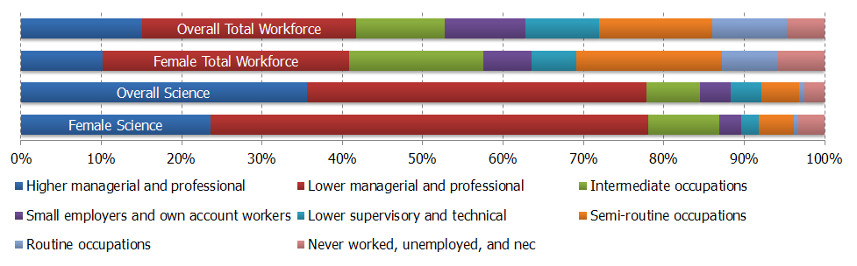
Source: APS 2010 (TBR Ref: W1.2/C4c)
When investigating gender and the socio-economic status groupings, it is apparent that a greater proportion of males are employed in the Higher managerial and professional socio-economic status (47.5%) than Females (23.6%), whereas females are more inclined to be within Lower managerial and professional classification (54.5%) than men (30.1%) (Figure 14 and Figure 15). A higher proportion of females within the science workforce are within the intermediate occupation socio-economic status (8.8%) than Males (4.5%). This accurately reflects research in other industries and is consistent with the difficulties that women face becoming board members and breaking the ‘glass ceiling’ into senior managerial positions.
There are higher proportions of male workers in Lower supervisory and technical, Semi-routine occupations and Routine occupations than female (11.1% in the male workforce compared to 7.2% within the female workforce) (Figure 14 and Figure 15). This split can reflect the types of science jobs that exist in the economy, which are more likely to attract men. There is also a feeling that the work required within certain roles is stereotyped or because of historical differences is not attractive to females.
Figure 15: Comparative representation of males in the overall science workforce and in the total workforce
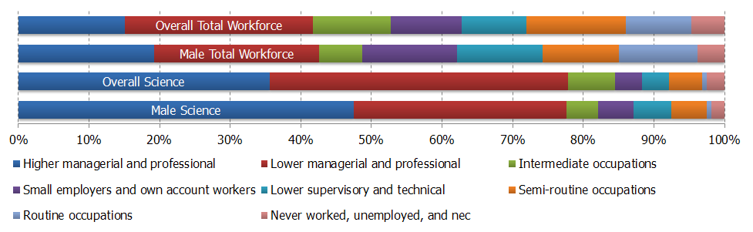
Source: APS 2010 (TBR Ref: W1.2/C4f)
The health sector influences the gender balance considerably. Almost 75% of Higher managerial and professional workers in the overall science workforce without health are male compared to 67% in the overall scientific workforce with health. When looking at the analysis for the overall science workforce without health, all socio-economic groupings have an increased proportion of males compared to females relative to the overall science workforce with health. This is reflected in the higher proportion of males (61%) in the scientific workforce without health (Table 21).
Table 21 shows that, with health excluded, the gender balance of the overall science workforce has a different breakdown and contains a higher proportion of men (61%). Interviews with employers and individuals in the sector support a gender divide in the workplace, with occupations seen as particularly attractive for women including those that support flexible working or are within teams in which females are employed already.
Table 21: Relative gender differences in the overall science workforce, removing health
Workforce | Male | Female | Count
Science Workforce (without health) | 61% | 39% | 4,293,600
Science Workforce | 50% | 50% | 6,015,890
Total Workforce | 45% | 55% | 28,693,810
The consultation exercise found that there are a number of challenges that women face in accessing science occupations. If females are also from a disadvantaged socio-economic background then they often face compound challenges in accessing work in scientific roles. It was felt that all levels of education (primary education to higher education) are crucial to attracting males and females to science. As such, those from lower socio-economic backgrounds face more barriers such as challenging schools, fewer personal networks and lower aspirations.
The Athena SWAN Charter was seen as particularly valuable for changing work and employment cultures in the Higher Education sector. However, little was known as to whether this had increased the supply of women from low socio-economic backgrounds into science.
Between 2005 and 2011 there has been an increase of almost 400,000 women and just fewer than 170,000 men in the workforce. The gender split has reversed in this period, with males making up 51.8% of the workforce in 2005 and 49.7% in 2011. This was seen to be driven by a number of factors including;
- The increase in the size of the healthcare workforce and particularly nursing and social care between these years.
- An increased supply of females into the workforce from higher and further education, particularly through subjects like biology and chemistry.

Disability
Disability is recognised as a protected characteristic within the workforce. Although disability is not always obvious, many employers provide disabled workers with ‘reasonable adjustments’ to ensure that disabled people have equal opportunities applying for and staying in work. Consultations with employers and stakeholders demonstrated that reasonable adjustments had been made to allow workers to continue or apply for jobs within their organisations. The consultation exercise also suggested that employers received few applications from disabled workers and that this was because disabled workers do not commonly seek employment in the science industry because of the nature of work that is required.

Primary Science Workforce
Figure 16 shows that disabled employees in the total workforce are underrepresented in the top two socio-economic classifications. This observation is also present in the primary science workforce, with underrepresentation in the Higher managerial and professional socio-economic classification more prevalent as a cause. Disabled workers are overrepresented in the primary science workforce in the Intermediate occupations and Lower supervisory and technical classifications; while these do not conflict with the trend observed amongst disabled employees in the total workforce, the observation is more pronounced.
Figure 16: Comparative representation of disabled people in the primary science workforce and in the total workforce
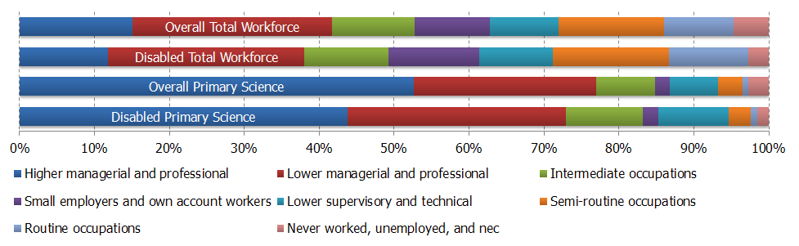
Source: APS 2010 (TBR Ref: W1.2/C5a)
Figure 16 shows that disabled workers are underrepresented in the Higher managerial and professional socio-economic classification; Figure 17 shows that this is exacerbated if the health sector is removed, with the proportion of disabled people employed in Higher managerial and professional occupations in the primary science workforce falling to 35.8% (from 44.2%). Subsequent analysis shows that the removal of health in the secondary science workforce and overall science workforce leads to a signification reduction in disabled people employed in Intermediate occupations. This does not happen insofar as the primary science workforce is concerned, which suggests that opportunities in Intermediate occupations outside the health sector are predominantly primary science occupations.
Figure 17: Comparative representation of disabled people in the primary science workforce and in the total workforce, excluding health
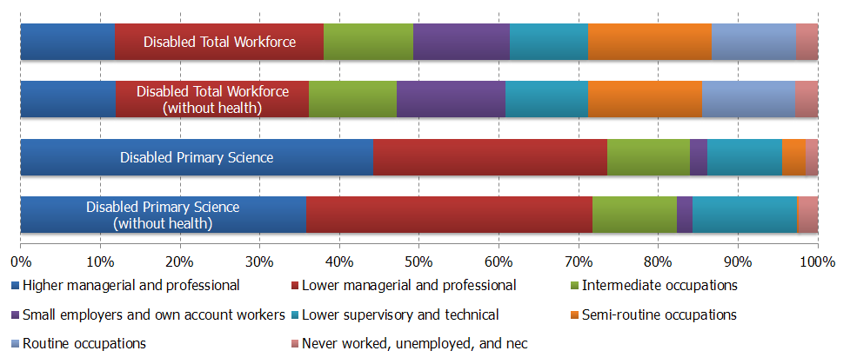
Source: APS 2010 (TBR Ref: W1.2/C5d)

Secondary Science Workforce
Figure 18 shows that, as identified earlier, disabled employees in the total workforce are underrepresented in the top two socio-economic classifications. This observation is also present in the secondary science workforce, although these two classifications nevertheless account for 76.3% of employment for disabled people, and the difference between disabled and non-disabled workers is 1.9 percentage points. Disabled workers are overrepresented in the secondary science workforce in the Intermediate occupations and Small employers and own account workers classifications; these observations are consistent with the trend observed amongst disabled employees in the total workforce.
Figure 18: Comparative representation of disabled people in the secondary science workforce and in the total workforce
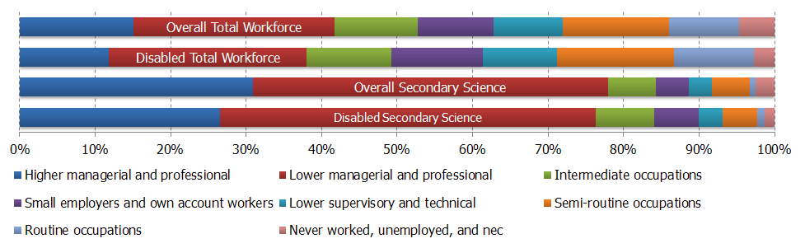
Source: APS 2010 (TBR Ref: W1.2/C5b)
Figure 19 contrasts with Figure 17 in the sense that, in the secondary science workforce, the removal of the health sector actually increases the proportion of disabled people employed in the top two socio-economic classifications, albeit marginally. As discussed in the previous section, the removal of the health sector also has an discernable impact on the proportion of disabled employees employed in Intermediate occupations. This vacuum is filled by relatively modest increases in the proportion employed in the Small employers and own account workers, Lower supervisory and technical, and Semi-routine occupations classifications.
Figure 19: Comparative representation of disabled people in the secondary science workforce and in the total workforce, excluding health
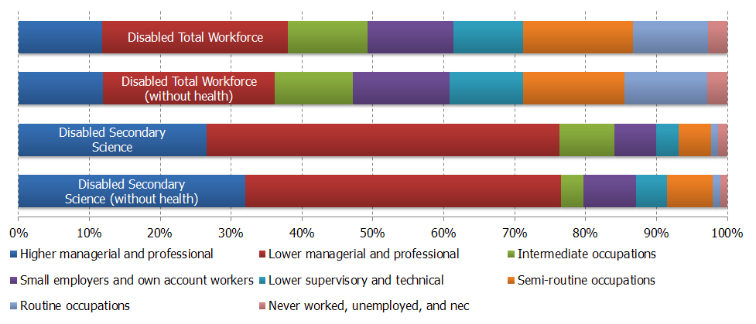
Source: APS 2010 (TBR Ref: W1.2/C5d)

Overall Science Workforce
Figure 20 shows that the overall science workforce contains, proportionally, fewer disabled workers than the total workforce.
Figure 20: Proportion of Disabled Workers in Workforce
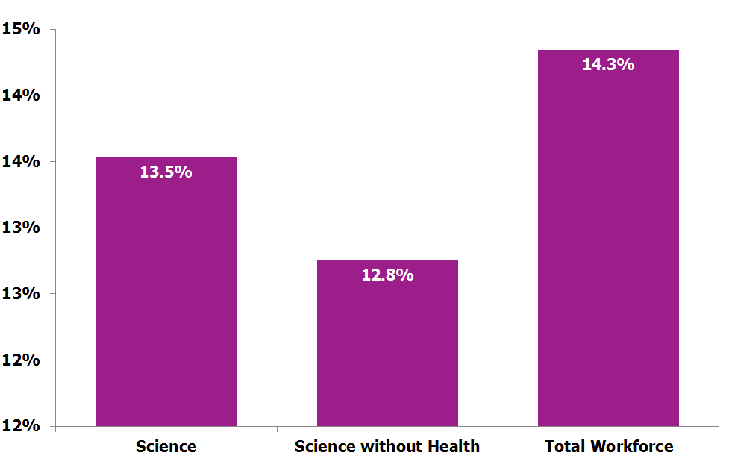
Source: APS 2011 (TBR Ref: W1/C5a)
Figure 21 shows that, despite having a smaller share of disabled workers than the total workforce, over 75% of disabled workers in the overall science workforce are found in the top two socio-economic status classifications. A larger proportion of disabled workers are within the Lower managerial and professional grouping (43%) than the non-disabled workforce (39.9%). Fewer disabled workers in the overall science workforce are in the higher managerial and professional grouping (32.7%) compared to the non-disabled overall science workforce (38.6%). This suggests that disabled workers might face issues in career progression and reaching the top managerial positions within science organisations.
There are fewer disabled workers within the lower three socio-economic status groupings (7.6% combined) than non-disabled (8.9%). This perhaps reflects the type of work found in these socio-economic classifications and also the attractiveness of occupations at these grouping levels. Interviews with firms suggested that they had not received applications from disabled workers for certain roles which require manual and physical skills despite companies being willing to provide reasonable adjustments to enable workers to carry out these roles.
Figure 21: Comparative representation of disabled people in the overall science workforce and in the total workforce
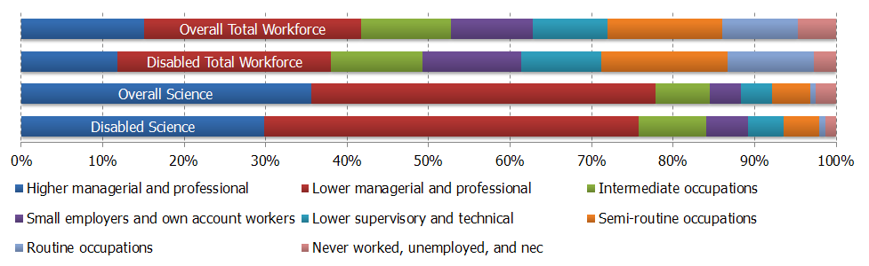
Source: APS 2010 (TBR Ref: W1.2/C5c)
Figure 22 shows the impact of removing the health sector on the distribution of disabled employees. The impact on the disabled total workforce is minimal, which confirms that health is a small component of the total workforce, relative to the overall science workforce. Removing the health sector adjusts the balance of Higher managerial and professional and Lower managerial and professional, with disabled science employees apparently achieving Higher managerial roles more easily in sectors other than health. The proportion of employees in Intermediate occupations falls noticeably when the health sector is excluded. This suggests that the health sector employs many disabled people in Intermediate occupations.
Figure 22: Comparative representation of disabled people in the overall science workforce and in the total workforce, excluding health
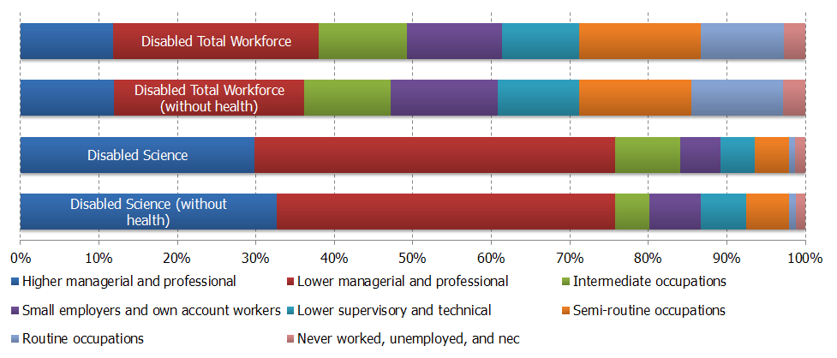
Source: APS 2010 (TBR Ref: W1.2/C5f)
The number of disabled people employed in the overall science workforce increased by 355,360 between 2005 and 2011. The proportion of disabled workers has increased across all socio-economic status groupings. In 2005, 8.4% of workers in the overall science workforce were disabled and in 2011, this had grown to 13.5% (Table 22). This mirrored the growth in the disabled workforce within the total workforce, but also demonstrates that the gap between the science workforce and total workforce in employing people with disabilities has not closed.
Table 22: Representation of disabled workers across workforce (2005 and 2011)
Workforce | Disabled 2011 | Disabled 2005
Science workforce | 13.5% | 8.4%
Science workforce without Health | 12.8% | 8.1%
Total Workforce | 14.3% | 9.4%
Source: APS 2011 (TBR Ref: W1/S5a)
The proportion of disabled workers in the overall science workforce excluding the health sector is lower (12.8%) than including the health sector (13.5%) (Figure 20). The rate of increase in disabled workers between 2005 and 2011 in the overall science workforce excluding the health sector is also below than that of the workforce including the health sector. This slower rate of increase determines that, in terms of disability, the science workforce excluding health is increasing diversity less rapidly, in addition to being less diverse. The NHS is seen as a desirable place to work by those with disabilities and this suggests that the rest of the science sector faces challenges in employing workers with disabilities.

Highest Qualification
Throughout the analysis, it is clear that the higher socio-economic groupings are overrepresented in the science workforce, relative to the total workforce. This section considers the qualifications profile of the science workforce and its relationship with the socio-economic composition of the science workforce and relative to the total workforce.

Primary Science Workforce
A high proportion (67.1%) of the primary science workforce qualified to NQF level 5 are within the higher managerial and professional socio-economic grouping. This is higher still when looking at NQF level 6 (78.7%) and NQF level 7 & 8 (87%). This demonstrates the highly qualified nature of the science workforce.
A high proportion of workers qualified to NQF Levels 1 to 4 are found (65-85%) within the top three socio-economic status groupings. At Level 5 and above, the majority (80%-93%) of workers are found within the top two socio-economic groupings.
Workers in Lower supervisory and technical, Semi-routine occupations and Routine occupations socio-economic groupings are most likely to have NQF level 1-3 qualifications. However, there are comparatively high proportions of Higher managerial and professional (5.5%) and Lower managerial and professional (21.6%) workers with NQF level 3 qualifications.

Secondary Science Workforce
The qualification profile of the secondary science workforce is different to the primary, with a high proportion of the secondary science workforce qualified to NQF level 5 and over within the higher and lower managerial and professional socio-economic groupings. However, the balance is different, with higher proportions of workers from lower managerial and professional socio-economic groupings with NQF level 5 and above. For example, 54.7% of workers qualified at NQF level 5 are from lower managerial and professional socio-economic grouping compared with 34.1% from higher managerial and professional socio-economic grouping.
Low proportions of workers from Lower supervisory and technical, Semi-routine occupations and Routine occupations socio-economic groupings are qualified to NQF level 4 and above. Small employers and own account workers are different, with 13.7% of workers from this grouping qualified to NQF level 7 & 8. Similar to primary science workforce, many workers from the lower socio-economic grouping are qualified to NQF levels 1 – 3.
This shows that low qualifications are not always a barrier to success in science. However, when looking at those with no qualifications, low proportions of workers are within the top two socio-economic status groupings (21.1%) compared with workers with NQF level 1 and above (all over 40%).
When comparing those with NQF Levels 1 and 2 in primary and secondary science with the total workforce, it is clear that comparatively low qualifications do not restrict workers in the Science workforce in obtaining higher socio-economic status.

Overall Science Workforce
Figure 23 is a reproduction of Figure 6, supplemented by the qualifications profile of the science workforce and total workforce. As already discussed, almost 78% of the science workforce is employed within the Higher and Lower managerial socio-economic groups; only 41.8% of the total workforce is employed in these two groups. Employees with graduate and postgraduate qualifications (NQF Level 5 and above) are similarly overrepresented in the science workforce; almost 59% of employees fall into this category, compared to just over 30% of the overall population.
Whether the prevalence of people employed in higher socio-economic groups in the science sector is caused by highly skilled individuals pursuing careers in science, or alternatively whether the availability of high calibre roles attracts people with advanced qualifications is an interesting proposition. It is difficult for these datasets to establish causality, but they can look more closely at correlation.
Figure 23: Socio-economic status and qualification profile of Science workforce (2011)
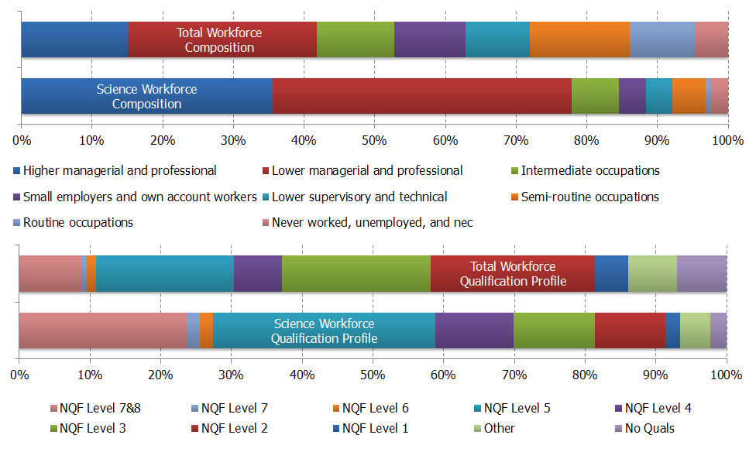
Source: APS 2010 (TBR Ref: W1.2/C8de)
Table 23 compares the qualifications profile of the science workforce with that of the total workforce in more detail. Almost 25% of the Scientific Workforce holds a NQF level 7 or 8 qualification compared with around 8% of the total workforce. There are also a relatively high proportion of workers with NQF level 5 qualifications (31.1%), again higher than the total workforce (19.2%). Employers and individuals consulted during the qualitative research stages acknowledged the requirement for certain qualifications (e.g. undergraduate, postgraduate) for roles within the science workforce. It was also noted that employers sought qualifications from certain universities (e.g. Oxbridge, Russell group) and that others, which nevertheless had good reputations, were not considered. This has an impact on the supply of scientists into the workforce, as many of the newer universities attract students from less affluent areas.
Table 23: Qualifications profile of the science workforce and total workforce (2011)
Qualification Level | Example Qualification | Science Workforce |  | Total Workforce
Qualification Level | Example Qualification | Count | % of Science Workforce | Count | % of Total Workforce
NQF Level 1 | GCSEs grades D-G | 124,230 | 2.1% | 1,329,950 | 4.7%
NQF Level 2 | GCSEs grades A*-C | 592,810 | 9.9% | 6,559,990 | 23.2%
NQF Level 3 | A-levels | 687,230 | 11.5% | 5,942,550 | 21.0%
NQF Level 4 | Certificates of higher education | 662,850 | 11.1% | 1,920,160 | 6.8%
NQF Level 5 | Bachelor and Foundation Degrees | 1,869,790 | 31.4% | 5,514,660 | 19.5%
NQF Level 6 | Other degrees | 111,660 | 1.9% | 355,430 | 1.3%
NQF Level 7 | Masters degrees | 109,480 | 1.8% | 204,970 | 0.7%
NQF Level 7&8 | Doctoral degrees | 1,410,700 | 23.7% | 2,491,970 | 8.8%
Other | N/A | 253,500 | 4.3% | 1,949,840 | 6.9%
No Qualifications | N/A | 136,870 | 2.3% | 1,987,200 | 7.0%
Total |  | 5,919,120 | 100% | 28,256,720 | 100%
Source: APS 2011 (TBR Ref: W1.2/S8)
The notion that the science workforce is highly qualified is supported by looking at the distribution of NQF level 7 & 8 qualifications (Figure 24). It shows that the distribution of employees with NQF level 7 & 8 is more spread across the total workforce, in the science workforce there is a higher proportion of higher managerial and professional (47.5%) and as a result there is less spread across the different socio-economic groupings.
Figure 24: Distribution of employees with NQF Level 7&8 qualifications, science workforce and total workforce
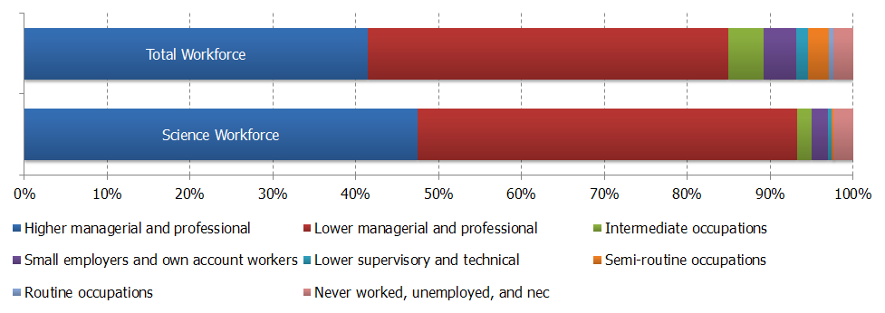
Source: APS 2011 (TBR Ref: W1.2/C8a)
However, Figure 25 shows that the overrepresentation of the top two socio-economic status groups in the science workforce is not limited to those with higher level qualifications. In the total workforce, just over 20% of those whose highest level of qualification is NQF Level 1 are employed in the top two socio-economic status groups. In the science workforce, over 40% of those whose highest level of qualification is NQF Level 1 are employed in the top two socio-economic status groups. Although those in the science workforce are more likely to fall into the top two socio-economic status groups if they have higher level qualifications, those in the science workforce with lower level qualifications are still more likely to fall into these groups than they would be in the total workforce.
Figure 25: Distribution of employees with NQF Level 1 qualifications, science workforce and total workforce
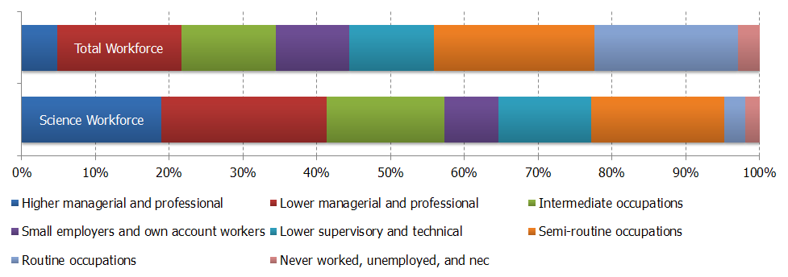
Source: APS 2011 (TBR Ref: W1.2/C8c)

Firm Size
This section considers the impact of size of firm (in terms of numbers of employees) in the science industry and any relationship that firm size may have on the socio-economic composition of the science workforce relative to the total workforce.
A large proportion (54%) of the total science workforce works in SMEs (those with less than 250 employees). Micro-businesses (1-10 employees) are also well represented (10.5% in the total science workforce) and show the importance of very small firms and enterprises to the science workforce. However, it was found through interview respondents that scientists were largely risk-averse when making career decisions and noted that finding employment within large organisations was preferable.
The inclusion of health within the definition is important to the firm size composition of the primary science workforce and has the result of skewing the distribution towards large employers. When health is included in the definition there are a lower proportion of workers (17.5%) in the 50-249 firms size group than without health (23.7%). Furthermore, all elements of the Science workforce with health, have proportionally less employers in ‘500 or more’ than their elements without health. These two differences are likely to be driven by large employing health institutions such as hospitals and doctors surgeries. Despite this, there is a still considerable proportion of employment in the 500 or more category for secondary, primary and total science workforce. This is likely to be driven by multi-national companies across a wide variety of sectors that employ large numbers of scientists in different roles within their chain of command.
Table 24: Firm size by Science Workforce (2011)
Firm Size | Primary | Secondary | Total Science | Total Workforce | Primary (without health) | Secondary (without health) | Science (without health) | Total workforce (without health)
1-10 | 12.3% | 10.0% | 10.5% | 17.9% | 12.4% | 10.8% | 11.1% | 18.5%
11-19 | 6.8% | 5.1% | 5.5% | 7.4% | 4.3% | 4.7% | 4.7% | 7.0%
20-24 | 3.4% | 3.4% | 3.4% | 3.8% | 2.7% | 3.2% | 3.1% | 3.6%
25-49 | 8.5% | 12.4% | 11.6% | 11.8% | 8.3% | 12.9% | 12.1% | 11.4%
50-249 | 17.5% | 24.5% | 23.0% | 20.2% | 23.7% | 28.1% | 27.3% | 21.1%
250-499 | 6.8% | 6.2% | 6.3% | 6.3% | 9.4% | 7.0% | 7.4% | 6.7%
500 or more | 31.2% | 26.2% | 27.2% | 15.3% | 25.1% | 19.9% | 20.8% | 13.6%
don't know but between 50 and 499 | 2.9% | 3.0% | 3.0% | 3.0% | 3.6% | 3.2% | 3.2% | 3.1%
don't know but under 25 | 1.5% | 1.3% | 1.3% | 2.0% | 1.3% | 1.3% | 1.3% | 1.9%
No answer & Not Known | 9.1% | 8.0% | 8.2% | 12.3% | 9.1% | 8.8% | 8.9% | 13.1%
Total | 100% | 100% | 100% | 100% | 100% | 100% | 100% | 100%
Source: APS 2011 (TBR Ref: W1/S7a.1)

Primary Science Workforce
The primary science workforce has the highest proportion of workers from large firms (37.9%) in comparison with SMEs (48.6%). A high proportion of primary science workers who work in SMEs (36.9%) and large firms (50.9%) are in a higher managerial and professional socio-economic status.
This is important when looking at interventions, the size of the business is often an indicator of the ability for a firm to address diversity issues. SMEs spoken to highlight that their diversity measures are largely driven by legislation.
Almost all primary workers at Routine occupation (100%) and Semi-routine occupation socio economic status (83.7%) work within SMEs. Firms which are between 11-19 and 20-24 employees have the highest share of employment for Semi-routine occupations (around 13% in both cases). Interventions targeting these socio-economic groups need to consider this and understand the different pressures that affect SMEs that may influence the success of an intervention.

Secondary Science Workforce
The Secondary Science workforce contains more workers from SMEs (55.3%) than large firms (32.4%). A secondary science worker in an SME is more likely to be at a Lower managerial and professional (46.3%) socio-economic status than a secondary science worker in a large firm, where they are more likely to be in a higher managerial and professional socio-economic status. From this, it can be assumed that members of the secondary science workforce that are employed by SMEs may find it harder to progress in to the highest socio-economic grouping.
There are high proportions of those from a Routine occupation socio-economic status in the secondary science workforce in micro–SMEs (43.1%). Just over half of Lower supervisory and technical and Semi-routine occupations workers work in businesses that employ 50-249 and 500 or more, reflecting the type of work that is required in many occupations that make up these groupings.

Overall Science Workforce
A large proportion of the scientific workforce work within SMEs (54%), whilst 33.5% work in large firms (Figure 26). Micro SMEs (1-10 employees) employ 10.5% of the scientific workforce, 23% are employed within firms that are between 25 and 49 people and 27.2% are employed in firms that employ between 50 and 249 employees. A number of issues arose through the consultation work which supplemented the data analysis. These are important to consider when looking at interventions and initiatives to increase the diversity of the workforce. There were questions about the ability of SMEs to monitor workforce changes. Due to the size of the organisations different recruitment practices, which relied on the local area in which they were located and networks that the employees had, were often observed.
Figure 26: Scientific Workforce by Firm Size (2011)
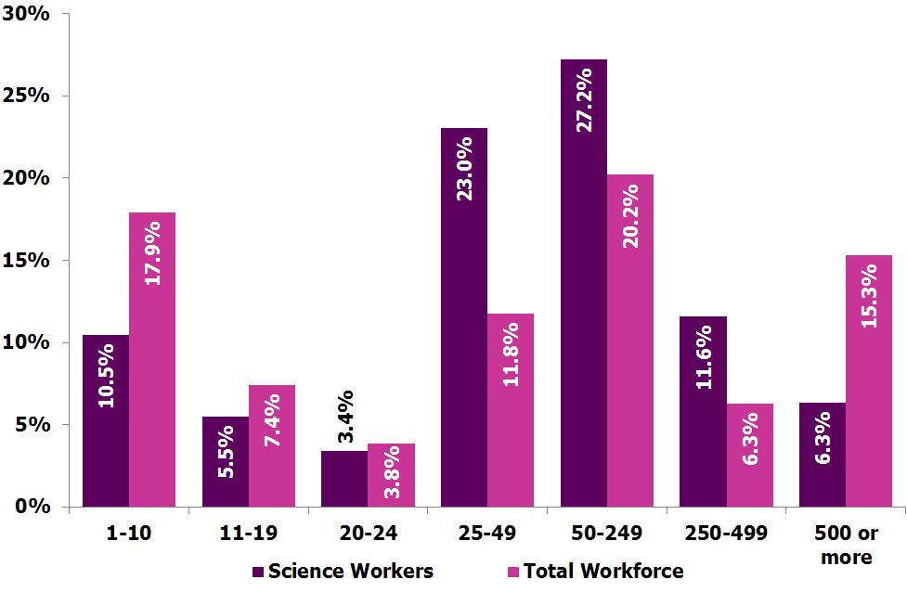
Source: APS 2011 (TBR Ref: W1/C7)
Science workers within the health sector can be employed in organisations of different sizes. Many are employed within hospitals, healthcare trusts and academe. However, smaller employers such as doctor’s surgeries, opticians and chiropodists also exist. The influence of organisations like hospitals and health trusts is shown within the data, indicating that the Science Workforce outside of health is slightly more likely to be employed in SMEs (58.7%) compared with the science workforce with health (54%).
It was noted that interacting with SMEs can be difficult as they have characteristics (such as constrained resources) which can restrict resources for participating in initiatives or strategies. Up to date information is also important as SMEs can also grow, decline or die less noticeably than larger firms. Suggestions on how SMEs can be interacted with were discussed within the workshops and interviews, and include interacting with organisations such as the Federation of Small Businesses and undertaking pilot studies.

Broad Sector
This section investigates broad sectors which were identified at the outset of the work, these include;
- Private
- Public
- Education
Table 25 shows the breakdown of the science workforce by broad sector. It shows that the science workforce is notably different to the total workforce, with proportionally less private sector employment, and higher shares of employment in the public sector and education. This supports what is known about the science workforce, that education (particularly academe) and the public sector (particularly public health, environment and defence) are notable employers of scientists across many roles.
Table 25: Broad Sector by Science Workforce (2011)
Workforce | Private | Public | Education
Primary Science | 59.6% | 33.6% | 6.6%
Secondary Science | 43.5% | 25.9% | 30.3%
Overall Science | 46.9% | 27.5% | 25.4%
Total Workforce | 72.1% | 16.7% | 10.7%
Source: APS 2011 (TBR Ref: W1.2/S6.1)

Primary Science Workforce
The primary science workforce has a larger proportion of workers (almost 60%) in the private sector than the secondary science workforce and the overall science workforce. Over one third of the primary science workforce works in the public sector, whilst only 6.6% work in education.
The majority of primary science workers in all three broad sectors are in the top two socio-economic status groupings. Almost 70% of primary science workers in the public sector are within the top socio-economic grouping. This shows a lack of lower socio-economic status grouping in public sector science roles.
Within Education, 91% of the workers are in the top two socio economic status groupings, there is a slightly higher proportion at Lower managerial and professional (47.7%) than higher managerial and professional (43.3%).
There are very few primary science workers at Lower supervisory and technical, Semi-routine occupations and Routine occupations socio economic status groupings who work in the public sector or education. This is one area in which the science workforce is lacking in representation; although determining whether this is a result of restrictive practice or a simpler, natural process.
The private sector is also heavily skewed towards the top two socio economic status groupings, but there are larger proportions of all other socio-economic groupings, showing that primary science workers from these socio-economic groupings are more likely to work in the private sector than public sector or education.
The private sector in the UK has regularly claimed that a dearth of scientists and engineers is holding it back and as a result attracting science workers from all socio-economic groupings would be of benefit for many firms. The data shows that the private sector is more likely to employ people from all socio-economic status groupings in primary worker occupations.

Secondary Science Workforce
The secondary science workforce has a lower proportion of its workforce in the private sector (43.5%) and public sector (25.9%), with a higher proportion of workers in Education (30.3%). There are also a high proportion of workers that are in the top two socio-economic status groupings. However, there are a number of important distinctions, which include:
- Within the public sector and education sector, there are a much higher proportion of people employed in the Lower managerial and professional classification than in the Higher managerial and professional classification. In Education, almost three quarters (73.5%) of the workforce is at lower managerial and professional and in public sector this is over half (53.7%). This is likely to be explained by the types of occupations found in education which could account for this (e.g. teachers).
- The private sector is also skewed towards the top two socio-economic groupings but has a higher proportion from the higher managerial and professional (45%) than lower managerial and professional (24.1%).
When looking at the socio-economic groupings;
- A low share of intermediate workers are employed within the private sector or education; the majority (63.8%) are in the public sector.
- Workers from the Lower supervisory and technical, Semi-routine occupations and Routine occupations socio-economic groupings are overwhelmingly found in the private sector (all over 85%).
It is clear that the private sector is an important employer of many of the lower socio-economic status groupings, despite this there is still a large proportion of the private sector workforce which is within the top two socio-economic groupings.

Overall Science Workforce
Just under half (46.9%) of the science workforce work within the private sector, a further 27.5% work in the public sector and 25.5% work in academia (Figure 27).
There are distinct differences within the broad sectors:
- The majority of science workers in the private sector (55.8%) are within the top two socio-economic status groupings, with the larger of the two groupings; Higher managerial and professional (36.1%).
- The science workforce in the public sector is slightly different in that 45% of the workforce are within the top two socio-economic groupings, with another larger proportion (16.5%) in the intermediate occupation socio economic status grouping.
- Almost three quarters (74%) of the science workforce in education are within the top two socio-economic groupings, with very few employees in lower supervisory and technical, semi-routine occupations and routine occupations (total together 0.2%)
Figure 27: Science Workforce by Broad Sector (2011)
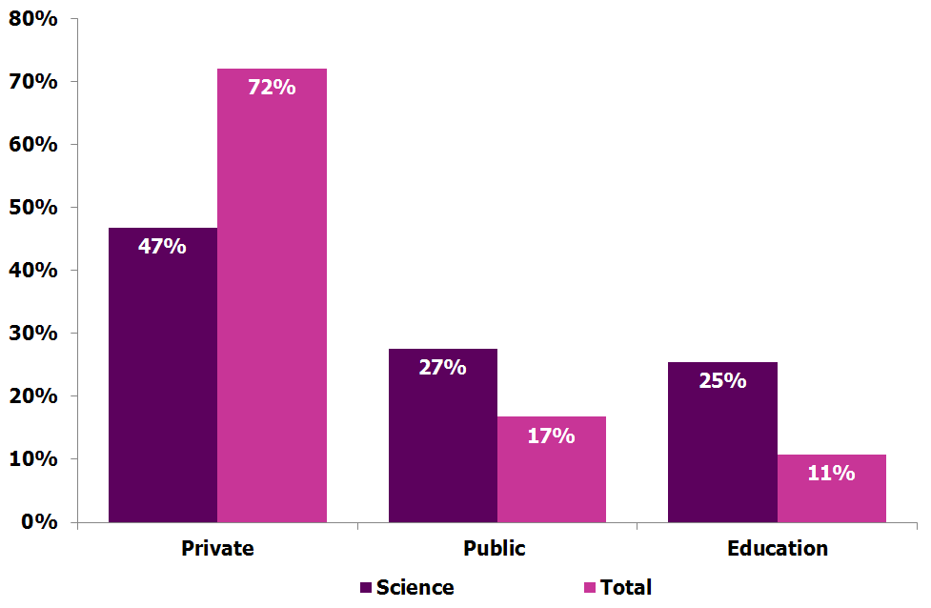
Source: APS 2011 (TBR Ref: W2/C6)

Wage Band
This section provides information on wage band and the relationship with the socio-economic composition of the primary, secondary and total science workforce. This section also investigates gender to provide further detail to the analysis. This draws from wage information provided to the Annual Population Survey; which is not as robust due to lower responses. Despite this is provides interesting insight into average wages for workers.

Primary Science Workforce
When looking at the overall comparison in wage band, differences between the primary science workforce and total workforce (Figure 28) those working in primary science are more likely to be in higher wage bands than those in the total workforce. For example, 10.4% of those working in the primary science workforce are earning £50K+, while only 6.1% of the total workforce earning this level. In addition, those working in the primary science workforce are less likely to be in the lower wage bands when compared to the total workforce. Only 16% of the primary science workforce earns less than £20K, whereas 42.9% of the total workforce is earns less than this.
Figure 28: Overall comparison between primary and total workforce
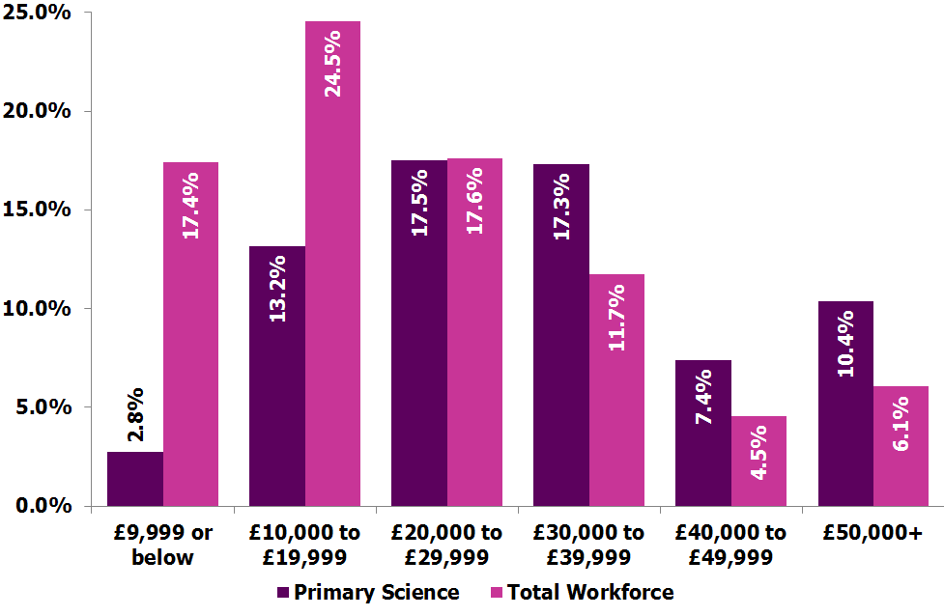
Source: APS 2010 (TBR Ref: W1.1/C9j)

Figure 29: Primary and wage band
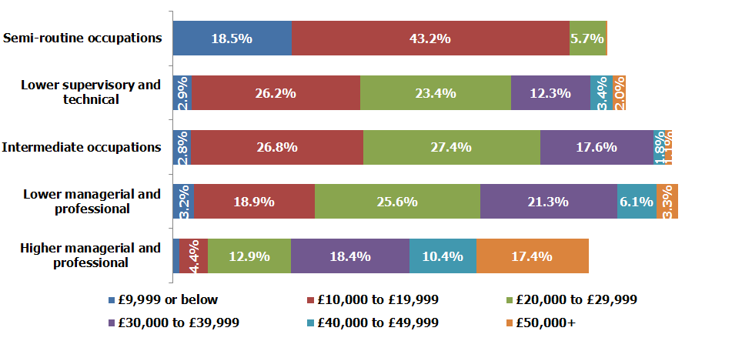
Source: APS 2010 (TBR Ref: W1.1/C9a)
However, the situation is more complicated when a comparison is made between the SES category and the wage band (Figure 29 and Figure 30). In the total workforce, those that are Higher managerial and professional are more likely to be in the higher wage band than those in the primary workforce: 19.7% in the total workforce earn £50K+ compared with 17.4% in the primary science workforce.
The primary science workforce tends to pay those in Intermediate Occupations better than the total workforce: 17.6% of those in Intermediate Occupations in the primary science workforce are earning £30 to £39,999K, with only 5.6% in the same wage band for the total workforce.
Figure 30: Total Workforce and wage band
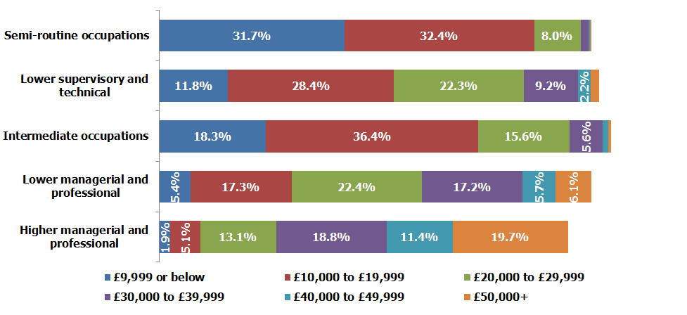
Source: APS 2010 (TBR Ref: W1.1/C9b)

Primary workforce wage band by gender
On the whole, Figure 31 illustrates that women in the primary science workforce are more likely to be in the two lowest wage bands than males. The £20K to £49,999 wage band contains similar proportions of male and females, demonstrating something close to parity between the genders. However, there remains an appreciable difference (4.2 percentage points) between those men and women in the primary science workforce earning the highest wage band.
However, women in the primary science workforce are likely to be higher earners than women in the total workforce. For example, only 4.6% of women in the total workforce are in the two top wage bands whereas 14.9% of women in the primary science workforce are in the two top wage bands. Furthermore, only 4.9% of women in the primary science workforce are within the lowest wage band, whereas 22.9% of women in the total workforce are earning £9,999 or below.
Figure 31: Primary workforce, gender and wage band
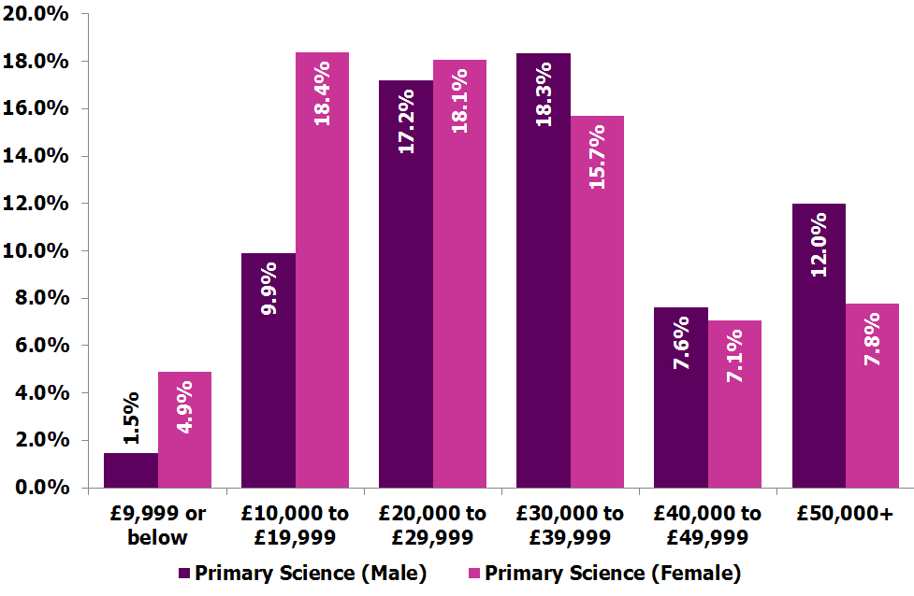
Source: APS 2010 (TBR Ref: W1.1/C9f)
Figure 32: Primary science and total workforce
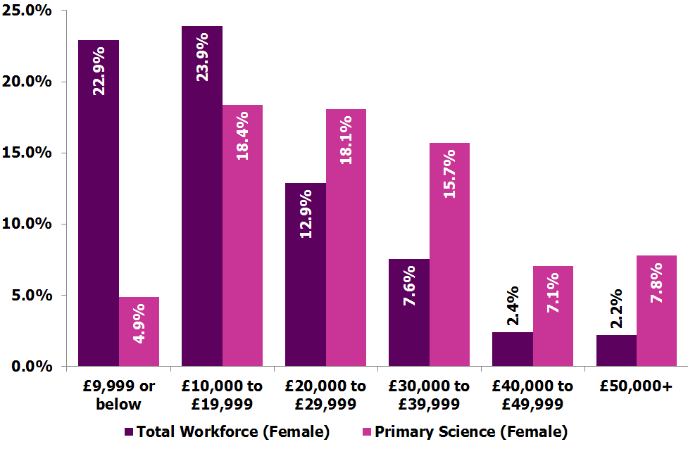
Source: APS 2010 (TBR Ref: W1.1/C9e)

Secondary Science Workforce
There is a similar trend evident in the overall comparison between the secondary science workforce and total workforce as seen earlier in the comparison between the primary and total workforce. Overall, those in the secondary science workforce are more likely to be in the top two socio-economic status groupings than those in the total workforce: 16% of the secondary science workforce are in the two top wage bands, with only 10.6% of the total workforce in the two top wage bands. Furthermore, those in the secondary science workforce are less likely to be in the top lowest wage bands than in the total workforce: 20.8% and 42.9% respectively.
Figure 33: Overall comparison between secondary and total workforce
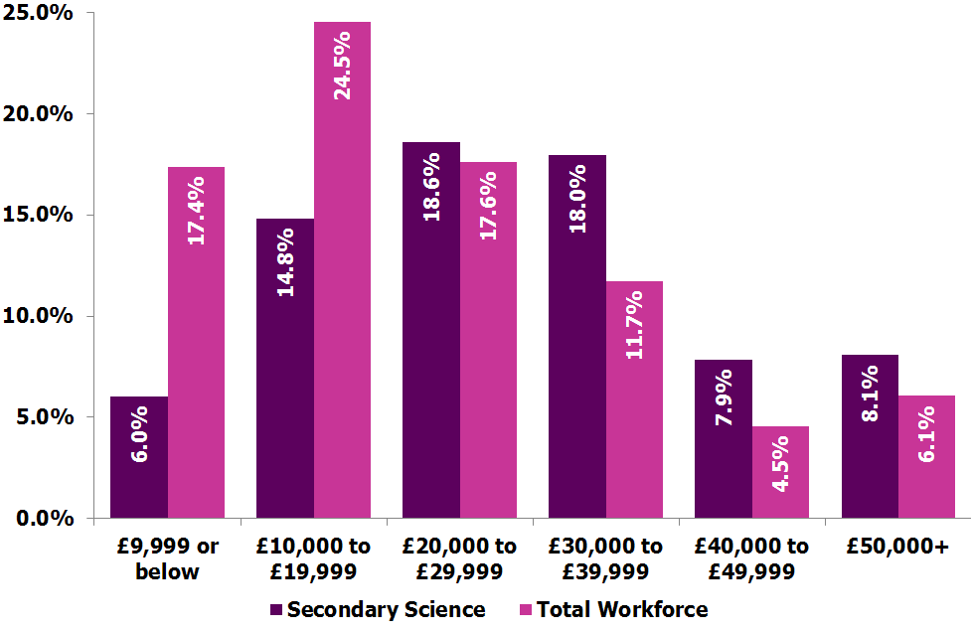
Source: APS 2010 (TBR Ref: W1.1/C9k)
There is a certain noteworthy phenomenon when the socio-economic status categories are compared between secondary science and total workforce, with respect to wage band (see Figure 34 & Figure 30). One interesting difference is that the secondary science workforce has more persons in Semi-Routines occupations earning £20K-£29,999 than those in the total workforce: 14.3% & 8% respectively. In addition, the secondary science workforce has a lower proportion of those in Semi-Routines occupations earning the lowest wage band when compared to the total workforce: 13.1% & 31.7% respectively. This finding suggests that the Semi-Routine occupations are better paid in the secondary science workforce than the total workforce.
Another aspect of the secondary science workforce is that they have a higher proportion of Lower Managerial and Professionals earning in the top three wage bands (£30K+) than the total workforce: 35.4% and 29% respectively. However, the secondary science workforce has a slightly smaller amount of Higher Managerial and Professionals earning the top wage band (£50K+) when compared with the total workforce: 17.1% and 19.7% respectively.
Overall, these findings illustrate that in general the secondary science workforce has substantially less of the workforce earning the lowest wage bands than the total workforce. However, when the socio-economic status categories are examined in detail it can be shown that those in the highest ranked occupations in the secondary science workforce are less likely to be in the top wage band than those in the total workforce.
Figure 34: Secondary workforce and wage band
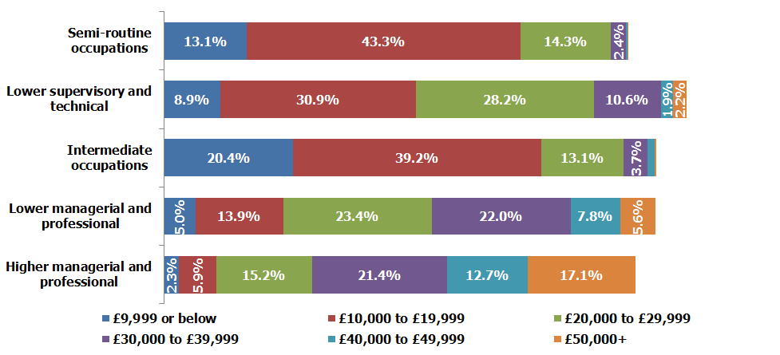
Source: APS 2010 (TBR Ref: W1.1/C9c)
Figure 35: Secondary science, gender and wage band
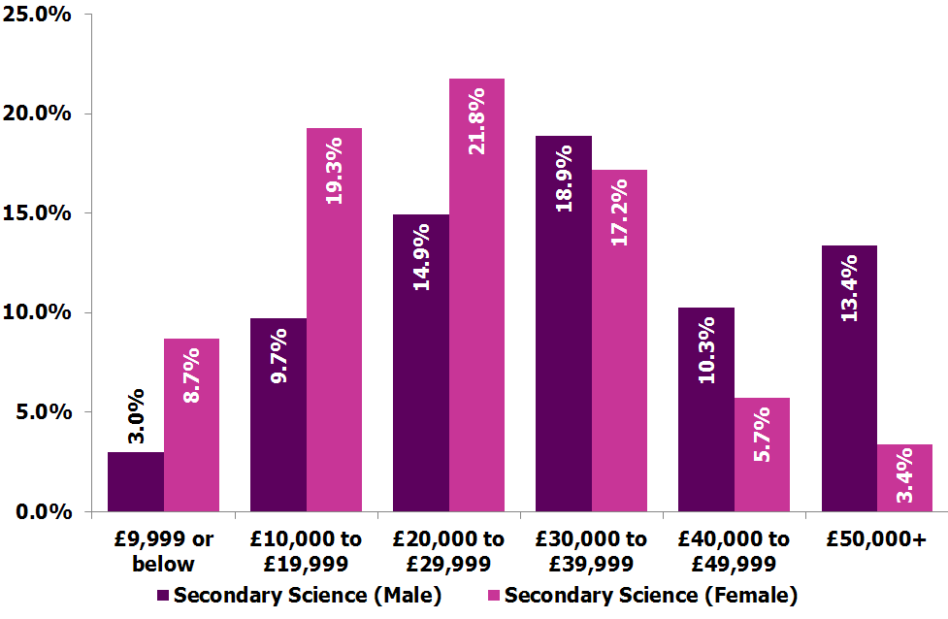
Source: APS 2010 (TBR Ref: W1.1/C9g)
Figure 35 illustrates males in the secondary science workforce are more likely to be in the highest wage bands than females. Surprisingly, 10% more males are earning the highest wage band than females (13.4% compared with 3.4%). In addition, females are more likely to be in the lowest wage bands, with 28% earning £19,999 or less, with only 12.7% of males in a similar situation. These findings suggest that more can be done to create a situation with more parity in wage band earning between genders in the secondary science workforce. It also is supported by the qualitative findings linked to gender around organisational culture and perceptions of the workforce (Section 6, page 31).

Overall Science Workforce
The science workforce has a higher proportion of workers in higher and lower managerial and professional occupations that earn £9,999 or below when compared with the total workforce. This characteristic is also evident, to a lesser degree, in intermediate occupations (see Figure 36).
Figure 36: £9,999 or below and Occupation
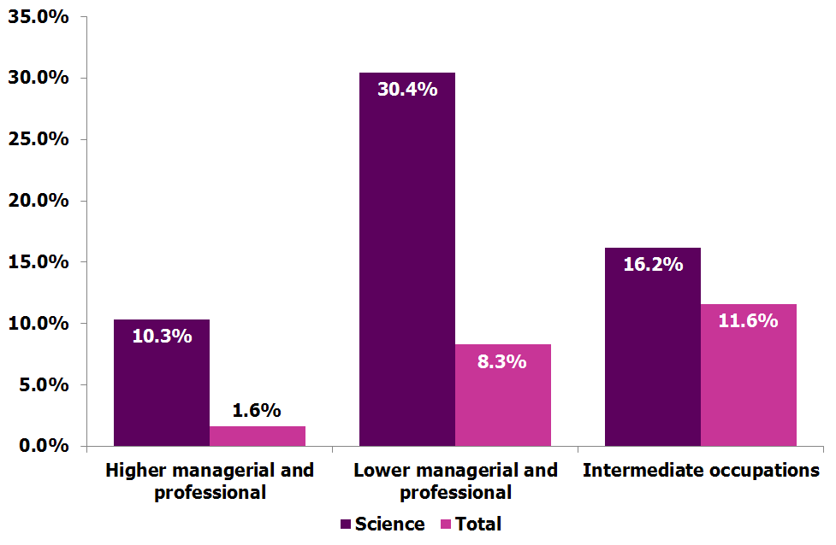
Source: APS 2011 (TBR Ref: W1/C9a)
A higher proportion of workers in the Higher managerial and professional socio-economic status grouping in the total workforce are earning £50k+ compared with the science workforce (19.7% to 17.2%).
Those earning £50k+ in the science workforce are more likely to be higher managerial and professional socio-economic status grouping than those in the total workforce (58.5% compared with 49%).
The science workforce has a lower proportion of workers in the routine occupations socio-economic status grouping in the lowest wage group, £9,999 or below, than in the total workforce (22% compared with 28.2%). However, there are a
higher proportion of workers in routine occupation socio-economic status grouping in the total workforce earning £20,000-£29,999 than in the science workforce (12.4% compared with 4.8%). These figures indicate that the science workforce is better for ensuring routine occupation employees are not in the lowest wage band, but more unlikely than the total workforce of providing a routine occupation than earns £20,000+.
Figure 37: Higher managerial and professional comparison
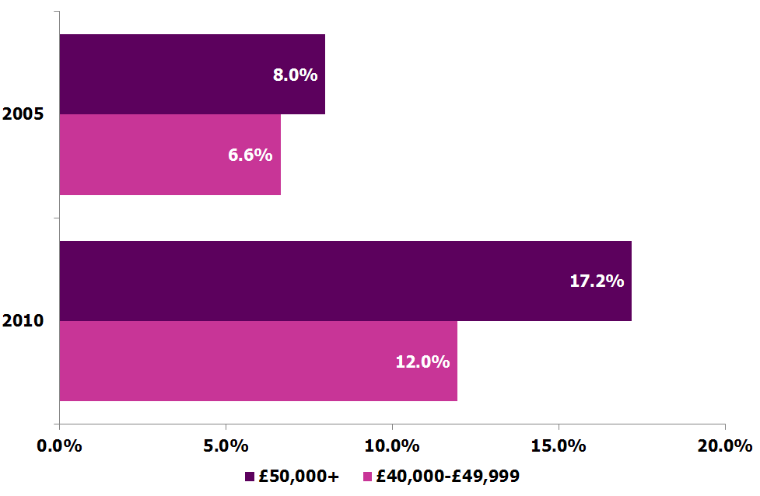
Source: APS 2011 (TBR Ref: W1.1/C9n)
There are two noteworthy trends worth outlining from a historical comparison, which suggest an increase in the polarisation of wage bands between managerial and professional socio-economic status groupings compared to other groupings.
First, there has been an increase in the proportion of workers in managerial and professional socio-economic status grouping earning higher wages bands in the science workforce. The above figure illustrates an increase in the proportion of workers in higher managerial and professional socio-economic status grouping earning either £40,000 to £49,999 or £50k+ when comparing 2005 with 2011. A similar increase has also been experienced in the science workforce for workers in the lower managerial and professional socio-economic status grouping: 3.1% to 7.6% for £40,000 to £49,999 and 1.8% to 5.3% for £50k+.
Second, there has been a slight increase in the proportion of the science workforce within routine occupation socio-economic status grouping, that are earning £9,999 or below (19.3% to 22%). A similar trend is apparent in the proportion of workers in lower supervisor and technical, earning the lowest wage band (4.5% to 6.8%).
However, it should be noted that the two trends identified are evident within the total workforce and not unique to the science workforce.
Figure 38: Science workforce, gender and wage band for intermediate occupations
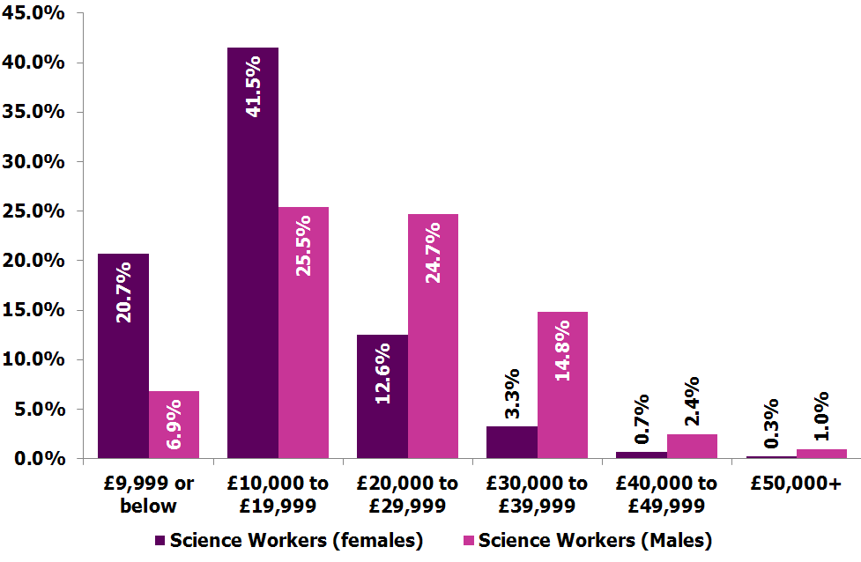
Source: APS 2011 (TBR Ref: W1.1/C9l)
Figure 38 demonstrates that in the science workforce females in intermediate occupations are more likely to be in the in the lower wage bands (£19,999 or below) than males: 62.2% of females are in the two lowest wage bands, compared with 32.4% of males. This finding suggests a present inequality between genders in this occupational category in the science workforce when it comes to wage band.
Figure 39: Science workforce, gender and wage band for higher managerial and professional
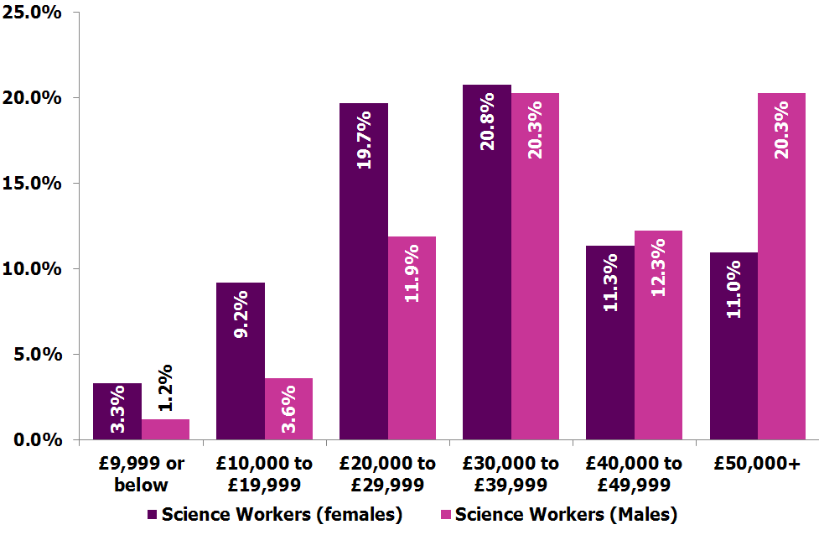
Source: APS 2011 (TBR Ref: W1.1/C9m)
A similar imbalance in wages occurs in the science workforce for Higher Managerial and Professional occupations, as shown in Figure 39 above. At present, there are a substantially higher proportion of females in the wage bands £10,000 to £19,999 and £20,000 to £29,999 than males: 28.9% and 15.5% respectively. In addition, there are a higher proportion of males (20.3%) in Higher Managerial and Professional occupations in the highest wage band than females (11%).

Comparison
This section provides a brief comparison between the primary science workforce, the legal workforce and the total workforce by focusing on some of the main indicators of diversity (e.g. age, ethnicity, gender). This is partly to contextualise the data analysis and also to benchmark how the science workforce compares with another workforce, which similarly faces issues with diversity. It should be noted that there is a considerable size difference in the volume of each workforce:
- The legal workforce contains 288,662 people
- The primary science workforce is 1,245,290 people (without health it is 758,600)
- The total workforce is 28,693,810 people
The size of the legal workforce should be sufficient to produce robust data, but nevertheless a smaller sample size is more vulnerable to impairments of data integrity. The relatively narrow definition of the legal workforce makes the primary science workforce the most appropriate of the three science workforce classifications to compare it to.
Table 26: Comparison of the four most senior socio-economic status groups (2011)
NS-SEC Category | Primary Science workforce | Primary Science workforce without Health | Legal Workforce | Total Workforce
Higher managerial and professional | 52.9% | 43.5% | 59.4% | 15.1%
Lower managerial and professional | 24.5% | 32.2% | 10.3% | 26.7%
Intermediate occupations | 7.9% | 9.2% | 27.6% | 11.0%
Small employers and own account workers | 2.0% | 2.5% | 1.6% | 10.0%
Source: APS 2011 (TBR Ref: W1.1:S1b & W2:S1)
Overall, there are notable differences in the composition of the respective workforces. Table 26, above, illustrates that the legal workforce has a higher proportion of employees in higher managerial and professional and intermediate occupations in comparison to the primary science workforce. In contrast, the primary science workforce has a greater proportion of lower managerial and professional and, to a lesser degree, small employers and own account employees than the legal workforce.
Overall, the legal workforce has a higher proportion of females (58.5%) than the primary science workforce (38.3%). However, females are relatively underrepresented in the Higher managerial and professional socio-economic status group within the legal workforce (46.5%). In contrast, females are relatively overrepresented in this socio-economic status group within the primary science workforce (41.2%). This would suggest that whilst relatively fewer women are employed within the primary science workforce, those that are appear slightly more likely to secure a senior position within the sector.
The primary science workforce is marginally more ethnically diverse than the legal workforce. The primary science workforce has a lower proportion of employees with white ethnicities (81.0%) than the legal workforce (85.1%). In addition, the primary science workforce has a much greater proportion of non-white persons in the Higher managerial and professional socio-economic status group (20.3%) than the legal workforce (10.8%). This reinforces the notion that cultural and parental pressure can often influence career choice and that science (and particularly health) are desirable in Asian or Asian British ethnic groups.
The primary science workforce contains a similar proportion of persons that are disabled (11.9%) to the legal workforce (11.7%). In particular, the science workforce has a higher proportion of workers in lower managerial and professional (14.3%) and intermediate occupations (15.7%) groupings with a disability than the legal workforce (11.1% and 12.7% respectively).

Comparison key messages
It is clear that many of the key gaps are not unique to the science workforce. As such there is a requirement for any proposed future intervention to consider what is occurring outside the sector. Whilst there has been some work across the legal workforce to increase diversity, activities pursued by organisations such as the Sutton Trust and the Law Society, for example, there remains a lack of focus (and success) in dealing with socio-economic status issues. This is similar to the science workforce and demonstrates what some interview respondents described as a “British unwillingness to talk about or investigate class”.

Deriving Socio Economic Status
This section outlines how the Socio Economic Status is derived within the Annual Population Survey. It draws upon resources available from the Office for National Statistics (ONS) and the Economic and Social Data Service (ESDS). The ONS uses the Nation Statistics Socio Economic Classification to measure the employment relations and conditions of occupations, which are seen to be central to showing the structure of socio-economic status. The NS-SEC is an occupationally based classification but is able to cover the whole adult population. The information required to create the NS-SEC is:
- Occupations coded to Standard Occupation Classification 2010
- Details of employment status: whether an employer, self-employed or employee; whether a supervisor; and the number of employees at a workplace.
In the past, similar information was required for Social Class and and Socio-economic Group. In using these two bits of information. The NS-SEC aims to differentiate positions within labour markets and production units in terms of their typical ‘employment relations’. There are diverse employment relations amongst employees and they occupy different labour market and work situations.
It is noted that this definition does and conceptual basis does not remove all barriers to explaining what socio-economic status is. Employment is not the only determinant of life chances and not everything can be explained by what a classification directly measures. However, a properly constructed and validated classification such as the NS-SEC removes at least one barrier to explanation and improves the possibility of explaining them. As it measures employment relations, i.e. aspects of work and market situations and of the labour contract, it enables us to more readily construct linkages that between NS-SEC outcomes and a variety of variables.
In order to derive the NS-SEC, three methods are used; full, simplified and reduced. These all require information on the industry of respondents in order to code occupations to the SOC2010 four-digit unit groups. The methods slightly vary (due to focus upon operations or analytics) but largerly follow thesame steps for deriving the NS-SEC. These are:
- Step 1: Code occupation to the SOC2010 four-digit unit group
- Step 2: Follow procedures when the answers to questions on employment status and size of
- organisation are missing Combine answers in the APS to produce the employment status/size of organisation variable
- Step 3: Derive the employment status/size of organisation variable. When considering the size of organisation for the full derivation method, a major organisation is taken as one employing 500 or more people.
- Step 4: Derive the NS-SEC category using a derivation matrix. The NS-SEC category is taken from the cells for SOC2010 unit group and employment status/size of organisation to provide a simplified NS-SEC.

Science Workforce Definition
In order to develop a definition for the science workforce, the research uses a previously used definition which was established between TBR and the Science Council’s New Registers Advisory Group. All occupations have a Standard Occupational Classification (SOC) code, these codes have then been split in to three groups based on their activities, namely Primary Science, Secondary Science and Non-Science.

This splitting up guided the identification of:
- Primary science workers: workers in occupations that are purely science based and require the consistent application of scientific knowledge and skills in order to execute the role effectively. E.g. Chemists, Science & Engineering Technicians, Pharmacists & Pharmacologists or Bio Scientists and Biochemists.
- Secondary science workers: workers in occupations that are science related and require a mixed application of scientific knowledge and skills alongside other skill sets, which are often of greater importance to executing the role effectively. E.g. Civil and Mechanical Engineers, Conservation & Environmental Protection Officers, Environmental Health Officers, Teaching Professionals.
- Non-science workers: workers in occupations that are not science based and have no requirement for science based knowledge or skills. E.g. Travel Agents, Town Planners, Musicians, Legal Professionals, and Housing & Welfare Officers.
This definition work is not without its pitfalls, many SOCs can be argued to be connected to primary science. However, there is a certain amount of debate as to where individuals fall. With no recognised definition of the science workforce, this definition allows more detailed intelligence to be created and helps to “much more information than available previously”.
Table 27: Primary Science SOC Grouping

SOC | Description | Grouping
1137 | Research and development managers | Primary Science
1212 | Natural environ & cons managers | Primary Science
2111 | Chemists | Primary Science
2112 | Bio scientists and biochemists | Primary Science
2113 | Physts, geologists & meteorologists | Primary Science
2125 | Chemical engineers | Primary Science
2129 | Engineering professionals n.e.c. | Primary Science
2211 | Medical practitioners | Primary Science
2212 | Psychologists | Primary Science
2213 | Pharmacists & pharmacologists | Primary Science
2214 | Ophthalmic opticians | Primary Science
2215 | Dental practitioners | Primary Science
2216 | Veterinarians | Primary Science
2321 | Scientific researchers | Primary Science
3111 | Laboratory technicians | Primary Science
3112 | Electrical & electronic technicians | Primary Science
3113 | Engineering technicians | Primary Science
3114 | Build & civil eng technicians | Primary Science
3115 | Quality assurance technicians | Primary Science
3119 | Science & eng technicians n.e.c. | Primary Science
3213 | Paramedics | Primary Science
3214 | Medical radiographers | Primary Science
3218 | Medical and dental technicians | Primary Science
5249 | Elec & electronic engineer n.e.c. | Primary Science
6113 | Dental nurses | Primary Science
6131 | Veterinary nurses and assistants | Primary Science
8114 | Chem and related process operatives | Primary Science
8138 | Routine laboratory testers | Primary Science

Table 28: Secondary Science SOC Grouping
SOC | Description | Grouping
1111 | Senior officials in national gov | Secondary Science
1113 | Senior officials in local gov | Secondary Science
1122 | Managers in construction | Secondary Science
1123 | Managers in mining and energy | Secondary Science
1136 | Info & communication technol mngers | Secondary Science
1181 | Hospital and health service mngers | Secondary Science
1182 | Pharmacy managers | Secondary Science
1183 | Healthcare practice managers | Secondary Science
1184 | Social services managers | Secondary Science
1211 | Farm managers | Secondary Science
1219 | Mngr anml hsbndry, frst, fish nec. | Secondary Science
2121 | Civil engineers | Secondary Science
2122 | Mechanical engineers | Secondary Science
2123 | Electrical engineers | Secondary Science
2124 | Electronics engineers | Secondary Science
2127 | Production and process engineers | Secondary Science
2132 | Software professionals | Secondary Science
2311 | Higher educ teaching prfsnals | Secondary Science
2312 | Further educ teaching prfsnals | Secondary Science
2313 | educ officers,school inspectrs | Secondary Science
2314 | Secondary eductn teaching prfsnals | Secondary Science
2315 | Prim & nurs eductn teaching profs | Secondary Science
2316 | Spec needs educ teaching profs | Secondary Science
2317 | Registrs & sen admins ed establish | Secondary Science
2319 | Teaching professionals n.e.c. | Secondary Science
2322 | Social science researchers | Secondary Science
2329 | Researchers n.e.c. | Secondary Science
2423 | Mngmnt cons, actuar, econs & statn | Secondary Science
2441 | Public service administrative profs | Secondary Science
3211 | Nurses | Secondary Science
3212 | Midwives | Secondary Science
3215 | Chiropodists | Secondary Science
3216 | Dispensing opticians | Secondary Science
3217 | Pharmaceutical dispensers | Secondary Science
3221 | Physiotherapists | Secondary Science
3222 | Occupational therapists | Secondary Science
3223 | Speech and language therapists | Secondary Science
3229 | Therapists n.e.c. | Secondary Science
3551 | Conservat & environ protection offs | Secondary Science
3568 | Environmental health officers | Secondary Science
4114 | Officers non-gov organisations | Secondary Science
4211 | Medical secretaries | Secondary Science
6111 | Nursing auxiliaries and assistants | Secondary Science
6112 | Amb staff (excluding paramedics) | Secondary Science
6139 | Animal care occupations n.e.c. | Secondary Science
8111 | Food, drink & tobac process operat | Secondary Science
8115 | Rubber process operatives | Secondary Science
8116 | Plastics process operatives | Secondary Science
8124 | Energy plant operatives | Secondary Science
8131 | Assemblers (electrical products) | Secondary Science
8132 | Assemblers (veh and metal goods) | Secondary Science
8133 | Routine inspectors and testers | Secondary Science
9119 | Fishng & agric reltd occupatns nec. | Secondary Science

Due to the data used, sexual orientation was not investigated.
http://www.bis.gov.uk/policies/science/science-and-society/stem-skills/diversity-in-science
http://www.sciencecouncil.org/sites/default/files/UK_Science_Workforce_FinalReport_TBR_2011.pdf
http://www.bis.gov.uk/policies/science/science-and-society/stem-skills/working-in-science
http://www.hefce.ac.uk/aboutus/sis/stem.htm
University and College Union, Degrees of decline? Core science and mathematics degree courses in the UK between 1998-2007, November 2006,
HM Treasury, Set For Success, 2006, available at; http://www.hm-treasury.gov.uk/d/robertsreview_introch1.pdf
BIS, Stem Graduate in Non Stem Jobs (2011), available at: http://www.bis.gov.uk/assets/biscore/further-education-skills/docs/s/11-771-stem-graduates-in-non-stem-jobs
BIS (2009) Demand for STEM skills, available at: http://www.bis.gov.uk/assets/biscore/corporate/migratedD/publications/D/Demand_for_STEM_Skills
Department for Education and Employment, The labour market for science, engineering and IT graduates: are there mismatches between supply and demand? Research Report 112: London, 1999. https://www.education.gov.uk/publications/eOrderingDownload/RB112.pdf
http://www.raeng.org.uk/news/releases/pdf/The_Labour_Market_Value_of_STEM_Qualifications_and_Occupations.pdf
http://www.thedataservice.org.uk/NR/rdonlyres/DDDF7114-B12E-4079-B7B3-9DE43EEE3A96/0/FESTEMDatareportJuly2011.pdf
http://www.raeng.org.uk/news/releases/pdf/The_Labour_Market_Value_of_STEM_Qualifications_and_Occupations.pdf
OECD Science, Technology and Industry Scoreboard 2011: http://www.oecdilibrary.org/docserver/download/fulltext/9211041ec014.pdf?expires=1334831173&id=id&accname=guest&checksum=52B38F61F36937B884CE4C54DD9D32E5
EU Labour Force Survey; US Current Population Survey; Australian, Canadian, Japanese and New Zealander labour force surveys, Korean Economically Active Population Survey, China Labour Statistical Yearbook 2010, Indian National Sample Survey and ILO Laborsta Database, May 2011.
OECD Science, Technology and Industry Scoreboard 2011:
http://www.nsf.gov/statistics/seind08/pdf/c03.pdf
http://www.nsf.gov/statistics/seind08/pdf/c03.pdf
http://www.sciencecouncil.org/content/science-workforce
http://www.employment-studies.co.uk/pubs/report.php?id=475
http://www.iop.org/publications/iop/2012/page_55925.html
It should be noted that a number of occupations (particularly engineers) could equally fall into primary science workforce. For more information, please go to the appendix (Section 9.11).
D.Rose (1998) The ESRC Review of Government Social Classifications Swindon: ESRC London: ONS.
Ibid
http://www.ons.gov.uk/ons/guide-method/classifications/archived-standard-classifications/soc-and-sec-archive/ns-sec-derivation-tables-based-on-soc2000--excel-.xls
There are also likely to be difficulties in categorising science occupations, particularly those in SMEs. Further work needs to understand how science occupations are categorised and whether the classifications and occupation codes need refining to reflect the range of science occupations.
HM Government (2012) White Paper: Open data, unleashing the potential: http://data.gov.uk/sites/default/files/Open_data_White_Paper.pdf
For example, excluding health from the primary science workforce reduces the proportion of the science workforce in the Higher managerial and professional socio-economic status group, whilst excluding health from the secondary science workforce has the opposite impact.
People with disabilities are still underrepresented in the science workforce, despite the rate at which diversity increased outperforming the total workforce between 2005 and 2011.
http://www.athenaswan.org.uk
http://www.iop.org/policy/diversity/initiatives/juno/index.html
http://www.ukmusic.org/edc/the-charter
http://www.stonewall.org.uk/at_work/diversity_champions_programme/default.asp
http://www.cih.org/equalityanddiversitycharter
http://www.legalservicesboard.org.uk/what_we_do/consultations/closed/pdf/decision_document_diversity_and_social_mobility_final.pdf
http://www.legalservicesboard.org.uk/what_we_do/consultations/closed/pdf/decision_document_diversity_and_social_mobility_final.pdf
http://www.bmj.com/content/328/7455/1545
http://www.iop.org/publications/iop/2012/page_55925.html
http://www.lawsociety.org.uk/practicesupport/equalitydiversity/inclusioncharter/procurementprotocol.page
http://www.lawsociety.org.uk/new/documents/2011/procurement%20report.pdf
http://www.london2012.com/documents/business/diversity-and-inclusion-business-charter.pdf
http://www.cipd.co.uk/hr-resources/practical-tools/diversity-business-case.aspx
http://www.cipd.co.uk/hr-resources/factsheets/diversity-workplace-overview.aspx
http://www.equalityhumanrights.com/uploaded_files/ehrc_education_60pp.pdf
Unleashing Aspiration: The Final Report of the Panel on Fair Access to the Professions, Cabinet Office 2009
FE STEM Data Project, Royal Academy of Engineering, July 2011
http://www.cogent-ssc.com/Apprenticeships/HA_Life_Sciences_Chemical_Science.php
http://www.cipr.co.uk/node/107177
http://www.bis.gov.uk/policies/higher-education/access-to-professions/gateways-to-professions
http://www.cstt.org.uk/
http://www.manchester.ac.uk/undergraduate/schoolsandcolleges/post-16/map/
http://www.pwc.co.uk/government-public-sector/issues/higher-apprenticeships.jhtml
The launch of the Science Council’s Registered Scientist and Registered Science Technician provides the basis for developing diversity by recognising non-traditional qualifications.
http://www.sciencecouncil.org/10-types-scientist
Graduate schools in the US require students to sit the GRE Test. GRE provides a common measure for comparing candidates' qualifications. GRE scores are used by admissions or fellowship panels to supplement undergraduate records, recommendation letters and other qualifications for graduate-level study. Prospective graduate and business school applicants from all around the world take the GRE.
http://www.direct.gov.uk/en/disabledpeople/employmentsupport/lookingforwork/dg_4000314
http://www.ncbi.nlm.nih.gov/pmc/articles/PMC27252/
http://www.primecommitment.org
http://www.efd.org.uk/recruitment/recruitment-agencies
This is perception is supported in the UK science workforce research gender analysis for primary and secondary science worker.
Using the definition of social capital as the linkages, values and bonds in society that facilitate co-operation within or among groups and enable individuals and groups to benefit, exclude others or reinforce dominance or privilege.
ASPIRES – Science Aspirations and Careers Choice five year longitudinal study of 10-14 year olds. http://www.kcl.ac.uk/sspp/departments/education/research/aspires/index.aspx
http://www.britishecologicalsociety.org/getting_involved/mentorship.php
For example, The Science Council can build on its 10 types of scientist? work with HEIs to support increased awareness of the wide range scientist roles within the workforce.
See definition in section 6.9.
A. Diamond (1996) The Economics of Science - Knowledge, Technology & Policy, Volume 9, Numbers 2-3 (1996), 6-49, DOI: 10.1007/BF02696298
M. Berge (1988). Predicted future earnings and choice of college major. Industrial and Labor Relations Review, vol. 41, issue 3, pages
http://www.guardian.co.uk/society/2009/jun/03/women-doctors-nhs-medicine-review
A further 12.5% indicated they were unsure about the size of their workforce, they provided rough indications but these were excluded from the final analysis.
http://www.timeshighereducation.co.uk/story.asp?storyCode=192584&sectioncode=26
Although without health this is 84.4%.
http://www.ons.gov.uk/ons/guide-method/classifications/current-standard-classifications/soc2010/soc2010-volume-3-ns-sec--rebased-on-soc2010--user-manual/index.html#13
Full details on the derivation are available from the ONS here: http://www.ons.gov.uk/ons/guide-method/classifications/current-standard-classifications/soc2010/soc2010-volume-3-ns-sec--rebased-on-soc2010--user-manual/section-13--deriving-the-ns-sec--full--reduced-and-simplified-methods.pdf
http://www.agcas.org.uk/agcas_resources/379-The-current-and-future-UK-science-workforce

