Leading the way: increasing the diversity of the science workforce
Project two: exploring the impact of socio-economic background on careers in science
For the Royal Society






tbr knows… economics, creative, skills, environment

economic research & business intelligence



Leading the way: increasing the diversity of the science workforce
Project two: exploring the impact of socio-economic background on careers in science
For the Royal Society

Prepared by TBR’s Skills and Labour Market Team
Enquiries about this report can be addressed to:
Andrew Rowell, Senior Research Analyst
Fiona Dodd, Head of Research
28 July 2026

Suite One Top Floor, Burgess House,
93-105 St James Boulevard,
Newcastle upon Tyne, NE1 4BW

Telephone: +44 (0) 191 279 0900
Fax: +44 (0) 191 221 2220
Email: info@tbr.co.uk
www.tbr.co.uk

Project Reference Number | PN031120
File Name | input.doc
Title | Progression in Science
Version number | Final V2
Last update | 03/10/2013
Name of Author | Andrew Rowell, Jonathan Guest
Name of Reviewer | Anna Morgan, Fiona Dodd
Document Status | Confidential
Review Status | Complete
Approval Status | Final
Document Information

Table of Contents
1. Headline Summary 1
2. Introduction 3
2.1 Aims 3
2.2 Structure of the document 4
3. Approach 5
3.1 Data 5
3.2 Methodology statement 6
4. Definitions 7
4.1 Science workforce and sectors 7
4.2 Socioeconomic background 7
4.3 Other defined characteristics 8
5. Context 10
5.1 Age 16 - 1986 10
5.2 Age 26 - 1996 11
5.3 Ages 30 and 34 – 1999-2000 and 2004-2005 12
5.4 Age 38 – 2008-2009 13
6. Evidence and Analysis 16
6.1 Working in science 16
6.2 Progression in science 22
6.3 Career and employment breaks 27
7. Concluding remarks 30
7.1 Practical conclusions 31
8. Appendix 32
8.1 Science Workforce Definition 32
8.2 Literature review 32
8.3 Data preparation 33
8.4 Data definitions 35
8.5 Analysis 45
8.6 Data sources 46

Headline Summary
- TBR was commissioned by the Royal Society as part of a programme of work which explores the barriers to diversity within the science workforce. TBR investigated career pathways and variations according to socioeconomic background, using data from the British Cohort Study 1970 (BCS70).
- This research develops new evidence on the linkages between pathways, progression routes and key transition points in a science career and how these vary according to socio-economic background.
- This section contains the headlines from the research. Further detail on the aims of the project, the approach, definitions and context as well as further information relating to the evidence and analysis are included in the main body of the report.
Impact of Education
- The longer an individual spends in continuous full-time education, and the higher their qualifications on leaving, the more likely they are to work in science.
- Those leaving education with degree-level or postgraduate qualifications were twice as quick to start a science career as individuals leaving school without five O-levels or equivalent.
- The higher an individual’s level of qualification on leaving continuous full-time education and the longer an individual spends in continuous full-time education, the faster they are likely to progress to a professional level occupation after entering science at a lower level.
- At technician level those who achieved Level 3 qualifications (two A-levels or equivalent) by the time they had left education progressed more quickly to technician level occupations than those leaving education without qualifications at this level.
Working in science
- Men are slightly (1.2 times) more likely than women to have worked in science.
- People from white ethnic backgrounds are 1.5 times more likely to have worked in science than those from black or ethnic minority communities.
- The higher an individual’s parental social class or parental education attainment, the more likely they are to work in science. The relationship between household income during childhood and the likelihood of working in science is less clear.
Time taken to enter science
- A high proportion (70%) of individuals join the science workforce around the ages of 29–34.
- Women tend to take longer to enter science after leaving continuous full-time education than men.
- Individuals from lower socioeconomic backgrounds generally take longer to enter science after leaving continuous full-time education than those from higher socioeconomic backgrounds.
Career patterns in science
- Men are more likely to have spent their entire working life in science than women (approximately 50% of women who have worked in science started work in another sector, compared with approximately 33% of men).
- Generally, people from higher socioeconomic backgrounds are more likely to work in science education than those from lower socioeconomic backgrounds. Conversely, people from lower socioeconomic backgrounds tend to be more likely to work in manufacturing than those from higher socioeconomic backgrounds.

Progression to higher occupational levels
- People who have worked in science at some point in their career are more likely to reach higher occupational levels than those who have never worked in science.
- Working in science can also impact on career progression in other sectors. Compared with those who have never worked in science, people who work in science are more likely to reach higher level occupations even if they leave the sector.
- Among those who have worked in science, the higher an individual’s socioeconomic background the more likely they are to progress to higher occupational levels. E.g. Science workers living in households in the highest income bracket (£20,800 or over) at age 16 are more than 5 times as likely to progress to a professional level occupation than those in the lowest household income bracket (less than £5,199 pa).
Speed of progression to higher occupational levels
- It takes women in science longer to progress to technician level occupations than men.
- Among those who have worked in science, individuals from lower socioeconomic backgrounds take longer to progress to technician and professional level occupations than those from higher socioeconomic backgrounds.
Patterns of career breaks
- Women who have worked in science are less likely to have taken a career break than those who have never worked in science. Women who have worked in science also take shorter career breaks than women who have never worked in science.
- The women who have worked in science and taken a career break are more likely to have done so to have a baby than women who have never worked in science: 27% of the career breaks taken by women in science are associated with the birth of a child, compared with 17% of the career breaks taken by women who have never worked in science.
Career breaks and career progression
- Within the science workforce, women in higher level occupations are less likely to take a career break than those in lower level occupations.
- The evidence suggests that career breaks hinder progression to the highest occupational levels since women who take a career break are less likely to progress to professional level occupations. Among those who do progress to higher occupational levels, women who take career breaks tend to take longer to progress than women who do not take career breaks.
- The majority of women who take a career break return to work on a part-time basis, even if they worked full-time previously. Women in science who took a break were slightly more likely to return on a part-time basis than those who have never worked in science.
- Women in science taking a career break to have a baby are more likely to return to work part-time than those who have never worked in science and take a career break to have a baby.
- Women in science were less likely to return to work at a lower occupational level than their position immediately before taking a career break than those who have never worked in science. Furthermore, women in science were more likely to return to work at a higher occupational level after taking a career break than those who have never worked in science.

Introduction
The Royal Society is currently delivering a four year programme (2011 – 2015) to develop a greater understanding of the barriers to diversity within the science workforce. The programme is interested in diversity in terms of gender, ethnicity, disability and socioeconomic status in the first instance
As part of the programme TBR was commissioned to explore career pathways within the science workforce and consider variations according to socioeconomic background. Specifically, this research provides insight into the interplay of socioeconomic background and the diversity characteristics noted above. This report follows research already undertaken to understand how representative the science workforce is of the wider population in terms of socioeconomic status and supports the identification of factors that limit participation and solutions to promote diversity.

Aims
The aim of the research is to define and understand the pathways, progression routes and key transition points in science careers and how this varies according to socioeconomic background (SEB). This involves delivering the following objectives:
- Consider movements in and out of the science workforce; including how people enter the sector, where they progress to and what the impact of career breaks and other gaps in employment are.
- Compare the career transitions of the science workforce with the wider population.
- Contextualise any change in the participation in the science sector with historical economic information to understand whether there appears to be any shifts in participation not explained by changes in the sectoral makeup of the economy.
Taking these objectives into account, the following research questions were identified by the Royal Society as being integral to supporting their work:
Does SEB impact on:
- Likelihood of entering the science workforce?
- Routes into the sector? Is there a typical route (E.g. school – university – science workforce) and is this different depending on SEB? Are there alternative routes into the sector? (E.g. apprenticeships?)
- How long people take to enter the sector?
- The speed of progression through occupational levels?
- The ability to reach the higher occupational levels?
Career/employment breaks and their impact:
- Does the science workforce have a different pattern of career breaks to the wider population?
- What is the impact of a career break on progression through the sector?
- Specifically, do women in science behave differently from women in other professions following the birth of children? Are they more or less likely to return to work and/or change career?
Generally:
- Can any differences be explained by trends in the wider economy/social context/specific events?
Following a review of the data it became clear that the analysis could also explore key differences in progression in science between academic/research routes and industry routes. This has also been taken into account in the analysis.

Structure of the document
This document is structured so that the reader is given an overview of the approach taken throughout the research (section 3), including the data sources and key definitions. Following this, the key messages from the analysis are presented with supporting information (section 2) and lastly, future work is identified to support further understanding (section 7).

Approach
This section outlines the data sources and definitions used, and provides a brief methodological statement. The appendix provides more detail on the datasets, methodology, output tables and analysis.

Data
As part of the previous research into socioeconomic status, TBR explored the feasibility of using existing secondary data to examine the role of socio-economic background in career progression. The investigation considered data sources that would allow comparison to be made between an individuals’ socioeconomic background and their socioeconomic progress in later life. The review suggested that the following datasets should be suitable:
- The British Household Panel Survey
The British Household Panel Survey (BHPS) is a longitudinal dataset that tracks households, and the individuals who have been part of them, over time and covers a broad range of economic and social indicators including employment, income and household relationships. This has now been replaced by the Understanding Society survey.
- The National Child Development Study
The National Child Development Study (NCDS) is a continuing, multi-disciplinary longitudinal study. It began when data were collected on 17,415 babies born in Great Britain (England, Scotland and Wales) between 3rd and 9th March in 1958. To date, there have been seven attempts to trace all members of the birth cohort in order to monitor their development in key domains – health, education, social and economic.
- The British Cohort Study of 1970
The British Cohort Study (BCS70) began in 1970 using data collected on births and families of babies born in the UK in one week in 1970. The first sweep aimed to compare social and biological characteristics of the mother with the results of the NCDS from 1958. Successive sweeps of the BCS70 gathered information on physical, educational, social and economic development characteristics of each participant (hereafter referred to as cohort members) rather than just medical information. The BCS70 was designed to replicate the success of the NCDS and therefore there is a considerable amount of compatibility between the data recorded in each series. To date the BCS70 has conducted 7 sweeps up to 2008-09 after the initial sample in 1970, with sweeps 4 (1996) to 7 (2008-09) taking place every four years.
All of the data sources contain extensive information on a number of topics from the individuals’ early lives to their adult careers and are stored in complex datasets. However, following review, the BHPS was not taken further because the surveyed sample decreases considerably and therefore loses the ability to track the careers of individuals in the initial sweep further into the study. The research continued to focus upon the BCS70 and the NCDS, but the data preparation stage identified some important gaps in the NCDS data. Crucially, it does not provide a classification for employment sector (but does have occupation) and does not give a consistent view of economic activity across the survey (specifically, periods of economic inactivity have poor coverage). As such, the research took forward the BCS70 as the sole source of data. The research draws on the BCS70 Activities Histories dataset, as well as variables from each of the BCS70 sweeps.
The BCS70 collected data on the births and families of babies born in the UK in one particular week in 1970. Survey information was collected at key points in survey respondents lives. The following table provides a record of respondent’s ages at different sweeps.
Table 1: BCS70 sweeps
Sweep number | Year of Sweep | Age at Sweep | Number in sweep
0 | 1970 | 0 | 16,571
1 | 1975 | 5 | 12,981
2 | 1980 | 10 | 14,350
3 | 1986 | 16 | 11,206
4 | 1996 | 26 | 8,654
5 | 1999-2000 | 30 | 10,833
6 | 2004-05 | 34 | 9,665
7 | 2008-09 | 38 | 8,874
Although there are almost half as many people in the 7th sweep (2008-09) compared with 1st (1970), the analysis depends greatly on information existing for us to conduct analysis. As such, certain analysis can lead to small sample sizes if cohort members are missing information on characteristics which are central to the analysis.

Methodology statement
The project followed three key methodological stages:
- Literature Review - a thorough literature review was undertaken to inform analysis, exploring previous work connected to the topic, how socioeconomic background is defined, the indicators used to measure it and other factors considered important in influencing an individual’s career path in science.

- Data preparation – This stage reviewed the variables available within the BCS70 and potential measures, classifications and indicators identified through the literature review to answer the research questions. The work also reviewed the changing composition of the total sample to judge whether people in specific socioeconomic groups are more likely to exit the sample.

- Data analysis - The data analysis employed a variety of statistical tests to answer the questions outlined in the introduction and assess the impact of SEB and other factors on routes into the sector and career progression. Two points to note:

- In reference to the likelihood of an event, 1 is the norm and therefore; “the event is 1.2 as likely to happen” - 1.2 is comparatively low.
- Within the graphs, the R² indicates how well data points fit a line or curve, the closer to 1 the figure, the more the regression line perfectly fits the data.
This report is the main outcome for this project.
Whilst these three phases are easily described on paper, in reality the process of manipulating this dataset in order to answer the questions was extremely challenging. As a result, significant resource was required to prepare the dataset and make it useable for this purpose. A large amount of coding was required to homogenise inconsistently held and captured data between each survey sweep and create a true time-series with consistent variables across the period. For example, each sweep uses a different categorisation of ethnicity. The team had to look at all the sweeps and connect them together and this was further complicated when the analysis required a combination of multiple variables from each sweep to create a measure. It’s not clear why the dataset is held in its current raw format. However, we would advise any researchers who subsequently decide to pursue an economic or labour market analysis to take the lessons learned in this project into account. A more detailed description of the main challenges is available in the appendix.

Definitions
This research project uses specific terminology which may be contested depending on opinion, but clarity on their use in this project is essential. These are summarised below:

Science workforce and sectors
There is no common definition of the science workforce. This is because the various activities and skills which occur in different science occupations cannot be easily separated. To illustrate the difficulty in creating a definition, teaching professionals are grouped together and this includes teachers of all subjects which makes it difficult to separate scientists and non-scientists. The definition used in this project was previously developed for the Science Council and used in the socioeconomic status research. This definition comprises of:
- Workers in occupations that are primarily science based and those in occupations that are science related and require a mixed application of scientific knowledge alongside other skill sets, which may be of greater importance to executing the role effectively. The definition is based on Standard Occupational Classification (SOC) codes and where the data is not precise the definitions have been aggregated. More information about this definition is in the appendix.

- Sectors that are primarily science based in their core activity as well as sectors that have a strong relationship to science. This again draws on definitions established for the Science Council and uses Standard Industrial Classifications (SICs). SICs can be grouped together and for the purpose of this research, we were able to analyse different sectors:
  - Academia (Higher Education and related activities),
  - Other education (Further Education and formal schooling),
  - Health (public and private),
  - Manufacturing,
  - Other science (all services and other activities).
A more detailed definition of the Science Sector is available on request (with detailed 3 digit SIC codes).

Socioeconomic background
Socioeconomic background describes the conditions of the household in which an individual lived as a child and is often closely related to the individual’s future life chances. Parental socioeconomic position is frequently used as a proxy for SEB. Following a review of other studies exploring SEB, the indicators used in this research include parental occupation, household income during childhood, the educational achievements of parents and an individual cohort member’s education (itself often used as a proxy measure of socioeconomic background). The SEB measures adopted were a mixture of the most useful indicators suggested by the literature review, and what it was possible to measure using BCS70 data.
Specifically, the following variables within BCS70 were used:
- Parental social class based on occupation, using the Registrar General’s Social Class (SC) classification:
- SC I - Professional occupations
- SC II - Managerial and technical occupations
- SC III N - Skilled non-manual occupations
- SC III M - Skilled manual occupations
- SC IV - Partly skilled occupations
- SC V - Unskilled occupations
- Household income at age 16, using figures not adjusted for inflation.
- Parents’ education:
- Highest age of either parent on leaving continuous full-time education.
- Highest qualification of either parent
- Cohort member’s education:
- Age the cohort member left continuous full-time education
- Highest qualification on leaving continuous full-time education

Other defined characteristics
There are thousands of variables available in the BCS70 and the potential for extensive supplementary analysis of the experiences of those from a range of backgrounds. A number other variables are analysed in the data:
Gender | The data makes clear distinctions between the genders. Later BCS70 sweeps record where someone’s gender has changed, but no cohort member in our analysis has undertaken gender reassignment.
Income | The following income brackets were used in the analysis to provide the analysis with an income/wealth socioeconomic background indicator:  - Less than £5,199 per annum (pa)  - £5,200 to £10,399 pa  - £10,400 to £15,599 pa  - £15,600 to £20,799 pa  - £20,800 or over  Adjusting these for inflation:  - Less than £12,915 pa  - £12,916 to £25,832 pa  - £25,833 to £38,749 pa  - £38,750 to £51,666 pa  - £51,667 or over
Ethnicity | Coding of ethnicity varies between BCS70 sweeps, depending on the Census classifications used at the time of each sweep. Due to the inconsistencies in survey coding it was difficult to develop an indicator which appropriately distinguishes between different minority ethnic groups. The analysis therefore distinguishes between cohort members from white ethnic backgrounds and those from black and ethnic minority communities.
Employment  - Breaks  - Entry to sector  - Leave sector | Activity and employment status of an individual across different sweeps is linked in the BCS70 Activity Histories dataset, to which a number of variables have been matched to create employment histories which help to identify when an individual takes a break from employment, moves in and out of working in science (occupations and sectors) and how long they spend in each role and sector.

Education  - Routes  - Qualifications | A detailed educational history was created by matching data from the various survey sweeps. This was used to provide a detailed account of each cohort member’s educational achievements, linked to their employment history. Limited data was available relating to type of school the cohort member attended and the institutions in which they achieved further qualifications, and it was not possible to explore routes into science in any great detail. Qualifications were coded against equivalent NVQ levels:  - Level 5 and above – Postgraduate qualifications  - Level 4 – First degree, teaching qualification, nursing qualification  - Level 3 – Two or more A-levels, RSA Advanced Diploma or Certificate  - Level 2 – Five or more O-levels, one A-level, RSA Diploma  - Below Level 2 – Less than five O-levels
Occupation  - Level | An individual’s occupations are categorised according to the level of skill associated with each occupation. Skill levels reflect the length of time it normally takes someone to become fully competent in a job, including the time needed for work-related training, to achieve any formal qualifications required, or to acquire the necessary experience. Occupations are described in terms of four skill levels:  - Level 1 – Entry level occupations usually require the completion of compulsory education, but may not require formal qualifications. They typically involve little work-related training. Examples include postal workers, hotel porters, cleaners and catering assistants.  - Level 2 – Semi-skilled occupations usually require a good general education, often signalled by the achievement of a satisfactory set of school-leaving examination grades. They typically involve more work-related training than Level 1 occupations. Examples include machine operation, caring occupations, retailing, and clerical and secretarial occupations.  - Level 3 – Technician level occupations usually require qualifications from further education or training after the completion of compulsory schooling, though not normally degree-level qualifications. They include skilled trades, and may involve a lengthy period of vocational training. Examples include electricians, chefs and laboratory technicians.  - Level 4 – Professional level occupations usually require Higher Education qualifications, or an equivalent period of relevant work experience. They include senior management positions. Examples include pharmacists, engineers, doctors and teaching professionals.
Career breaks | An individual is considered to have started a career break if they have left a job to take a career break or because they are pregnant, and if they are currently looking after home or family, on maternity leave, in education, in voluntary work, travelling or on extended holiday, or engaged in another, unspecified activity. Individuals are considered to have ended a career break if their subsequent activity is recorded as employment, a Government training scheme, illness, disability, or retirement.

Context
Can any results be explained by trends in the wider economy/social context/specific events?
It is difficult to link any trends to specific events or changes. However, this section explores the ages of respondents during the study period and some of the linkages that can be made to increases in earnings & quality of life, increased higher education participation, cultural & social changes, periods of high and low unemployment, economic growth and economic structural changes.
The UK economy and labour market has changed dramatically since the 1970s when the cohort was born. It has also changed somewhat from when they were likely to leave school (at 16) in 1986 and when they were in the labour market (in their mid to late 20s) during the 1990s and 2000s. Some of the findings from the analysis can be linked to specific cultural, social and economic moments during the period of time studied. This section identifies key moments in the survey respondent’s lives and provides a range of information relating to contemporary events/conditions in order to contextualise the evidence and analysis provided later in the report.

Age 16 – 1986
When the survey respondents were 16 (in 1986) many were leaving continuous full time education or were considering their employment or further study options. This analysis found that the average age of science workers who left continuous full-time education was slightly higher (18 years) than those who had never worked in science (17.4 years).
Around the mid to late 1980s, there were large changes in educational participation patterns. The general trend across the UK and other countries since 1970 has been for increasing participation in Higher Education. The increases in higher education participation in the late 1980s were a consequence of Robbins Report (1963) which sought the expansion of Higher Education in the UK, this was also a time of distance learning, with the new Open University and in 1992 through the Further and Higher Education Act. Within the UK, there have been several periods of rapid growth (around the late 1960s, 1988 to 1993 and mid-2000s) and Higher Education in the UK is now delivered by 130 universities (and 187 further education colleges) who educate just under 2.5 million students.
Growth in higher education has also supported growth in female participation in higher education. In 2011/2012 significantly more women studied on higher education courses than men. However, despite the growth in participation by females, a range of societal and cultural characteristics exist which influence subject choice. Courses selected by males and females differ greatly, with more men studying engineering courses and more females studying arts and humanities courses. In some courses the balance has shifted and a higher proportion of females are now studying on medicine and dentistry courses than men. However, some courses remain the preserve of one gender, with computer science almost exclusively male and veterinary science almost exclusively female.
Many of those turning 16 in 1986 were also considering their future participation in the labour market. The UK economy was going through some huge changes in its structure throughout the 1980s. These changes were driven by industrialisation, the maturing of the economy and political philosophy. For example, employment within the public sector has changed dramatically as the NHS has developed in line with advances in medicine and welfare requirements and previously publicly-owned firms have been privatised (e.g. British Telecom, Rolls-Royce and British Steel).

Age 26 – 1996
At age 26, almost all respondents had finished full-time education and had entered the labour market, although many had not entered the science workforce by this point.
Many cohort members will have joined the labour market during the early 1990s recession, but by 1996 the UK was experiencing a period of sustained economic growth and reduced unemployment, with growth figures of between 2 and 4% over the late 1990s and early 2000s (Figure 1).
Figure 1: Annual GDP Growth
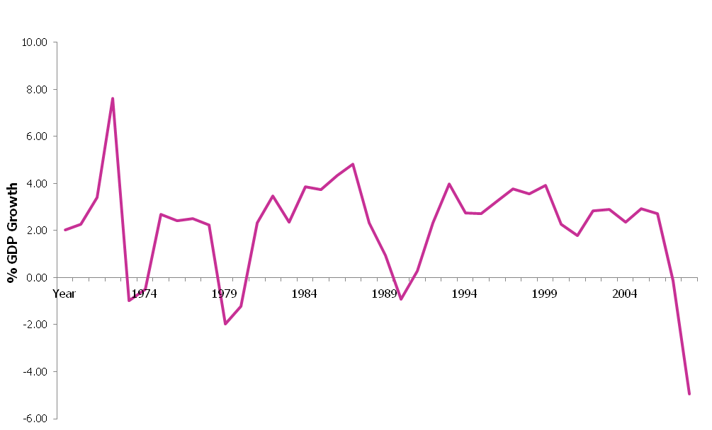
Source: Three centuries of data - Bank of England (2009)
Sustained economic growth can reduce poverty and unemployment. However, some groups can remain marginalised from the labour market for complex reasons connected to political, social and cultural structures. Whilst economic growth means a buoyant labour market, the structure of the economy impacts on those within it and those entering it.
The sectors which make up science and science occupations have changed as scientific knowledge and technology has developed. Whole industries have almost disappeared from national statistics (e.g. coal mining) or have changed so dramatically that the skills needed during the 1970s are almost obsolete (e.g. telecommunications). However, in contrast the routes into employment for certain sectors have remained relatively fixed.
The rise of employment in the service sector, which has resulted in an increase of almost 11 million jobs, came at the same time as declining employment in manufacturing, which has reduced by approximately 5 million jobs since the 1960s. This can be seen in the chart (Figure 14) below which show the divergent fortunes of two sectors (using Motor Vehicle Manufacturing and Real Estate as exemplars).

Figure 2: Employment in Real Estate and Motor Vehicle Manufacturing the UK (1970–2012)
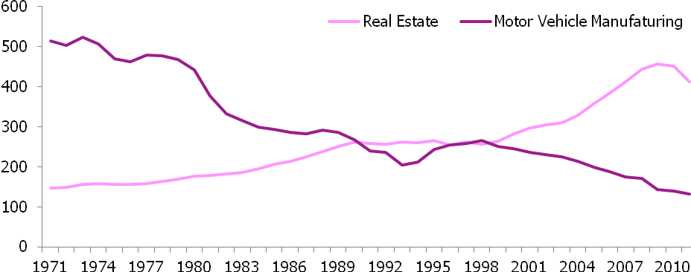
Source: Cambridge Econometrics MDM Databank (2012)

Ages 30 and 34 – 1999–2000 and 2004–2005
A higher than average proportion of science workers entered the scientific workforce between the ages of 29–34 years old. In entering the science workforce between 1999 and 2005, their experience to date has been one centrally of sustained economic growth, impacting positively upon earnings and quality of life. Between 1970 to 2009 in the UK, GDP and real household disposable income per head grew on average by 1.9% and 2.4% per year respectively. Rises in earnings, consumer spending, disposable income and earnings since 1970 mean that people are better off today than 20 or 30 years ago.
The late 1990s saw economic policy attempt to maintain economic growth. The early 2000s saw the ‘Dot Com’ bubble burst, as a rise in equity markets, fuelled by investments in new internet-based companies lost confidence when many firms reported huge losses and others folded within months of their offering. Despite this, the economy was comparatively stable throughout the late 1990s and early 2000s and UK economic performance between 1997-2007 was so strong that GDP per capita grew faster in the UK than any other G6 country.
House prices across the UK (and particularly in London) began to rise rapidly, leading many to believe that this would continue. Financial and services sectors continued to grow in employment terms whilst sectors relating to electrical machinery, communication, financial intermediation, business services and distribution were also performing well and supporting growth.
However, despite such economic growth, it is important to consider that divides within society exist and there are sections of society which are marginalised. For example, ethnic minority populations can face difficulty in accessing employment because of the socioeconomic disadvantages linked to the areas in which they live; discrimination and social exclusion; poor recognition/acceptance of the skills and qualifications they possess; inadequate support for their family and caring roles and limited opportunities to gain skills useful for employment, such as fluency in English.
It is widely recognised that gender inequality in the workplace also remains a challenge, with women continuing to be disadvantaged in key areas of employment and income. This is despite significant effort having been applied to breaking down the barriers that lead to such inequality. The patterns and nature of inequality vary considerably from country to country. For example, whilst the proportion of women who have paid jobs across in parts of Southern and Eastern Europe stands at around 50%, well over 70% of women in most of the Nordic countries have jobs, a similar figure to the number of men.
Women can also face difficulties re-entering the labour market, with those taking career breaks particularly challenged by income penalties for time-off and difficulty keeping up with the pace of change in STEM sectors. Societal and cultural changes have influenced public policy and the introduction of legislation which provides paid-leave for new mothers has supported women in many sectors. Despite this, those that take career breaks can often face barriers in progression throughout the labour market.

Age 38 – 2008–2009
As the cohort makes its way to 40, the UK is faced with difficult economic and social challenges. Unemployment was rising (Figure 3), with youth unemployment specifically rising and the 2008/09 recession had started, with growth starting to occur in 2012/13.
The 2008/09 global recession took a severe toll on the UK economy and labour market. The economy was in recession for six consecutive quarters (the UK economy finally moved out of recession in the last quarter of 2009). GDP fell by 2.6% in a single quarter (Q1 in 2009) which is also the same percentage by which the economy expanded during the whole of 2007.
Despite the UK being in recession longer than other G7 economies and the last to exit recession, unemployment rates have not been as severe as some European countries. However, whilst unemployment is lower than other countries, there have been other effects including more part-time working, more self-employment, decline in real wages and restrictions on public-sector pay.
Unemployment is as key factor in determining someone’s life chances. Welfare supports individuals and families throughout periods of unemployment but despite this support unemployment is inextricably linked to poverty, low education and social exclusion. Unemployment averaged 3.8% during the 1970s (an increase on the rate in the 1960s) increased to an average of 9.6% in the 1980s and today stands at 7.7% (Figure 3).

Figure 3: Unemployment Rate (1992 to 2012)
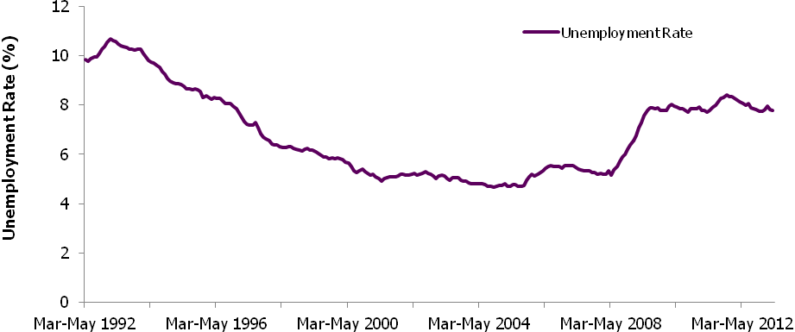
Source: ONS (2012)
Unemployment has a range of impacts upon the labour market, these include:
- Unemployment rates for men and women diverging as in the past there were fewer women in the labour market to lose their jobs, whilst the recent recession has been dubbed the ‘mancession’ by many due to the high incidence of men losing jobs.
- Job losses in the public sector affected women and certain ethnic groups disproportionately as women and BME workers are more likely to be employed in healthcare and education. Job losses in heavy industry, such as the steel and coal industries, and construction have driven unemployment rises for males in certain areas of the UK.
- The geographical impact of job losses can affect certain areas and groups of people. Decline in certain industries can affect groups of people which rely on those industries. For example, the decline of the textile industry in Bradford has affected some ethnic groups more than others.
Unemployment and the reasons for unemployment are highly complex. For example, long term and short term unemployment can affect different sub-groups of the labour market and be driven by factors such as local labour market, skills and demographic characteristics.

As the UK economy seeks further economic growth, the UK Government has placed greater emphasis on the importance of encouraging the study of Science and supporting Science, Technology, Engineering and Mathematics (STEM) industries. This has been motivated by a clear imperative to maintain economic prosperity through driving up productivity. The relationship between innovation and productivity (Lord Sainsbury 2007), research and productivity (Roberts 2001) and skills and productivity (Lord Leitch 2006) continually reinforce the significance of STEM industries. To grow the economy, a larger and more diverse workforce is sought by policy makers. However, requirements for more workers are challenged by:
- The perception of science roles and activities by particular groups which affect the types of workers attracted to science careers.
- Lack of recognition/understanding of the business case for a diverse workforce and the skills, approaches and interests which can only be of benefit to the creative endeavour of science.
- Cultural and social responsibilities which affect how workers interact with the science labour market.
- A range of employment barriers for certain groups including ingrained structural and cultural barriers which exist in other sectors (e.g. glass ceiling).
- The austere financial climate has also dictated that public funding for education and health (key science sectors) will become scarcer.

Evidence and Analysis
This section presents responses to questions posed in the introduction. Each of the questions is answered in the boxes at the beginning of the section and the analysis is grouped into movement into the science workforce, the impact of different socioeconomic backgrounds on progression and how career and employment breaks affect individuals, followed by some contextual analysis to explore the background for changes seen.

Working in science
Does SEB impact on likelihood of entering the science workforce?
The analysis suggests that SEB does impact upon likelihood of entering the science workforce. The higher an individual’s socioeconomic background, measured in terms of parental social class or parental education, the more likely they are to work in science. The link between parental income at age 16 and working in science is less clear.
Does SEB impact on how long people take to enter the sector?
In general, individuals from lower socioeconomic backgrounds take longer to enter science after leaving continuous full-time education.
Does SEB impact on routes into the sector? Is there a typical route and is this different depending on SEB? Does SEB impact on alternative access routes into the sector?
Due to poor data availability on the types of institutions in which qualifications were achieved there was little analysis available on alternative access routes into science. The data suggests a ‘typical’ route of remaining in full-time education through further and higher education, with the longer an individual spends in continuous full-time education, and the higher their qualifications on leaving, the more likely they are to work in science. Three typical routes are provided in section 6.1.1.

Likelihood of working in science
Around half (47%) of the BCS70 cohort have worked in science. Men are slightly more likely to have worked in science than women. People from white ethnic backgrounds are more likely to have worked in science than those from black or ethnic minority communities.
The higher an individual’s socioeconomic background, measured in terms of parental social class or parental education, the more likely they are to work in science. Measured using these indicators, the relationship between socioeconomic background and working in science is so strong that it could be described as a gradient, just as the relationship between socioeconomic background and a child’s educational achievement is often described in the literature as a gradient. Figure 4 (below) illustrates this relationship.

Figure 4: Percentage entering science by parents' age on leaving continuous full-time education
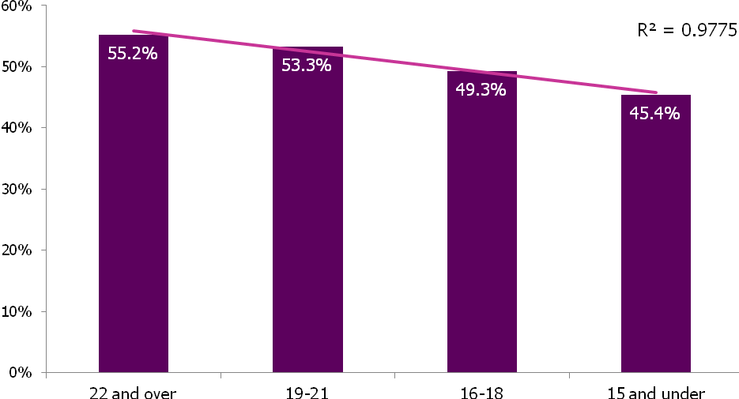
Source: BCS70 (TBR ref: S1/S1)
A relationship between household income during childhood and the likelihood of working in science is less clear. Individuals in households in the middle income bracket at age 16 (£10,400 to £15,599 pa) are most likely to have worked in science. Those in households in the lowest income bracket at age 16 (less than £5,199 pa) are least likely to have worked in science.
The longer an individual spends in continuous full-time education, and the higher their qualifications on leaving, the more likely they are to work in science. The average age on leaving continuous full-time education is higher among those who have worked in science (18 years) than among those who have never worked in science (17 years and 5 months). Figure 5 (below) shows the relationship between qualifications and working in science.

Figure 5: Percentage entering science by highest qualification on leaving continuous full-time education
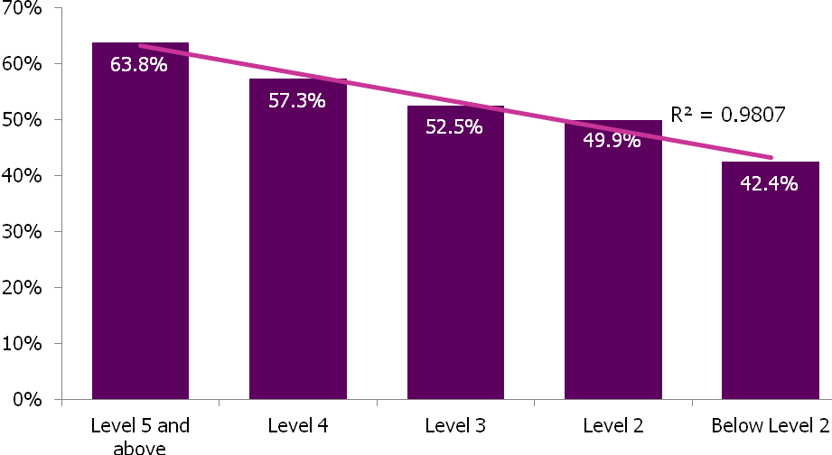
Source: BCS70 (TBR ref: S1/S1) – See qualification levels in Definitions.
Time taken to enter science
The youngest age at which anyone in the BCS cohort started work in science is 16; the oldest is 38. There appear to be significant entry points to science at ages 29–34 (70% of those who have worked in science entered the workforce within this age range). Women tend to take longer to enter science after leaving continuous full-time education than men. Individuals with lower socioeconomic backgrounds – measured by parental social class, household income or parental education – generally take longer to enter science after leaving continuous full-time education than those with higher socioeconomic backgrounds, as shown in Figure 6 (below).

Figure 6: Years between leaving full-time education and entering science by parental social class
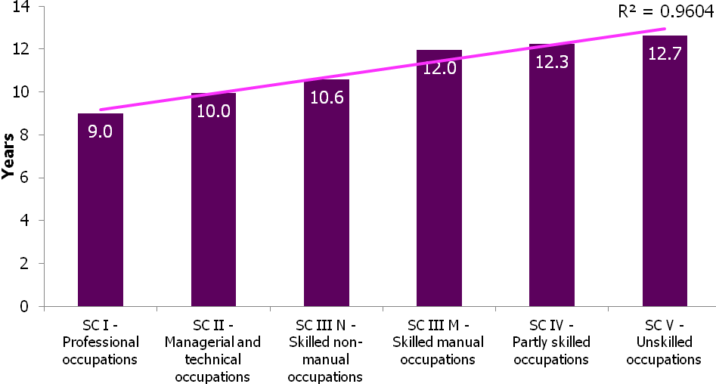
Source: BCS70 (TBR ref: S4/S1)
The more highly qualified an individual on leaving continuous full-time education, the quicker they enter science. On average, individuals leaving school without five O-levels or equivalent took almost twice as long to enter science as those leaving education with degree-level or postgraduate qualifications.
Career patterns in science
27% of science workers have spent their entire working life to date in science. 42% started work in another sector and moved into science. 31% started in science and left the sector. Men are more likely to have spent their entire working life in science than women. Half of the women who have worked in science started work in another sector, compared with around a third of men. Women who started work in science are 1.4 times more likely to have left the sector than men who started work in science. 59% of women who started work in science subsequently left, compared with 51% of men.
There appears to be little crossover between science careers in academia and science careers in manufacturing. Very few people starting a science career in academia have worked in manufacturing, and few people starting a science career in manufacturing have worked in academia. The greatest crossovers appear to be between science careers in health and other education.
Analysis suggests that there are no statistically significant differences in career patterns in science for which socioeconomic background, measured by parental social class, household income or parental education, might account. There is a stronger relationship between an individual’s own education and their career patterns in science. In general, the higher an individual’s qualifications on leaving continuous full-time education, the more likely they are to have started work in science and stayed in the sector.
Around a quarter (23%) of those who have worked in science have worked in the health sector. Smaller proportions have worked in education (17%) and manufacturing (15%), while around half (51%) have worked in other science sectors. Gender, ethnicity, socioeconomic background and education each appear to influence the science sectors in which people work.
Among science workers, women are more likely to work in education or health than men. Men are more likely to work in manufacturing than women. People from white ethnic backgrounds are more likely to work in academia or manufacturing than those from black and minority ethnic communities, but are no more likely to work in other educational settings. People from black and minority ethnic backgrounds
are more likely to work in health than people from white ethnic backgrounds.
Generally, people from higher socioeconomic backgrounds among science workers are more likely to work in education than those from lower socioeconomic backgrounds. Conversely, people from lower socioeconomic backgrounds tend to be more likely to work in manufacturing than those from higher socioeconomic backgrounds, as Figure 7 (below) illustrates. The relationship between socioeconomic background and working in science in the health sector is less clear; some indicators such as parental social class suggest that people from higher socioeconomic backgrounds are more likely to work in health, but other indicators do not.
Figure 7: Science sectors worked in by parental social class
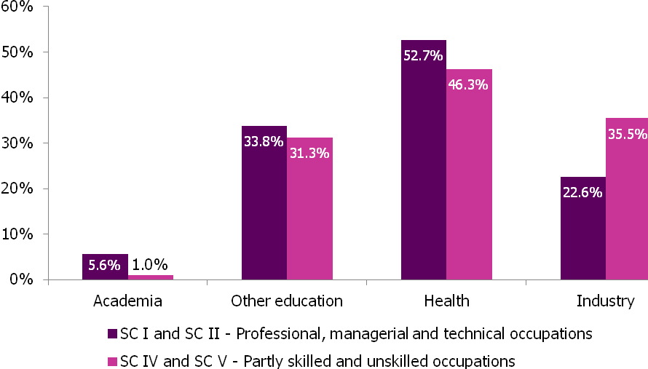
Source: BCS70 (TBR ref: S2_S3A/S1)
The higher an individual’s qualifications on leaving continuous full-time education, the more likely they are to work in science in education. The lower their qualifications, the more likely they are to work in manufacturing. People leaving continuous full-time education with postgraduate qualifications are especially likely to work in academia.
In addition, men are 1.2 times more likely than women to have worked in science and people from white ethnic backgrounds are 1.5 times more likely to have worked in science than those from black or ethnic minority communities.

Three typical careers in science
Three typical careers in science are presented here on the basis of the analysis that has been undertaken. It shows the different socioeconomic backgrounds which are likely determinants of the career patterns experienced by persons A, B and C.
Three typical careers in science
Person A (male)Person B (male)Person C (female)Career pattern in scienceMoved to a science-related job after working in another sector. Promoted to a technician level occupation after almost 9 years. Left science shortly after.Started work in a technician-level science occupation, and has been in science roles since. Promoted to a professional level occupation after 6 years.Moved to a technician-level science occupation after starting work in another sector. Took a career break at age 30, before returning to work part-time. Left science a few years later.Parental social classSC IV - Partly skilled occupationsSC I - Professional occupationsSC III - Skilled non-manual occupationsHousehold income at
age 16£5,200 to £10,399 pa£20,800 or over£10,400 to £15,599Parents’ age on leaving continuous full-time education152117Parents’ highest qualificationBelow Level 2DegreeLevel 3Age left continuous full-time education162118Highest qualification at end of continuous full-time educationFive O-levelsDegreeLevel 3Age started work in science272128First occupation in scienceLevel 2Level 3Level 3Sectors worked inManufacturingAcademia, other educationHealth, other educationHighest occupation reachedLevel 3Level 4Level 3

Progression in science
Does SEB impact on the ability to reach the higher occupational levels?
For those who have worked in science, the higher an individual’s socioeconomic background the more likely they are to progress to higher occupational levels.
Does SEB impact on the speed of progression through occupational levels in science?
A range of factors affects progression through different levels but individuals from lower socioeconomic backgrounds (measured by parental social class or parental education) can take longer to progress to professional level occupations than those from higher socioeconomic backgrounds. However, household income at age 16 does not appear to account for differences in the speed of progression to professional level occupations.
Progression to higher occupational levels
People who have worked in science are more likely to reach higher occupational levels than those who have never worked in science. In part, this reflects the high level of technical skills and knowledge needed to work in science, but it appears that working in science can also impact on career progression in other sectors. Compared with those who have never worked in science, people who work in science are more likely to reach higher level occupations even if they leave the sector. The higher the occupational skill level at which an individual enters science, the more likely they are to progress to higher levels. Women working in science, however, are significantly less likely to progress to technician level occupations than men, and less likely than men to progress to professional level occupations.
Figure 8: Working in science and highest occupational level reached
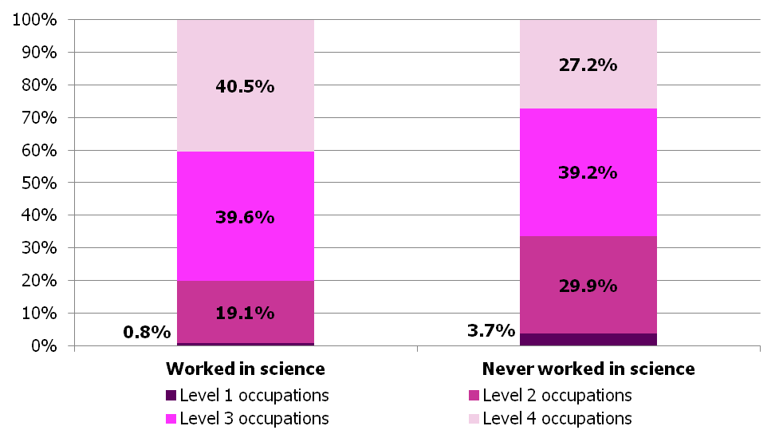
Source: BCS70 (TBR ref: S6/S2)
The higher an individual’s socioeconomic background – measured in terms of parental social class, household income or parental education – the more likely they are to progress to higher occupational levels. Science workers living in households in the highest income bracket at age 16, for example, are more than five times as likely to have been in professional level occupations as those in the lowest household income bracket.
Parental background has a slightly stronger effect on progression to higher occupational levels in science than among those who have never worked in science. Figure 9 (below) shows the strength of the relationship between household income at age 16, and working in science and professional level occupations later in life.
Figure 9: Percentage in professional level occupations by household income at age 16
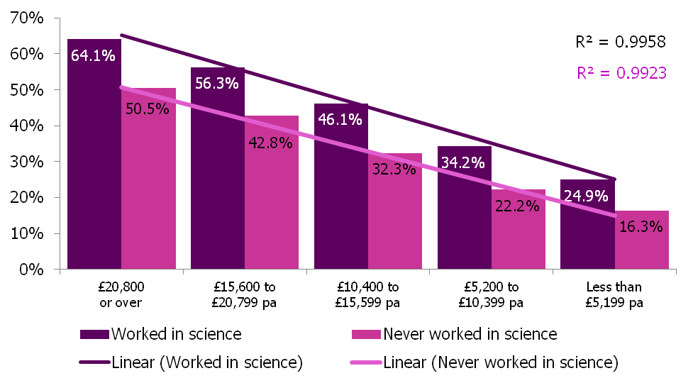
Source: BCS70 (TBR ref: S6/S2)
Among those who have worked in science, the longer an individual spends in continuous full-time education, and the higher their level of qualification on leaving, the more likely they are to progress to higher occupational levels. The average age of leaving education among those who have worked in professional level occupations was 19 years and 5 months, compared with 16 years and 5 months among those who did not progress beyond entry level or semi-skilled occupations. As shown in Figure 10 (below), those leaving continuous full-time education with degree-level or postgraduate qualifications are significantly more likely to have been in professional level occupations than those who left education without a level 2 qualification (five or more O-levels or equivalent).

Figure 10: Percentage working in professional level occupations by highest qualification on leaving continuous full-time education
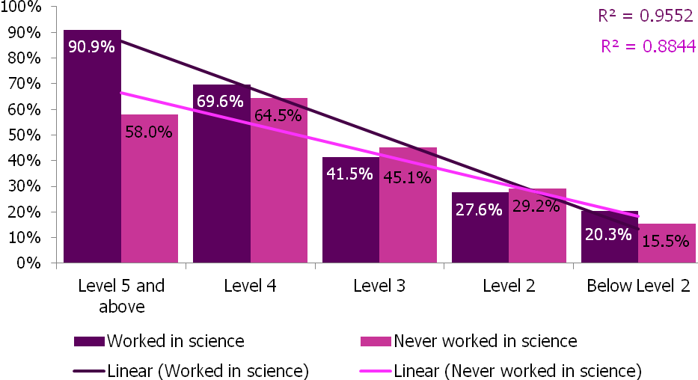
Source: BCS70 (TBR ref: S6/S1) – See qualification levels in Definitions.
Speed of progression to higher occupational levels
Our analysis does not suggest that gender, ethnicity or socioeconomic background can account for differences in the speed of progression from entry level to semi-skilled occupations, though it should be noted that the sample for this analysis is small because few people start work in science in entry level occupations.
It takes women in science longer to progress to technician level occupations than men. As Figure 11 (below) illustrates, among those who have worked in science, individuals from lower socioeconomic backgrounds – measured by parental social class, household income or parental education – take longer to progress to technician level occupations than those from higher socioeconomic backgrounds.

Figure 11: Average time taken to progress to technician level occupations from lower levels by parents' age on leaving continuous full-time education
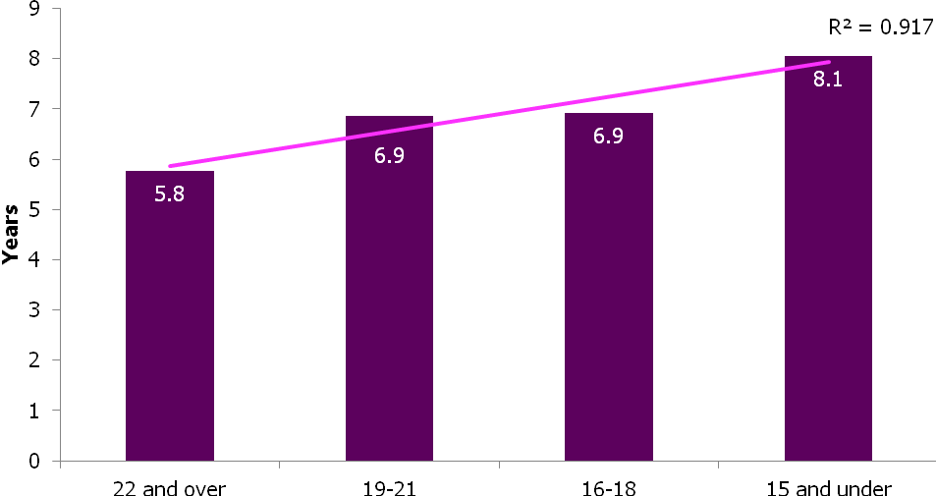
Source: BCS70 (TBR ref: S5/S2)
Educational attainment also impacts on the speed of progression to technician level occupations. Among those who have worked in science, individuals who achieve Level 3 qualifications (two A-levels or equivalent) or above in continuous full-time education progress more quickly to technician level occupations than those leaving education without qualifications at this level.
Neither gender nor ethnicity appear to account for differences in the speed of progression to professional level occupations. Some – but not all – measures of socioeconomic background suggest a relationship between SEB and the speed of progression to professional level occupations. Among those who have worked in science, individuals from lower socioeconomic backgrounds – measured by parental social class or parental education – take longer to progress to professional level occupations than those from higher socioeconomic backgrounds. Household income at age 16 does not appear to account for differences in the speed of progression to professional level occupations.

Figure 12: Average time taken to progress to professional level occupations from lower levels by highest social class of parents at age 16
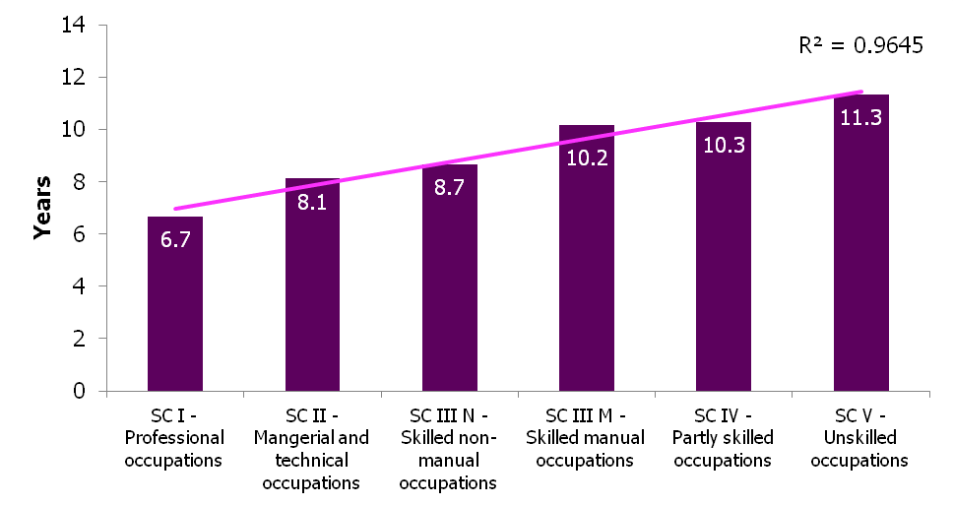
Source: BCS70 (TBR ref: S5/S2)
The higher an individual’s qualification levels on leaving continuous full-time education, the faster they are likely to progress to a professional level occupation after entering science at a lower level. Individuals leaving continuous full-time education with a Level 2 qualification (five O-levels or equivalent) but no higher might expect to take more than twice as long to progress to a professional level occupation than those leaving education with a degree level or postgraduate qualification, as shown in Figure 13.
Figure 13: Average time taken to progress to professional level occupations from lower levels by highest qualification on leaving continuous full-time education
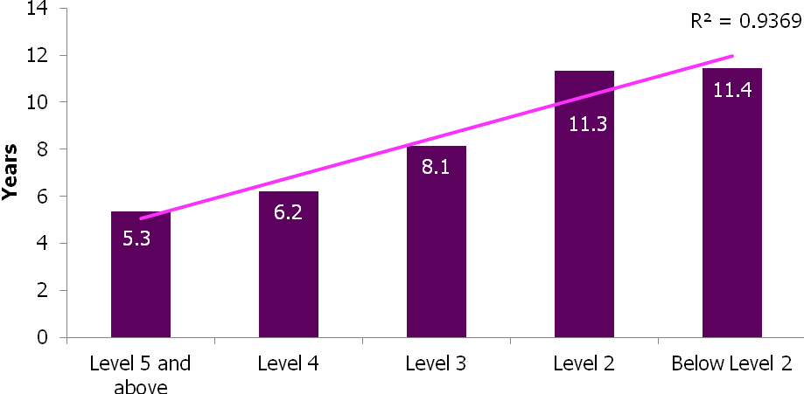
Source: BCS70 (TBR ref: S5/S2) – See qualification levels in Definitions.

Career and employment breaks
Does the science workforce have a different pattern of career breaks to the wider population?
Women working in science are less likely to take careers breaks than the wider population. Their career breaks are more often connected to the birth of a child than other reasons and are often shorter.
What is the impact of a career break on progression through the sector?
Women in science who take a career break are more likely to progress to Level 3 occupations than those who do not take a career break. However, they are less likely to progress to degree-level occupations, suggesting career breaks hinder progression to the highest occupational levels.
Specifically do women in science behave differently from women in other professions following the birth of children? Are they more or less likely to return to work and/or change career?
Women in science taking a career break to have a baby are more likely to return to work part-time than those who have never worked in science and take a career break to have a baby. Women in science who take a career break to have a baby are likely to return to work at a lower occupational level than those who take a career break not associated with the birth of a baby.

Patterns of career breaks
Almost a third of women (32%) in the BCS70 sample have taken one or more career breaks. Very few men (3%) had taken a career break. Most women have taken a single career break; relatively few (4% of all women in the sample) have taken more than one. No-one in the sample has taken more than three career breaks.
Women who have worked in science are less likely to have taken a career break than those who have never worked in science. 28% of women who have worked in science have taken a career break, compared with 36% of women who have never worked in science.
On average, women who have worked in science start their first career break at a slightly later age (22 years and 8 months) than women who have never worked in science (21 years and 10 months). Women who have worked in science also take shorter career breaks than women who have never worked in science, as shown in Figure 14 (below). The length of career breaks reflects the definition adopted in this analysis.

Figure 14: Average length of career breaks taken by women
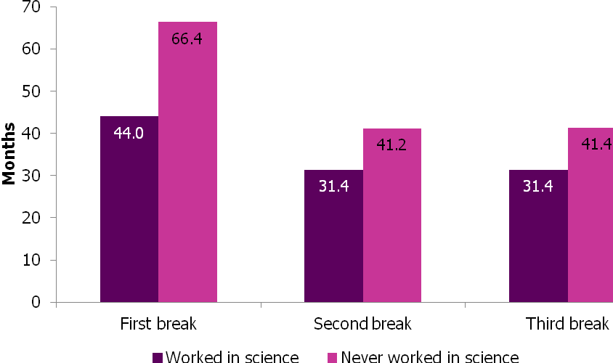
Source: BCS70 (TBR ref: S7/S1)
Women who have worked in science are more likely to have taken a career break to have a baby
than women who have never worked in science. 27% of the career breaks taken by women in science are associated with the birth of a child, compared with 17% of the career breaks taken by women who have never worked in science.
Career breaks and career progression
Within the science workforce, women in higher level occupations are less likely to take a career break than those in lower level occupations. Women in entry level and semi-skilled occupations are more than twice as likely to have taken a career break as those in technician level or professional level occupations.
Women in science who take a career break are no less likely to progress to technician level occupations than those who do not take a career break. However, women who take a career break are less likely
to progress to professional level occupations, suggesting that career breaks hinder progression to the highest occupational levels.
Among those who do progress to higher occupational levels, women who take career breaks tend to take longer to progress than women who do not take career breaks. Women who had taken career breaks took an average 8 years and 11 months to progress to technician level occupations after entering science at lower levels (not counting the length of their career breaks), for example, compared with an average 8 years among women who have not taken a career break. Similarly, women who have taken career breaks took an average 10 years and 5 months to progress to professional level occupations (not counting the length of their career breaks), compared with an average 9 years and 4 months among women who have not taken a career break.
The majority of women who take a career break return to work on a part-time basis, even if they worked full-time previously. Among women who worked full-time before taking a career break, women in science were slightly more likely to return on a part-time basis than those who have never worked in science.
Women taking a career break to have a baby are more likely to return to work part-time than those taking career breaks for other reasons. Women in science taking a career break to have a baby are more likely to return to work part-time than those who have never worked in science and take a career break to have a baby.
Figure 15: Proportion of women working full-time before a career break who returned to work full-time
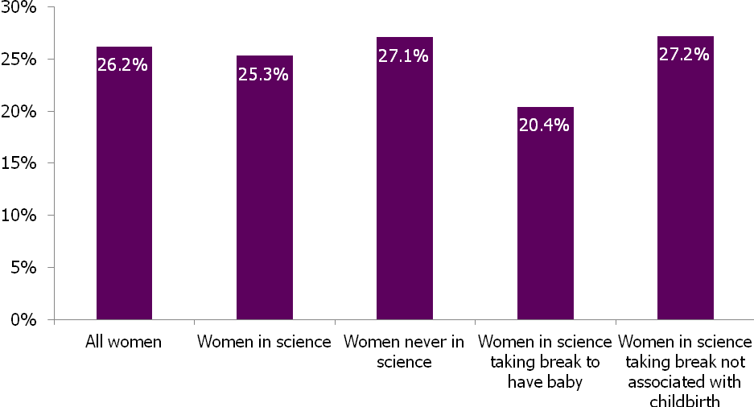
Source: BCS70 (TBR ref: S9/S3)
Many women also return to work at a lower occupational level than their position immediately before taking a career break. Women in science were less likely to do so than those who have never worked in science. Women taking a career break to have a baby were more likely to do so than those taking career breaks for other reasons.
On the other hand, career breaks provide opportunities for some women to progress to higher occupational levels. Women in science were more likely to return to work at a higher occupational level after taking a career break than those who have never worked in science. Women taking a career break to have a baby were no less likely to return to work at a higher occupational level than those taking a career break not associated with the birth of a baby.

Concluding remarks
This research develops ground-breaking empirical evidence on the linkages between pathways, progression routes and key transition points in science and how these vary according to socio-economic background.
In our assessment of literature in this area, we have uncovered few research studies which provide this level of detail or focus upon similar topics. Accordingly, this research contributes a valuable resource and foundation for future discourse around progression in science.
There are a range of conclusions from the research which provide a focus for future activities and research. Developing these further would be a worthwhile next step, particularly where they relate to barriers to diversity in the science workforce. These conclusions are discussed briefly below:
- The role of an individual’s education is essential to their professional career in science; there is a clear relationship between time in education and qualifications attained and working in science.
- A high proportion of individuals entered the science workforce between the ages of 29 and 34 this may shape how activities are directed or information is targeted. For example, the role of continuing professional development, part-time courses and engaging people outside of compulsory and/or full-time education infrastructures needs to be considered.
- The variables connected to socioeconomic background do not all have the same influence. Compared with parental social class and education, household income at age 16 appears to have less influence on the likelihood of working in science and speed of progression. The impact of the socioeconomic background measure was greatest in connection with the time it takes an individual to enter science, the science sectors an individual works in, and how an individual progresses through their professional life. This reinforces the influence of role-models and demonstrates the importance of support to continue education (in general - not necessarily financially).
- There are differences in the experiences of men and women and white and non-white individuals in working in science (e.g. people from white ethnic backgrounds are more likely to have worked in science than those from black or ethnic minority communities) and career breaks (almost a third of women in the sample have taken one or more career breaks and very few men had taken a career break). Unfortunately, due to lack of data, this research found it difficult to explore other characteristics in the analysis.
- The influence of career breaks on women’s working lives is considerable and the evidence in this report suggests that there are identifiable areas of support for women in science who take career breaks to have children. There is a need for further investigation to understand in detail the factors which hinder progression to the highest levels for some, and for others support their progression.
- The research suggests that there may be limited socioeconomic diversity in some of the key employment sectors. For example, people from higher socioeconomic backgrounds were more likely to work in education and those from lower socioeconomic backgrounds more likely to work in manufacturing. Exploring the intricacies of employment patterns and progression routes in these sectors would be useful for encouraging greater diversity in the future.
- The research suggests that individuals who have worked in science and move to another sector find that their career progression benefits from their past in science. Compared with those who have never worked in science, people who have are more likely to reach higher level occupations even if they move away from science sectors. This highlights the importance of STEM skills to employability and progression across the UK economy.

Practical conclusions
A number of more practical research considerations were made throughout the research process. These are reflected upon below:
- There is no unanimously agreed definition for the science workforce and economic sectors which are connected to Science. An agreed definition for sectors (most usefully using SICs) and occupations (SOCs) would support future analysis of the workforce and potentially help to identify elements of science which are facing challenging economic and workforce issues.
- The process of putting together and preparing the data used in this report was resource intensive. Engaging with the owners and holders of longitudinal datasets such as Understanding Society, NCDS and BCS70 to ensure that social mobility and socioeconomic background are more straightforward to assess would be an important step for not only those investigating science but for the investigations of socioeconomic linkages across all elements of the UK workforce.

Appendix

Science Workforce Definition
In order to develop a definition for the science workforce, the research uses the definition established by TBR for the Science Council’s New Registers Advisory Group and also used in the first project for the Royal Society to explore Socio-Economic Status. All occupations have a Standard Occupational Classification (SOC) code; these codes have then been split in to three groups based on their activities:

- Primary science workers: workers in occupations that are purely science based and require the consistent application of scientific knowledge and skills in order to execute the role effectively. E.g. Chemists, Science & Engineering Technicians, Pharmacists & Pharmacologists or Bio Scientists and Biochemists.
- Secondary science workers: workers in occupations that are science related and require a mixed application of scientific knowledge and skills alongside other skill sets, which are often of greater importance to executing the role effectively. E.g. Civil and Mechanical Engineers, Conservation & Environmental Protection Officers, Environmental Health Officers, Teaching Professionals.
- Non-science workers: workers in occupations that are not science based and have no requirement for science based knowledge or skills. E.g. Travel Agents, Town Planners, Musicians, Legal Professionals, and Housing & Welfare Officers.
This definition work is subject to professional judgement as to which group SOCs are part of. With no recognised definition of the science workforce, this definition allows more detailed intelligence to be created and helps to create “much more information than available previously”.

Literature review
The literature review was conducted in two stages. The first stage aimed to define key concepts relating to socio-economic background, and to identify the most appropriate measure or measures to use in analysis, taking account of the indicators available in the BCS70 and NCDS. The second stage considered other key influences on career paths in science.
Stage one of the review used the following Google Scholar search:
(measuring OR assessing OR validating) AND ("socio-economic status" OR "socio-economic background" OR "socio-economic position")
Our search returned around 18,300 results. Focusing on the first 500 results (sorted by relevance), we included papers with some discussion of approaches to measuring socio-economic position, where they described the use of indicators available in the NCDS or BCS70. We excluded papers which did not consider the validity of the socio-economic indicators they used, and papers which described the use of indicators not available in our data sources.
Stage two of the review used the following Google Scholar search:
("career path" OR "career progression" OR "career break") AND science
This search returned around 17,100 results. Focusing on the first 300 results (sorted by relevance), we included papers with some discussion of the influences on career progression in science, or of the issues relating to career breaks. We excluded papers which were not relevant to the science workforce.
We used the pearl growing technique in both stages to identify further relevant papers from the citations in those we included. In total, we reviewed 75 papers.

Data preparation
Data preparation involved a thorough review of data sources identified as having the potential to be useful in the research. The review informed a final specification for the research. A dataset was then constructed according to this specification.

Review of data sources
TBR’s previous research for the Royal Society identified three data sources that appeared to allow comparison between an individuals’ socioeconomic background and their career progress in later life. All three of these data sources contain extensive information on a number of topics covering cohort members’ early lives to their adult careers.

British Household Panel Survey
The British Household Panel Survey (BHPS) is a longitudinal dataset that tracks households, and the individuals within them, over time. It covers a broad range of economic and social indicators including employment, income and household relationships. The BHPS has now been replaced by the Understanding Society survey.
Following review, the British Household Population Survey was not taken further because the surveyed sample decreases considerably over successive sweeps. This limits the ability to track the careers of individuals in the initial sweep further into the study.

National Child Development Study
The National Child Development Study (NCDS) is a continuing, multi-disciplinary longitudinal study which began when by collecting data on 17,415 babies born in Great Britain between 3rd and 9th March 1958. To date, there have been seven attempts to trace all members of the birth cohort in order to monitor their health, education, and social and economic circumstances.
After review, the NCDS was also rejected. Significantly, the NCDS does not record the sector in which an individual works, if they are employed (though occupation is recorded). This means that a sector-based definition of the science workforce could not be used. Nevertheless, the NCDS was considered to have the potential to provide broad comparisons with trends and issues identified using other data sources.
Until later waves, the NCDS records different periods of employment, unemployment and economic inactivity in separate variables. Successive periods of each type of activity recorded in NCDS datasets do not necessarily represent consecutive periods of activity – a period of unemployment, for example, may fall between two periods of employment recorded as ‘job 1’ and ‘job 2’. Later waves of NCDS take a more familiar approach to recording differences in economic activity, using a single categorical variable at each point. However, they do not provide coverage of cohort members’ full activity history since leaving full-time education, and need to be merged with data from earlier sweeps to create this coverage.
A further complication is that start and end dates for each period of activity relate to the activity itself, rather than to a defined time period consistent for all cohort members. Additionally, the number of different periods of activity varies between cohort members. Constructing a complete history of each cohort member’s economic activity therefore means organising different periods of activity across each of the types recorded into a single longitudinal record, where start and end dates are not consistent across records and where the number of different periods also varies between cohort members. While constructing such a dataset is possible, this approach was rejected due to the complexity of the task and the impact this would have had on project timescales.
The NCDS Employment Histories dataset was considered as an alternative to data from the individual NCDS sweeps. The Employment Histories dataset provides a record of the different periods of employment for NCDS cohort members since leaving full-time education, covering the period 1974–2000. However, it is difficult to determine the extent to which the dataset provides a full employment history for all NCDS cohort members. Based on inclusion in the NCDS sweeps used to develop the Employment Histories dataset (but not taking completion of the required variables into account), there appears to be a full employment record for between 8,583 and 9,850 members of the cohort (46–53%). Between 3,122 and 6,087 cohort members may have an incomplete employment record (17–33%). Employment histories appear to be missing for between 3,888 and 5,586 members of the cohort (21–30%).
Additionally, the NCDS Employment Histories dataset does not provide a full history of economic activity, since it does not include periods of unemployment or time spent out of the labour market. Furthermore, it does not cover activities recorded in the two most recent NCDS sweeps (2004 and 2008). Nevertheless, while the Employment Histories dataset does not provide a full longitudinal record of economic activity for each cohort member, our review suggested it could provide a foundation for the development of one. This would require periods of unemployment and economic inactivity to be organised alongside the employment data already within the dataset.
The development of the NCDS Employment Histories dataset required extensive data cleansing, particularly in relation to date variables. Similar cleansing processes would need to be applied to data on unemployment and inactivity if the NCDS Employment Histories dataset was to be used as a foundation for the development of a full longitudinal record of economic activity of cohort members, adding significantly to the complexity of the task. This option was also rejected because of the impact on project timescales.

British Cohort Study 1970
The British Cohort Study 1970 (BCS70) is a longitudinal study which began by collecting data on births and the families of babies born in the UK in one week in 1970. The first sweep aimed to compare the social and biological characteristics of mothers with the results of the 1958 National Child Development Study. Successive BCS70 sweeps have gathered information on the physical, educational, social and economic development of each cohort member. BCS70 was designed to replicate the success of the NCDS, and there is a considerable amount of compatibility between the two. To date there have been seven sweeps of the survey.
Unlike NCDS, BCS70 records periods of different economic activity as a single categorical variable at each point. The BCS Activities History dataset provides a complete history of cohort members’ economic activity since leaving full-time education, covering the period 1986–2008. It was decided to use this as the basis for our research. A full history (with no gaps) is available for 12,005 members of the BCS70 cohort (63%). Three cohort members have a history with gaps, and these records were excluded from analysis. Activity histories are missing for 7,093 cohort members (37%).

Data preparation
Significant resource was required to prepare a dataset for analysis. The BCS Activities History dataset contains one record for each period of activity. The data therefore required reformatting to create a single longitudinal record for each individual, so that different periods of activity could be compared within a single record, rather than across records. The specification then required a range of variables from individual BCS70 sweeps to be matched with the Activities History dataset. This was complicated by the fact that many of the measures defined in the specification were derived using a combination of variables from each sweep. A large amount of coding was required to standardise variables which were recorded inconsistently between each BCS70 sweep.

Data definitions
A large number of variables were extracted or derived from datasets relating to individual BCS70 sweeps and matched with the Activities History dataset to construct the dataset used in this research. The definitions of key indicators are described below.

The science workforce
There is no universally accepted definition of the science workforce. The research used the definition developed by TBR and the Science Council’s New Registers Advisory Group. This definition was also used in TBR’s previous research for the Royal Society. The definition is twofold: it takes both an occupational view of the science workforce, and a sectoral view.
The research defined science occupations in terms of the Standard Occupational Classification 2000 (SOC 2000). A distinction was made between occupations that are primarily science based (requiring the consistent application of scientific knowledge and skills in order to execute the role effectively), and those which are science related (requiring a mix of science skills and knowledge and other skillsets, which may be of greater importance to executing the role effectively).
Table 2: Primary science workforce: Standard Occupational Classification 2000
SOC | Description | SOC | Description
1137 | Research and development managers | 3111 | Laboratory technicians
1212 | Natural environ and cons managers | 3112 | Electrical and electronic technicians
2111 | Chemists | 3113 | Engineering technicians
2112 | Bio scientists and biochemists | 3114 | Building and civil engineering technicians
2113 | Physicists, geologists and meteorologists | 3115 | Quality assurance technicians
2125 | Chemical engineers | 3119 | Science and engineering technicians not elsewhere classified
2129 | Engineering professionals not elsewhere classified | 3213 | Paramedics
2211 | Medical practitioners | 3214 | Medical radiographers
2212 | Psychologists | 3218 | Medical and dental technicians
2213 | Pharmacists and pharmacologists | 5249 | Electrical and electronic engineers not elsewhere classified
2214 | Ophthalmic opticians | 6113 | Dental nurses
2215 | Dental practitioners | 6131 | Veterinary nurses and assistants
2216 | Veterinarians | 8114 | Chemical and related process operatives
2321 | Scientific researchers | 8138 | Routine laboratory testers

Table 3: Secondary science workforce: Standard Occupational Classification 2000
SOC | Description | SOC | Description
1111 | Senior officials in national government | 2423 | Management consultants, actuaries, economists and statisticians
1113 | Senior officials in local government | 2441 | Public service administrative professionals
1122 | Managers in construction | 3211 | Nurses
1123 | Managers in mining and energy | 3212 | Midwives
1136 | Info and communication technology managers | 3215 | Chiropodists
1181 | Hospital and health service managers | 3216 | Dispensing opticians
1182 | Pharmacy managers | 3217 | Pharmaceutical dispensers
1183 | Healthcare practice managers | 3221 | Physiotherapists
1184 | Social services managers | 3222 | Occupational therapists
1211 | Farm managers | 3223 | Speech and language therapists
1219 | Managers in animal husbandry, forestry and fishing not elsewhere classified | 3229 | Therapists not elsewhere classified
2121 | Civil engineers | 3551 | Conservation and environmental protection officer
2122 | Mechanical engineers | 3568 | Environmental health officers
2123 | Electrical engineers | 4114 | Officers non-government organisations
2124 | Electronics engineers | 4211 | Medical secretaries
2127 | Production and process engineers | 6111 | Nursing auxiliaries and assistants
2132 | Software professionals | 6112 | Ambulance staff (excluding paramedics)
2311 | Higher education teaching professionals | 6139 | Animal care occupations not elsewhere classified
2312 | Further education teaching professionals | 8111 | Food, drink and tobacco process operatives
2313 | Education officers, school inspectors | 8115 | Rubber process operatives
2314 | Secondary Education teaching professionals | 8116 | Plastics process operatives
2315 | Primary and nursery education teaching professionals | 8124 | Energy plant operatives
2316 | Spec needs education teaching profs | 8131 | Assemblers (electrical products)
2317 | Registrars and senior administrators of educational establishments | 8132 | Assemblers (vehicles and metal goods)
2319 | Teaching professionals not elsewhere classified | 8133 | Routine inspectors and testers
2322 | Social science researchers | 9119 | Fishing and agriculture related occupations not elsewhere classified
2329 | Researchers not elsewhere classified

Science sectors were defined in terms of the Standard Industrial Classification 2007 (SIC 2007). A distinction was made between sectors whose core activity is science based, and sectors whose activity is related to science.
BCS70 codes occupations using 2-digit SIC 1992 or SIC 2003 codes, while our science definition uses SIC 2007 at 4-digit level. The definition was mapped to the BCS70 data in two stages:
- First, the definition was mapped to 2-digit SIC 2007 codes by examining the category (core, related or non-science) into which the majority of 4-digit codes fell within each 2-digit code. In most cases, this was straightforward. In some cases there was an even split, and categories were applied to the 2-digit codes by prioritising ‘core’ over ‘related’, and ‘related’ over ‘non-science’.

Table 4: Core science sectors: Standard Industrial Classification 2007
SIC | Description | SIC | Description
0510 | Mining of hard coal | 3811 | Collection of non-hazardous waste
0610 | Extraction of crude petroleum | 3812 | Collection of hazardous waste
0620 | Extraction of natural gas | 3821 | Treatment and disposal of non-hazardous waste
0910 | Support activities for petroleum and natural gas extraction | 3822 | Treatment and disposal of hazardous waste
1920 | Manufacture of refined petroleum prod | 3831 | Dismantling of wrecks
2011 | Manufacture of industrial gases | 3832 | Recovery of sorted materials
2012 | Manufacture of dyes and pigments | 3900 | Remediation activities and other waste management services
2013 | Manufacture other inorganic basic chemicals | 4313 | Test drilling and boring
2014 | Manufacture of other organic basic chemicals | 4612 | Agents involved in the sale of fuels, ores, metals and industrial chemicals
2015 | Manufacture fertilisers and nitro compounds | 4645 | Wholesale of perfume and cosmetics
2016 | Manufacture of plastics in primary forms | 4646 | Wholesale of pharmaceutical goods
2017 | Manufacture of synthetic rubber in primary forms | 4671 | Wholesale of solid, liquid and gaseous fuels and related products
2020 | Manufacture of pesticides and other agrochemical products | 4675 | Wholesale of chemical products
2030 | Manufacture of paints and related products | 4773 | Dispensing chemist in specialised stores
2041 | Manufacture of soap and detergents, cleaning and polishing preparations | 4774 | Retail sale of medical and orthopaedic goods in specialised stores
2042 | Manufacture of perfumes and toilet preparations | 4775 | Retail sale of cosmetic and toilet articles in specialised stores
2051 | Manufacture of explosives | 5110 | Passenger air transport
2052 | Manufacture of glues | 5121 | Freight air transport
2053 | Manufacture of essential oils | 5122 | Space transport
2059 | Manufacture of other chemical products not elsewhere classified | 7120 | Technical testing and analysis
2110 | Manufacture of basic pharmaceutical prod | 7211 | Research and experimental development on biotechnology
2120 | Manufacture of pharmaceutical preparations | 7219 | Other research and experimental development on natural sciences and engineering
2446 | Processing of nuclear fuel | 7220 | Research and experimental development on social sciences and humanities
2651 | Manufacture of instruments and appliances for measuring, testing and navigation | 7320 | Market research and public opinion polling
2660 | Manufacture of irradiation, electromedical and electrotherapeutic equipment | 7490 | Other professional, scientific and technical activities not elsewhere classified
3030 | Manufacture of air and spacecraft and related machinery | 7500 | Veterinary activities
3250 | Manufacture of medical and dental instruments and supplies | 8610 | Hospital activities
3313 | Repair of electronic and optical equipment | 8621 | General medical practice activities
3316 | Repair and maintenance of aircraft and spacecraft | 8622 | Specialist medical practice activities
3511 | Production of electricity | 8623 | Dental practice activities
3512 | Transmission of electricity | 8690 | Other human health activities
3513 | Distribution of electricity | 8710 | Residential nursing care activities
continued

SIC | Description | SIC | Description
3514 | Trade of electricity | 8720 | Residential care activities for learning disabilities, mental health and substance abuse
3521 | Manufacture of gas | 8730 | Residential care activities for the elderly and disabled
3522 | Distribution of gaseous fuels through mains | 8790 | Other residential care activities
3523 | Trade of gas through mains | 8810 | Social work activities without accommodation for the elderly and disabled
3530 | Steam and air conditioning supply | 8891 | Child day-care activities
3600 | Water collection, treatment and supply | 8899 | Other social work activities without accommodation not elsewhere classified
3700 | Sewerage

Table 5: Secondary science sectors: Standard Industrial Classification 2007
SIC | Description | SIC | Description
0111 | Growing of cereals, except rice | 2454 | Casting of other non-ferrous metals
0113 | Growing vegetables and melons, roots and tubers | 2540 | Manufacture of weapons and ammunition
0116 | Growing of fibre crops | 2611 | Manufacture of electronic components
0119 | Growing of other non-perennial crops | 2612 | Manufacture of loaded electronic boards
0121 | Growing of grapes | 2620 | Manufacture of computers and peripheral equipment
0124 | Growing of pome fruits and stone fruit | 2630 | Manufacture of communication equipment
0125 | Growing of other tree, bush fruit and nuts | 2640 | Manufacture of consumer electronics
0129 | Growing of other perennial crops | 2670 | Manufacture of optical instruments and photo equipment
0130 | Plant propagation | 2680 | Manufacture of magnetic and optical media
0141 | Raising of dairy cattle | 2711 | Manufacture of electric motors, generators and transformers
0142 | Raising of other cattle and buffaloes | 2712 | Manufacture of electricity distribution and control apparatus
0143 | Raising of horses and other equines | 2720 | Manufacture of batteries and accumulators
0145 | Raising of sheep and goats | 2731 | Manufacture of fibre optic cables
0146 | Raising of swine/pigs | 2732 | Manufacture of other electronic and electrical wires/cable
0147 | Raising of poultry | 2733 | Manufacture of wiring devices
0149 | Raising of other animals | 2740 | Manufacture of electric lighting equipment
0150 | Mixed farming | 2812 | Manufacture of fluid power equipment
0161 | Support activities for crop production | 2896 | Manufacture of plastics and rubber machinery
0162 | Support activities for animal prod | 2910 | Manufacture of motor vehicles
0163 | Post-harvest crop activities | 2920 | Manufacture of bodies for motor vehicles and trailers
0164 | Post-harvest crop activities | 2931 | Manufacture of electric equipment for motor vehicles
0170 | Hunting, trapping and related service activities | 2932 | Manufacture of other parts and accessories for motor vehicles
0311 | Marine fishing | 3040 | Manufacture of military fighting vehicles
0312 | Freshwater fishing | 3091 | Manufacture of motorcycles
0321 | Marine aquaculture | 3311 | Repair of fabricated metal products
continued

SIC | Description | SIC | Description
0322 | Freshwater aquaculture | 4110 | Development of building projects
1011 | Processing and preserving of meat | 4120 | Construction of residential and non-residential buildings
1012 | Processing and preserving of poultry meat | 4211 | Construction of roads and motorways
1013 | Production of meat and poultry meat products | 4212 | Construction of railways and underground railways
1020 | Processing of fish, crustaceans and molluscs | 4213 | Construction of bridges and tunnels
1031 | Processing and preserving of potatoes | 4221 | Construction of utility projects for fluids
1032 | Manufacture of fruit and vegetable juice | 4222 | Construction of utility projects for electricity and telecommunications
1039 | Other processing and preserving of fruit and vegetables | 4291 | Construction of water projects
1041 | Manufacture of oils and fats | 4299 | Construction of other civil engineering projects not elsewhere classified
1051 | Operation of dairies and cheese making | 4311 | Demolition
1052 | Manufacture of ice cream | 4312 | Site preparation
1061 | Manufacture of grain mill products | 4321 | Electrical installation
1062 | Manufacture of starches and starch products | 4322 | Plumbing, heating and air-conditioning installation
1071 | Manufacture of bread, fresh pastry goods and cake | 4329 | Other construction installation
1072 | Manufacture of rusks and biscuits; manufacture of preserved pastry goods and cakes | 4331 | Plastering
1073 | Manufacture of macaroni, noodles, couscous and similar farinaceous products | 4332 | Joinery installation
1081 | Manufacture of sugar | 4333 | Floor and wall covering
1082 | Manufacture of cocoa, chocolate and sugar confectionery | 4334 | Painting and glazing
1083 | Processing of tea and coffee | 4339 | Other building completion and finishing
1084 | Manu of condiments and seasonings | 4391 | Roofing activities
1085 | Manufacture of prepared meals and dishes | 4399 | Other specialised construction activities not elsewhere classified
1086 | Manufacture of homogenised food preparations and dietetic food | 4511 | Sale of cars and light motor vehicles
1089 | Manufacture of other food products not elsewhere classified | 4519 | Sale of other motor vehicles
1091 | Manufacture of prepared  feeds for farm animals | 4520 | Maintenance and repair of motor vehicles
1092 | Manufacture of prepared pet foods | 4531 | Wholesale trade of motor vehicle parts and accessories
1101 | Distilling, rectifying and blending of spirits | 4532 | Manufacture of made-up textile articles, except apparel
1102 | Manufacture of wine from grape | 4540 | Sale, maintenance and repair of motorcycles and related parts and accessories
1103 | Manufacture cider and other fruit wines | 4631 | Wholesale of fruit and vegetables
1105 | Manufacture of beer | 4632 | Wholesale of meat and meat products
1106 | Manufacture of malt | 4633 | Wholesale of dairy products, edible oils/fats
1107 | Manufacture soft drinks and mineral waters | 4634 | Wholesale of beverages
continued

SIC | Description | SIC | Description
1310 | Prep and spinning of textile fibres | 4636 | Wholesale of sugar and chocolate and sugar confectionery
1320 | Weaving of textiles | 4637 | Wholesale of coffee, tea, cocoa and spices
1330 | Finishing of textiles | 4638 | Wholesale of other food, including fish, crustaceans and molluscs
1391 | Manufacture of knitted and crocheted fabrics | 4639 | Non-specialised wholesale of food, beverages and tobacco
1392 | Manufacture of made-up textile articles, except apparel | 4721 | Retail sale of fruit and vegetables in specialised stores
1393 | Manufacture of carpets and rugs | 4722 | Retail sale of meat and meat products in specialised stores
1394 | Manufacture of cordage, rope, twine and netting | 4723 | Retail sale of seafood in specialised stores
1395 | Manufacture of non-wovens and articles made from non-wovens, except apparel | 4724 | Retail sale of bakery products in specialised stores
1396 | Manufacture of other technical and industrial textiles | 4725 | Retail sale of beverages in specialised stores
1399 | Manufacture of other textiles not elsewhere classified | 4726 | Retail sale of tobacco products in specialised stores
1411 | Manufacture of leather clothes | 4729 | Other retail sale of food in specialised stores
1412 | Manufacture of workwear | 6201 | Computer programming activities
1413 | Manufacture of other outerwear | 6202 | Computer consultancy activities
1414 | Manufacture of underwear | 6203 | Computer facilities management activities
1419 | Manufacture of other wearing apparel and accessories | 6209 | Other IT and computer service activities
1420 | Manufacture of articles of fur | 6311 | Data processing, hosting and related activities
1431 | Manufacture knitted and crocheted hosiery | 6312 | Web portals
1439 | Manufacture other knitted and crocheted apparel | 7021 | PR and communication activities
1511 | Tanning, dressing, dye leather/fur | 7022 | Bus and other management consultancy activities
1512 | Manufacture of luggage, handbags and the like, saddlery and harness | 7111 | Architectural activities
1520 | Manufacture of footwear | 7112 | Engineering activities and related technical consultancy
2060 | Manufacture of man-made fibres | 8292 | Packaging activities
2211 | Manufacture of rubber tyres and tubes; retreading and rebuilding of rubber tyres | 8411 | General public administration activities
2219 | Manufacture of other rubber products | 8412 | Regulation of the activities of providing health care, education, cultural services and other social services, excluding social security
2221 | Manufacture of plastic plates, sheets, tubes | 8413 | Regulation of and contribution to more efficient operation of businesses
2222 | Manufacture of plastic packing goods | 8421 | Foreign affairs
2223 | Manufacture of builders’ ware of plastic | 8422 | Defence activities
2229 | Manufacture of other plastic products | 8423 | Justice and judicial activities
2361 | Manufacture of concrete products for construction purposes | 8424 | Public order and safety activities
2362 | Manufacture of plaster products for construction purposes | 8425 | Fire service activities
continued

SIC | Description | SIC | Description
2363 | Manufacture of ready-mixed concrete | 8430 | Compulsory social security activities
2365 | Manufacture of fibre cement | 8510 | Pre-primary education
2369 | Manufacture of other articles of concrete, plaster and cement | 8520 | Primary education
2410 | Manufacture of basic iron, steel and ferro-ally | 8531 | General secondary education
2420 | Manufacture of tubes, pipes, hollow profiles and related fittings, of steel | 8532 | Technical and vocational secondary education
2431 | Cold drawing of bars | 8541 | Post-secondary non-tertiary education
2432 | Cold rolling of narrow strip | 8542 | Tertiary education
2433 | Cold forming or folding | 8551 | Sports and recreation education
2434 | Cold drawing of wire | 8552 | Cultural education
2441 | Precious metals production | 8553 | Driving school activities
2442 | Aluminium production | 8559 | Other education not elsewhere classified
2443 | Lead, zinc and tin production | 8560 | Educational support activities
2444 | Copper production | 9411 | Activities of business and employers membership organisations
2445 | Other non-ferrous metal production | 9412 | Activities of prof membership organisations
2451 | Casting of iron | 9499 | Activities of other membership organisations not elsewhere classified
2452 | Casting of steel | 9900 | Act extraterritorial org and bodies
2453 | Casting of light metals

- Lookups were then created to convert 2-digit SIC 1992 codes to SIC 2003, and then to convert SIC 2003 codes to SIC 2007. As the SIC coding system is hierarchical, these lookups were derived by trimming the detailed SIC conversion tables from ONS to 2-digit level, and cross-tabulating the results (without removing duplicate 2-digit codes).
Converting SIC 1992 to SIC 2003 codes was straightforward. Converting SIC 2003 to SIC 2007 was more difficult. Categories were assigned according to where the largest proportion of SIC 2003 codes fell within 2-digit SIC 2007 codes. Where there was an even split, categories were assigned by prioritising ‘core’ over ‘related’, and ‘related’ over ‘non-science’. Results were adjusted manually to recode some sectors. For example, our process matched SIC 2003 sector 85 (Health and Social Care) to SIC 2007 sector 87 (Social Care), which meant that the 2-digit definition identified no BCS cohort members in the Health sector. The lookup file was therefore manually adjusted to match SIC 03 sector 85 to SIC07 sector 86 (Health).
A classification of science sectors was also developed to analysis to distinguish between Academia, other education, health, manufacturing and other science:
- Academia includes SIC 2007 code 85 (Education) and SOC 2000 codes 1181, 1182, 1183, 1184, 1185, 2111, 2112, 2113, 2121, 2122, 2123, 2124, 2125, 2126, 2127, 2128, 2129, 1137, 2211, 2212, 2213, 2214, 2215, 2216, 2311, 2321, 2322, 2329, 2421, 2422, 2423, 2451 or 2452.
- Other education includes SIC 2007 code 85 (Education) and all SOC codes not defined as Academia.
- Health includes SIC 2007 codes 75 (Veterinary activities) or 86 (Health).
- Industry includes SIC 2007 codes 10–39 (Manufacturing, Utilities, Repair and Waste Management).

Socioeconomic background
Socioeconomic background describes the conditions of the household in which an individual lived as a child and is often closely related to the individual’s future life chances. Parental socioeconomic position is frequently used as a proxy for SEB. Following a review of other studies exploring SEB, the indicators adopted in this research include parental occupation, household income during childhood, the educational achievements of parents and an individual cohort member’s education (itself often used as a proxy measure of socioeconomic background). These measures were a mixture of the most useful indicators suggested by the literature review, and what it was possible to measure using BCS70 data.
Specifically, the following variables within BCS70 were used:
- Parental social class based on occupation, using the Registrar General’s Social Class (SC) classification:
- SC I - Professional occupations
- SC II - Managerial and technical occupations
- SC III N - Skilled non-manual occupations
- SC III M - Skilled manual occupations
- SC IV - Partly skilled occupations
- SC V - Unskilled occupations
- Household income at age 16, using figures not adjusted for inflation.
- Parents’ education:
- Highest age of either parent on leaving continuous full-time education.
- Highest qualification of either parent
- Cohort member’s education:
- Age the cohort member left continuous full-time education
- Highest qualification on leaving continuous full-time education

Education and qualifications
A detailed educational history was constructed by matching data from the various BCS70 sweeps. This was used to provide a detailed account of each cohort member’s educational achievements, linked to their employment history. Limited data was available relating to the type of school the cohort member attended and the institutions in which they achieved further qualifications, and it was not possible to explore routes into science in any great detail.
Qualification levels were coded against NVQ equivalents, broadly following the methodology used in the Labour Force Survey. This methodology is based on international standards, and was previously used to measure progress against national and local targets for qualifications attainment (Public Service Agreement targets and National Indicators); it remains the basis of the measure used to report qualification levels among the adult population. Qualifications cannot be coded against the more detailed National Qualifications Framework because of the lack of detail on higher degrees in the BCS70 data.
Qualifications variables were derived from BCS70 sweeps 3, 5 and 6. BCS sweep 4 does not include dates of qualification attainment, and therefore could not be used.

A ‘broad equivalent’ approach was taken to code parental qualification levels, because of the lack of detail on parents’ qualifications in BCS70. First degree qualifications were coded at Level 4, A-levels at Level 3, O-levels at Level 2 and CSEs at Below Level 2. A more detailed approach was taken to code cohort member’s own qualifications.
Table 6: Examples of qualifications and their NVQ equivalents
NVQ level | Example qualifications
NVQ Level 5 | Higher degree
NVQ Level 4 | First degree  HNC, HND, BTEC Higher  Teaching qualification  Nursing qualification  RSA Higher Diploma  Other HE qualification
NVQ Level 3 | 2 or more A-levels  GNVQ Advanced Level  RSA Advanced Diploma or Certificate  ONC, OND, BTEC National  City and Guilds Advanced Craft  4 or more AS-levels
NVQ Level 2 | 5 or more GCSE grades A*–C, O-levels, CSE grade 1  1 A-level  2–3 AS-levels  BTEC First or General Diploma  RSA Diploma  City and Guilds Craft
Below NVQ Level 2 | GNVQ Foundation Level  GCSE below grade C, CSE below grade 1  BTEC First or General Certificate  RSA other  City and Guilds other  Key Skills  Entry Level

Our methodology diverges from the LFS approach in some places:
- At an individual level, Trade Apprenticeships cannot be apportioned to Levels 2 and 3. Because a level cannot be assigned to apprenticeships, they were recorded separately in our dataset.
- Similarly, the Scottish Certificate of Sixth Year Studies cannot be apportioned to Levels 2 and 3. All CSYS qualifications are assumed to be at Level 3.
- There is insufficient detail on Scottish qualifications to code these against NVQ levels. SCE Higher qualifications were all coded to Level 2 because of a lack of detail on the number of qualifications attained (in LFS, three or more SCE Higher qualifications are considered to be equivalent to a Level 3). Other Scottish qualifications were ignored.
- All ‘other’ qualifications were coded as Below Level 2. In LFS, ‘other’ qualifications are apportioned to Level 1 (Below Level 2), Level 2 and Level 3.
Once coded, qualifications variables were cleaned to take account of inconsistencies:
- Level 3 qualifications were assumed not to have been achieved until age 17.
- Level 5 qualifications were assumed not to have been achieved until age 21.
- Level 4 qualifications recorded as being achieved at ages 16 and 17 were assumed to be Level 2 qualifications.
- Level 4 qualifications recorded as being achieved at ages 18 and 19 were assumed to be Level 3 qualifications.
- Level 4 qualifications were assumed not to have been achieved before lower level qualifications, and where recorded were removed.
- Where lower level qualifications are not recorded but a higher level qualification is recorded as being achieved, the lower levels were assumed to have been achieved at the same time.

Household income at age 16
The following income brackets were used in analysis:
- Less than £5,199 per annum (pa)
- £5,200 to £10,399 pa
- £10,400 to £15,599 pa
- £15,600 to £20,799 pa
- £20,800 or over
Adjusted for inflation, these income brackets are:
- Less than £12,915 pa
- £12,916 to £25,832 pa
- £25,833 to £38,749 pa
- £38,750 to £51,666 pa
- £51,667 or over

Ethnicity
Coding of ethnicity varies between BCS70 sweeps, depending on the Census classifications used at the time of each sweep. Due to the inconsistencies in survey coding it was difficult to develop an indicator which appropriately distinguished between different minority ethnic groups. The analysis therefore distinguishes simply between cohort members from white ethnic backgrounds and those from black and ethnic minority communities.
Ethnicity was coded using data from BCS sweep 7. Missing data was then backfilled using data from earlier sweeps (sweep 6, then sweep 5, etc.).

Disability
No consistent definition of disability existed before the establishment of the Disability Discrimination Act (DDA) in 2005. The BCS survey does not use a consistent methodology to record cohort members’ disabilities.
The Joseph Rowntree Foundation developed a disability indicator using BCS70 in work it undertook on the education and employment of young people with disabilities. Although this might have provided a model for our own definition, a review suggested that BCS70 respondents did not always fully understand the questions they were asked. Some respondents are reported to have a disability but not an impairment; others are reported to have a handicap but not a disability. For this reason, a disability indicator was not developed in this research.

Occupations
Cohort members’ occupations were categorised according to the level of skill associated with them, based on the levels described in the Standard Occupational Classification. Skill levels reflect the length of time it normally takes someone to become fully competent in a job, including the time needed for work-related training, to achieve any formal qualifications required, or to acquire the necessary experience. Occupations are described in terms of four skill levels:
- Level 1 – Entry level occupations usually require the completion of compulsory education, but may not require formal qualifications. They typically involve little work-related training. Examples include postal workers, hotel porters, cleaners and catering assistants.
- Level 2 – Semi-skilled occupations usually require a good general education, often signalled by the achievement of a satisfactory set of school-leaving examination grades. They typically involve more work-related training than Level 1 occupations. Examples include machine operation, caring occupations, retailing, and clerical and secretarial occupations.
- Level 3 – Technician level occupations usually require qualifications from further education or training after the completion of compulsory schooling, though not normally degree-level qualifications. They include skilled trades, and may involve a lengthy period of vocational training. Examples include electricians, chefs and laboratory technicians.
- Level 4 – Professional level occupations usually require Higher Education qualifications, or an equivalent period of relevant work experience. They include senior management positions. Examples include pharmacists, engineers, doctors and teaching professionals.

Career breaks
An individual was considered to have started a career break in a particular period if they had left employment in the previous period for a career break or because they are pregnant, and if they were looking after home or family, on maternity leave, in education, in voluntary work, travelling or on extended holiday, or engaged in another, unspecified activity in the current period.
Individuals were considered to be continuing a career break if they were on a career break in the previous period and in the current period were either in full-time or part-time education, looking after home or family, in voluntary work, on maternity leave, travelling or on extended holiday or engaged in an other, unspecified activity.
Individuals were considered to have ended a career break if their activity following one or more periods defined as a career break is recorded as employment, a Government training scheme, illness, disability, or retirement.

Analysis
Analysis was designed to extract maximum insight from the dataset constructed. A range of statistical tests were involved, undertaken using SPSS. As well as simple frequencies, these included chi-squared tests, logistic regression tests, analysis of variance (ANOVA) tests and the calculation of odds ratios. These tests were used to identify key features in our analysis which were of sufficient interest to report on. The report was not intended to provide a detailed exposition of our statistical analysis.
Odds ratios, however, were referred to in the report a number of times. Odds ratios are used to calculate the likelihood that a particular outcome will occur given a particular exposure, compared with the likelihood of the same outcome occurring without that exposure. They are also used to compare outcomes among two different groups, each given the same exposure. For example, we used odds ratios to calculate whether it was more likely that men would work in science compared with women. An odds ratio higher than one suggests the outcome is more likely; an odds ratio lower than one suggests the outcome is less likely. In this example, we found that men were 1.2 times more likely to have worked in science than women.
Charts in the report showed the coefficient of determination (the r-squared value, annotated R²), calculated for a regression line which showed the strength of the relationship between the data points and variables in the chart. The closer to 1 the R2 value, the more perfectly the regression line fits the data in the chart.

Data sources
Chamberlain, R, Chamberlain, G and Centre for Longitudinal Studies, University of London Institute of Education. 1970 British Cohort Study: Birth and 22-Month Subsample, 1970-1972 [computer file]. 3rd Edition. Colchester, Essex: UK Data Archive [distributor], May 2013. SN: 2666.
Butler, N. et al. , 1970 British Cohort Study: Five-Year Follow-Up, 1975 [computer file]. 3rd Edition. Colchester, Essex: UK Data Archive [distributor], May 2013. SN: 2699.
Butler, N., Bynner, J.M. and Centre for Longitudinal Studies, University of London Institute of Education. 1970 British Cohort Study: Ten-Year Follow-Up, 1980 [computer file]. 4th Edition. Colchester, Essex: UK Data Archive [distributor], May 2013. SN: 3723.
Butler, N., Bynner, J.M. and Centre for Longitudinal Studies, University of London Institute of Education. 1970 British Cohort Study: Sixteen-Year Follow-Up, 1986 [computer file]. 5th Edition. Colchester, Essex: UK Data Archive [distributor], May 2013. SN: 3535.
Bynner, J.M. and Centre for Longitudinal Studies, University of London Institute of Education. 1970 British Cohort Study: Twenty-Six-Year Follow-Up, 1996 [computer file]. 4th Edition. Colchester, Essex: UK Data Archive [distributor], May 2013. SN: 3833.
Centre for Longitudinal Studies, University of London Institute of Education. 1970 British Cohort Study: Twenty-Nine-Year Follow-Up, 1999-2000 [computer file]. 3rd Edition. Joint Centre for Longitudinal Research, [original data producer(s)]. Colchester, Essex: UK Data Archive [distributor], May 2013. SN: 5558.
Centre for Longitudinal Studies, University of London Institute of Education. 1970 British Cohort Study: Thirty-Four-Year Follow-Up, 2004-2005 [computer file]. 3rd Edition. Colchester, Essex: UK Data Archive [distributor], May 2013. SN: 5585
Centre for Longitudinal Studies, University of London Institute of Education. 1970 British Cohort Study: Thirty-Eight-Year Follow-Up, 2008-2009 [computer file]. 3rd Edition. Colchester, Essex: UK Data Archive [distributor], May 2013. SN: 6557.
Centre for Longitudinal Studies, University of London Institute of Education. 1970 British Cohort Study: Activity Histories, 1986-2008 [computer file]. Colchester, Essex: UK Data Archive [distributor], January 2012. SN: 6943.

TBR and the Royal Society are grateful to the Centre for Longitudinal Studies (CLS) at the Institute of Education, University of London for the use of these datasets and to the UK Data Service for making them available. Neither CLS nor the UK Data Service bear any responsibility for the analysis or interpretation of the data.

Adjusted for inflation, this was approximately £51,667 or over per annum in 2012.
Adjusted for inflation, this was approximately less than £12,915 per annum in 2012.
http://royalsociety.org/policy/projects/leading-way-diversity/
TBR and the Science Council – Leading the way: increasing the diversity of the science workforce for the Royal Society, Project One: Understanding diversity and socio-economic status in the science workforce (2012)
In seeking to answer this, we will provide context to the analysis as it is no longer possible to compare results between surveys and information is difficult to link explicitly to wider events.
http://www.esds.ac.uk/longitudinal/access/bhps/L33196.asp
https://www.understandingsociety.ac.uk/about
http://www.esds.ac.uk/longitudinal/access/ncds/l33004.asp
http://www.esds.ac.uk/longitudinal/access/bcs70/l33229.asp
For example, some engineering roles will use their science knowledge and skills alongside less scientific specific skills such as project management, written communication skills and consultancy.
Using an inflation rate of 148.5% between 1986 and 2012. Inflation averaged 3.5% between 1986 and 2012. The data uses figures from Retail Prices Index and is not precise but provides a better understanding in today’s money: http://www.thisismoney.co.uk/money/bills/article-1633409/Historic-inflation-calculator-value-money-changed-1900.html
http://www.guardian.co.uk/education/datablog/2013/jan/29/how-many-men-and-women-are-studying-at-my-university
Roemer, Michael, and Mary Kay Gugerty. "Does economic growth reduce poverty?." CAER II (1997).
Hills, John. "An Anatomy of Economic Inequality in the UK-Report of the National Equality Panel." LSE STICERD Research Paper No. CASEREPORT60 (2010).
Office for National Statistics: Social Trends: Income and wealth S41 (2010)
ONS Social Trends 40 (2010) states “Household disposable income (total income from wages, salaries and state benefits, after the deduction of taxes) per head in the UK increased by more than 140 per cent in real terms between 1971 and 2008.”
Pessoa, João Paulo, and John Van Reenen. "UK ECONOMIC PERFORMANCE." (2012).
Pessoa, João Paulo, and John Van Reenen. "UK ECONOMIC PERFORMANCE." (2012).
Yeandle, Sue, Bernadette Stiell, and Lisa Buckner. "Ethnic minority women and access to the labour market." Synthesis report GELLM series 4 (2006).
Equality and Human Rights Commission, (2011), How Fair is Wales?
The Economist, (2011), Closing The Gap, 26 November.
Arun, Shoba V., Thankom G. Arun, and Vani K. Borooah. "The effect of career breaks on the working lives of women." Feminist Economics 10.1 (2004): 65-84.
TBR for Royal Academy of Engineering (2013) Retention and lapsing membership diversity project
Atkinson, A. B., 1998, 'Social Exclusion, Poverty and Unemployment' in Hills, J. (ed.) Exclusion, Employment and Opportunity, Centre for Analysis of Social Exclusion (CASE), London School of Economics and Political Science, London, pp 1-20.
P Devine (2006), The 1970s and After: The Political Economy of Inflation and the Crisis of Social Democracy”, Soundings Lawrence & Wishart
HM Treasury, (2007), Sainsbury Review of Science and Education.
Roberts, G, (2002), SET for Success.
HM Treasury, (2006), Leitch Review of Skills.
C.Hill, C. Corbett, and A. St Rose. Why So Few? Women in Science, Technology, Engineering, and Mathematics. American Association of University Women. Washington, DC, 2010 states: “Why are so few women in science, technology, engineering, and mathematics? The answer lies in part in our perceptions and unconscious beliefs about gender in mathematics and science”
Simpson, R and Yochanan A. "The time bounded glass ceiling and young women managers: career progress and career success–evidence from the UK." Journal of European Industrial Training 24.2/3/4 (2000): 190-198.
It is difficult to make a link to specific social, cultural and economic issues between 1999 and 2004 which have driven this. However, there could be links to higher education participation and structural economic changes which affect the ages of workers entering science.
Including a period in education, looking after home or family, in voluntary work, on maternity leave, travelling or on extended holiday following the end of a period in employment, including employment left due to pregnancy.
For example, the coverage of data on disability, religion and belief and sexual orientation was inconsistent.
https://www.understandingsociety.ac.uk/about/longitudinal-studies-guide
http://www.esds.ac.uk/longitudinal/access/ncds/l33004.asp
http://www.esds.ac.uk/longitudinal/access/bcs70/l33229.asp
http://www.agcas.org.uk/agcas_resources/379-The-current-and-future-UK-science-workforce
http://www.esds.ac.uk/longitudinal/access/bhps/L33196.asp
https://www.understandingsociety.ac.uk/about
http://www.esds.ac.uk/longitudinal/access/ncds/l33004.asp
An NCDS Activities History dataset which provides full details of cohort member’s economic activity (including periods out of work) over the period 1974–2008 has subsequently been released.
The data cleansing process is documented in the UK Data Service’s Data Note 2007/1, which accompanies the NCDS Employment Histories dataset. Data Note 2007/2 documents the process of creating the Employment Histories dataset following data cleansing, and provides an example of the complexity of the SPSS code required.
http://www.esds.ac.uk/longitudinal/access/bcs70/l33229.asp
TBR, The current and future UK science workforce, Science Council,
Veterinary activities were coded in the Health sector in previous versions of the Standard Industrial Classification.
See the LFS User Guidance for details.
Data Service, Measuring Adult Educational Attainment Using the Labour Force Survey, 2013.
Using an inflation rate of 148.5% between 1986 and 2012. Inflation averaged 3.5% per year over this period. The adjustment uses figures from the Retail Price Index and is not precise, but provides a better understanding in today’s money: http://www.thisismoney.co.uk/money/bills/article-1633409/Historic-inflation-calculator-value-money-changed-1900.html
Joseph Rowntree Foundation, The education and employment of disabled young people, 2005
ONS, Standard Occupational Classification 2010, Volume 1: Structure and descriptions of unit groups, 2010

